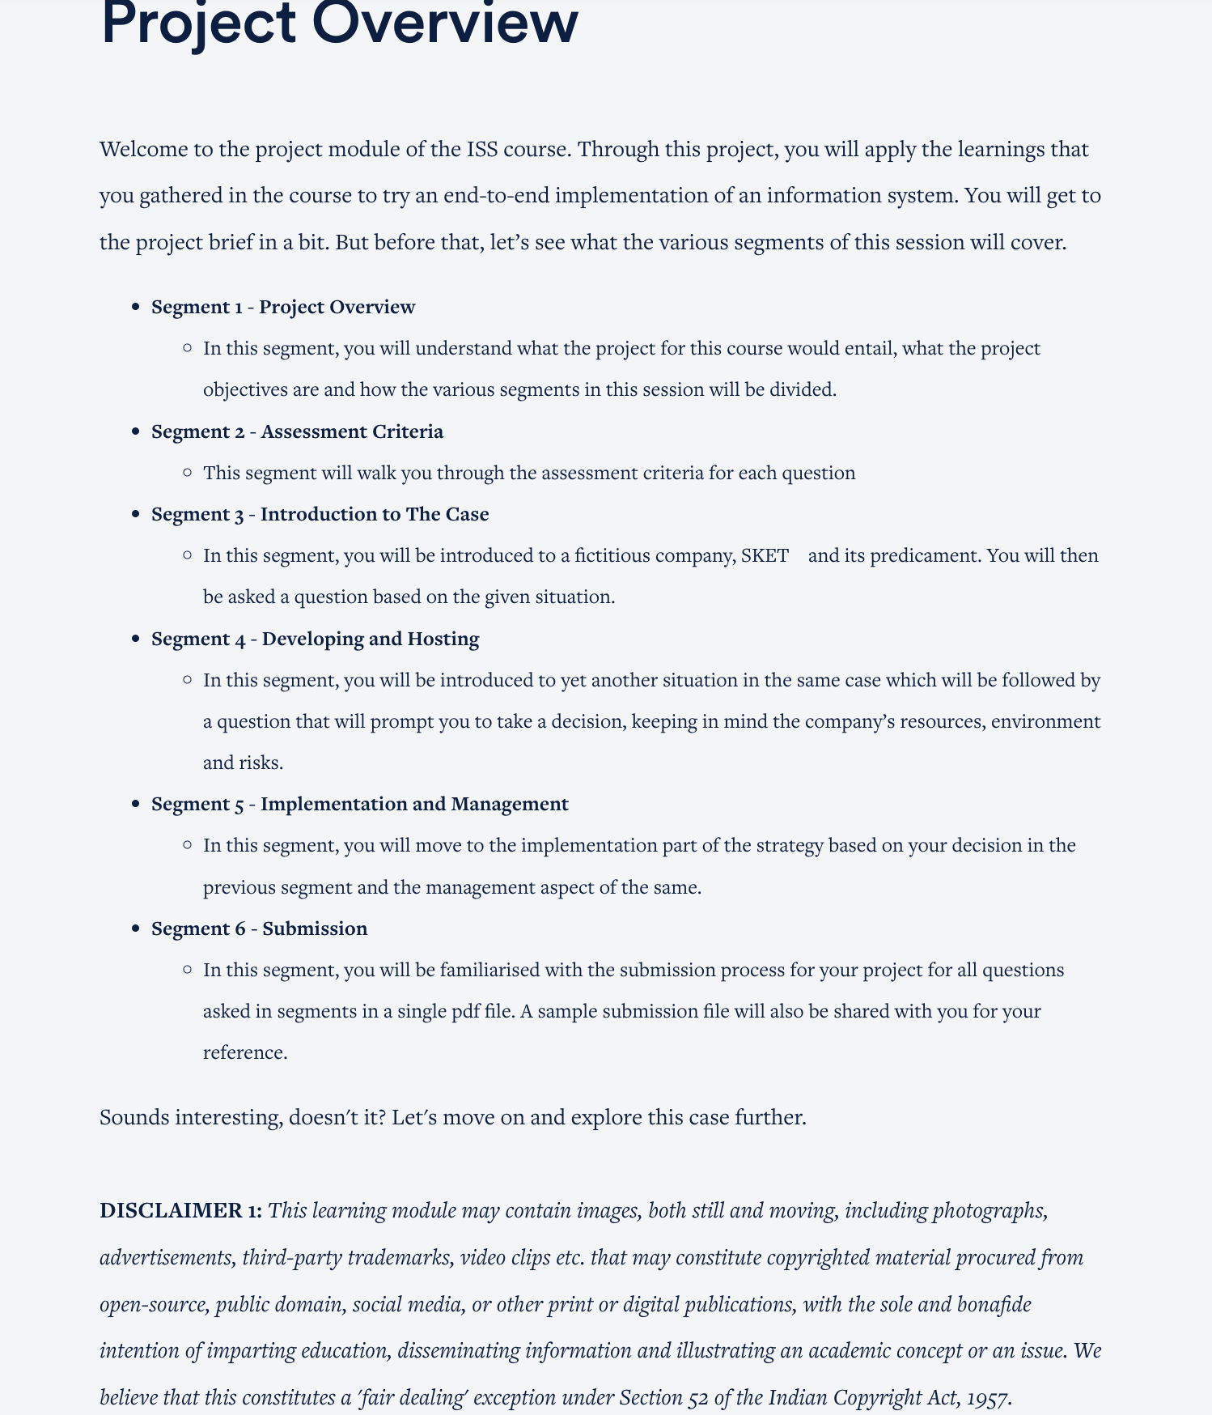

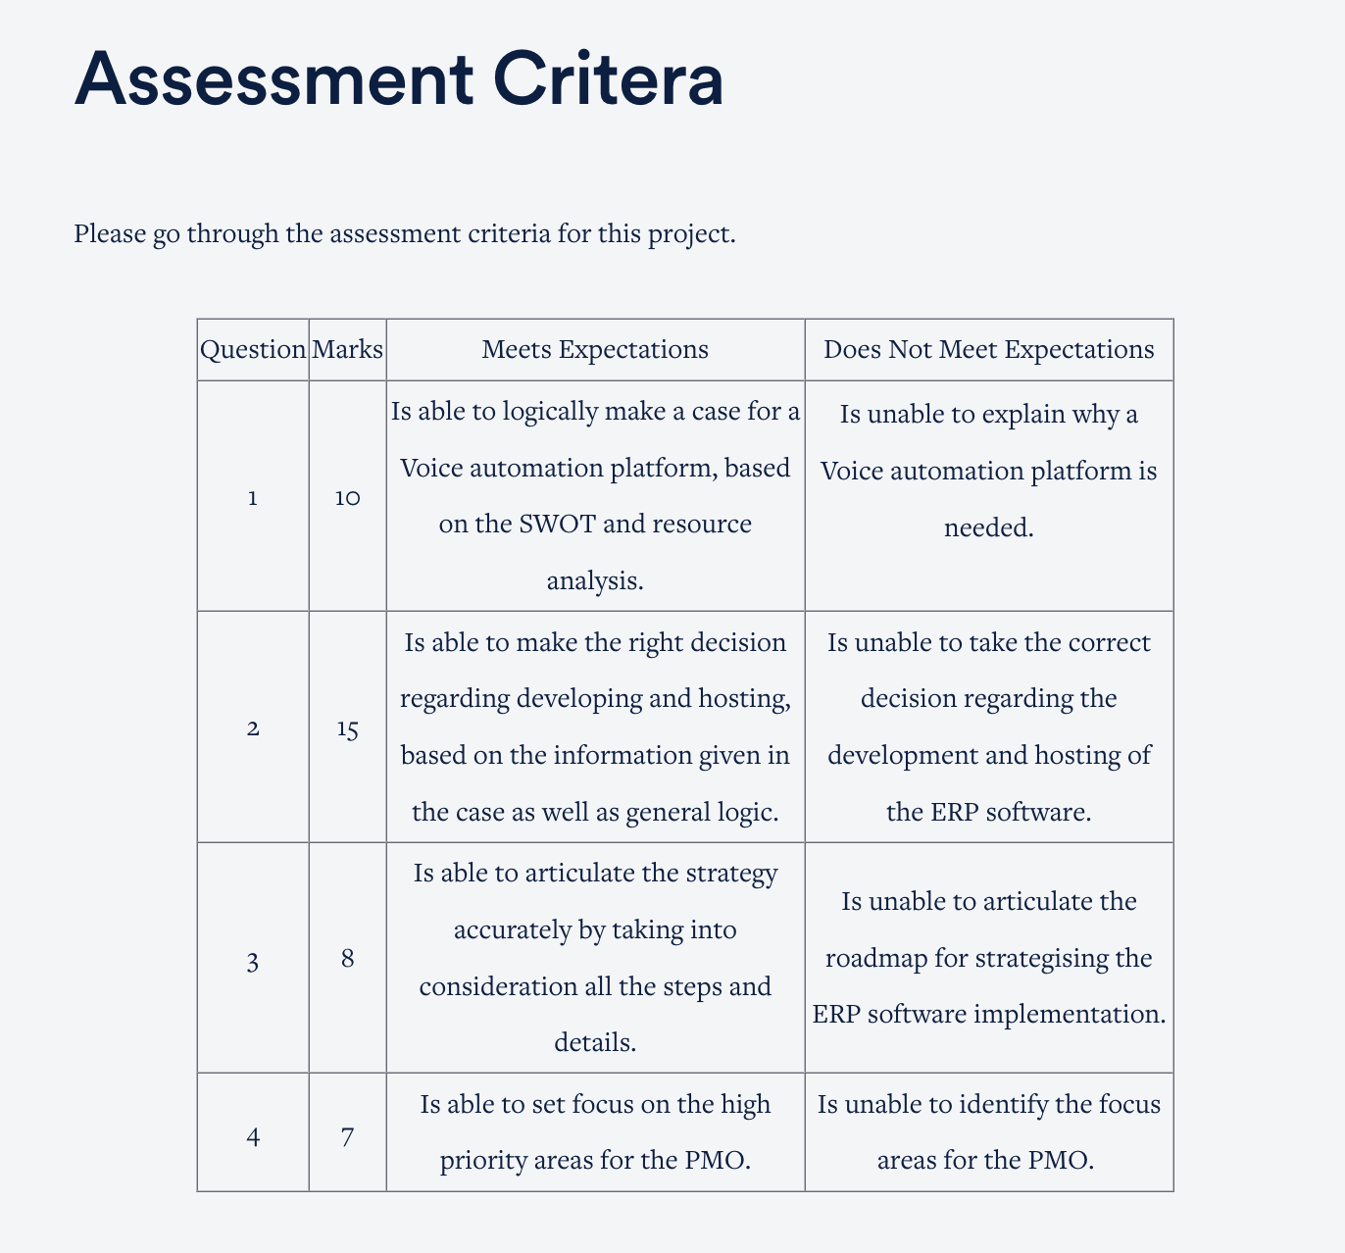



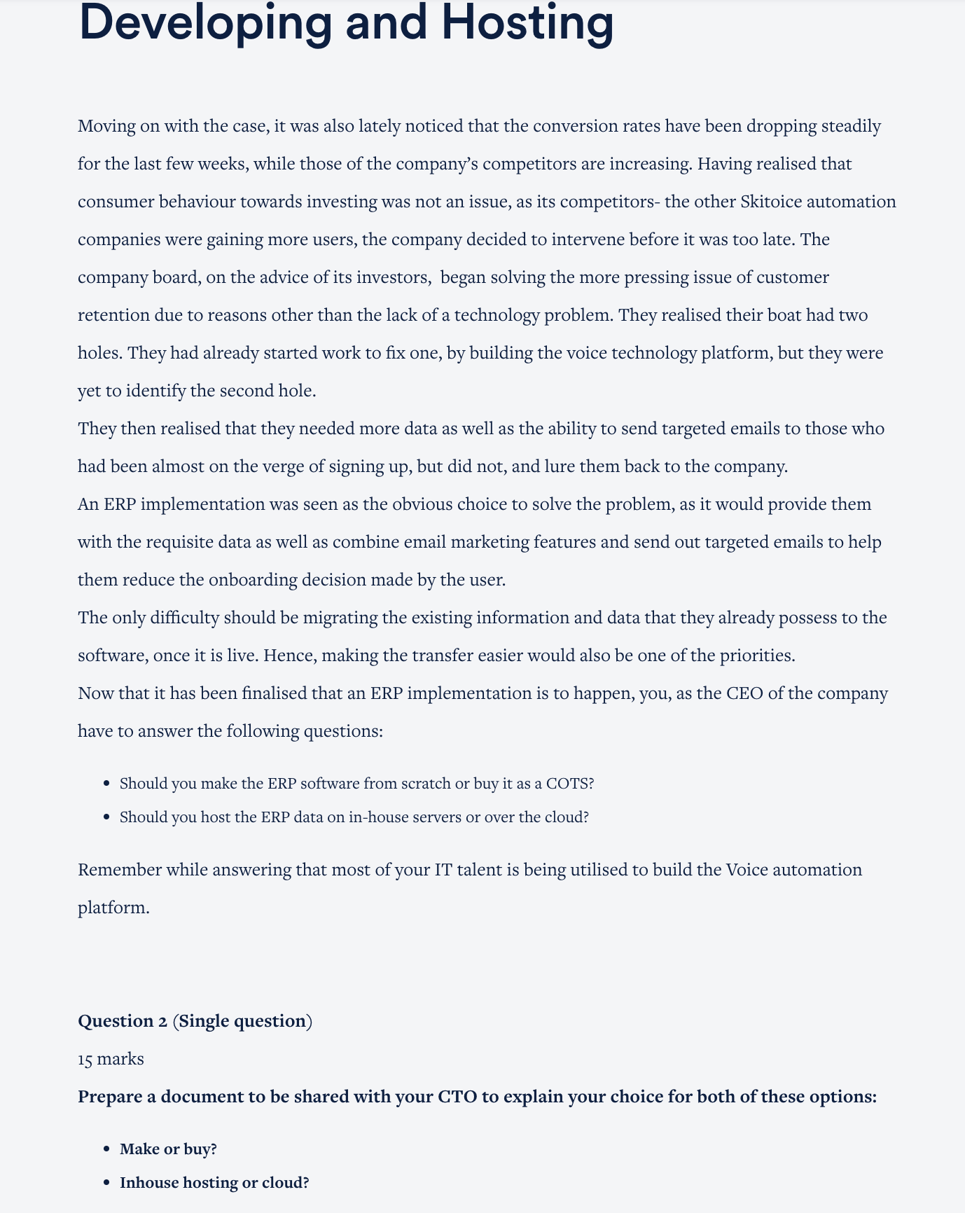

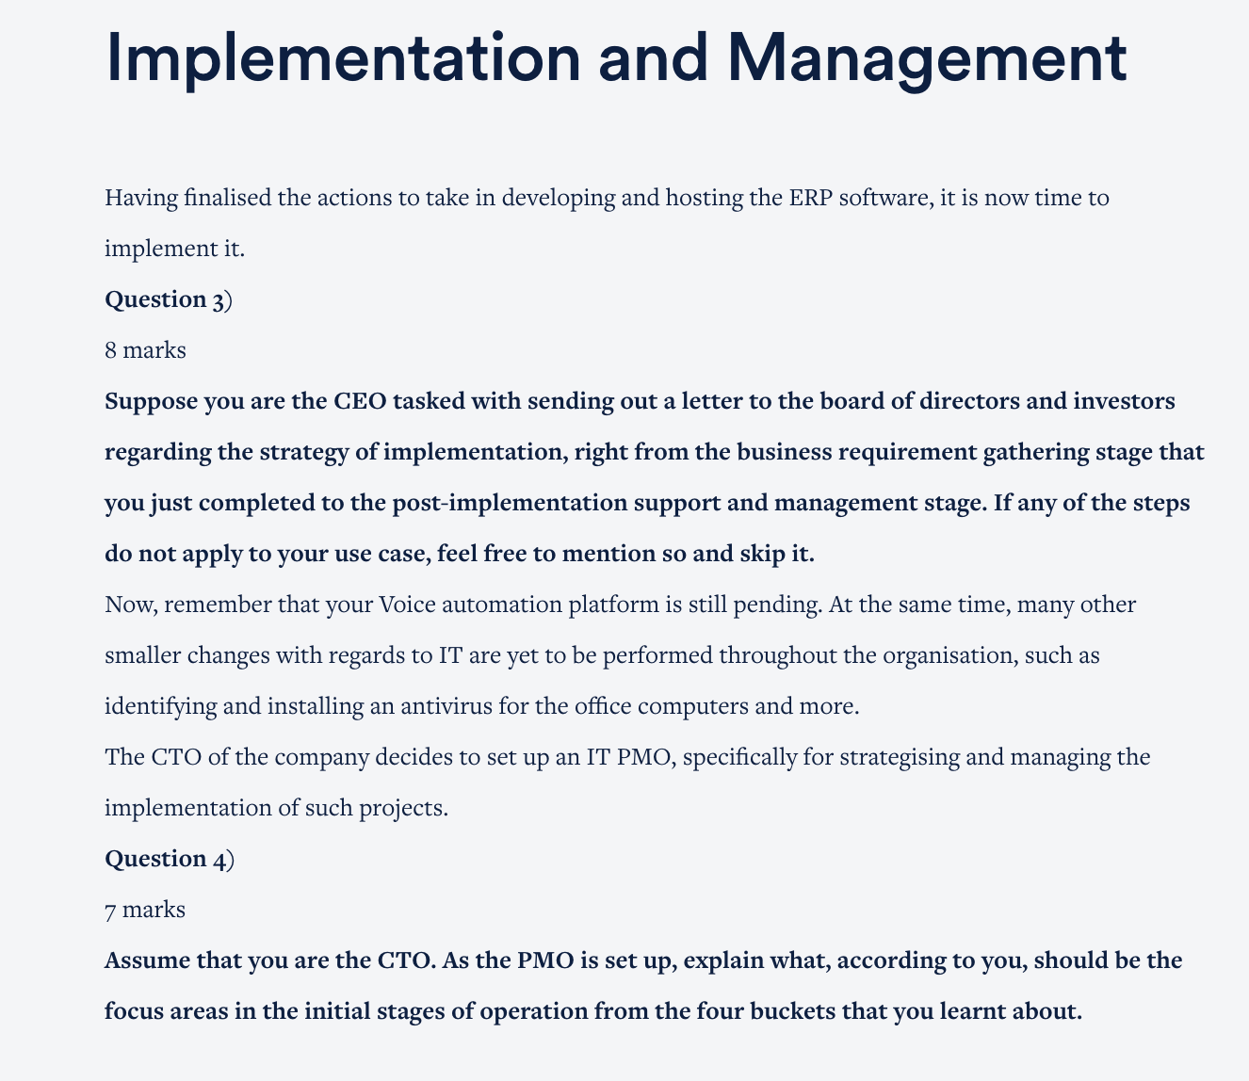

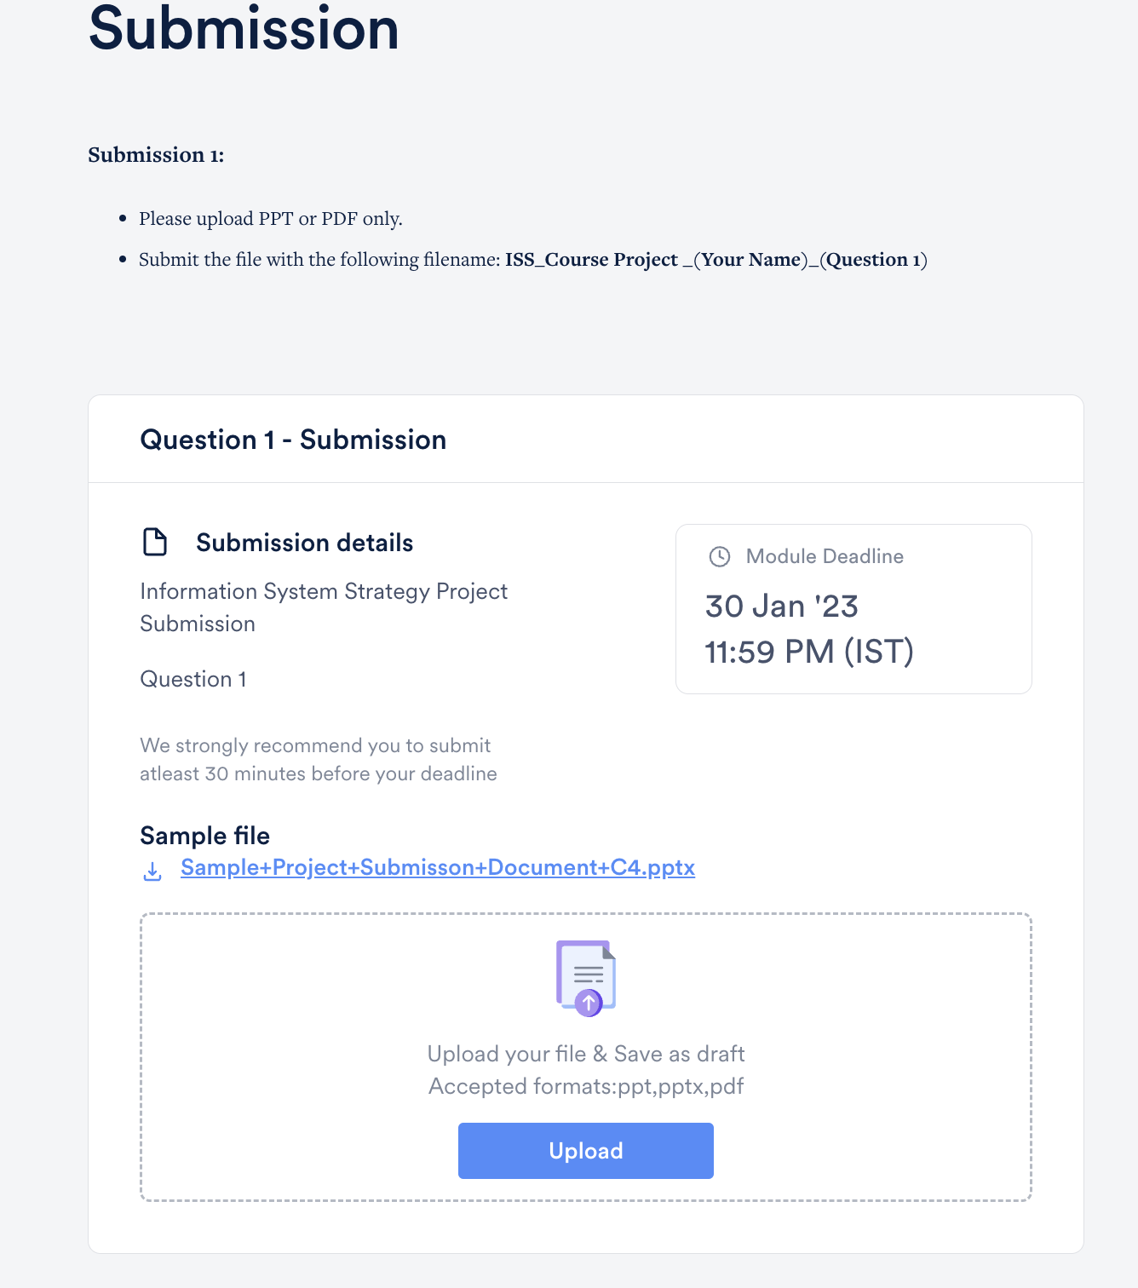

Sample Template for Submission 1 : <https://docs.google.com/presentation/d/17wGC4v7pEk9gpl-CxinpWZlh1xgyYfHt/edit#slide=id.p1>

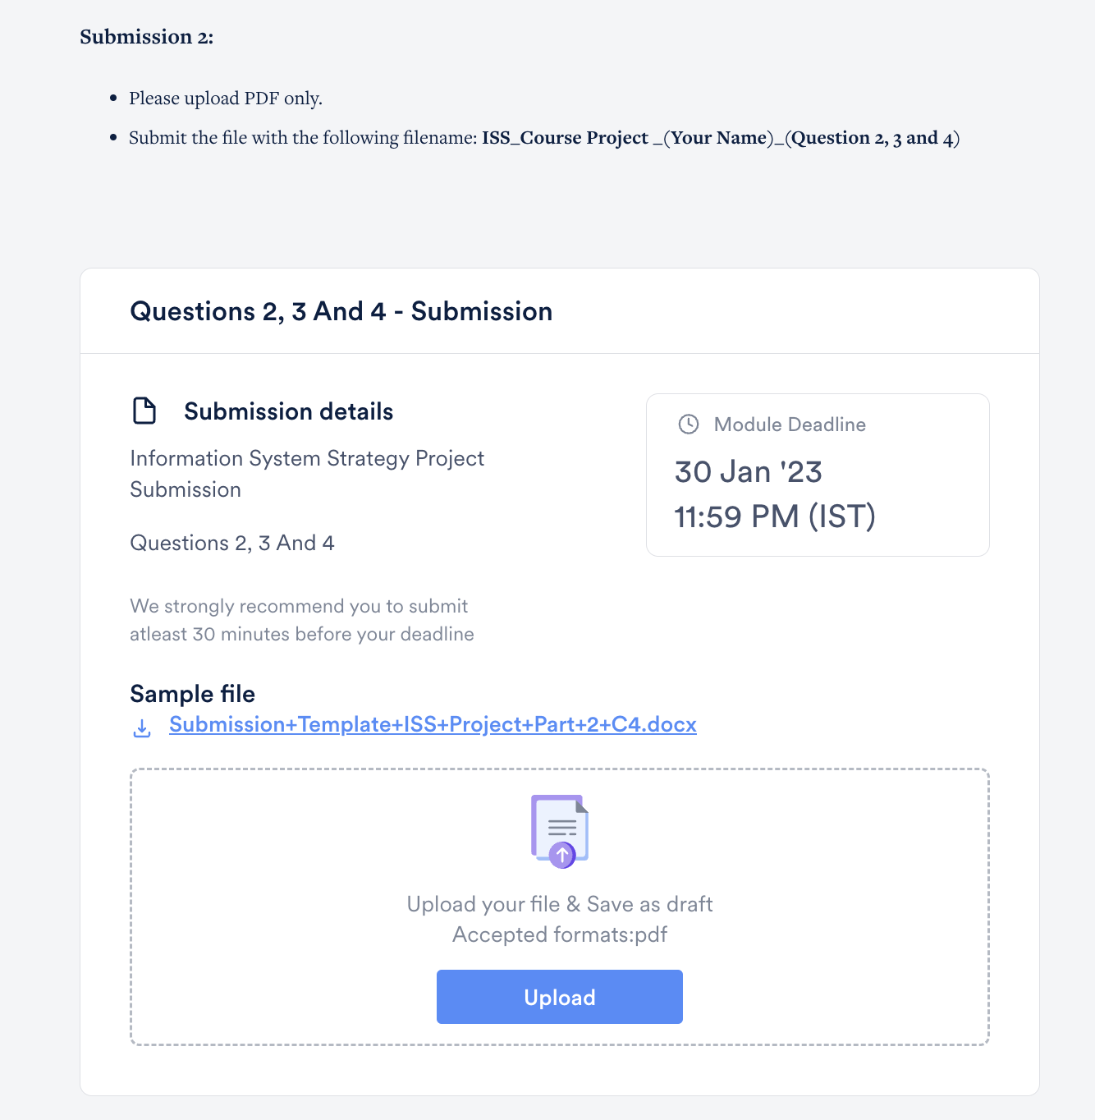

Sample Template for Submission 2 :

<https://docs.google.com/document/d/1oZFPsx2835kSyO44SiuDHXzNmh19qCmE/edit>