ORGANIZATIONAL CULTURE AND ITS IMPACT ON EMPLOYEE MOTIVATION

***Student name:***

***Student id:***

***Course name:***

***Subject name:***

**Acknowledgement**

My advisors were important in my success in completing this study. The internet is home to a wealth of resources, including scholarly journals and papers, as well as data sets, all of which contributed to the success of this research endeavour. In addition, I would like to express my appreciation to every one of the writers of those publications for providing me with helpful material; without their contributions, completing this dissertation would not have been feasible. I would also like to express my gratitude to my contemporaries for their support and assistance throughout this research project and in spreading the word about it. In conclusion, I would like to express my gratitude to the administration of my institution for granting us permission to carry out this research. I was able to improve my understanding of the corporate culture and the factors that motivate employees thanks to this experience.

**Abstract**

This research has identified the importance of organizational culture and its impact on employee motivation. The research started with introducing the research topic with sets of research aims, objectives, and questions for maintaining the research direction followed by helping in giving a particular format for the research which thus helps in evaluating different types of organizational culture and finding the most suitable one for boosting employee motivation and performance. The research aim was set to study the different concepts associated with organizational culture which can be used to understand how it is related to employee motivation. Followed by a literature review where the researcher’s views of different authors’ work and thus were evaluated in this part, wherein several concepts associated with the research were discovered. The literature review section of the paper states that maintaining an effective working and organizational culture by knowing the needs and requirements of the employees helps in increasing the level of motivation among the various employees. Followed by a methodology section, which helped in discovering the research methods which were used in the research like positivism philosophy, deductive approach, and descriptive design. The methodology part contains the various methods and techniques which are being used by the researcher to collect and gather various types of information and data.  Further, it also highlighted secondary data collection methods applied and the use of secondary sources such as articles, websites, journals, and newspapers for collecting accurate and authentic information. In the analysis section, the findings and the literature review section, and the objectives of the research were analysed to see the limitations of the study, the new findings, and the potential for future research were also mentioned. Lastly, this research concluded with a list of recommendations that can be adopted by other organizations to be followed as a culture for uplifting employee motivation was adopting transparency and adopting rewarding performance culture in the organization, along with many more such suggestions.

**Table of Contents**

1. Introduction 6

1.1 Introduction 6

1.2 Background of the study 6

1.3 Research Rationale 8

1.4 Significance of the Research 9

1.5 Research Aim 10

1.6 Research Objective 10

1.7 Research Question 11

1.8 Dissertation Structure 11

1.9 Summary 11

2. Literature Review 11

2.1 Concept of organizational culture and employees' motivation in the workplace and their interrelationship 12

2.2 Theories related to organizational culture and employee motivation 13

2.3 Impact of organizational culture on the organization 19

2.4 Impact of employee motivation on the organization 22

2.5 Role of organizational culture in building employee motivation 23

2.6 Strategies used to increase employee motivation in the organization 24

2.7 Impact of organizational culture and employee motivation on the internal and external environment of the business 26

2.8 Literature Gap 28

2.9 Summary 28

2.10 Conceptual framework 29

3.0 Methodology 30

3.1 Research Onion 30

3.2 Research Philosophy 30

3.3 Research Approach 31

3.4 Research Design 32

3.5 Sampling Techniques 32

3.6 Data collection methods 33

3.7 Data analysis 34

3.8 Ethical consideration 34

3.9 Limitations 34

3.10 Timescale 36

4.0 Findings and Analysis 36

4.1 Thematic Analysis 37

Theme 1: Application of Maslow’s Hierarchy of Needs in improving organizational culture and employee motivation 37

Theme 2: Organizational culture strategies followed by large organizations 40

Theme 3: Role of organization’s internal and external environment on its culture 43

Theme 4: Various organizational culture tactics applied by organizations to improve employee motivation 44

Theme 5: Impact of organization’s vision and external environment on organizational culture 46

Theme 6:  Role of money, rewards, and job duty on employee motivation 47

Theme 7: Three levels of organizational culture 49

Discussion 50

5.0 Conclusion and Recommendation 54

5.1 Conclusion 54

5.2 Linking with objectives 54

5.3 Recommendation 55

5.4 Future scope 59

References 60

Appendices 70

# 1. Introduction

## 1.1 Introduction

Organizational culture refers to the behaviour which is followed by the employees in an organization. This behaviour has a significant impact on the productivity of all the departments of the organization. Organizational culture is one of the most important parts of being able to compete with others and keep a good brand image as it is reflected in the company's policies and attitude towards customers too. Organizational culture is usually used to describe the right way to act in an organization, and it is made up of people who share the same beliefs and values that were set by the leaders (Paais and Pattiruhu, 2020, p. 577). The organization's primary goal is to offer employees motivation by focusing on hygiene factors and enabling more satisfaction at work. By motivating and empowering employees and by timely communication with employees involving staff members during the decision-making process an organization can achieve the same. Organizational structure tends to provide guidance for individual employees by reporting relationships between employees and employers in the workplace.

An organization's culture tends to describe proper ways to behave in the organization. The culture consists of shared beliefs and values created by company leaders. Communicating and reinforcing the processes by using various methods, employees' behaviours, and understanding to shape employees' work performance. Following a strong culture is determined to achieve successful outcomes. In organization leaders are the ones who follow organizational culture regularly and go beyond to communicate with employees so that they can follow specific cultural rules. Leaders have a clear perspective about the values and are determined to run the businesses seamlessly. Ineffective organizational culture can bring down organizational performance as well as leadership quality.

The following dissertation aims at finding out the kind of behavior which needs to be followed in an organization to develop employee motivation. The dissertation has been divided into five chapters where this chapter aims to define the objectives, aims, and rationale for writing this research.

## 1.2 Background of the study

Organizational culture is a set of shared values, expectations, and ways of doing things that help team member’s work together to reach specific goals. A good organizational culture is made up of good things that help people do their jobs better and work more efficiently. Organizational culture affects every part of a business, from being on time to the way people talk to each other. It can also help employees do their jobs better. When the culture of an organization matches up with what employees need, employees feel more comfortable, valued, and supported. Culture is one of the most important things a company needs to do to bring in talented new workers. The organization is one of the biggest grocery stores in the UK, and the company needs to care about what its employees need. Organization’s culture is one of its most important ideas, and the company's main goal is to serve thousands of communities and help them build strong relationships with each other. The company thinks that organizational culture works and can help employees do their jobs better, which will increase the value of the brand in the current market (Kawiana*et al.,* 2018, p. 35).

Improving an organization's culture leads to enhanced organizational performance. Culture can provide a strategic competitive advantage which helps to increase a company's leverage in the marketplace. A strong culture can bring benefits to increasing trust and cooperation during the decision-making processes. Culture also provides informal control mechanisms and strong identification for understanding employees' requirements toward the organization. An organization with strong defined culture has influenced employees to justify employees' behaviours in the workplace for maintaining effective organizational culture. Ineffective and negative workplace culture is leading to hampering employees' performance and company profits in the organization. Since company leaders play an important role in shaping and sustaining workplace culture. In organization leaders often outline any unusual natures of company culture and come with strategic outcomes. Individual organizations follow different organizational cultures based on the company domain. For instance, most private company's key aspects are to increase revenue and grow in the current market.

Employees' motivation not only relies on money, but it also reflects on other cultural activities for running the business seamlessly. Organizational culture plays an important role in developing and maintaining employees' motivation levels within the employees. While employees feel valued and included, they work more effectively with the best potential. The alignment between organizational culture and employee motivation is influential to improve organizational performance. It is considered that a high-performing culture can maximize company purpose, play, and potential for minimizing emotional pressure, inertia, and economic pressure. The level of better organizational culture reflects motivating employees. It is considered that organizations can develop a strong culture by rewarding and acknowledging employees based on their work performance. Moreover, this research is mainly about the primary concept of organizational culture which has an impact on employees' motivation. The primary purpose of this research is to highlight the impact of organizational culture on employees' motivation in this study.

## 1.3 Research Rationale

The rationale for doing this research is to understand the various concepts, theories, and strategies for developing organizational culture. The purpose of this research would helps researcher understanding the concept of organizational culture completely to use it for developing employee motivation and achieving organizational goals. This study looks at how the culture of an organization affects employees' work performance and motivation at work. Organizational culture is an important part of an organization because it helps employees be more motivated and do better work, which is good for the whole organization. So, this would gives researcher a clear picture of what organizational culture is and how it affects how motivated employees are at work (Pancasila *et al.,* 2020, p. 387). This research will help to understand the importance of organizational culture including time management, employee benefits, and stakeholder engagement. Nowadays, employees feel more comfortable, valued, and supported to work in an aligned organizational culture. Thus, each organization needs to understand the impact of organizational culture and the connection with employees' motivation. This research addresses the required aspects for creating a positive organizational culture which will eventually increase employees' motivation toward the organization. With the information demonstrated in this research would help researchers to understand the concepts of organizaional culture and its importance for employee motivation in the workplace.

Google, Apple, Amazon, and Facebook, all of these companies have become almost the topmost companies in the world. To be in the position one requires cultural support which if maintained can do wonders for the company. Thus, doing this research can help in understanding every aspect related to an organizational culture which can thus be further used by future generations to develop employee motivation in the company.

The research paper contains various types of motivational as well as cultural theories which helps in contributing towards the existing academic knowledge. The theories and models related to the culture and motivation in the business helps in generating knowledge that the better the organization culture, the better and higher motivation level among the various employees. The various data and information which are being used by the researchers to conduct this paper helps the various organizations to know about the organizational culture and motivated employees are independent with each other (Paais and Pattiruhu, 2020). The respective research paper is very beneficial for the organizations as well as practitioners as this paper helps in understanding the various importance of cultural and motivational theories as well as models to achieve the desired outcomes and results.

## 1.4 Significance of the Research

The significance of this research is to get tremendous ideas on how the organisational cultural equilibrium has motivated the employees towards their works. Through this research, it has been discovered that the “Clan Culture” has a positive significance in creating a highly coordinated, collaborative, and mutually understanding scenario among the employees. This culture provokes the concept of high team dynamics and team spirit to mitigate the business challenges and make the business profitable and feasible in the competitive marketplaces. The “Maslow’s Hierarchy Theory” is adopted by the Business Managers and Strategic Leaders of the businesses to motivate the employees as per their safety, physiological, belonging, love, esteem, and self-actualisation-based requirement to create highly involving workplaces. The existing and other practitioners would also gather deeper ideation on how the “Staff Rewarding Policy” motivates the employees to create a clan type of organisational culture.

Evidence has shown that 47% of job seekers stated company culture is the driving reason for maintaining productivity thus it becomes important to improve the culture of an organization in order to attract more talent in the organization (Kawiana *et al.,* 2018, p. 35). On the other hand, 91% of managers define organizational culture as equally important to work with skill and experience. Nearly 35% workers estimate that workers will not work in an organization if employees feel organizational culture is not effective. Due to ineffective organizational culture employees might not feel motivated, able to interact with others which increases employee turnover. However, 26% of employees leave the company if they are not able to interact or build connections with colleagues. 23% employees are more likely to stick with the same company where the manager or leaders clearly defines role and responsibility with work purpose. 58% employees stick to the company for a longer period of time with lower paying job roles because of the organizational culture. More than 88% of employees agree that a strong organizational culture is the key for successful business outcomes. The significance of this research is to understand the importance of organizational culture so that it can be used to improve the motivation of the employees in an organization. Maintaining a positive workplace culture would be able to influence employees and keep them motivated in the work-field (Pham et al., 2019, p. 446).

*Research argument*

According to (Maamari and Saheb, 2018), Organizational culture plays an important role in the process of maintaining and developing  the level of motivation among the various employees. The researcher of the paper states that if the companies focus on developing a strong culture of acknowledging and rewarding the efforts of the employees, it eventually increases the level of motivation. As per the view of the researcher of the particular study, it has been identified that an appropriate level of motivation among the employees helps in enhancing the level of performance of the employees that directly contribute towards high level of production in the business.

The research argument has identified how the organizational culture is creating a positive endowment in the employee motivation for organizational growth and sustainability. From this research study, the learners would gather tremendous ideas on the unique strategies in the employee motivation level enhancement by the business enterprises in the recent contemporary business world. The key value of this research study paper is to get deeper ideation on how the business organizations are accepting the staff motivation theories to influence the staff’s work desire and job involvement rate. Considering the research aims, objectives, and rationale, the key argument of this research study paper is *whether the organizational culture has a footprint on the employee motivation towards their job or not*

This research is important as there are various theories, models, frameworks, and strategies that have been developed around organizational culture. However, none of the preset articles conveys how these theories are applied in real-world businesses, which shall be done in the secondary research of this study and thus a conclusion shall be derived with a list of recommendations on how the organizational culture can be adopted by organizations to develop employee motivation.

## 1.5 Research Aim

The primary aim of the research is to evaluate and understand various concepts and theories of organisational culture and its impacts and role for employee motivation and thus recommend strategies on how it can be practiced.

## 1.6 Research Objective

The objectives of this research are mentioned below:

* To understand the concept and theories associated with organizational culture and employee motivation and their interrelationship in the workplace.
* To mention the various impacts of organizational culture and employee motivation on the business.
* To assess the role and significance of organizational culture in building employee motivation.
* To recommend the different strategies which can be used by other organizations to improve their employee motivation by enhancing organizational culture.

## 1.7 Research Question

Q1. What are the concepts associated with organizational culture and employee motivation and how do they interrelate?

Q2. What are the different theories related to organizational culture and employee motivation?

Q3. What are the positive and negative impacts of organizational culture and employee motivation in an organization?

Q4. What is the role of organizational culture in building employee motivation?

Q5. What are the different strategies which can be used to increase employee motivation in the organization?

Q6. What is the impact of organizational culture and employee motivation on the external environment of the business?

## 1.8 Dissertation Structure

This dissertation is divided into five chapters and each chapter carries an individual aspect of this research. The first chapter is an introduction, which introduces the main concept of this research by stating the objectives, aims, and research questions associated with this research. The second chapter is a literature review, where all the topics of literature associated with research are reviewed to find a literature gap that needs to be fulfilled with the help of this research. The third chapter is a research methodology that states the approach which will be taken while conducting the research and thus defines the data collection process with justification for chosen methods. The fourth chapter is findings and analysis, where all the information associated with the research is collected. This data consists of examples of how theories are implemented, evidence of the literature, which was found, and also some quantifiable data associated with the research. Lastly, the fifth chapter is the conclusion and recommendation which defines the concluding idea on the researched topic, along with some recommendations which are developed after completing the research.

## 1.9 Summary

This chapter gives an overview of a research topic, which is how the culture of an organization affects employees' motivation. Along with that, it stated the goals of doing this research, objectives, and questions to help to get the research move forward.

# 2. Literature Review

## 2.1 Concept of organizational culture and employees' motivation in the workplace and their interrelationship

As per the view of Ameen*et al.,* (2018, P. 2), Organizational culture is shared beliefs and values which are shared by leaders and then reinforced with several methods for shaping employees' behaviours, perceptions, and understanding.

Employee motivation refers to the zeal of employees towards achieving organizational goals. Companies with proper organizational culture tend to reach success by guiding employees. Since, organizational culture refers to following proper structure and moving toward organizational success as it has a system in place which increases employee productivity, performance, and engagement in the workplace (Achievers, 2022).

As per the view of Ameen*et al.,* (2018, P. 2), engaging and encouraging people to work more efficiently is facilitated in part by an organization's culture. A company with a positive work culture can motivate its personnel to work toward achieving certain set goals. In addition, Kawiana*et al.*, (2018), suggested that organizational culture helps to create a positive office environment to increase staff productivity. Influential corporate culture can sustain high levels of employee engagement and productivity, hence influencing people to be more productive. The close connection between employees and the organization has eventually contributed to the improvement of the work environment. For example, the organizational culture of an organization is crucial and effective for employee work performance. The organization is one of the leading brands, thus firm leaders ensure that each employee acquires the skills and expertise necessary to achieve future objectives (Leitão*et al.,* 2019, p. 3803).

 Employee motivation refers to the level of energy, innovation, commitment and many more that the staff and members of the company hold during the day-to-day activities of the business. Maintaining an effective working and organizational culture by knowing the needs and requirements of the employees helps in increasing the level of motivation among the various employees. Organizational culture plays an important role in the process of maintaining and developing the level of motivation among the various employees. The better the organization culture, the better and higher motivation level among the various employees. The concept of motivation as well as organizational culture is known to be an important factor for the purpose of determining the success of the organization. In this competitive market, each organization or company is facing difficulties in the survival in the dynamic market (Saad and Abbas, 2018). In order to create an effective place and position in the competitive market, the various organizations need to focus on creating a strong and appropriate organizational culture as well as motivational programs for the employees. These various factors eventually reflect on the success, performance level, productivity as well as success of the organization.

## 2.2 Theories related to organizational culture and employee motivation

***Organizational culture Theories***

According to Ideas, (2021), Organizational culture tends to identify the role of leaders in cultivating or conducting business with stakeholders, employees, and business ventures. However, Culture can identify defined consistent organizational behaviours for leaders and employees. On the other hand, as suggested by Bizfluent (2019), Organizational culture can bring opportunities for achieving an organization's strategic objectives, attract potential employees and address those employees who are not able to stand out in the organization. Moreover, organizational culture reflects the core values of the organization as well as leadership aspects. There have four types of organizational culture which are best known for competing

***Hofstede model***

Geert Hofstede identifies the national and regional characteristics that contribute to company culture and impact employee conduct at work. Hofstede has identified five characteristics of workplace culture; the following are additional features of this study.

*Strength Distance*

The power distance index is established for various work cultures in which employees are delegated power. Most of the company holds team members and leaders accountable for constructing respective teams and addressing problems. Consequently, team members would be able to respect team leaders and complete the organization's order (Leitão*et al.,* 2019, p. 3803). Following are some of the features of this model, *Comparing masculinity to femininity*. In an organization, organizational culture is the result of contrasts between male and female values. Due to varying policies in the decision-making processes, organizations where male employees outnumber female employees have distinct policies. Therefore, the organization must continue to employ both men and women. In addition, it is essential to provide equitable opportunity to all employees, as this will assist in preserving strong company culture. *Individualism*, multiple organizations rely on collaboration and employees' shared interests to collaborate and operate as team members. The organizations believe in the exchange and discussion of individual employees' ideas to generate new inventive ideas. Certain firms have a culture in which employees are motivated to work as a unit but prefer to work independently.

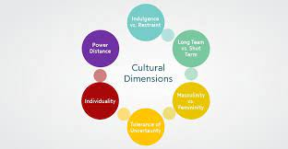

**Figure 1: Hofstede cultural dimensions**

(Source:Tejayadi *et al*., 2019, p. 63)

*Uncertainty avoidance index*, the ambiguity of novel or uncommon situations for employees defines this element. The index defines the level of employee tolerance for both pleasant and unpleasant situations. This organization's principal objective is to prevent incompetence and assure the proper manner to address any difficulties.*Long term perspective*, Organizations prioritize establishing long-term connections with employees and value their efforts to meet managerial exceptions. Employees who have a long-term stake in the connection tend to feel more connected to the firm and prioritize long-term objectives. Thus, businesses that present employees as short-term targets are more likely to minimize long-term reductions and short-term aims (Tejayadi *et al*., 2019, p. 63).

***Different types of organizational culture***

*Adhocracy culture-* Adhocracy combines "Ad Hoc" and "Bureaucracy." The adhocracy is predominantly adaptable and unrestricted by bureaucratic policies and processes. There is constant invention and development, which operate at a rapid pace and might be tough. Developing a strategy and engaging in brainstorming would enable employees to contribute unique and expansive suggestions for enhancing work performance. *Clan culture-* Clan culture is prevalent in small or family-owned firms that lack a hierarchical structure. This culture's principal objective is to make employees feel equally valued and included in the organization. This culture is characterized by high employee engagement for the development of effective customer service. Thus, the organization must recognize the value and generate ideas that would propel the business forward (Tejayadi *et al*., 2019, p. 63).

*Hierarchy culture-* The hierarchy culture exemplifies corporate culture in the United States by establishing structure, levels of power, and procedures. In this culture, structures and operations are well defined and linked with the organization. This type of culture facilitates the brand's risk management and operational effectiveness. *Market culture-* The culture of the market defines profit margins and staying ahead of the competition. Thus, it is an important external factor in ensuring consumer pleasure. Market culture tends to analyse every position inside a business. Utilizing superior products and services has ultimately enabled the company to achieve its objectives.

***Employee motivation Theories***

As stated by indeed Career Guide, (2018), Motivation theories can assist management teams in determining the most effective means of attaining company objectives or pursuing desired outcomes. However, this research paper defines a manager as able to support staff with more efficiency. In addition, Skilbeck, (2019) suggested that it helps boost productivity by reducing workplace mortality and raising profit margin. By embracing motivation theory, one can comprehend and grasp the factors that affect employees to achieve particular goals. The motivation theory assists in identifying actions that effectively motivate employees, influencing them to work hard and achieve rewards. The following motivating theories assist the organization in increasing production, earnings, employee satisfaction, and staff retention (Tejayadi *et al*., 2019, p. 63).

*The notion of Maslow's hierarchy of requirements-* Maslow's hierarchy is a psychological theory that identifies the types of individuals required to accomplish progressively complicated requirements. This hypothesis comprises the following five stages of need:

*Physiological,* it is essential to provide appropriate water, clothing, shelter, and food for meeting fundamental psychological needs. In the workplace, employees must be content with their earnings and capable of meeting their physiological demands. *Safety-* This level considers the need to feel protected. After the global epidemic, employees are currently becoming increasingly concerned about health safety and security. In addition, it is important that employees feel comfortable at work and have a sense of job security. *Socialization-* To meet their sociability demands, employees must develop strong connections with co-workers and form pleasant contacts that allow them to feel included and at home in the workplace. An organization can maintain a healthy work environment if its employees can form strong friendships through team-building exercises and employee meals. Since employees spend most of their time at work, they must maintain a favourable workplace culture (Jamali*et al.,* 2022, p. 2).

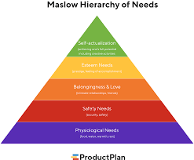

**Figure 2: Maslow'sHierarchy of Needs**

(Source:Jamali*et al.,* 2022, p. 2)

*Esteem,* employees typically attain this level by obtaining acknowledgment, which boosts their confidence and self-esteem in the workplace. Providing constructive comments and recognizing employees' accomplishments are two approaches that influence employees' self-esteem. Employees must have confidence in the professional workplace. Increasing confidence will eventually assist individuals in achieving achievement and establishing a solid professional sector.

*Self-actualization,* when an employee reaches this stage, they face multiple hurdles, complexity, and long-term or personal goals. Self-actualization motivates employees to achieve certain objectives effectively.

***McClelland's notion of the need***

McClelland's need theory suggests that most human beings have three distinct needs, which, when satisfied, motivate and affect individuals. By comprehending McClelland's need theory, firm managers can comprehend the employees' needs of the company. In addition, it influences and guides employees to achieve specified goal-setting objectives. Depending on how well these three demands are met, it is possible to encourage people to improve their work performance (Fitria, 2018, p. 82).

*Need for membership-* The affiliate theory describes individuals who desire membership in a group and are regarded as acceptable by others. This approach assists managers in determining if individuals are capable of working in teams and gaining experience. Affiliation motivates employees and frequently improves their interpersonal abilities, allowing them to create strong and lasting relationships with co-workers.

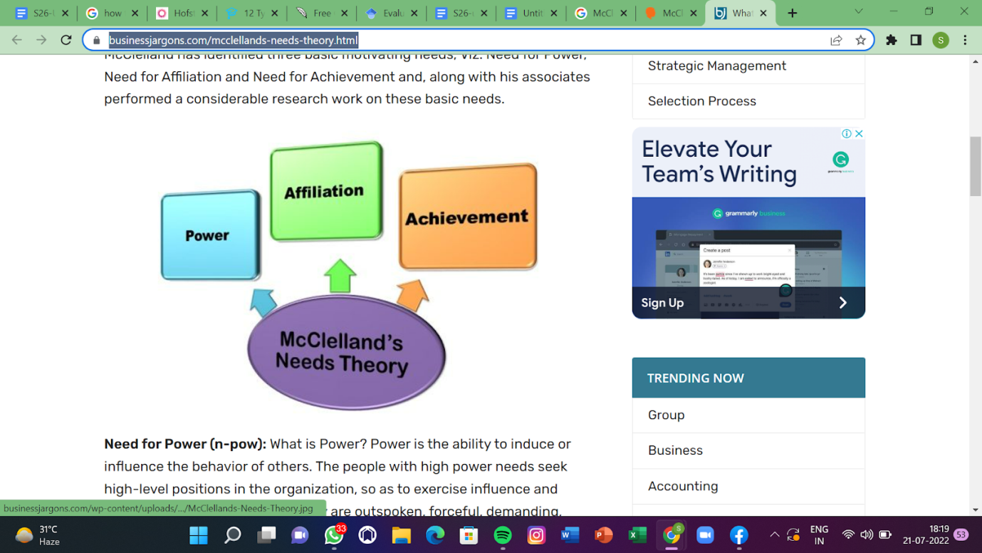

**Figure 3: McClelland's notion of the need**

(Source:Prihantari and Astika, 2019, p. 197)

*Need for accomplishment-*Several employees' primary objective is to attain success and prominence. Individuals can be competitive and maintain strong work-ethic standards. In addition, it is believed that employees may have a strong desire for an acknowledgment after completing certain tasks, and employee feedback is also collected. However, creating unique incentives for employees inspires and motivates them to achieve through competition.

*Need for energy-* Some individuals are significantly more engaged in influencing others and would have a beneficial impact in the workplace, according to research. These types of personnel are more likely to serve as group leaders, organizing activities and delegating duties. In addition, they tend to persuade co-worker’s to achieve short- and long-term objectives. Permitting this person to assume responsibility for leadership abilities in encouraging and influencing co-worker’s to increase employee job satisfaction (Prihantari and Astika, 2019, p. 197).

This respective theory states that every employee of the organization has one of the three main drivers of motivators which are the need of affiliation, power, and achievement. These different motivators are not inherent, and these are being developed through life experience as well as culture (Mamedov, 2022). This respective theory states that these above-mentioned needs have significantly influenced the behavior of the individual which is known to be useful in order to understand the managerial context.

***Herzberg’s Motivation Hygiene theory***

Maslow's Hierarchy of Needs is an expanded form of Herzberg's Motivation Hygiene theory, which is a novel motivation theory. Herzberg proposed that contentment and discontent is a valid indicator of the maintenance of a positive workplace environment. This hypothesis considers both hygiene and incentive issues.

*Motivating elements*

*Advancement*, Advancement is an upward and positive component of the job, according to Herzberg. Unfavourable features result in negative organizational advancement (Chatterjee *et al.,* 2018, p. 15).*Work*, The work's content has either beneficial or bad consequences on employees. Those who are either content or unsatisfied with their workplace are typically confronted with difficult work conditions and a low degree of engagement at work. *Potential for growth*, the potential for growth under this notion is comparable to Maslow's Hierarchy of Needs. This indicates the opportunities for career advancement and personal development. Improving personal and professional development affords the chance to acquire new techniques and abilities while expanding professional expertise (Tejayadi *et al*., 2019, p. 63).

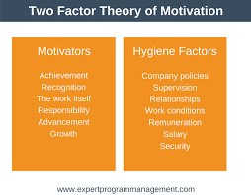

**Figure 4: Herzberg’s Motivation Hygiene theory**

(Source:Sarhan*et al.*, 2020, p. 183)

*Responsibility*, both individual and group members are held accountable for their actions. During decision-making procedures, the obligation and authority rest with achieving satisfaction. *Recognition*, While employees are paid for their work performance, they are permitted to pursue individual objectives. Hostile recognition results in criticisms and fosters a negative work environment. *Achievement*, Possessing the ability to resolve work-related challenges with favourable results is a positive accomplishment for accomplishing difficult assignments on schedule. Negative achievement is typically indicative of a failure in the workplace or poor job-related characteristics throughout decision-making procedures. *Hygienic elements*- *Interpersonal relations*, According to Sarhan*et al.*, (2020, p. 183), Interpersonal relationships encompass both personal and professional ties with co-workers, superiors, peers, and subordinates. Thus, it has contributed to the maintenance of a positive work atmosphere. On the other hand, Pancasila*et al*., (2020, p. 387), Employees who are content with their pay tend to feel motivated and influenced at work, which ultimately encourages them to retain productivity. *Corporate governance and administration*- Each corporation has its own set of distinct policies and administrative procedures. Individual employees must adhere to rules and regulations to create a positive working environment.

Supervision entails an employee's evaluation of another's competency or ability. With bad leadership and management, job satisfaction can decline in the workplace.*Laborconditions* ,Working conduction refers to the physical surroundings of the workplace, including favourable or poor working circumstances. Included in a poor work environment is the quantity of work, tools, ventilation, temperature, and safety.  Herzberg's theory consists of the two dimensions for the purpose of job satisfaction which are hygiene and motivation. In order to apply Herzberg's theory, the company must focus on identifying the various hygiene issues and these identification of the hygiene issues helps in creating an effective environment which increases employee motivation as well as satisfaction (Chiat and Panatik, 2019). Through the help of this respective theory, the organization can decrease the level of dissatisfaction among the employees by the help of making various types of policies which are fair and equal to all.

## 2.3 Impact of organizational culture on the organization

***Positive impact***- As opined by Chatterjee*et al.,* (2018, p. 15), organizational culture is made up of the rules and habits that a company sets for its employees. This system is also about having the same beliefs, assumptions, and values at work. The three layers of an organization's culture make up the shape of a circle. The first layer is made up of artifacts, the second of value and belief, and the third is made up of assumptions. Because business is so competitive, it's important to understand organizational culture. On the other hand, according to Bose and Emirates, (2018, p. 71), organizational culture also plays an important role in gaining a competitive edge. Thus, organizational culture makes sure that all employees have the same goals and are in line with the company's goals. The people in charge make sure that employees' actions, goals, and productive work all go in the same direction. The brand also thought that keeping a positive organizational culture meant that employees would be committed and do their jobs well.

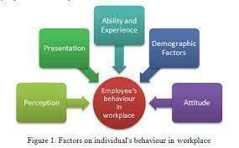

**Figure 5: Employee behavior in the workplace**

(Source: Siddiqi and Tangem,2018, p. 153)

The organization's culture is seen as being both driven from the inside and the outside. The internal organizational culture shows how employees feel about their knowledge and expertise. Employees can understand both explicit and implicit customer requirements when there is a high level of internal organization. On the other hand, an externally driven culture focuses on results and employee performance, like meeting customer needs, which is one of the most important business ethics. The business is run by a company that has a strong commitment to improving ethics and integrity. An organizational culture that is driven from the inside makes sure that brands use an ethical brand image to keep a strong competitive edge in the current market (Siddiqi and Tangem, 2018, p. 153).

Here are some of the good things that can happen when one follows the organizational culture-*Simple recruitment, most* of the company's hiring practices are based on the culture of the current staff and a decreasing list of priorities. Follow-up on organizational culture is mostly about getting employees more motivated so they feel valued and at ease working with other employees. *Better onboarding*, if employees know what the company's vision, goals, and objectives are, they are more likely to do their jobs well and move toward possible results. Every part of a company's culture is built into it, and this makes other people want to join the team. One of the best ways to get to know a company's culture is to talk about it with other team members (Ciobanu*et al*., 2019, p. 36).

*Increased retention,* new employees need to feel welcome and at ease at work, which encourages them to work hard for the company. With the following positive organizational culture, employees feel more comfortable and can easily interact with others (Pancasila*et al.,* 2020, p. 387).

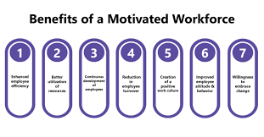

**Figure 6: Benefits of motivating workplace**

(Source:Pancasila*et al.,* 2020, p. 387)

*Improvement of employees*, Effective organizational culture can change the way employees think and help them value working styles that are similar so that they can provide better services in less time. Employees who are motivated and have a lot of influence can work more hours, while employees who aren't as motivated are more likely to work less (Small Business - Chron.com, 2018). *Elevated productivity*, when employees are happy and at ease, one of the most important things is for employees to work hard and feel valued and respected at work. So, it has helped people keep good relationships with their co-workers, which tends to keep a good work environment at the office. Each employee works toward the same goals because of the organization's overall values and goals (Belete*et al.,* 2018, p. 2).

***Negative impact***-*Poor communication,* Leaders in an organization must communicate values, norms, vision, goals, and key changes in a manner that people can completely comprehend for processes to take place. While employees do not feel valued or included, fear has ultimately replaced respect. According to the data, four out of every employee does not trust their employer (Razak*et al.*, 2018, p. 67). *Toxic employees-* In the business sector, the level of rivalry has raised the poisonous working environment, which has decreased knowledge exchange and boosted company politics. Based on research, it has been determined that employees exposed to toxic coworkers are 46 percent more likely to be terminated for misconduct and to propagate toxic behaviours within their teams. Thus, the HR manager must recruit candidates with superior technical capabilities that contribute to the maintenance of the corporate vision.

## 2.4 Impact of employee motivation on the organization

***Positive impact***- As stated by Mohelska and Sokolova, (2018, p. 2225), each firm employs efficient customer relationship management to comprehend brand-specific client needs. Customer requirements can be comprehended by identifying the business culture and actual brand awareness impact. To achieve their objectives, the primary focus of leading firms is on customer satisfaction, profitability, and output. Engaged personnel can drive the company's expansion and success. Listed below are some successful aspects that contribute to enhanced employee engagement with the brand. *Unified vision*- Leaders are responsible for guiding and instructing personnel, as well as influencing them to adhere to the organization's vision and values. Employees need to have clear objectives; hence, employees must have a clear attitude. Employees can work toward achieving specific goals and objectives when they have a clear mindset. If employees are attached to the company's vision, they will be devoted and loyal to the brand, which displays employee engagement naturally (Di Stefano *et al.,* 2019, p. 2482). *Building trust-* Mutual trust is one of the most significant factors that contribute to the maintenance of a positive working environment in the workplace. Transparency is one of the most effective strategies for organizational development because communication between members raises their degree of trust.

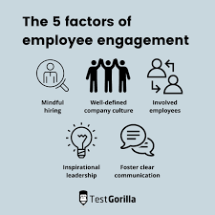

**Figure 7: Importance of positive work-environment**

(Source: Ali and Anwar, 2021, p. 21)

*Positivity among team members*-How team members communicate and engage with one another reflects the culture of the organization. Negative personnel tend to lower morale, productivity, and profit margin. Additionally, negative workers tend to increase employee turnover. Leaders are responsible for avoiding bad personnel and fostering a positive workplace (Ali and Anwar, 2021, p. 21). *Employees' performance is recognized* -Recognizing employees' performance is one of the simplest methods for recognizing employees' performance and accurately identifying the task completed. Recognizing the efforts of other coordinators increases employees' self-esteem and leads to improved performance. As a result of being recognized, employees feel appreciated and included, which increases their motivation and pushes them to work more successfully toward attaining defined goals.

***Negative impact***- *Create discord at work*- Negative individuals can create conflict and disorder in the office, which might hinder the motivation of other employees. Employees can lack the same level of motivation and develop resentment in the job. Frequently, firm management cannot provide an equal amount of motivation to each employee. The major objective is to identify individuals that require additional motivation in comparison to higher performing employees and to provide the motivation required to improve performance.*Employees concentrate on rewards*- After developing confidence, one of the negative elements of employee motivation is that employees focus on receiving incentives and are content with achieving goals. In other words, the staff is focused more on rewards than on enhancing the quality of their job for clients and customers (Di Stefano *et al.,* 2019, p. 2482).

## 2.5 Role of organizational culture in building employee motivation

It is considered that a strong organizational culture represents a better understanding of employees' performance in the workplace. Employee engagement can create a motivated, happy, and committed work environment. Moreover, engaged employees are more likely to relate to the organization's mission, objectives, and goals. Following effective organizational cultures is more influential for productive work while maintaining a positive work environment by reducing employee turnover.

As opined by Ilyas*et al.,* (2020, p. 195), Company culture has a direct effect on how employees behave ethically at work. When there is a good organizational culture, employees are more likely to act responsibly and ethically, which is good for the workplace. When a company's culture is bad, it can encourage people to act in ways that aren't moral. For example, good leaders can help other team members reach the goals that have been set. Managers who don't care about ethics can model bad behaviour, which keeps the workplace in an unethical state. When people do things that aren't right, it makes it harder for their team to work together and get good results. Ethical managers try to keep their employees doing good things by giving those rewards. So, it has helped to keep a positive culture in the organization and move toward success. If a company has a culture where employees are rewarded for reaching certain goals and objectives, then each employee will work harder to reach their goals. But setting goals should not be the only thing one thinks about. So, the leaders of an organization need to keep an eye on how each employee is doing and make sure there is an ethical way to follow up. In the current market, bad organizational culture makes it easier to keep doing things that aren't right. Companies that try to get rid of their corporate culture end up with a bad organizational culture. Instead, companies need to motivate their workers, which will lead to a positive and ethical organizational culture in the long run. If an organization has a negative organizational culture, the company management system needs to solve the problems and turn them into good things. Leaders who are good at what they do can deal with the real problems that make an organization's culture bad and keep the organization's culture good (Leitão*et al.,* 2019, p. 3803). The primary goal of most companies' cultures is to share beliefs and attitudes so that people can see potential problems and evaluate interesting benefits for the business.

## 2.6 Strategies used to increase employee motivation in the organization

According to Razak*et al.,* (2018, p. 67), organizational culture can create the most important things for working as a team, which are good communication, trust, and honesty. Without achieving the goals of these three pillars, levels hurt how well employees do their jobs. By making an effective working team in the organization, most of the employees have a good life and are very involved in their work. Other authors Paais and Pattiruhu, (2020), When an organization's culture is bad, employees leave more often and are less motivated. So, it's up to the organization's management systems and its employees to keep the organization's culture strong. As per the view of Pratap, (2021), When employees are motivated, they can work more efficiently and get the job done faster. Leaders are the ones who can get people to work hard and influence them to get good research results. So, it's important to have a good leader who also fits the culture of the organization. Less inspiring leaders often talk about a negative organization's culture, which has a direct effect on how motivated employees are. When an organization has a bad culture, outside forces often create emotional pressure. With good organizational culture, employees know how to talk to each other well and don't say anything bad. Emotional pressure includes things like fear, shame, and peer pressure. This kind of indirect motivation can hurt performance because employees are more worried about being disappointed than about getting better at their jobs. When an organization has a bad culture, employees are less likely to be motivated and less likely to work on improving their skills. So, it leads to less work getting done and less productivity in the organization (Ciobanu*et al.,* 2019, p. 36).*Activities encouraging employee engagement*- The working environment is dependent on an organization's culture that has a well-defined mission and expectations. Motivating and encouraging employee’s influences their workplace engagement and interaction with others. Thus, it has led to a rise in high-level staff engagement and workplace productivity. Organizational culture influences the formation of solid relationships and the establishment of a positive environment in the workplace (Fitria, 2018, p. 82).



**Figure 8: Impact of organizational culture**

(Source:Fitria, 2018, p. 82)

*Supporting employees to increase performance*-Communities are promoted by businesses to attract potential and qualified employees to the workplace. Organizational culture can foster a high-performance culture, which enhances work performance and contributes to the maintenance of a positive work environment. The organizational culture can improve the workflows that impact decision-making. In addition, it assists fellow team members in overcoming all obstacles and maintaining workplace productivity. Employees that are knowledgeable and well-informed frequently remain motivated to accomplish duties on schedule. A culture that supports and influences workers within an organized work framework can facilitate coordination with others (Di Stefano *et al.,* 2019, p. 2482). *Practicing innovative ideas to develop productivity-* With the use of resources and technologies, employees can increase their workplace productivity and performance. The organizational culture influences the overall working structure, which brings together skilled individuals. Employees with similar backgrounds and talents can work more efficiently and promptly on crucial initiatives (Jehanzeb and Mohanty, 2018, p. 171).

## 2.7 Impact of organizational culture and employee motivation on the internal and external environment of the business

*External Environment- Customers of the Business*-According to Al-Suraihi*et al*., (2021, p. 2), it has been found that work-life balance and a focus on the team are important for an organization's culture. It's important to follow each attribution to keep a good work-life balance. Organizational culture is how employees interact with each other and with other people who are important to the business, such as customers, suppliers, and the media. So, organizational culture has been important for every part of the organization and has helped define the best ways to run a business. By following an effective organization's culture, a brand's reputation and image on the market can improve, and the organization's identity can be seen from the outside.

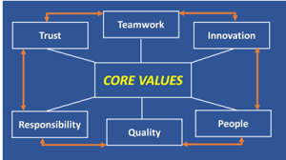

**Figure 9: Core values of organizational culture**

(Source: Song *et al.,* 2018, p. 249)

Customers can tell the difference in the quality of work, but employees aren't happy about it. When employees are motivated and influenced, they can work more efficiently and keep up their productivity to get tasks done quickly. Employees who aren't happy or satisfied tend to leave their jobs more often and contribute to a bad organizational culture at work. When customers see how happy and positive the employees are, they know that the customers are happy. This mood tends to lead to happy and positive interactions, which is good for the brand because it makes customers more interested in it. Most businesses have problems with morals and how people act. Customers notice bad behaviour, and most of them don't bother to complain about it because they'd rather just leave. Research has shown that 82% of employees at leading companies are highly dissatisfied with their work, while only 68% of employees at underperforming companies are engaged and happy with their jobs. Employees who are motivated can not only work well and finish tasks on time to keep the workplace productive, but they can also inspire others. With a clear mind and a positive attitude, employees can do their jobs well and reach the goals they've set (Song *et al.,* 2018, p. 249).

The way a company operates and does its work is based on its culture, and employees must follow official rules and requirements. Effective company culture affects the business as a whole and motivates people to work toward business success. Giving employees chances to shine and become more productive is a good way to keep them happy. But employees care about their jobs and the company, so they make sure the company is doing well and that everyone works well. If customers can talk to each other freely and positively, it helps the company and leads to better research results (Kurdi*et al.,* 2020, p. 3561).

The way each employee acts can affect how well the whole organization does. Group punishment can make it hard for employees to get along with their bosses. Customers can understand and respect what the other person is saying. Traditional work environments encourage employees to find out what customers want and make the workplace a good place to be. So, each employee feels included and valued, which makes them more likely to work hard at work. Thus, it has spread a positive vibe among the customers which tends to maintain customer engagement within the brand (Ali and Anwar, 2021, p. 21).

***Internal Environment-****Leadership*, According to Studies, (2020), every level of an organization's culture requires a high level of communication, support, and enforcement. Moreover, leaders are one of the most important internal components that create a culture and define its influence within a company. In the other context, PossibleWorks (2021) stated, Unsuccessful leaders can diminish organizational positivity by exerting enormous pressure on people. Leaders must both guide team members and establish behavioural expectations for staff. *Employees*- People have played a significant role in influencing the impact of organizational culture. It has been determined that if corporations are unable to regulate individuals and how they behave, they may be compelled to impose guidelines for employee conduct. Organizations can exert influence over the hiring procedure, and poor hiring practices can significantly affect organizational culture. The organization must design hiring procedures that facilitate intelligent hiring decisions and are consistent with its goal and vision. *Relationships among employees*, creating a good environment that boosts internal motivation and enhances the employee experience through fostering relationships with co-workers and supervisors. Employees who respect and appreciate their co-workers are more inclined to go above and beyond their area of competence and to feel good about assisting team members by performing tasks efficiently*.* It is difficult for employees to be enthusiastic about performing the same task repeatedly. Thus, leaders and managers are necessary to keep employees motivated and influential at work. Instead of increasing pressure, having start-to-finish time accountability for clients, products, or projects would instill a sense of ownership among staff (Di Stefano *et al.,* 2019, p. 2482).

## 2.8 Literature Gap

The present literature is about the importance of organizational culture and its impact on employees' motivation. Along with that, it also defined the effectiveness of negative organizational culture on employees' motivation and the strategies that can help avoid negative organizational culture and maintain positive organizational culture. Further, it also presented several theories related to organizational culture and employees' motivation in the workplace. This literature does not, however, describe the application of these tactics or the correct method for sustaining organizational culture and employee motivation in the workplace. Furthermore, it also failed to give enough examples and real-life case study incidences on how the existing theories are applicable. Thus, this research aims at finding examples, evidence, and proven techniques that are applied by the organizations in the real world, and thus can be followed by other organizations too.

## 2.9 Summary

At first, this literature defines the concept of organizational culture and employees' motivation in the workplace, and their interrelationship. Thus, usage theories related to organizational culture and employee motivation such as Hofstede, Maslow's hierarchy needs, McClelland's notion of need, and Herzberg's Motivation Hygiene theory. Later defines the impact of organizational culture on the organization as well as the impact of employee motivation on the organization. Along with that also describe the role of organizational culture in building employee motivation. Furthermore, it refers to some of the strategies used for increasing employee motivation in the organization. Lastly, defined the impact of organizational culture and employee motivation on the internal and external environment of the business.

## 2.10 Conceptual framework

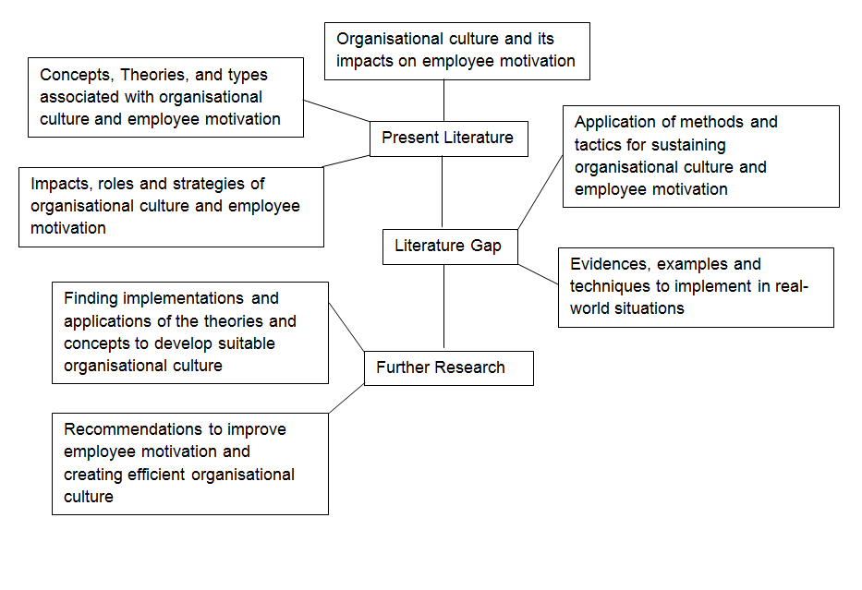

**Figure 10: Conceptual Framework**

(Source Developed by the author)

As per the possible factors behind the impact of organizational culture on the motivation level of the employees, the two aspects are being responsible. The above conceptual framework reflects two different types of variables which includes the independent and dependent.  The independent variable bureaucratic and supportive organizational culture. On the other hand, the dependent variable of the conceptual framework is the employee motivation. Both the dependent as well as independent variable plays an important role in the process of understanding the impact of organizational culture on employee motivation.

# 3.0 Methodology

## 3.1 Research Onion

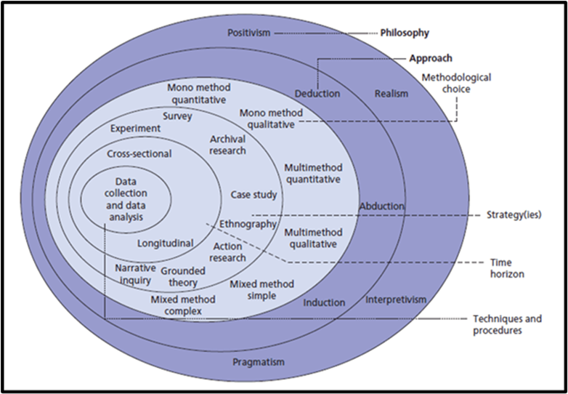

**Figure 11: Research onion**

(Source: Zuiev*et al*., 2020, p. 106)

Saunders’s research onion can define each layer of research methodology for conducting the research with efficiency. This research clearly describes the concept of research methods by outlining each step specifically in a proper manner. With the help of the research onion, researchers can maintain research efficiency by clearly each step which makes it easier for readers to understand research concepts (Ameen*et al.,* p.02).

## 3.2 Research Philosophy

Research philosophy refers to the belief with which the data is collected, analyzed, and used in the research. There are four types of research philosophy, interpretivism, positivism, pragmatism, and realism. Positivism is the research philosophy used in this study. Positivism is a research philosophy that is based on the facts that can be seen and measured. On the other hand, interpretivism research philosophy refers to the specific role played by the researcher while observing the world (Paais and Pattiruhu, 2020, p. 577).

This research is using interpretivism research philosophy for collecting all the required information related to organizational culture for employee motivation and developing several pieces of evidence for theories developed in the literature review. The justification for using interpretivism research philosophy is it will help in gaining only factual knowledge based on observation which will help in maintaining the reliability of this research. Furthermore, the evidence derived will help organizations in the future as the research is going to find out the key elements of organizational culture followed by big organizations for developing employee motivation. Since, interpretivism research philosophy belief in multiple realities and interpreted the situation. The interpretivism research approach involves the vigorous process of setting empirical experimentation, and hypotheses, measuring the results, and the ability to codify results including laws and predictions. The positivist research philosophy tends to collect qualitative data to prove the existing theories (Mohajan, 2018, p. 23).

Interpretivism research is done to find out how organisational cultur*e* affects employees’ motivation with scientific evidence. During this research, evidence would be gathered to find out the most important things about the research topic. Interpretivism research philosophy usually refers to several empirical experiments and hypotheses that can be used to finish the research while keeping its credibility.

## 3.3 Research Approach

The research approach refers to the plans and procedures which are followed to conduct the research. The research approach is one of the important aspects of research methods as it helps the researchers to maintain efficiency while collecting data. There are three types of research approaches, deductive, inductive, and abductive research approaches (Zuiev*et al*., 2020, p. 106). With the help of an Inductive research approach, researchers can develop theories or concepts regarding collecting information and further prove their hypotheses developed previously. On the other hand, the deductive research approach represents the scientific investigation where the research studies the existing theories and concepts for analyzing effective ways to address the hypotheses (Ameen*et al.,* p.02).  This research will be conducted using a deductive research approach for understanding existing data and information related to research results.

Justification for using the deductive research approach involves associating only with the scientific investigation which will thus help in proving the data collected reliable, based on evidence over assumptions which will further help in implementing the collected information rightly in the real world (Al-Qurabat *et al.,* 2018). For instance, the deductive approach will help in finding the evidence related to how theories are being applied and what are their results or how they are being applied, evidence. The deductive research approach refers to the possibility to define the relationship between research concepts and variables. Since, the deductive approach is associated with scientific investigation and helps researchers to think logically and thus purpose any further suggestions accordingly (Snyder, 2019, p. 333). The deductive approach will collect evidence aligned with related theories that can be applied for conducting the research. Deductive approach represents interrelations between different variables and concepts. Moreover, deductive research approach is linked with scientific investigation which influences researchers to conduct the research with maintaining logical outcomes.

## 3.4 Research Design

Research design is a framework of research techniques and methods to be applied by the researcher during the process of research. Research design plays a major role in the research methodology section as it helps in approaching the research with defined steps which further helps in discovering more details, information, and transparency which further helps in understanding the main concepts of the research better. Mainly there are three types of research design, exploratory, explanatory, and descriptive which help researchers to represent the research properly to the reader. This research is using descriptive research design as it helps the researcher to collect the information systematically (Zangirolami-Raimundo *et al.*, 2018, p. 356).

Justification for using descriptive research design involves obtaining a systematic procedure that will help in completing the research in a particular format and will guide the researcher towards the next steps which need to be taken and thus help in describing a particular phenomenon developed out of this research (Bloomfield and Fisher, 2019). The main purpose of descriptive research design is to obtain information systematically defining phenomena, populations, and situations aligned with the results of the research. This research will help in understanding the whole process of an organizational culture systematically, and thus how it can be used to develop employee motivation shall also be discovered. Using descriptive research design would help researchers to obtain systematic information for conducting the research with proper guidelines and format.

## 3.5 Sampling Techniques

Sampling techniques refer to the method for choosing and analysing the samples. There are five different sampling methods. Random sampling, Convenience, systematic, cluster, and stratified sampling (Ngozwana, 2018, p. 19). Sampling techniques refer to the aspect where researchers collect samples based on existing situations and people for conducting the entire research. There are two different basic types of sampling techniques, probability, and non-probability. This research is using secondary data collection methods, therefore, using probability sampling techniques for this research paper. Most researchers prefer using non-probability research sampling as it suits secondary data analysis. This research paper is using articles, websites, journals, research papers, and many more for collecting data and information related to the research topic (Viloria *et al.,* 2018, p. 670).

Justification for using these samples involves that a wide range of data is being analysed before presenting the relevant data which will thus help in achieving the research objectives, and understanding the complete concept of organizational culture. Furthermore, there are already several theories, concepts, and literature already developed on this matter, but with the use of secondary data, how these theories are useful or are implemented shall be found in the findings of this research. While conducting a study, it is important to design an empirical study for justifying the sample size during the data collection process. The key aim of sample size justification is to define how data would be collected by providing valuable information and given inferential objectives. Researchers use different types of sampling which involve information. While researchers need to analyse specific issues related to the topic, it would help in analysing the truth behind the existing theories (Ameen*et al.,* p.02).

## 3.6 Data collection methods

Data collection refers to the method adopted for collecting the data in the research process. A researcher can collect the information based on two types: primary and secondary. The first is primary data, which comes from first-hand sources and the researcher himself collects the data required for the research. Secondary data refers to the collection of data from second-hand sources which implies sourcing information from other researchers’ work such as journals, articles, newspapers, and many more. In this research paper, the researcher will use secondary data to write a good paper about the effect of organizational culture on employee motivation (Malakar*et al.,*2018, p. 5717).

This research is using secondary collection methods and the data would be collected from secondary literature resources with some quantifiable data too. In the secondary data collection process, information is collected from sources such as government websites, libraries, archives, company websites, and articles so that a wide range of resources can be considered before concluding and formulating the lessons from the research. This research conducts secondary data collecting methods for different purposes. Secondary data collection methods are very cost effective and researchers do not require an excessive amount of money, effort, or time to go out and collect and analyse the data by themselves (Babii 2020, p. 87). Analysing this source of information will thus help the researchers in getting all the evidence, information, quantitative data, and examples that can prove the authenticity of the concepts discovered in the literature review.

## 3.7 Data analysis

Data analysis is the process used by researchers to reduce information from the collected data and interpret data for valuable insights related to research topics. By using data analysis researchers can reduce the size of information with meaningful research outcomes. There are three types of data analysis, descriptive, predictive, and thematic analysis (Ragab and Arisha, 2018, p. 2). The use of predictive analysis enables researchers to determine and address research issues. On the other hand, the descriptive analysis identifies actual issues and valuable insights.

The following research involves using thematic analysis as it helps in analysing qualitative data across various data sets and reporting the repeated patterns which will thus help in understanding the required organizational culture for employee motivation (Ryder *et al.,* 2020, p. 255).

## 3.8 Ethical consideration

The ethical consideration ensures all the information and data that has been collected do not harm or create any controversy. This research is conducting secondary data collection methods therefore it is important collecting accurate and relevant information by avoiding any fake information. Moreover, research ethics refers to using authentic and accurate resources by not complicating research results (Omri *et al.,* 2021, p. 1014). While conducting research, ethical consideration is a guide for research designs and practices. Thus, it is required for the researchers to adhere to a certain code of conduct while collecting data. This research is using secondary data collection methods thus it is important for the researcher to identify false information and avoid taking fake information. Since this research is using secondary data collection methods and all the information collected via secondary resources thus the data might be old. Therefore, in the research lack of the latest information would be visible. The primary aim of researchers is to use ethical research methods and procedures (Greening, 2019, p. 88).

## 3.9 Limitations

During the research, it is important to maintain research efficiency with a detailed approach and manner. This research is using secondary data collection methods which refer to limited available data. Due to low budget costs, researchers tend to avoid any subscription costs. Since most organizations do not provide permission for conducting interviews or surveys. After the global pandemic, government restrictions have increased thus it has become difficult for researchers to collect accurate and authentic information (Ameen*et al.,* p.02).  Moreover, several libraries are not open due to covid safety protocols. Thus, the researcher won’t use such reliable source libraries to find more secondary data. Also, the researcher will have to deal with the short time, which is one of the problems and limitations of this research. These are the problems that the researcher will have to deal with if he or she wants to write a good research paper (Meng and Berger, 2019, p. 64).

## 3.10 Timescale

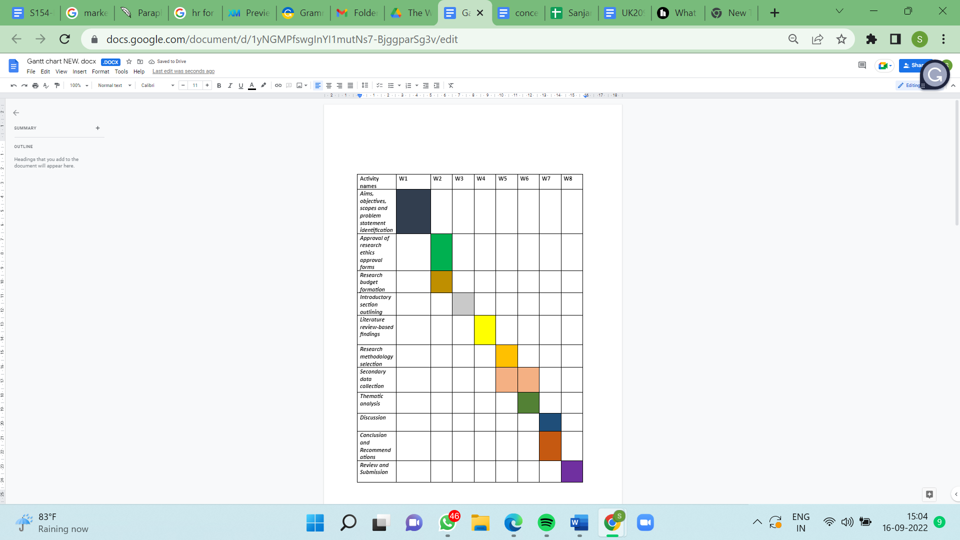

**Figure 12: Gantt chart**

(Source: Developed the learner)

# 4.0 Findings and Analysis

The study has been conducted considering the objectives and questions of the research to present the following findings. These findings include the application of motivational theory to improve the organisational culture and motivating employees. These findings are aimed to provide an understanding about the organisational culture adopted by large and successful organizations like Google, Apple and coca cola in relation with various organisational culture and motivational theories and concepts. Which will be helpful to highlight the aspects for creating a successful organisational culture and to motivate employees. These findings are based on thematic analysis to maintain the relativity with the objectives of the research and also with the secondary data collected through available literature, the literature gap shall be addressed in the following.

## 4.1 Thematic Analysis

## Theme 1: Application of Maslow’s Hierarchy of Needs in improving organizational culture and employee motivation

According to Perkbox (2020), 87 % of firms concur that employee engagement and culture are two of the most important workplace problems. One of the major objectives is to enhance company culture, which will ultimately promote employee motivation. Regularly, the culture can influence the level of motivation among employees. Vantage Circle HR Blog (2018), suggested that an organization is to collaborate and strive to inspire others. Maslow’s theory of motivation posits high-level motivation or self-actualization about basic needs. Maslow’s hierarchy of requirements begins with physiological demands, followed by safety, belonging, esteem, and self-actualization.

***Maslow’s Hierarchy of Needs: Business Application***

*Physiological-* Providing a safe workplace, clean facilities, adequate lighting, heat, and airflow with the necessary equipment. Google provides bicycles and electric automobiles for worker meetings, as well as gaming centres, eco-friendly furniture, and organic gardens. Google’s major mission is to ensure that its employees live comfortably and continuously enhance their health, well-being, and morale. *Safety-* Not brutally criticizing o-workers and encouraging them to take risks by treating them with respect. Facebook’s CEO oversees one of the fastest-growing companies. Facebook’s chief executive officer conducts business and never offers positions based on expertise or age. Facebook values the ideas of its employees in diverse and distinct ways. *Belonging-* Co-workers play a crucial role in sustaining a positive work environment within the firm. For example, the HBO Corporate Social Responsibility team joins HBO workers, non-profit partners, and talented employees to address social challenges, interact with communities, and promote industry engagement. Leadership from the top down motivates employees to take action, educate others, and help make the world a better place (StackPath, 2018).*Esteem-* Recognizing an employee’s contribution to the overall success of the organization. Individual employees are essential to feeling valued and important. Southwest permits its staff to go the extra mile to satisfy customer needs and empowers them to realize the company’s vision. *Self-Actualization-* Providing employees with the ability to be innovative, have a vision for the future and provide direct feedback to top leadership. Google has enabled the creation of the most innovative work environment. The company is more focused on innovation, with 49 percent establishing innovation principles. One of Google’s core principles is to encourage employees to spend 20% of their time pursuing creative ideas.

It has been analysed that enhancing the organizational culture would boost employee motivation. This subject employs Maslow’s hierarchy of wants to comprehend the fundamental necessities of employees. According to Maslow’s theory, there are four needs: physiological, safety, belonging, esteem, and self-actualization (Di Stefano *et al.,* 2019, p. 2482).

According to Nguyen *et al.* (2020, p. 660), a positive organizational culture influences the scope of higher employee motivation, coordinated team, and high-performing work culture. By adopting the clan type of work culture, the strategic leaders of the business entities can simply generate a mutually understanding and transparent communication-based work culture among the teammates. This kind of team collaboration evaporates the concept of innovative group thinking and participative-based decision-making to resolve complex business problems. Most business enterprises think that the organizational culture is an influencing factor in the staff’s job involvement and desire to perform their work perfectly. Considering Maslow’s Hierarchy-based staff motivation theory, the organizations such as Apple and Google are offering a safer and hygienic work culture for the employees.

By investing in the UV-C disinfecting technology and frequent sanitizing tactics, these organizations are offering a Covid-safety work ambiance. It makes the employees fear-free and stimulates them to go back to their physical work in the post-Covid session. In contrast, Werner and Balkin (2021, p. 20) stated that the theory is not tested empirically, and henceforth, the Business Managers cannot precisely estimate how much satisfaction score is needed to jump to the next level of motivation. However, it has been notified that the employees would not only be motivated to do their work by getting monetary hikes, but also have to satisfy them through their safety-based and self-actualization-based needs (respect, equality, and self-empowerment scopes).

As cited by Spicer (2020, p.137), most business organizations are using the “Monetary-based Staff Rewarding Policy” to motivate their employees. By getting monetary-based appreciations in the form of performance appraisals, salary hikes, promotional scope, bonuses, and yearly incentives, the employees are involved in their offered responsibilities. In contrast, Ali and Anwar 2021, p. 25) argued that the employees in the contemporary business phase are not getting motivated by the traditional staff rewarding approaches. The “Flexi-work culture”, “Rotation-based Duty”, and “Need-based Remote Working” is added to the staff motivation approach. This kind of nonmonetary rewarding approach has a high demand in the modern business world over the monetary-based rewarding strategy. Today’s employees want to get motivated and highly involved in their professional responsibilities in case the organizational culture offers an exclusive “Work-Life Balance”.

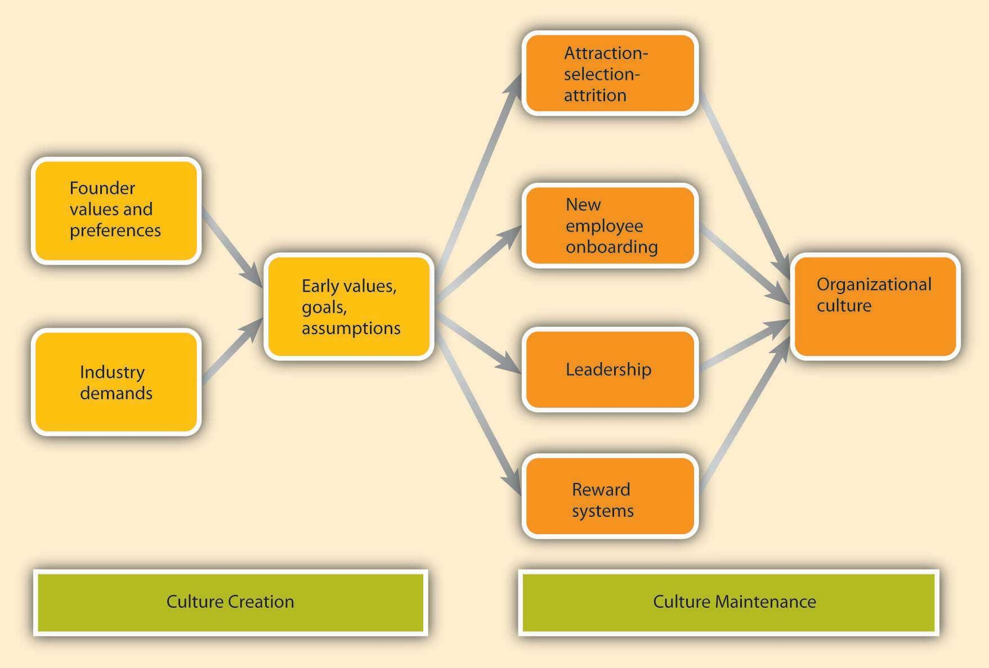

**Figure 13: Role of organisational culture**

(Source:Paais and Pattiruhu, 2020)

As opined by Paais and Pattiruhu (2020, p. 579), the *Three-level organizational culture* is motivating the employees to perform their role-play significantly in organizational growth and sustainability. The “*Artifacts*'' level indicates the office infrastructure, safety style, dress norms, and office decorum. If the organizations stick motivational quotes on the most visible walls of the workplace, the employees can be motivated while fixing their eyes on them. Besides, the organizations in the present era are offering recreations such as coffee breaks or small-minute gossip breaks to reduce the boredom of work among the employees. The “*Exposed Values*” indicate the ethics, respect, and zero discrimination among the employees n the workplace. The “*Shared Basic Assumptions*'' are the presence of a high level of self-confidence among the employees. Lubis and Hanum (2020, p. 89) argued that this kind of organizational culture cannot measure the success level of employee satisfaction and motivation. However, the organizations such as Zappos are using this culture to stimulate their workers.

## Theme 2: Organizational culture strategies followed by large organizations

Several companies and their effect on organizational culture are analysed in this study as further-

Google is ranked among the best workplace cultures for good reason. The company parodies cliches associated with tech start-up companies, such as free food, nap pods, foosball tables, and a workplace filled with pricey canines. Google's employees are believed to love the company's culture for its friendly environment at the workplace (Razak*et al.*, 2018, p. 67). Google’s employees view its mission as organizing the world's information and making it universally accessible. Google is one of the world's most ambitious and self-motivated individuals. However, it is challenging to maintain an engaged and interested audience for an extended period. *HubSpot*- According to Startups.com (2019), HubSpot has been renowned for its exemplary workplace culture for quite some time. HubSpot does not have a door policy, thus all employees have access to the office. Another article refers to Butter, (2019), company culture at HubSpot that has extended across a large geographical area. The organization employs more than 1,960 people across the globe. In addition, the company strives to keep its personnel satisfied to promote productivity and promptness. *Amazon*- Over the past two decades, technology companies have become increasingly innovative worldwide. Amazon is an intriguing scenario about organizational culture. When discussing their own experiences, most employees use terms like bruising, unrelenting, and churn and burn. Amazon, on the other hand, is one of the most successful businesses in the world (Belete*et al.,* 2018, p. 2).

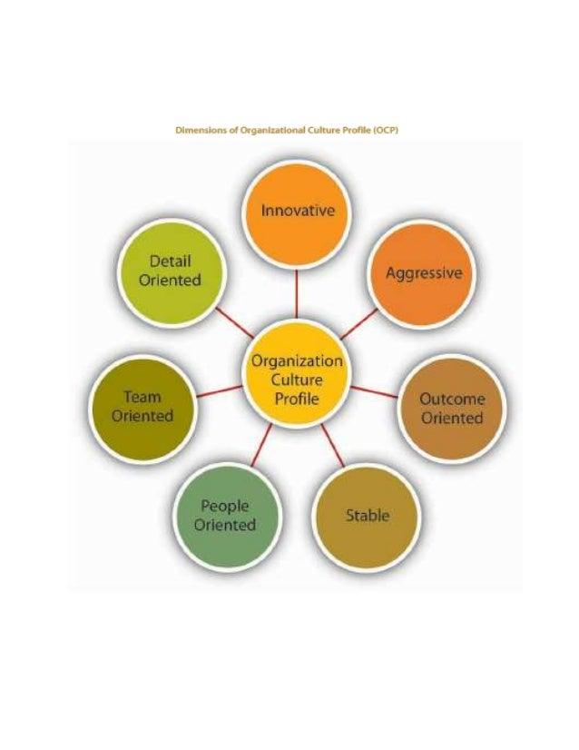

**Figure 14: Organisational culture in Google**

(Source:Ali and Anwar, 2021)

However, some people enjoy a hectic and demanding work atmosphere. Most people believe that Amazon does not have a positive company culture. Diverse people react differently to different situations, resulting in the success of the company's culture. *Forever 21*- Although Forever 21 is not a technically oriented business, its organizational culture has a negative impact. Since the firm has sued its employees on multiple occasions, forever 21 is a terrible place to work. Along with this, the CEO supplied a 30 percent approval rating. Additionally, the company provides no benefits to its employees and requires workers to remain in the store during their lunch breaks and after completing lengthier shifts. The second theme illustrates the influence of organisational culture on various organisations by defining both positive and negative features. This theme initially identifies the organization's capacity to sustain a positive organisational culture in the workplace (Ali and Anwar, 2021, p. 21). Employee motivation and organizational culture are interlinked. Organisational culture can impact work satisfaction and employee performance which can influence the level of motivation and organisational commitment (Paais and Pattiruhu, 2020). A highly satisfied individual will remain highly motivated and organisational culture has a positive influence on work performance. A satisfied employee will remain motivated to improve performance and be willing to learn while reducing the intention of employee turnover.

Every organization, regardless of size, recognizes the significance of employee motivation, which tends to shape morale, productivity, profitability, and decreased turnover. The companies listed below are concerned with the motivation of their employees to achieve organizational objectives and following are influences because of organizational culture on employees- *Coca-Cola*- By giving benefits and significant perks, Coca-Cola strives to maintain the satisfaction of its staff. The advantages include education money such as tuition reimbursement and an undergraduate scholarship that is renewable. The company also offers a Matching Gifts Program with a $10,000 maximum per participant. In addition, Coca-Cola communicates effectively with employees through constructive discourse and performs employee surveys to obtain real-time employee input (Di Stefano *et al.,* 2019, p. 2482). *DreamWorks Animation-* DreamWorks has provided non-monetary incentives such as free group exercise courses in the office. Additionally, the company gives personal workstations and complimentary smoothies to encourage staff participation. Involve staff in engagement activities for maintaining an upbeat workplace. Oftentimes, employees perceive this as a tough job and lose enthusiasm, however, offering incentives motivates them to contribute to the company's continuous growth. The success of DreamWorks depends on a combination of methods and incentives for establishing an engaging workplace culture by encouraging people to feel valued and innovative (Pancasila*et al.,* 2020, p. 387).

Some organizations face difficulties in retaining their organizational culture, resulting in decreased employee motivation. Several company names and their impact on employee motivation are provided below.*Kraft Heinz corporation*- As stated by Chron.com (2020), Kraft Heinz is one of the nation's most well-known consumer brands, alongside Oscar Mayer, Kraft, Planters, Jell-O, and Lunchables. The majority of employees responded that the company's culture harmed the organization. Other authors suggested Linkedin.com (2020), Employees are dissatisfied with tracking firm expense reductions and struggle to maintain a work-life balance. An ex-employee has indicated that the leader does not respect or care about other employees and is only concerned with increasing profits. The average employee rating is 2.6 stars out of five, making these one of the two lowest-rated companies.

*Dillard’s*- There are more than 300 Dillard's department store locations in more than 29 states. Dillard's is a family-owned firm, and family members are satisfied with their work responsibilities, whereas employees are not. Dillard's employees are unsatisfied due to unreasonable sales expectations and poor management methods. In addition to employee unhappiness, the organization also experiences business losses (Ciobanu*et al*., 2019, p. 36).

This theme highlighted various companies that care about staff engagement since it has assisted the brand in achieving its objectives. The organisational culture is significant for influencing the behaviour of employees and impacting the growth and development opportunities maintaining a culture of engagement can help to increase employee motivation and productivity. Creating an organisational culture of engagement will help to produce tangible results by maintaining agility, collaboration, diversity, innovation, performance, and recognition of employees. Organisations strive to build a high performing workforce which requires motivating them through extrinsic rewards, monetary and non-monetary benefits, fringe benefits and conducting feedback to improve relationships with employees and the employer.

## Theme 3: Role of organization’s internal and external environment on its culture

Based on facts, it has been determined that more than 500 company leaders regard workplace culture to be an important component. Business executives have recognized that a robust organizational culture can produce fruitful results. Organizational culture tends to achieve company-specific goal setting and the implementation of employee motivation. According to, three factors contribute to increased employee performance. The author further suggested that firms are renowned for adhering to distinct organizational cultures (Siddiqi and Tangem, 2018, p. 153).

When employees feel inspired at work, there is an increase in productivity. Employees tend to work for the organization since they enjoy their work environment. Consequently, leaders have played a crucial role in guiding and instructing people in the pursuit of specified goals and enhancing employee enthusiasm. Play is viewed as an instinct for learning, exploration, and problem-solving through experimentation (Pham et al., 2019, p. 446).

Understanding the role of organisational culture in developing employee motivation can be critically analysed to investigate entrepreneur orientation to analyse work satisfaction organisational commitment and employee performance. It is significant for organisations to create a culture which allows employees to improve work satisfaction for enhancing employee performance and remain motivated. Managing employee motivation and performance can be a challenging task which requires the employer to understand the elements of profit and effective performance while focusing on leadership to motivate the workforce and maintain competitiveness (Soomro and Shah, 2019).

The purpose is directly related to the consequence of establishing identity. Leaders, for instance, are the ones who recognize and respect the effort of empowering and teaching employees. Consideration is given to the work's potential, which improves the employee's identity. Moreover, work is capable of enhancing the capacity and influence of employees to accomplish tasks effectively. Employees experience emotional pressure at work since their identities are threatened by numerous forces. Fear, embarrassment, and peer pressure are examples of emotional pressure. Additionally, when the staff performs favors to prevent dissatisfaction. The main concept of emotional pressure is individual task completion (Achievers, 2022).

Economic pressure is an external force that motivates individuals to acquire more money and avoid penalties. The major objective is not simply to remove oneself from work, but also one's identity. Inertia exemplifies the work when the motivation is unrelated to the work and when employees have neglected addressing certain issues while at work. It is regarded as inertia when employees lack a distinct understanding of their workplace (PossibleWorks, 2021). On the other hand, the author (Kurt, 2021) said that workplace culture reflects behaviour establishing defined norms and explaining tacit conventions for working together. In addition, it represents the monitoring of organizational culture by individual employees to influence the founder, manager, and executives throughout decision-making processes. Regarding cultural development, each employee has tasks and responsibilities for adhering to organizational culture in the workplace. Important because it corresponds with firm cultural factors such as employee engagement, productivity, retention rate, favourable recruitment, and working atmosphere. It is just as crucial to adhere to a successful organization's culture as it is to implement a sound business strategy because it helps sustainably improve work performance. By adhering to an effective organizational culture, employees are better able to comprehend the essential competencies required to sustain a strong organizational culture (Kurt, 2021).

## Theme 4: Various organizational culture tactics applied by organizations to improve employee motivation

Listed below are some of the tactic’s leaders use to retain staff motivation within the firm.

*Zappos provides employment incentives-*According to Skilbeck, (2019), It is 3.6 times more probable that employees will be engaged in everyday activities and goal-setting strategies involve the establishment of clear and precise objectives. To motivate employees, it is necessary to clearly state what is expected of them by the firm. In addition, Chron.com (2022) refers to persuading employees to develop goals based on visualization to achieve success. Developing links between people's ambitions and goal-setting is an important part. Each team member is motivated by distinct factors that coincide with the organization's overall objectives. 55 percent of employees would be motivated if they considered the significance of their work. Zappos is a worldwide e-commerce retailer with an adequate labor force (Leitão*et al.,* 2019, p. 3803). The Zappos reward scheme hinges on organizational cohesion and "Doing more with less." The company's fundamental concept is a peer-to-peer framework in which employees share low-cost and frequent rewards. *Apple ensures prompt employee payment-* Apple likes to have a relatively high office environment ranking. According to the research, it is acknowledged as one of the best private sectors in the United Kingdom in 2018, while LinkedIn placed Apple in sixth place. For example, Apple surprises its employees during the holiday season by extending vacation time for the entire workforce. In addition, during the Thanksgiving holiday, there are three consecutive days off instead of one. Initially, Apple understood the efforts of the entire staff and proceeded toward achieving success. The second reason for delivering rewards is to satisfy cultural, regional, and individual needs. Consequently, employees feel appreciated and included on the job (ThoughtCo, 2020).

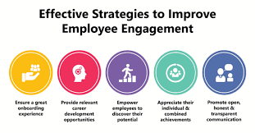

**Figure 13: Effective strategies to improve employee engagement**

(Source: ThoughtCo, 2020)

*GE Healthcare acknowledgment of cultural revitalization-* GE recognized that continual participation was essential for sustaining the impact of altering organizational characteristics. Restructuring manufacturing facilities can enhance employee engagement and recognition initiatives. Continuous employee recognition communication can enhance staff motivation.

Organisational culture and effective leadership are equally important for enhancing employee motivation and work satisfaction. From an empirical standpoint and understanding of different theories of motivation, work satisfaction, and performance, it can be argued that leadership is significantly related to work satisfaction and employee motivation (Rivaldo, 2021).

Therefore, the company holds weekly meetings to evaluate staff performance (Leitão*et al.,* 2019, p. 3803). The purpose of scheduled meetings is to foster a healthy work atmosphere. Commemorating small to large accomplishments*-* Instead of only celebrating large victories, businesses should also celebrate small accomplishments regularly to keep people motivated. Monthly or weekly objectives for monitoring employee performance must be established. Employees do not need to be performance-driven or KPI-focused and may instead be working on personal development to set goals for dealing with difficult stakeholders. If milestones were not met, the brand should concentrate on what is impeding team success and how to overcome the obstacles. Based on the examination of theme five, identifies various organisational tactics for encouraging employees. For example, Zappos is one of the multinational e-commerce organisations that provides a conducive work atmosphere for its employees (Tejayadi *et al*., 2019, p. 63).

## Theme 5: Impact of organization’s vision and external environment on organizational culture

Each business has a unique culture that influences its ability to compete and respond effectively to the external environment. On the other hand, internal environment aspects require progression. These external and internal environmental elements have a significant effect on organizational culture (Impact of Organizational Culture, 2018). *Mission*- Numerous fundamental questions describe the missions of organizations. Successful companies typically have a distinct understanding of their ultimate mission to achieve that mission. Apple's initial mission statement is one of the best examples that states the company's ultimate objective with precision (Jamali*et al.,* 2022, p. 2). *Leadership*- Great leaders motivate team members to work toward productive outcomes. Most leaders give up if they are unable to achieve setting objectives. Instead, it is necessary to convey and comprehend unique components that drive the brand to confront actual obstacles and work on its implementation. *Communication*-Individually successful businesses rely on open communication between team leaders and workers to enhance work performance and produce superior results. Two-way communication can enhance hierarchical structure by reaching from the top to the bottom. Organizations with inadequate communication frequently cause damage to leadership structures and erode worker trust. *Learning*-Learning is one of the most essential human activities that contribute directly and indirectly to an organization's performance. Current technological advancements are accelerating the rate of change, necessitating that firms find ways to respond and encourage innovation to create opportunities for their staff. Elon Musk is the leader of prosperous companies such as Apple, Google, Amazon, and other cluster companies, and he is eager to explore great opportunities (Siddiqi and Tangem, 2018, p. 153).

Political, economic, social, and technological variables affect the organization as external forces. Similarly, internal elements that contribute to an organization's performance are unavoidably matched with external environmental factors. An organization with a distinct sense of mission can explain itself and link itself with positive components of the world. Leaders that are more likely to learn from and interact with people are also capable of learning from and communicating effectively with the organization's external environment (Malakar*et al.,*2018, p. 5717). Amazon, for example, is the sole corporation revolutionizing the global marketplace for the purchase and sale of quality goods. Thus, the brand has a reputation for communicating well with customers and suppliers. Amazon is a customer-driven innovation machine that relies on people always being correct. In addition, it develops a rapidly growing organization that has effectively responded to the customer's understanding of the brand's requirements. External developments, such as the #The MeToo movement has a significant effect on society (TriNet, 2018). Sexual harassment is eradicated as a result of these changes. Most organizations are also addressing gender equity issues by ignoring the compensation differences between male and female employees within the same job titles.

## Theme 6:  Role of money, rewards, and job duty on employee motivation

Employee engagement is the extent to which workers feel driven and included in the organization. Principal internal elements that affect employee engagement include job tasks, work connections, and advancement possibilities. In another sense, external growth refers to career possibilities, including family and social duties that compete with one another. Addressing the aspects that influence employee engagement and motivation aids in making optimal business decisions.(TriNet, 2018). *Job duties*- The everyday tasks and interactions of employees have a significant impact on employee engagement. People like to work in fields that they are enthusiastic about and actively explore. Someone who enjoys interacting with coworkers is more likely to work in customer service than in information technology.*DifferentGrowthOpportunities*- Workers are driven by difficulties and rewards in the job when they face obstacles with limited upward mobility and engagement level. Opportunities for professional development and progress typically depend on employee participation.*Money*- The majority of the organization provides additional funds for employee motivation to boost staff engagement. The prospect of receiving additional compensation is more likely to drive individuals to work hard to achieve certain results (Bhardwaj *et al*., 2021, p. 170). *Grades and rewards*others recognize Gardens as one of the common sources of external motivation. Good grades are required to motivate and persuade people to work more efficiently. In addition, receiving little rewards and vouchers based on weekly performance motivates staff to do well to achieve success. *Promotions*- Promotion is one of the key external employee engagement factors during employee motivation procedures. Promotions have a crucial role in employee motivation and workplace engagement. Employees prefer recognition and a sense of belonging within the firm. However, internal incentives generate significantly more long-term uncertainty. *Positive responses*- One of the most effective ways to achieve company goals is by providing staff with immediate rewards that serve as external motivation. Positive feedback tends to impact employees and boost their work performance psychologically. According to research findings, 46% of organizations believe that praising workers' work performance can inspire them. Additionally, it assures that employees are more productive, engaged, and likely to remain with the organization for a longer amount of time (Kushneryk, 2022). It is essential to be sincere when offering compliments to others. In the current market, fake praises might backfire and have a negative influence. *Carrots and Sticks*- "Carrot and Stick" refers to going above and above where employers use rewards (Incentives, Bonuses, Recognition, positive feedback) or punishments (Incentives, Bonuses, Recognition, negative feedback) (decreasing payment, negative feedback, and demotivation). More evidence aids the organization in supporting rewards and improved outcomes for external motivators. Reward motivates employees to work more effectively towards achieving particular aims (Ameen*et al.,* p.02). Likewise, punishment motivates employees to perform harder to avoid negative feedback.The seventh theme is to represent the impact of employee motivation on internal and external organisational environment elements. The internal elements are specified in terms of job responsibilities and several prospects for advancement, which influence employees' motivation and productivity (Bhardwaj *et al*., 2021, p. 170).

Understanding the different strategies implemented by organisations to improve employee motivation requires a critical understanding of factors influencing work satisfaction. It can be critically argued that developing human resource management in business is significant which allows people to develop knowledge which impacts the productivity of the organisation. Human resource management is responsible for maintaining employee satisfaction by motivating them through organisational culture and offering different reward opportunities (Ali and Anwar, 2021).

## Theme 7: Three levels of organizational culture

The main goal of organisational culture is to find out who works there and how committed they are. Organizational culture gives people a way to talk to each other and understand each other on a basic level. Organizations use different tools and methods to change behaviour and how they work. Organizational culture has an indirect effect on behaviour when reasonable management tools are used, such as strategic direction, activities, technology, goals, interaction, decision making, collaboration, and relationships with other people. Research suggests that Schein brings organisational culture models to the table (Schein's model of organisational culture, 2020). Organizational culture is made up of basic assumptions that people must find out or develop to learn how to deal with any problem. Culture is thought about at different levels, which tends to make cultural things happen more in an organisation. There are 3 stages of organisational culture that influence the organisation. *Three levels in organizational culture- Artifacts*: Behaviours and artifacts are the most effective level of culture with constructed physical and social environments in the organization. This marks the surface of organizational culture and visible elements that follow in the workplace (Zangirolami-Raimundo *et al.*, 2018, p. 356). Physical artifacts refer to architecture and interior arrangements related to physical space and office design. Technology also plays an important role in maintaining an organization's culture by reflecting the values via operations, knowledge, and materials. *Exposed values* -Espoused values represent less visible levels compared to artifacts and behaviours. The constituents of this level of culture offer underlying meaning and interrelationship where patterns of artifacts and behaviours align with deciphered. Espoused values represent the values and rules followed in the organization's behaviours. *Underlying assumptions*-Underlying assumptions refer to an unconscious level of culture related to company values, period, and transformation. Underlying assumptions are most of the time difficult to describe and hardly understood by people (Ngozwana, 2018, p. 19). The organizational culture model refers to the framework with ten steps aligned with the company's organizational culture. These steps are completed by a group of employees who are part of an organization involved in solving business problems. Obtainment leadership commitment: In an organization leaders need to emphasize openness and candour are required for addressing culture whether it is good or not. Group selection for self-assessment: The group of people needs to be cut across the levels and functions which are more concerned with business problems. Statement related to the business problem: It is required for the business to identify related areas of improvement or culture analysis that might be pointless or state Revision of cultural concept and levels: After agreeing on strategic or tactical goals the concept of culture is divided into three levels: visible artifacts, espoused values, and tacit assumptions. Identification of artifacts, Identity organization espouses values: Most of the time it is reiterated as part of "Vision" where the organization needs to operate for a viable and competitive future. Comparison values with artifacts, Addressing basic underlying assumptions. The decision regarding the next step; After completing all the steps it is required to build a sufficient insight plan for the next steps regarding changing the program and addressing cultural elements for the evolution of the required culture (Viloria *et al.,* 2018, p. 670).

## Discussion

The findings of the study would be more realistic and particular with availability of primary data collected through surveying and observing the culture of various successful organisations, as these findings are based on mostly available theories and cultural framework of various organisations. Organisational culture provides a system of knowledge and standards allowing employees to acquire through observation and evaluation of the working environment. Developing high performing motivated employees requires developing an organisational culture of shared values and beliefs which allow them to interact with people, structure, and control systems to influence behavioural norms. Organisational culture impacts the skills and development of employees and improves organisational financial performance. Understanding motivation in employees is directly related to work satisfaction which regulates enthusiasm for the workforce, fair opportunities, and scope for personal and professional growth and development (Soomroand Shah, 2019). Moreover, it requires creating a vision and supportive leadership behaviour to motivate employees to derive high performance expectations and achieve complex tasks.

*First theme*- From the first theme the matter of discussion would be the application of organizational culture and employee motivation. The hierarchy motivational theory is significant to understand the motivational factors of individuals and groups but there are several limitations and challenges associated with this theory; these inherent limitations of this theory may cause limitations in its application. Maslow's need for hierarchy theory suggests a set of theories which must be satisfied in hierarchy, which is a sequence of different motivational factors but that sequence might not always work in real life situations. Because all employees may not have the similar pattern of hierarchy of motivational factors, some employees might be looking for recognition rather than monetary rewards and vice-versa.

The second theme is reflected in Google and Hubspot, the firms that pursue a positive organisational culture to increase employee engagement. On the other hand, this theme also describes some companies with a bad organisational culture that must enhance the work performance of their personnel. According to the analysis of the second category, Amazon and Forever 21 have a bad organisational culture. Consequently, employees are dissatisfied with the company's management practices. The employees of Forever 21 said that the corporation does not provide any benefits and requires them to remain in the store during lunch time. According to the second theme it is considered that some companies follow a positive organizational culture where some need to improve organizational culture. For instance, Forever 21 is one of the leading clothing brands that still does not follow an effective leadership style. Thus, the brand needs to improve organizational culture as employees are not satisfied with organizational culture and tend to increase employee turnover. It is significant for the corporate culture to develop a good rewarding and motivation system to influence creativity, diligence, innovation and initiative of employees for enhancing business performance and achieving strategic goals. An effective reward system is formulated and implemented through organisational policies to reward employees properly and fairly for consistence performance which increases work satisfaction and overall productivity. Offering the rewards have the merit which influences motivation and creates a highly satisfied team. Lack of motivation can influence employee dissatisfaction impacting overall productivity. It requires firms to formulate effective compensation policies as part of reward management and offer them to motivate the workforce to deliver high performance and recognise their contribution. It can be critically argued that rewards and incentives are established for driving better accomplishment and are related to the social context impacting the motivation level of individuals through organisational culture and values.

*Third theme-* In the discussion of the third theme, Coca-Cola and DreamWorks Animation are among the leading corporations and are also able to maintain a favourable work atmosphere to boost employee motivation. As a result, organisations can recognise the significance of employee motivation in achieving the objective and vision of the business. In addition, this theme indicated the negative or low levels of employee motivation followed by the organisation. This theme asserts that two organisations must prioritise organisational culture development to reduce employee motivation. Kraft Heinz & Dillard's is one of the businesses facing difficulties in maintaining employee motivation in the present market. Poor corporate culture and management structure have resulted in dissatisfied personnel. It has been found out based on the third theme that some of the organizations recognize the importance of employees' motivation for reaching toward specific goals and objectives. With this finding it is recognized that Kraft Heinz & Dillard’s is facing difficulties related to employee’s motivation due to lack of organizational culture in the company. Human resources are a significant part of organisational culture which requires planning and achieving the goals and strategies of an organisation by influencing good performance from employees. Effective leadership can motivate employees which results in good work satisfaction. The critical analysis of employee motivation work performance and work satisfaction can be regulated by the pillars of leadership which allows developing emotional involvement and modifying the behaviour of individuals to focus on duties and obligations by stimulating positive performance.

*Fourth theme-*  it has been determined that employees are willing to work in an environment conducive to their development. In this theme, the first author argues that employees' emotions and pressure also constitute a significant aspect of their work performance. Economic pressure motivates people to earn more money and advance in their job. In addition, this issue analyses several other aspects of creating a positive working environment. Paying significant attention to extrinsic motivation is required for organisations to improve reward management in the form of praise, promotion, or salary increment. While it can be observed that extrinsic motivation can be efficient but does not offer a long-lasting solution as intrinsic motivation has a longer impact. It can be critically analysed that individuals expect work satisfaction in their environment according to the standards which are applicable to them. Certain aspects of work are adapted by individuals based on desires and personal and professional needs which impact the level of perceived satisfaction.

The fourth finding is to discover the role of organizational culture for increasing employees' motivation in the organization. However, this research is about two authors' perspectives related to findings. The strength of these findings is that it defines two authors' different perspectives related to employee motivation and organizational culture. Thus, the data has been collect based on the two authors would help for conducting future aspects.

*Fifth theme-*, it has been determined that the majority of businesses are more concerned with employee motivation and, as a result, are more focused on establishing an organisation culture for achieving stated goals. In addition, this theme is articulated in terms of numerous brands and their staff motivation techniques. According to theme five is about the different practice’s organizations follow for maintaining employee’s motivation and minimizing employee’s turnover in the organization. The strength of these findings is understanding organization policies for employee engagement. Zappos influence and encourage employees for increasing employee motivation. Job dissatisfaction often reflects evaluation of previous and current work experience and it can be concluded that quality of work and fulfilling basic needs are significant in work satisfaction which motivates individuals to achieve and accomplish tasks based on work ethics. Human resources require continuous motivation to effectively do that job with efficiency and without motivation employees can feel discouraged.

*Sixth theme*-The sixth theme focuses on the relationship between organisational culture and the internal and external business environments. According to the theme analysis, internal aspects such as Mission, leadership, communication, and learning are mentioned. External influences, on the other hand, include political, economic, social, and technological factors. Provide examples of companies that have transformed the workplace atmosphere. By the sixth theme it is discovered that individual business organizations follow different organizational cultures. However, this theme is defined about common internal and external factors which have significant organizational culture variables but these are needed to deeply understand and analyse these factors because management of an organisation can have control over the internal factors but cannot entirely control the external factors which have major impacts on the cultural and operational performance of an organisation.

*Seventh theme-* The seventh theme of this research examines External factors include money (compensation), promotions, Grades and rewards, good comments, and carrots and sticks. These are the variables that have inspired and encouraged people to achieve specific goals in the workplace. The monetary benefits provided to employees act as motivational factors and also suggest the cultural framework of an organisation. But only monetary rewards are not sufficient to create a strong organisational culture, the managerial practices to deal with employees regarding the development and growth and also for the defining and explanation of their duties by management would be useful to achieve the synergy from employees.

It introduces Schein's organisational cultural models and their impact on preventing employee unhappiness by identifying potential problems. With the help of eight themes, it is to discover the purpose of organizational culture and its impact in the entire organization. Based on the theme, researchers have identified the importance of organizational culture as it tends to motivate employees to reach specific organization objectives. The eighth theme focuses on the function of organisational culture and the connection between organisational culture and employee motivation. This theme represents the basic function of organisational culture and the various methods for altering employee conduct.

# 5.0 Conclusion and Recommendation

## 5.1 Conclusion

According to the research above, organizational culture is one of the most important factors for keeping employees motivated. The whole study is about how important organizational culture is and how it helps companies like organizations keep their workers motivated. Based on research, it has been found that organizational cultures can set and move toward specific goals. The organization is one of the biggest supermarket chains in the UK, and the company puts a lot of effort into keeping its employees motivated. This helps the brand keep its work efficiently and meet customer needs. Along with the good things about organizational culture, this research also pointed out the bad things about it when it comes to employees' motivation. With the help of this research, it has been found that an organization's culture is one of the most important things it needs to do to stay competitive. The concept of organizational culture is rapidly increasing as the majority of brands consider an organization's culture as the key to competing with others and accomplishing specific setting objectives. Thus, the organization is focused on developing organizational culture as it is aligned with employee engagement and company growth.

## 5.2 Linking with objectives

This research represents the importance of organizational culture for employees' motivation. For maintaining research efficiency, this research has set four different research objectives. The first research objectives define the impact of organizational culture on employees' motivation in the workplace. This objective has been covered in the entire research but mainly in chapter two literature review section and chapter four findings and analysis section. The second research objective is to define the impact of negative organizational culture on employees' work performance and motivation. This research objective has been covered in the literature review and finding’s part where researchers collected the information and data based on secondary data resources. The third objective is to define organizational culture's impact on customer satisfaction and employee engagement which has been discussed in the literature review part. The last and fourth objective is to define and estimate the important factors of brand awareness for maintaining positive organizational culture related to employee engagement. This objective is linked in the entire research but mainly in the literature review and finding section.

## 5.3 Recommendation

In an organization, it is required to remain transparent in dealing with major challenges for moving toward a successful outcome. Offering flexible scheduling can increase workplace requirements. Thus, it demonstrates a proper understanding of organizational culture by including staff members in evolving required schedules. Furthermore, policies can be developed to stay away from negative organizational culture. Lastly, employees can be incentivised for following positive organizational culture in the workplace.

*Adopting transparency in the organization:* Transparency is a fundamental practice in the organization. If the organization practices transparency in its workplace, the credibility among the employees and the organization will increase. Furthermore, every employee can express their innovative ideas without feeling fear. The organization can share their challenges, this will motivate the employees to come up with different unique solutions together. Hence, this brings collaboration and improves communication between the employees. Each employee can perform efficiently if they understand each other's strong and weak points in the task. The practice of transparency embraces different perspectives about the challenges (Taylor *et al.,* 2018, p. 263). Thus, it is recommended that the company invest in communication and collaboration tools to increase transparency among the employees.

*Rewarding performance culture:* Studies show that companies with a culture emphasizing rewards have significantly lower turnover rates. The likelihood of employees quitting their jobs in a year is twice as high for those who do not feel recognized (Sari *et al.,* 2021, p. 98). Thus the company should identify specific behaviours that create alignment with the company's goals and values. This way the organization can offer recognition as frequently and rewards who demonstrate these same behaviours and performance. Hence, the organization can encourage the employees to get into it. The organization can introduce peer-to-peer recognition for effective recognition in the culture. This reduces the managerial overhead and ensures that everyone is recognized for the work.

*Developing relationship culture among employees:* The organization can create strong relationships in the workplace by driving employee engagement. Engagement among the employees takes a considerable amount of time, effort, and strong team-building activities. Based on observations, different companies generate collisions in the workplace and create engagement among the employees. Since they will interact personally, unplanned interactions can occur between them that can increase the chances of encounters (Alghamdi*et al.,* 2018, p. 186). This way the employees can share knowledge with others and this leads to improving their performance. During the collision, the organization can offer enough space so that the employees can focus, and increase productivity and collaboration. To increase interaction, the company can encourage eating lunch together. This way, the employees can easily interact with each other if they are on the same team. In the workplace, employees generally feel reluctant to interact normally, and having lunch together can cultivate relationship building.

*Embracing a freedom culture to motivate the employees:* The organization must build a culture of trust, by not adopting micromanagement. Micromanage in the workspace increases the inefficiency of the workspace. The organization must trust its employees by bringing autonomy to the workspace. This way, the employees feel encouraged to manage their responsibilities effectively. The organization can establish an autonomous workspace by providing opportunities where the employees can make their own decision regarding their risks. Every employee has their way of accomplishing the activities that depend entirely on their professional experience, skills, and personal preferences. Thus, if the organization adopts these differences in the workspace, this will increase innovation and employees will feel more encouraged to feel creative (Erlangga*et al.,* 2021, p. 99). Lastly, the employees will feel more accountable for their responsibilities and increase a greater sense of team and organizational culture.

*Practicing flexibility as a culture-* The organization can adopt flexibility in the business to enhance employee morale. Employees can handle complicated tasks effectively if the organization can adapt to short-term change calmly and quickly. Organizational flexibility can diversify the products, can simplify the task in a simple process, and innovate both in terms of human resources management and organizational structure. The employees will feel more dynamic and efficient in completing the activities. At present, the business environment is changing drastically, making it imperative for an organization to stay abreast of this change to remain competitive and ensure sustainability in the business (Khan et al., 2021, p. 585). If the organization practices flexibility, the company can adopt the changes in difficult times and can use the change as an opportunity.

*Having a culture of following the company's vision and purpose-* In research, it has been found that employees are driven by a desire to perform meaningful work - work that adds value to their purpose and enables them to feel purposefully significant about their work. Even if the work seems little, if it provides a sense of purpose and value, the employees create a significant mark on that work. Therefore, the organizations must communicate the vision and value to the employees so that they realize their work matters to achieve that organizational purpose (Hussainy*et al.,* 2020, p. 40). As a result, the employees will feel more motivated and will learn new skills to increase the effectiveness of the performance. The organizational leaders have the responsibility to connect their employees to the company's purpose. This way they can build their sense of personal growth and can realize how their performance has an impact on the organization.

*Having a culture of providing regular constructive feedback-* The constructive feedback builds trust among the employees. The employees will get the knowledge of what their area of improvement is. The organization must balance the positive and negative while providing feedback. This way, it will help the employees to accept the feedback without holding a grudge. The leaders must recognize their abilities, believe in their potential, and must appreciate the work before giving feedback. In addition, the employees will view the feedback more positively and open communication channels more often to make this type of feedback exchange more common (Kang *et al.,* 2020, p. 338). This way they will feel more at ease in the workspace and feel more productive in the future. There is always room to grow, and constructive feedback assists the employees to meet the organizational expectation.

*Follow Maslow's Hierarchy of needs to build an organizational culture and develop employee motivation-* To achieve the company's vision and mission, it must establish a strong company culture. Therefore, everyone in the organization should be able to relate to it. The organizational culture creates difference and makes a competitive advantage. Hence, the organization must allocate the necessary time and effort to build a company culture. A strong culture will attract prospective employees to get hired. Hence, building a strong company culture is not a destination, but an ongoing process. Because within the culture, everyone will evolve and make progress. As a result, the culture will take a new organizational structure. The organization must invest time, energy, and resources into nurturing its company culture and exemplifying it in every way so that employees can grasp and emulate it (Ramani*et al.,* 2018, p. 1348).

Based on the dissertation, it has been found that Maslow's hierarchy of needs can improve the organizational culture. This theory consists of five different levels of needs that are: Physiological, Safety, Socialization, Esteem, and self-actualization.

* In the first level of Physiological need, the organization must provide clean work conditions, job security, and the appropriate salary that they deserve to satisfy all their needs and requirements at this level. The workload must be manageable so that the employees get enough time for relaxation.
* In the second level of safety needs, the company can provide health care facilities such as providing health insurance coverage and offering excellent retirement plans.
* After getting assurance of survival and safety, the employees have the urge to feel belonging in the company. Without cultivating relationships, employees are likely to feel lonely and isolated. Therefore, the organization must build a culture, where the employees can achieve their desire to be a part of the community. The company can offer happy hours where the employees can spend time with others and can have food. Also, the organizations can conduct birthday and holiday parties, this way the employees will feel happy if the company remembers their birthday (Le *et al.,* 2021, p. 1063).
* Every employee needs recognition, hence the employees have the desire for appreciation, reputation, and respect. The esteem needs to motivate the employees for making progress in the workspace. After the initial levels have been achieved the employees look for the opportunity to accomplish their esteem needs. The organization can provide recognition for excellent performance in difficult tasks, offering opportunities for job advancement, and offering monetary incentives that include extra bonuses and cash rewards. By having this recognition, employees feel valued and appreciated in their job.
* Employees at the self-actualization level feel achievement when they utilize their full potential. In this way, employees feel satisfied when their skills, talents, and resources are utilized to their full potential. The organization at this level can provide enrichment and a sense of value to the employees' work. Hence, the company can allow for creative flexibility and offer space so that the employees find their true selves in their work (Mubarok*et al.,* 2019, p. 2222). This will make them feel rewarded and also the employees can take pride in the work.

## 5.4 Future scope

Based on the findings and analysis of the research, the research is significant for addressing issues related to organisational culture and its impact on employee motivation in the academic and professional fields. The study serves the purpose of undertaking the research to discuss factors of employee motivation and organisational culture created with the help of secondary data analysis and create a scope for future to undertake similar research to enhance the existing research allowing the researcher to use primary data investigation in the different or same region while increasing the research context. This will create a scope for future investigation and allow researchers to draw insights while addressing the core challenges. In the present study, limitations are not addressed, however, in light of the study, the use of secondary sources allowed for making an evaluation based on the previous work undertaken. In the future, undertaking a similar work will allow looking for a different perspective with an enhanced field of investigation in the dimensions of HRM and employee relations in the context of organisational culture.

After completing the above research, it is observed that organizational culture plays a significant role in employee motivation. Companies like Google and Heinz follow the clan culture and maslow hierarchy of needs in a particular manner which is discussed above and the same can be replicated by other organizations too. However, most of the findings were examples from big companies which are having good resources to implement the above given recommendations as well. However, there are several small and medium enterprises as well which might be looking for developing employee motivation and thus increase the chances of employee retention in their company. These small companies cannot follow the above given strategies because of lack of resources; thus, the future research is suggested to be on how small-scale companies can increase employee retention in their companies by developing organizational culture and applying various other methods too.

# References

Achievers 2022 *Organizational Culture: Definition, Importance, and Development - Achievers* [Online]. Achievers. Available from: <https://www.achievers.com/blog/organizational-culture-definition/> [Accessed 21 July 2022].

Alghamdi, F., 2018. Total quality management and organizational performance: A possible role of organizational culture. *International Journal of Business Administration*, *9*(4), pp.186-200.

Ali, B.J. and Anwar, G., 2021. An empirical study of employees’ motivation and its influence job satisfaction. *Ali, BJ, & Anwar, G.(2021). An Empirical Study of Employees’ Motivation and its Influence Job Satisfaction. International Journal of Engineering, Business and Management*, *5*(2), pp.21-30.<https://www.researchgate.net/profile/Kofand-Anwar/publication/350582297_An_Empirical_Study_of_Employees'_Motivation_and_its_Influence_Job_Satisfaction/links/6067a4b7458515614d2e4d78/An-Empirical-Study-of-Employees-Motivation-and-its-Influence-Job-Satisfaction.pdf>

Al-Qurabat, A.K.M. and Idrees, A.K., 2018. Energy-efficient adaptive distributed data collection method for periodic sensor networks. *International journal of internet technology and secured transactions*, *8*(3), pp.297-335.

Al-Suraihi, W.A., Samikon, S.A., Al-Suraihi, A.H.A. and Ibrahim, I., 2021. Employee turnover: Causes, importance and retention strategies. *European Journal of Business and Management Research*, *6*(3), pp.1-10.

Ameen, A.M., Ahmed, M.F. and Abd Hafez, M.A., 2018. The impact of management accounting and how it can be implemented into the organizational culture. *Dutch Journal of Finance and Management*, *2*(1), p.02.

Babii, A., 2020. Important aspects of the experimental research methodology. *ВісникТернопільськогонаціональноготехнічногоуніверситету*, *97*(1), pp.77-87.

Belete, A.K., 2018. Turnover intention influencing factors of employees: an empirical work review. *Journal of Entrepreneurship & Organization Management*, *7*(3), pp.1-7.

Bhardwaj, A., Mishra, S. and Jain, T.K., 2021. An analysis to understanding the job satisfaction of employees in the banking industry. *Materials Today: Proceedings*, *37*, pp.170-174.

Bizfluent (2019) *Organizational Culture & Negative Effects | Bizfluent* [Online]. Bizfluent. Available from: <https://bizfluent.com/info-8211344-organizational-culture-negative-effects.html> [Accessed 21 July 2022].

Bloomfield, J. and Fisher, M.J., 2019. Quantitative research design. *Journal of the Australasian Rehabilitation Nurses Association*, *22*(2), pp.27-30.

Bose, I. and Emirates, U.A., 2018. Employee empowerment and employee performance: An empirical study on selected banks in UAE. *Journal of Applied Management and Investments*, *7*(2), pp.71-82.

Buter, A. (2019) *5 Ways a Strong Culture Positively Impacts Your Business* [Online]. Blue Kite. Available from: <https://flybluekite.com/strong-culture-positively-impacts-business/> [Accessed 21 July 2022].

Chatterjee, A., Pereira, A. and Bates, R., 2018. Impact of individual perception of organizational culture on the learning transfer environment. *International Journal of Training and Development*, *22*(1), pp.15-33.

Chiat, L.C. and Panatik, S.A., 2019. Perceptions of employee turnover intention by Herzberg’s motivation-hygiene theory: A systematic literature review. *Journal of Research in Psychology*, *1*(2), pp.10-15.

Ciobanu, A., Androniceanu, A. and Lazaroiu, G., 2019. An integrated psycho-sociological perspective on public employees’ motivation and performance. *Frontiers in psychology*, *10*, p.36.

Di Stefano, G., Scrima, F. and Parry, E., 2019. The effect of organizational culture on deviant behaviors in the workplace. *The International Journal of Human Resource Management*, *30*(17), pp.2482-2503.

Erlangga, H., Sos, S. and Erlangga, H., 2021. The Influence of Motivation, Ability, Organizational Culture, Work Environment on Teachers Performance. *Turkish Journal of Computer and Mathematics Education*, *12*(4), pp.99-108.

Fitria, H., 2018. The influence of organizational culture and trust through the teacher performance in the private secondary school in Palembang. *International Journal of Scientific & Technology Research*, *7*(7), pp.82-86.

Greening, N., 2019. Phenomenological research methodology. *Scientific Research Journal*, *7*(5), pp.88-92.

Hussainy, S.S., 2020. Review on Motivational Theories & Models: Its application for Employees’ Retention in Organizations. *International Journal of Business and Applied Social Science*, *6*(1), pp.40-46.

Ideas (2021) *What Is Organizational Culture and Why Is It Important? - Ideas* [Online]. Ideas. Available from: <https://www.wework.com/ideas/professional-development/creativity-culture/what-is-organizational-culture> [Accessed 21 July 2022].

Ilyas, S., Abid, G. and Ashfaq, F., 2020. Ethical leadership in sustainable organizations: The moderating role of general self-efficacy and the mediating role of organizational trust. *Sustainable Production and Consumption*, *22*, pp.195-204.

Impact of Organizational Culture (With Sample Survey) (2018) *Impact of Organizational Culture (With Sample Survey)* [Online]. Impact of Organizational Culture (With Sample Survey). Available from: <https://www.indeed.com/hire/c/info/organizational-culture> [Accessed 21 July 2022].

Indeed Career Guide (2018) *8 Reasons Why Organizational Culture Is Important | Indeed.Com* [Online]. Indeed Career Guide. Available from: <https://www.indeed.com/career-advice/career-development/why-organizational-culture-is-important#:~:text=A%20work%20environment%20that%20possesses,workforce%20engagement%2C%20which%20drives%20productivity.> [Accessed 21 July 2022].

Indeed.com, How to Motivate Your Employees (2020) *How to Motivate Your Employees* [Online]. How to Motivate Your Employees. Available from: <https://www.indeed.com/hire/c/info/how-to-motivate-your-employees> [Accessed 21 July 2022].

Indradevi, R., 2020. Workplace spirituality: Successful mantra for modern organization. *Journal of Critical Reviews*, *7*(6), pp.437-440.

Jamali, A., Bhutto, A., Khaskhely, M. and Sethar, W., 2022. Impact of leadership styles on faculty performance: Moderating role of organizational culture in higher education. *Management Science Letters*, *12*(1), pp.1-20.

Jehanzeb, K. and Mohanty, J., 2018. Impact of employee development on job satisfaction and organizational commitment: person–organization fit as moderator. *International Journal of Training and Development*, *22*(3), pp.171-191.

Kang, E., 2020. The relationship between reinforcement of employee's customer-centric behavior and employee motivation factors. *Advances in Social Sciences Research Journal*, *7*(7), pp.338-347.

Kawiana, I.G.P., Dewi, L.K.C., Martini, L.K.B. and Suardana, I.B.R., 2018. The influence of organizational culture, employee satisfaction, personality, and organizational commitment towards employee performance. *International research journal of management, IT and social sciences*, *5*(3), pp.35-45.

Khan, S., Mishra, S. and Ansari, S.A., 2021. Role of organizational culture in promoting employee development: a review of the literature. *Linguistics and Culture Review*, *5*(S3), pp.585-595.

Kurdi, B., Alshurideh, M. and Alnaser, A., 2020. The impact of employee satisfaction on customer satisfaction: Theoretical and empirical underpinning. *Management Science Letters*, *10*(15), pp.3561-3570.

Kurt, Dr. S. (2021) *Herzberg’s Motivation-Hygiene Theory: Two-Factor - Education Library* [Online]. Education Library. Available from: <https://educationlibrary.org/herzbergs-motivation-hygiene-theory-two-factor/> [Accessed 21 July 2022].

Kushneryk (2022) Employee Motivation and Its Effect on Employee Performance - Tech Moths [Online]. Tech Moths. Available from: <https://www.techmoths.com/business/employee-motivation-and-its-effect-on-employee-performance/> [Accessed 21 July 2022].

Le, D., Aquino, P., Truc, N., Si, L., and My, L., 2021. Factors affecting employees' motivation. *Management Science Letters*, *11*(4), pp.1063-1070.

Leitão, J., Pereira, D. and Gonçalves, Â., 2019. Quality of work life and organizational performance: Workers’ feelings of contributing, or not, to the organization’s productivity. *International journal of environmental research and public health*, *16*(20), p.3803.

Lubis, F.R. and Hanum, F., 2020, December. Organizational culture. In *2nd Yogyakarta International Conference on Educational Management/Administration and Pedagogy (YICEMAP 2019)* (pp. 88-91). Atlantis Press.<https://www.atlantis-press.com/article/125949878.pdf>

Maamari, B.E. and Saheb, A., 2018. How organizational culture and leadership style affect employees’ performance of genders. *International Journal of Organizational Analysis*.

Malakar, N.K., Hulley, G.C., Hook, S.J., Laraby, K., Cook, M. and Schott, J.R., 2018. An operational land surface temperature product for Landsat thermal data: Methodology and validation. *IEEE Transactions on Geoscience and Remote Sensing*, *56*(10), pp.5717-5735.

Mamedov, N., 2022. Student-Led Music Curriculum: Achieving Self-Regulated Learning through Project-Based and Inquiry-Based Pedagogies.

Meng, J. and Berger, B.K., 2019. The impact of organizational culture and leadership performance on PR professionals’ job satisfaction: Testing the joint mediating effects of engagement and trust. *Public Relations Review*, *45*(1), pp.64-75.

Mohajan, H.K., 2018. Qualitative research methodology in social sciences and related subjects. *Journal of Economic Development, Environment and People*, *7*(1), pp.23-48.

Mohelska, H. and Sokolova, M., 2018. Management approaches for Industry 4.0–the organizational culture perspective. *Technological and Economic Development of Economy*, *24*(6), pp.2225-2240.

Mubarok, E.S., 2019. The Effect of Organizational Culture and Work Motivation on Employee Performance: The Mediating Role of Job Satisfaction. *European Journal of Business and Management*, *11*(35), pp.2222-1905.

Ngozwana, N., 2018. Ethical dilemmas in qualitative research methodology: Researcher’s reflections. *International Journal of Educational Methodology*, *4*(1), pp.19-28.

Nguyen, P.T., Yandi, A. and Mahaputra, M.R., 2020. Factors that influence employee performance: motivation, leadership, environment, culture organization, work achievement, competence and compensation (A study of human resource management literature studies). *Dinasti International Journal of Digital Business Management*, *1*(4), pp.645-662. https://www.dinastipub.org/DIJDBM/article/download/389/258

Nurture an Engaged and Satisfied Workforce | Vantage Circle HR Blog (2018) *Employee Motivation- A Comprehensive Guide* [Online]. Nurture an Engaged and Satisfied Workforce | Vantage Circle HR Blog. Available from: <https://blog.vantagecircle.com/employee-motivation/> [Accessed 21 July 2022].

Omri, N., Al Masry, Z., Mairot, N., Giampiccolo, S. and Zerhouni, N., 2021. Towards an adapted PHM approach: Data quality requirements methodology for fault detection applications. *Computers in Industry*, *127*, p.103414.

Paais, M. and Pattiruhu, J.R., 2020. Effect of motivation, leadership, and organizational culture on satisfaction and employee performance. *The Journal of Asian Finance, Economics and Business*, *7*(8), pp.577-588.<https://www.koreascience.or.kr/article/JAKO202026061031735.pdf>

Paais, M. and Pattiruhu, J.R., 2020. Effect of motivation, leadership, and organizational culture on satisfaction and employee performance. *The Journal of Asian Finance, Economics and Business*, *7*(8), pp.577-588.

Paais, M. and Pattiruhu, J.R., 2020. Effect of motivation, leadership, and organizational culture on satisfaction and employee performance. *The Journal of Asian Finance, Economics and Business*, *7*(8), pp.577-588.

Pancasila, I., Haryono, S. and Sulistyo, B.A., 2020. Effects of work motivation and leadership toward work satisfaction and employee performance: Evidence from Indonesia. *The Journal of Asian Finance, Economics and Business*, *7*(6), pp.387-397.

Perkbox (2020) *Why Employee Motivation Is Important & How to Improve It* [Online]. Perkbox. Available from: <https://www.perkbox.com/uk/resources/blog/why-employee-motivation-is-important-and-how-to-improve-measure-and-maintain-it> [Accessed 21 July 2022].

Pham, N.T., Tučková, Z. and Phan, Q.P.T., 2019. Greening human resource management and employee commitment toward the environment: an interaction model. *Journal of Business Economics and Management*, *20*(3), pp.446-465.

PossibleWorks (2021) *How Organizational Culture Impacts Employee Engagement and Performance &ndash; PossibleWorks* [Online]. PossibleWorks. Available from: <https://possibleworks.com/blog/how-organizational-culture-impacts-employee-engagement-and-performance/> [Accessed 21 July 2022].

Pratap, A. (2021) *How Is Organizational Culture Linked with Job Satisfaction?* [Online]. notesmatic. Available from: <https://www.notesmatic.com/how-is-organizational-culture-linked-with-job-satisfaction/> [Accessed 21 July 2022].

Prihantari, G.A.P.E.D. and Astika, I.B.P., 2019. Effect of role overload, budget participation, environmental uncertainty, organizational culture, competence, and compensation on employee performance. *International research journal of management, IT and social sciences*, *6*(4), pp.197-206.

Ragab, M.A. and Arisha, A., 2018. Research methodology in business: A starter’s guide. *Management and organizational studies*, *5*(1), pp.1-14.

Ramani, S., Könings, K.D., Mann, K.V., Pisarski, E.E. and van der Vleuten, C.P., 2018. About politeness, face, and feedback: Exploring resident and faculty perceptions of how institutional feedback culture influences feedback practices. *Academic Medicine*, *93*(9), pp.1348-1358.

Razak, A., Sarpan, S. and Ramlan, R., 2018. Effect of leadership style, motivation and work discipline on employee performance in PT. ABC Makassar. *International Review of Management and Marketing*, *8*(6), p.67.

Rivaldo, Y., 2021. Leadership and motivation to performance through job satisfaction of hotel employees at D'MerlionBatam. *The Winners*, *22*(1), pp.25-30.

Ryder, C., Mackean, T., Coombs, J., Williams, H., Hunter, K., Holland, A.J. and Ivers, R.Q., 2020. Indigenous research methodology–weaving a research interface. *International Journal of Social Research Methodology*, *23*(3), pp.255-267.

Saad, G.B. and Abbas, M., 2018. The impact of organizational culture on job performance: a study of Saudi Arabian public sector work culture. *Problems and Perspectives in Management*, (16, Iss. 3), pp.207-218.

Sarhan, N., Harb, A., Shrafat, F. and Alhusban, M., 2020. The effect of organizational culture on the organizational commitment: Evidence from hotel industry. *Management Science Letters*, *10*(1), pp.183-196.

Sari, F., Sudiarditha, I.K.R. and Susita, D., 2021. Organizational Culture and Leadership Style on Employee Performance: Its Effect through Job Satisfaction. *The International Journal of Social Sciences World (TIJOSSW)*, *3*(2), pp.98-113.

Schein’s model of organizational culture - apppm (2020.) *Schein’s Model of Organizational Culture - Apppm* [Online]. Schein’s model of organizational culture - apppm. Available from: <http://apppm.man.dtu.dk/index.php/Schein%27s_model_of_organizational_culture#:~:text=Based%20on%20this%20observation%2C%20Schein,external%20adaptation%20and%20internal%20integration> [Accessed 21 July 2022].

Siddiqi, T. and Tangem, S., 2018. Impact Of Work Environment, Compensation, And Motivation On The Performance Of Employees In The Insurance Companies Of Bangladesh. *South East Asia Journal of Contemporary Business, Economics and Law*, *15*(5), pp.153-162.

Skilbeck, R. (2019) *Six Strategies To Maintain Employee Motivation* [Online]. Forbes. Available from: <https://www.forbes.com/sites/rebeccaskilbeck/2019/02/12/six-strategies-to-maintain-employee-motivation/?sh=7663c7c81d35> [Accessed 21 July 2022].

Small Business - Chron.com (2018) *Positive & Negative Effects of Employee Motivation | Small Business - Chron.Com* [Online]. Small Business - Chron.com. Available from: <https://smallbusiness.chron.com/positive-negative-effects-employee-motivation-14535.html> [Accessed 21 July 2022].

Snyder, H., 2019. Literature review as a research methodology: An overview and guidelines. *Journal of business research*, *104*, pp.333-339.

Song, J.H., Chai, D.S., Kim, J. and Bae, S.H., 2018. Job performance in the learning organization: The mediating impacts of self‐efficacy and work engagement. *Performance Improvement Quarterly*, *30*(4), pp.249-271.

Soomro, B.A. and Shah, N., 2019. Determining the impact of entrepreneurial orientation and organizational culture on job satisfaction, organizational commitment, and employee’s performance. *South Asian Journal of Business Studies*.

Spicer, A., 2020. Organizational culture and COVID-19. *Journal of Management Studies*, *57*(8), pp.1737-1740.<https://openaccess.city.ac.uk/id/eprint/26042/10/>

StackPath (2018) *StackPath* [Online]. StackPath. Available from: <https://www.forconstructionpros.com/business/article/21034176/4-steps-to-motivate-your-workforce-to-perform-their-best> [Accessed 21 July 2022].

Studies, G. (2020.) *5.4 Internal Factors of Organizational Culture – Organizational Behavior* [Online]. 5.4 Internal Factors of Organizational Culture – Organizational Behavior. Available from: <https://granite.pressbooks.pub/mgmt805/chapter/internal-factors-of-organizational-culture/> [Accessed 21 July 2022].

Taylor, W.C., Suminski, R.R., Das, B.M., Paxton, R.J. and Craig, D.W., 2018. Organizational culture and implications for workplace interventions to reduce sitting time among office-based workers: a systematic review. *Frontiers in Public Health*, *6*, p.263.Tejayadi, I.P.W., Laba, I.N. and Pradana, G.Y.K., 2019. The effect of organizational culture on employee satisfaction in Mercure Resort Sanur. *International Journal of Green Tourism Research and Applications*, *1*(1), pp.63-72.

The Best and Worst Company Culture Examples | Startups.com (2019) *The Best and Worst Company Culture Examples* [Online]. The Best and Worst Company Culture Examples Startups.com. Available from: <https://www.startups.com/library/expert-advice/best-worst-company-culture-examples> [Accessed 21 July 2022].

ThoughtCo (2020) *Maslow’s Hierarchy of Needs Explained* [Online]. ThoughtCo. Available from: <https://www.thoughtco.com/maslows-hierarchy-of-needs-4582571> [Accessed 21 July 2022].

TriNet (2018) *What Is Organizational Culture and Why Is It Important? | TriNet* [Online]. TriNet. Available from: <https://www.trinet.com/insights/what-is-organizational-culture-and-why-is-it-important> [Accessed 21 July 2022].

Viloria, A., Lis-Gutiérrez, J.P., Gaitán-Angulo, M., Godoy, A.R.M., Moreno, G.C. and Kamatkar, S.J., 2018, June. Methodology for the design of a student pattern recognition tool to facilitate the teaching-learning process through knowledge data discovery (big data). In *International conference on data mining and big data* (pp. 670-679). Springer, Cham.

Werner, S. and Balkin, D.B., 2021. Strategic benefits: How employee benefits can create a sustainable competitive edge. *The Journal of Total Rewards*, *31*(1), pp.8-22.<https://www.researchgate.net/profile/Steve-Werner-3/publication/351117557_Strategic_Benefits_How_Employee_Benefits_Can_Create_a_Sustainable_Competitive_Edge/links/608861e1907dcf667bcac26f/Strategic-Benefits-How-Employee-Benefits-Can-Create-a-Sustainable-Competitive-Edge.pdf>

Zangirolami-Raimundo, J., Echeimberg, J.D.O. and Leone, C., 2018. Research methodology topics: Cross-sectional studies. *Journal of Human Growth and Development*, *28*(3), pp.356-360.

Zuiev, P., Zhyvotovskyi, R., Zvieriev, O., Hatsenko, S., Adamenko, M., Kuprii, V., Nakonechnyi, O., Shyshatskyi, A., Neroznak, Y. and Velychko, V., 2020. Development of complex methodology of processing heterogeneous data in intelligent decision support systems. *Восточно-Европейскийжурналпередовыхтехнологий*, *4*(9-106), pp.14-23.

# Appendices

**Appendix 1**



**Hofstede cultural dimensions**

**Appendix 2**



**Malow’sHierachy of Needs**

**Appendix 3**

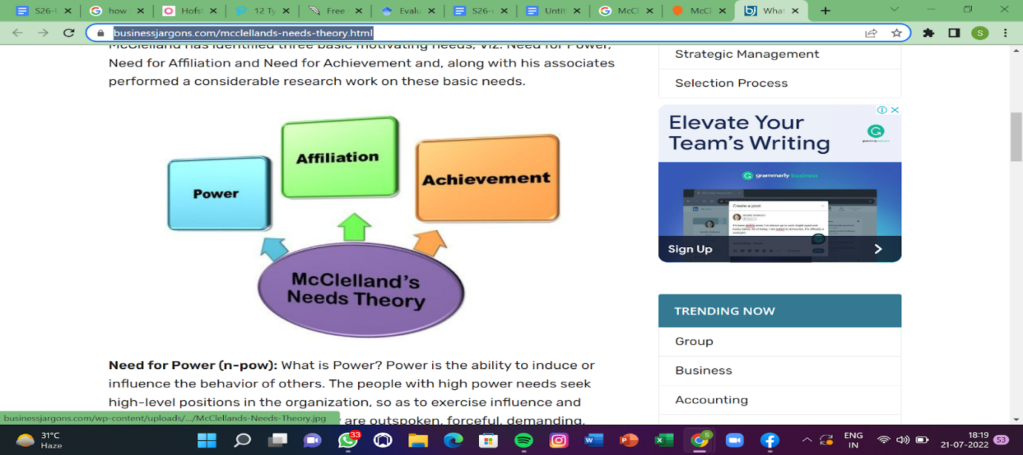

**McClelland's notion of the need**

**Appendix 4**



**Herzberg’s Motivation theory**

**Appendix 5**



**Employee behavior in the workplace**

**Appendix 6**



**Benefits of motivating workplace**

**Appendix 7**



**Factors of employee engagement**

**Appendix 8**



**Impact of organizational culture**

**Appendix 9**



**Core values of organizational culture**

**Appendix 10**



**Research onion**

**Appendix 11**



**Gantt chart**

**Appendix 12**



**Effective strategies to improve employee engagement**