- Most governments and international entities are concerned about “vaccination hesitancy”, that is, a person’s reluctance to take a vaccine. In the appendix you will find a table that provides the results of an analysis of such vaccine hesitant customers (i.e., these customers are either unwilling or undecided about getting the Covid-19 vaccine). The table provides the results of a regression analysis that provides various individual-level factors (e.g., demographics, attitudes, etc.) that predict people’s unwillingness or undecidedness to take the Covid-19 vaccine. Note, please don’t get bogged down in terms of analytics—all we need to know is that the larger the number/coefficient, the greater is the vaccine hesitancy for that group of customers (compared to the reference group; also, bold indicates statistical significance). Now imagine you are advising the government on vaccine hesitant individuals.
First, based on your eyeballing of the table and your knowledge of the STP (Segmenting, Targeting, and Positioning) process, describe what are the key vaccine resistant segments that the government should be worried about? Second, how would you advice the government go about targeting (e.g., with PSAs) each of these vaccine resistant segments? What are some of the issues that we might face while targeting each of these vaccine resistant segments? Third, besides your general advice, the government also needs more specific advice on some PSAs/ads that they have created. For your reference, some sample PSAs/ads that the NHS plans on rolling out in England are provided in the appendix. What are your reactions to these ads? Would these ads be efficacious for the intended segments? Would similar ads for other segments work well? How may they be improved? Finally, revisiting the various vaccine resistant segments and their plausible reasons for resisting vaccines, could you offer some additional pointers to the government from the Go-Stop Signal framework? Again, please note that this is not a analytical methods (or regression) question so please do not get bogged down in the numbers/methodology. (14 marks)
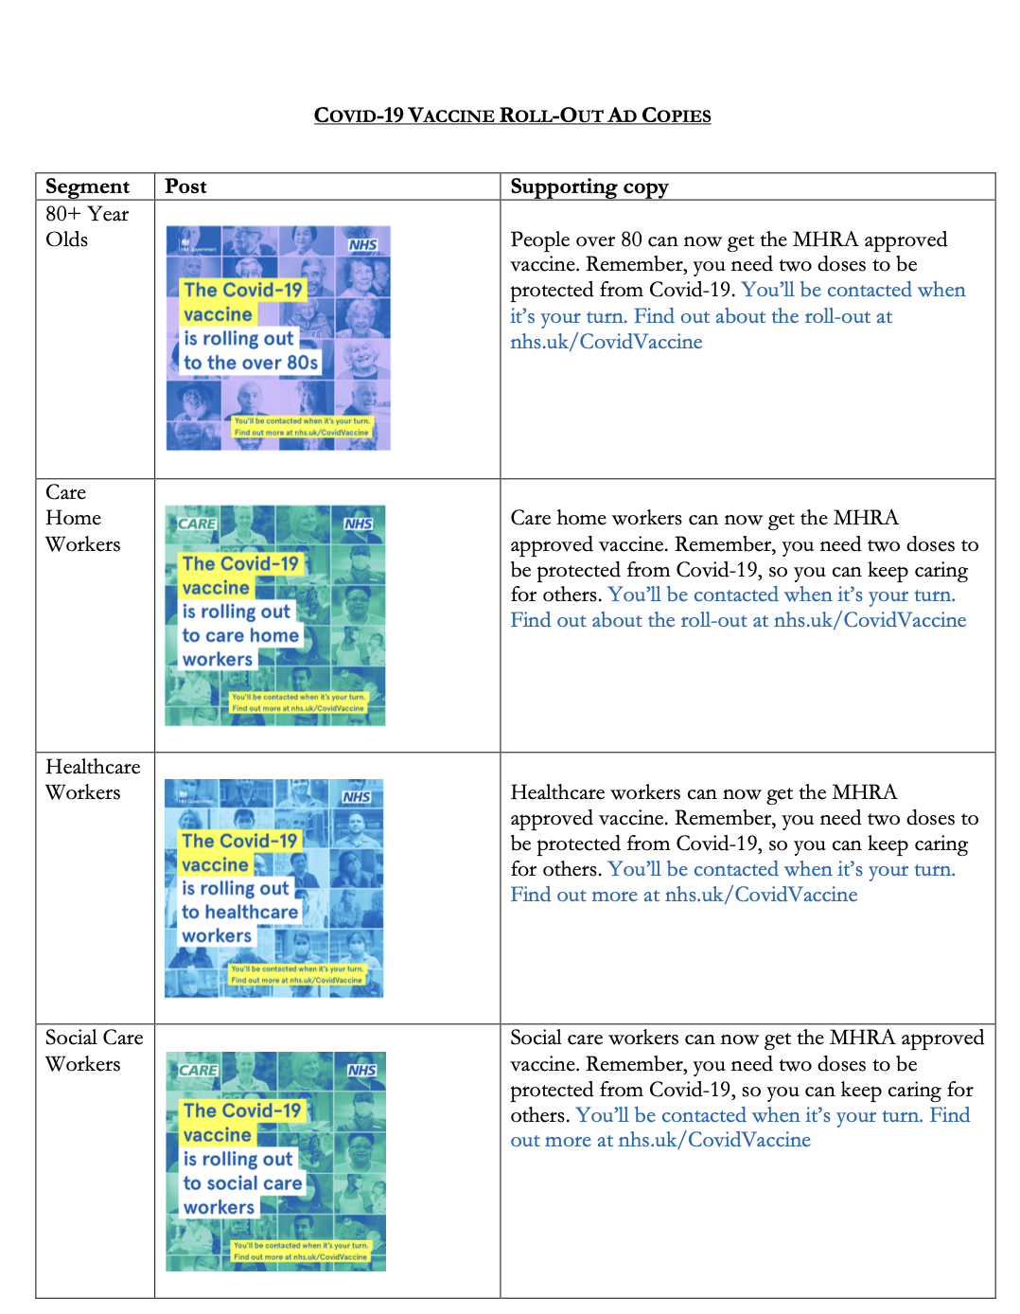
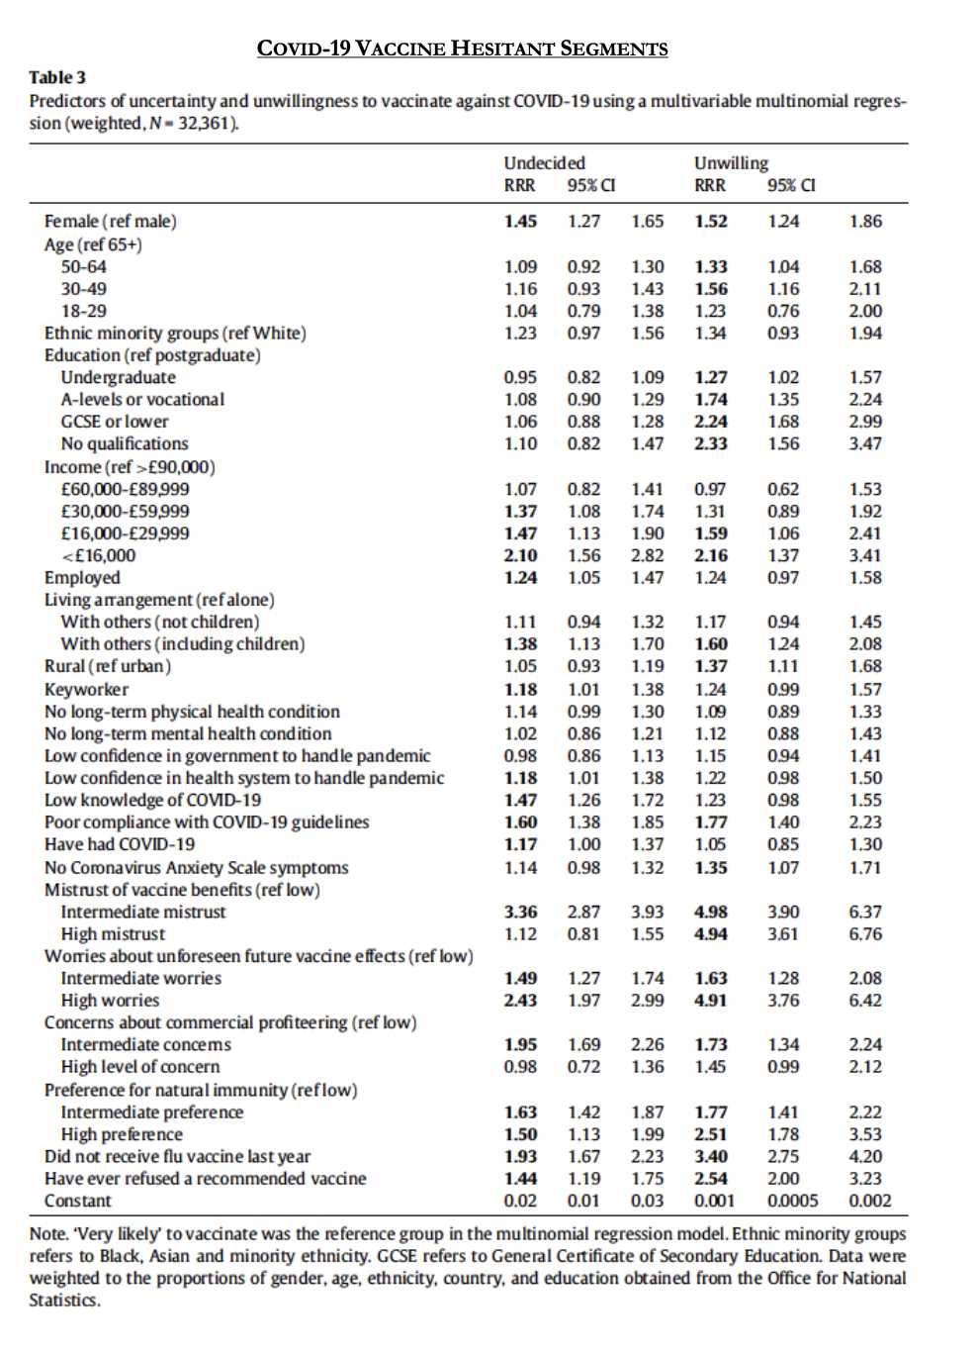

- Please view the following TV ads that was recently aired during the Superbowl ad breaks on February 7, 2021:
  - Klarna: https://www.youtube.com/watch?v=MxPPVRGVa7E
  - Mountain Dew: https://www.youtube.com/watch?v=9cEiYQwYLPk
What is your opinion on them: unfavorable, neutral, or favorable? Why? Explain your reasoning for each ad in detail. (12 marks)

