Student Name: Kavitha Macha Student ID: N0965820

A Car Number Plate Recognition System
for Car Park Registration

Introduction
In the modern era, the expotential growth of vehicular movement has become a major source of concern for the population living in capitals, metropolitan areas, and urban areas. As a result, it has become difficult for various law enforcement agencies to monitor each one of the vehicles that circulate on the streets. These agencies are tasked with the responsibility of apprehending the vehicles. There were 907 million passenger vehicles on the road in 2014, and 329 million commercial vehicles worldwide, compared to 678 million passenger vehicles in 2006 and 248 million trucks. This represents a 33.7 percent increase in passenger vehicle sales and 32.6 percent in commercial vehicles. If this upward trend continues, it will last until 2035.
Worldwide, approximately 1.7 billion registered vehicles will be on the road. This raises the issue of a requirement to implement a system capable of effectively and accurately identifying vehicles. Several safety and traffic violations are two areas that can benefit from such a system. Maintain a safe environment for the public on the roads. The VLPDR (Vehicle Licence Plate Detection and Recognition). A system is one that can extract information about a vehicle by analysing the vehicle’s images. Automatically identifying the vehicle and providing more detailed information about it.

Related Work
This section focuses on previous research that has been conducted by a variety of research. Numerous methods for detecting and recognising licence plates can be found in the literature. To start, it takes a long time to compute and recognize the licence plates are the major disadvantage. The urgency of this in regards to real-time applications is obvious. Furthermore, there will always be a compromise between computation time and performance rate. Computational time is required to obtain an accurate result and to maximize the system's overall performance.
Instead of sensor – or RFID – based vehicle parking management systems, ANPR cameras are used to photographs of the licence plates of vehicles. Additionally, it is used to collect electronic tolls on pay-per-use roads and to maintain traffic records. These ANPR cameras outperform other technologies in terms of efficiency. Three cameras are incorporated into this system. At the entry and exit points, two cameras are used. Within the parking lot, another camera is used to determine the number of vacant spaces and their location. At the entrance, the LCD display indicates the location of available parking spaces and guides the driver’s vehicle to the closest available space.
Image Acquisition
Location of License Plate
Character Segmentation
Character Recognition

Flashing signals in parking lots, which quickly evolved into automated licence plate recognition(ALPR) technology being utilized for security purposes at truck parks, warehouses, factories, border crossings, banks, airports, stadiums, and motorways(Cornwall, 2009). Automatic number plate recognition (ANPR) is a process that identifies and recognizes vehicles based on their licence plate or number plate. ANPR extracts the vehicle’s licence plate from digital images via image processing techniques.
Automatic number plate recognition (ANPR) is a widely used tool for vehicle identification worldwide. Rather than the sensor or RFID – based vehicle parking management systems currently in use, it is primarily used to capture vehicle licence plate

Capturing an accurate moving-image shot of a car is very difficult such that nothing, especially the licence plate, is missed. The fourth step’s progress Is dependent on the accuracy of the third and previous steps, both of which involve determining the vehicle licence plate number and identifying the characters.
The camera is an essential step one in the production process, which is to take a picture. The photos are taken in RGB mode so that number crunching can be performed on them after they are scanned to look at colors. Prior to thr final color-grading, the picture has had already been through an RGB conversion, which stripped it of its noise, and was then grayscale binarized.
The licence plate localization algorithm takes into account both shape an textural characteristics, as well as acceptable plate values for registration, to aid in finding the licence plate in the image. In our model, we have attained a rather high level of plate localization. It achieves the best possible level of licence plate localization with this algorithm. A licence plate possesses several vertical edges since it incorporates characters, regions, digits, and borders. Sobel edges: Performs edge detection on the input image.
The determination process of characters works best when it treats each image as an independent entity, and segments them into unique characters lossy page regular expression (regex) isolation is a universal feature of most LPR systems.
The layout of the characters on the plate is listed below:
Adjust the image’s contrast and brightness to go across the entire range of shades(0-255)
Select an acceptable exposure.
Distinguish various parts of the image by considering all things that are physically or virtually connected in the image.
When identifying images and models, the simplified or reduced-resolution approach is employed, which results in representing the images and models with reduced-pixels. Each matrix element corresponds to a sub-to-and-unit in high resolution is reduced, the picture degradation due to noise and distortion is reduced, the error is decreased.

Input frame (from camera)

Pre-Processing
Vehicle Detection
Output
Character Recognition
Character Segmentation
Number Plate Extraction
Number Plate Localization

The general nature of the ANPR system is captured in two paragraphs: one package is capable of obtaining digital image capture of the licence plate and processing it with a character recognition software. ANPR plates can be bought for substantially less, and so their accuracy is compromised. The four key parts of a licence plate recognition system are image acquisition, plate detection, character segmentation, and character recognition.
ANPR is a method of vehicle identification that is purposefully recognised. ANPR systems enable a vehicle's license plate to be recognized in real time, thus reducing in some instances the time required to identify a vehicle. When it comes to ANPR, a growing list of scenarios is available for this technology, for example:
Law Enforcement
The Metropolitan Police Service (MPS) uses ANPR technology to aid in disturbing crime, including travel criminal activities, organized crime groups and terrorists on the local, national and regional levels. England, Scotland, and Northern Ireland to track and their stolen vehicles and locate stolen goods.
Car Park Access Control
In parking access control, the ANPR technology is used. Where ANPR has been used to identify a licence plate for a specific vehicle for a reserved car park area and where restricted entry to pre-registered approved vehicles is enforced.
Weighbridges
An automatic number plate retrieval system can alleviate traffic circulation problems caused by the queuing and fusion at peaks. The ANPR system identifies cars with valid licences and vehicles that have to pay the required congestion charge or toll charge. ANPR technology is becoming increasingly necessary as vehicle identification is necessary in the real time.
Automated number plates recognition by ANPR technologies allows for an effective, efficient and time-saving automated identification process for vehicle.

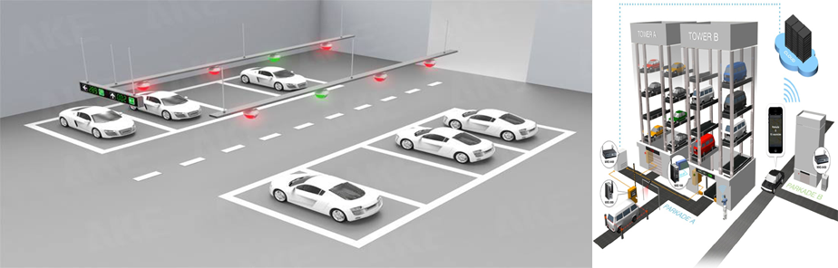
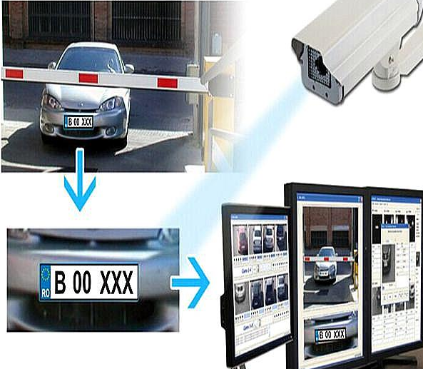

Elements of ANPR systems
Normally, an ANPR system contains a software and hardware component.
Hardware component comprises of:
Camera(s) - In the phase of image acquisition, digital cameras are used. Automobile cameras are primarily used to capture vehicle images or video footage.
Infra-Red - The device provides illumination by night with an infra-red-light source so as to allow the camera to take photos during night.
Frame Grabber - This is the computer's interface with the digital camera. The Frame Grabber is tasked with temporarily storing and transmitting the digital image from the camera to the computer.
Computer – It is the central ANPR processing unit. The ALPR application has been installed on your computer.
Software component comprises of:
ALPR Software – This software has the OCR capability that leads to the
Digital image extraction of the number plate.
Database – This is the ideal place to store the data.
Back End Software – It is located on a server and contains numerous
capabilities such as
Data collection from cameras
Data mining is the process of examining and analysing previously
collected data.
Permitting data sharing with other agencies

ANPR Implementations
RPX-LIVE is a sophisticated, interactive vehicle surveillance application that uses RoadPixel ANPR engine to interface. It can log all vehicle movements; it carries out real-time database checks and alerts; and transmitting vehicle data instantly to the RoadPixel Cloud-based Back Office (RPX-BOF). The intuitive user interface enables monitoring and control of any site entrance, parking lot, or traffic flow from a desktop environment. The same GUI can be used in a Police or Enforcement vehicle with a Touch Screen or Tablet PC to compare passing traffic to multiple hotlists.
ROADSTER-M1 is a powerful Rugged mobile/in-vehicle PC fully E-Marked which can support a large range of police and mobile enforcement applications. Usually installed in the boots of a vehicle, the vehicle has a variety of tough high-gloss touch screens and backlit keyboards that match all types of vehicles. The PC Unit and its connectors can also be protected from damage caused from other objects in the car boot by a perforated metal cage. In addition to its ANPR capability, ANPR-M1 allows recording and encrypting on-board wind-screen camera analogy on a dedicated MPEG channel. The ROADSTER-M1 is specifically suited for moving vehicle applications with different voltages and temperatures.
ANPR on Mobile Devices
Check Plate is a lightweight ANPR capture tool that works well during the day and night-time when portable devices are not available. Once a vehicle has been registered, a database can be checked for the relevant information to the user. Check Plate uses include vehicle checks, public parking services, and safety inspections at locations such as airports, train stations, city halls and state buildings.
There are many advantages to having an ANPR in place, such as a lightweight and inexpensive ANPR (Check Plate) reading and number plate reading systems which make it possible for the front-line personnel to link with information stored data from the back office, as well as highly efficient, making them particularly suitable for fleet management.
This app has the ANPR reading functionality as well as other related tools installed on a smartphone or a handheld computer so enforcement officers can view all violations that information without having to get in their car. The TES Licence Plate ANPR application flags any vehicle that is not the list as a potential violation.

Challenges
A Several factors may prevent the ANPR system from functioning effectively, including certain:
Misidentification: In case of partial reading of the number, a remote computer can ineffectively identify or could not decrypt the number plate. Characters and numbers could be mis detected and the identity could be changed, the characters could be read as numbers and vice versa.
The software must deal with several potential difficulties. Includes these.
Low image resolution, generally because the plate is too distant but sometimes because the camera is of poor quality.
Images that are hazy, especially when they are moving.
Inadequate lighting and contrast caused by excessive exposure, reflection, or shadows.
The plate is obscured by an object, most frequently a tow bar, or by dirt on the plate.

Conclusion
This article discusses the basic elements of an ANPR system, including plate position, Character separation, and recognition. The purpose of this study is to determine whether a comprehensive system is feasible. Typically , an ANPR system consists of two components. A camera for capturing images of vehicle number plates and software for retrieving the plates numbers from the captured images using a character recognition tool. A licence plate recognition system’s four critical components are image acquisition, licence plate detection, character segmentation, and character recognition. vehicle identification systems based on licence plate recognition could be developed. In that case, no additional hardware, such as transmitters mounted on a vehicle, or responses, would be required. The device works well with a wide variety of vehicle licence plate images, including those that have been scratched, scaled or distorted.
I confirm that I am aware of, and am abiding by, the university’s expectations for proof- reading

References
Ankur Kr Aggarwal, Aman Kr Aggarwal, “Vehicle Registration Plate Recognition System Based on Edge Transition by Row and Column Profile on Still Image”, International Journal of Engineering Research & Technology (IJERT) Vol. 2 Issue 1, January-2013 ISSN: 2278-0181, pp. 1-8
M.M. Rashid, A. Musa, M. Ataur Rahman, N. Farhana, and A. Farhana, “Automatic Parking management System and fee collection using Number Plate Recognition”, International Journal of Machine Learning and Computing, Vol. 2, No.2, April 2012, pp. 93-98.
Xin Fan, IEEE Member, and Guoliang Fan, IEEE Senior Member, “Graphical Models for joint Segmentation and Recognition of Number Plate Characters, “ IEEE SIGNAL PROCESSING LETTERS, JANUARY 2009.
Christos Nikolaos E. Anagnostopoulos, Member, IEEE, Ioannis E. Anagnostopoulos, Member, IEEE, Vassili Loumos, Member, IEEE, and EleftheriosKayafas, Member, IEEE, “A Number Plate-Recognition Algorithm for Intelligent Transportation System Applications” IEEE transactions on intelligent transportation systems, vol. 7, no. 3, September 2006.
S. Z. Wang and H. M. Lee, “Detection and recognition of number plate Characters with different appearances,” in Proc. Conf. Intel. Transp. Syst., 2003, vol. 2, pp. 979–984.
Bora, Kayhan, Nergiz Ercil Çağiltay, and Dr. Hakan TORA. 2009. “Car Plate Recognition.” Turkey: Atilim University.
Tran Duc Duan, Tran Le Hong Du, Tran Vinh Phuoc, Nguyen Viet Hoang, “Building an Automatic Vehicle Licence-Plate Recognition System”, International Conference in Computer Science, RIVF’05, February 21-24, 2005, Can Tho, Vietnam.
David J. Roberts and Meghann Casanova, “Automated Licence Plate Recognition Systems: Policy and Operational Guidance for Law Enforcement”, a research report submitted to the US Department of Justice, September 2012.
Yan, Dai, Ma Hongqing, Liu Jilin, and Li Langang. 2001. “A High Performance License Plate Recognition System Based on the Web Technique.” In 2001 IEEE Intelligent Transportation Systems, 2001. Proceedings 2001 IEEE August 25-29, 2001, Page(s): 325-29, doi: 10.1109/ITSC.2001.948677.

