Module Title: | Financial Derivatives and Risk Management
Assessment Title: | Report
Individual/Group: | Individual
Weighting: | 60%
Submission Date: | Please Check your assessment diary

Instructions To Students For Submission Of This Coursework

Your coursework task is to answer the following question based on key FD&RM topic areas.

Question (2,500 words)

The task is to explore the concept of arbitrage in relation to pricing. Theoretical pricing and the actual listing of prices in markets are sometimes at odds with one another and this can lead to inefficiencies in prices and create arbitrage trading opportunities. Your task is to describe and explain the concept of arbitrage and show numerically how arbitrage opportunities can occur in the markets. You are required to observe historical market prices (in 2020) and see if they are efficient compared to what the theoretical value should be.


This assignment is essay based and is designed to show your understanding of this fundamental concept in finance. Your focus should be on arbitrage opportunities created in the following markets;
  - Forwards/futures

The key focus is on the following areas;

- Discuss the concept of arbitrage and how it can be used in your chosen market. [Marked at 50%]
- Provide some analysis to demonstrate further your understanding of arbitrage and how such a strategy could be constructed.
[Marked at 40%]
- Your assignment should be presented in essay format. This piece of work is theoretical and would suite this approach the best. These marks are awarded for the writing quality of your piece.
[Marked at 10%]

Word limit maximum 2,500 words. The standard university rules apply here so the maximum word count of your assignment should be 2,750. All assignments must show a word count.

Other Information
It is essential to support your arguments with appropriate literature citations and it will not be possible to gain a “first” unless you demonstrate wide and relevant reading.

Extenuating Circumstances or Requests for an Extension
Please note: do not contact the module leader with queries about extenuating circumstances or requests for an extension. Follow the instructions which apply and which are available in SBS/SHU websites.

MARK GRID FOR Question

Learning Outcome | Fail (<50%)  Categorical mark : 0-48  Grade Based Mark : 0-6 | 50% - 59%  Categorical mark : 52-58  Grade Based Mark : 7-9 | 60%-69%  Categorical mark : 62-68  Grade Based Mark : 10-12 | 70%-79%  Categorical mark : 72-78  Grade Based Mark : 13-15 | >80%  Categorical mark : 82  Grade Based Mark : 16
Discussion on arbitrage given and how this applies to the chosen market place.  Maximum marks 50% | Little or no discussion on arbitrage. | Some discussion on arbitrage and the chosen market place. | Good discussion on arbitrage and the chosen market place. Making reference to key texts. | Excellent discussion on arbitrage showing a depth of understanding regarding the theory and how this would work in the chosen market place. | Exceptional discussion on arbitrage showing a depth of understanding regarding the theory and how this would work in the chosen market place
Analysis and demonstration of an  arbitrage trade in this market place. Maximum marks 40% | Little or no analysis or  demonstration attempted. | A basic analysis or  demonstration attempted. | A good attempt to  demonstrate and present some data to show arbitrage opportunities. | An excellent and  imaginative presentation of how an arbitrage trade could be constructed in the chosen market place. | An Exceptional and  Highly imaginative presentation of how an arbitrage trade could be constructed in the chosen market place
Written communication  Maximum marks 10% | Poorly written, hard to follow, spelling and grammatical errors | Able to follow points made some spelling and grammatical errors. | Very reader-friendly, few or no spelling and grammatical errors. | Very reader-friendly, few or no spelling and grammatical errors, imaginative/ innovative approach to communication. | Exceptionally Very reader-friendly, no spelling and grammatical errors, imaginative/ innovative approach to communication.

Once we have calculated your provisional mark of the task, we will apply the following Categorical mark grid.
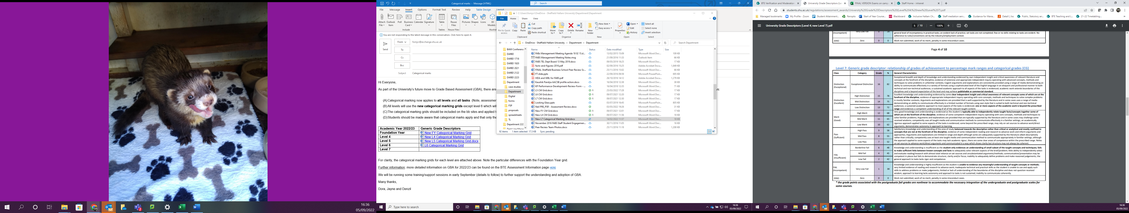
Example : If you score 67 , the categorical mark would be 68 and the grade based mark would be 12.
The maximum you could get is 82 (categorical mark), ie 16 based on grade based marking.
The report should be 2,500 words in length. This word limit relates to the word count given by the word counters in Microsoft Word and should be included at the end of the document. Work that is >10% over the word limit will be penalised by a reduction of 10 marks from the mark you would have been awarded. Note that all text apart from the list of references and appendices at the end of a document is included in the word count.

Other Information
It is essential to support your arguments with appropriate literature citations and it will not be possible to gain a “first” unless you demonstrate wide and relevant reading.

Extenuating Circumstances or Requests for an Extension
Please note: do not contact the module leader with queries about extenuating circumstances or requests for an extension. Follow the instructions which apply and which are available in SBS/SHU websites.

Guidance on referencing
Sheffield Hallam University is now using APA 6* referencing style in order to extend the choice of online tools and apps you can use to make referencing easier. Find out about APA referencing and the range of apps and online tools for quick and easier referencing at https://libguides.shu.ac.uk/referencing.

Instructions to students for submission of coursework

Online submission: The submission point will be available on the Blackboard site for this module where you need to upload your work.

Turnitin submission: You must submit your work to the turn it in tool.
You should submit your work before 3pm.

