ASSIGNMENT
SESSION | Aug-2022
PROGRAM | BACHELOR of Commerce (BCom)
SEMESTER | I
course CODE & NAME | DCM1103 – Fundamentals of Accounting I
CREDITS | 4
nUMBER OF ASSIGNMENTS & Marks | 02  30 Marks each
Note: Answer all questions. Kindly note that answers for 10 marks questions should be approximately of 400 - 450 words.
Q.No | Assignment Set – 1  Questions | Marks | Total Marks
 | - Explain the Limitations of Accounting | 5 | 10
 | - Discuss the concepts and conventions of accounting | 5
 | - Explain the debit and credit rules using the accounting equation | 5 | 10
 | - Classify the following as Assets, Liability, Income and Expenses  Particular Rs Particular Rs  Salaries 36,320 Purchases 1,44,670  Sales 1,73,500 Sundry Debtors 1,430  Plant & Machinery 34,300 Travelling Expenses 2,630  Commission Paid 1,880 Carriage Inward 240  Stock 11,100 Sundry Creditors 14,260  Repairs 1670 Capital 62,500  Sundry Expenses 460 Drawings 3,500  Returns Inward 1,000 Cash at Bank 1,090  Discount Allowed 1,150 Returns Outward 400  Rent and Rates 3,220 Investments 6,000 | 5
 | Enter the following transactions in the double column cash book of Mr. Kumar and balance it.  2021  Aug.  1 Opening Balance: Cash in Hand Rs.4,250  Cash at Bank Rs.13,750  2 Paid to petty cashier Rs.2,500  2 Cash sales Rs.1,750  3 Paid to Arun by cheque Rs.3,750  3 Received a cheque from Mr. Ram Babu Rs.4,500 paid into bank.  5 Received cheque from Mr. Jayaraman Rs.6,000 paid into bank  8 Cash purchases Rs.2,500  8 Paid rents by cheque Rs. 2,500  9 Cash withdrawn from bank for office use Rs.2,500  10 Cash sales Rs.3,750  14 Stationery purchased Rs.1,000  20 Cash sales Rs.6750  21 Paid into bank Rs.10,000  23 Withdrew cash for personal use Rs.1,000  25 Salaries paid by cheque Rs.9000. | 10 | 10

Q.No | Assignment Set – 2  Questions | Marks | Total Marks
 | 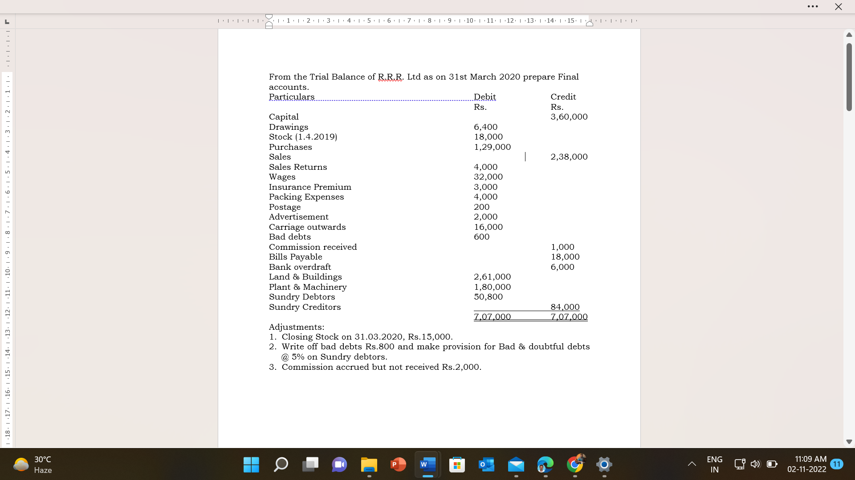 | 10 | 10
 | - Explain the different types of Errors. | 5 | 10
 | - From the following particulars of Sports Club, prepare Receipts and Payments account for the year ended 31st March 2018.  Particulars ₹ Particulars ₹ ₹  Opening cash balance 1/4/17 10,000 Subscriptions received:  Opening bank balance 1/4/17 15,000 2016 – 2017 4,500  Interest paid 5,000 2017 – 2018 65,000  Telephone expenses 7,000 2018 – 2019 5,000 74,500  Upkeep of grounds 22,500 Tournament expenses 12,500  Life membership fees received 5,500 Tournament fund receipts 15,000  Bats and balls purchased 13,000 Closing balance of cash 5,000 | 5
 | Raheem & Co. purchased a fixed asset on 1.4.2018 for Rs.2,50,000. Depreciation is to be provided @10% annually according to the Straight-line method. The books are closed on 31st March every year. Pass the necessary journal entries, prepare Fixed asset Account and Depreciation Account for the first two years. | 10 | 10

