BACKGROUND INFORMATION

This assignment helps students develop planning and scheduling skills to improve industry practices. It examines an existing project to develop a scope baseline and reschedule all activities from an existing project. The final component addresses the review of a journal paper on schedule.

ASSESSMENT LEARNING OUTCOME

On completion of the module, students should be able to:

a) Recognise the significance of process, technology, and people to the success of projects and in the management of projects.

b) Define and specify an appropriate sequence of phases into which the work can be divided.

c) Given a task network and estimates of the resources and duration of each task, compute the minimum duration (critical path) and the total cost.

d) To determine the resources required to meet the desired target date beyond the minimum duration.

e) Given a set of available resources to determine a realistic target date for a task network.

f) Given a task network, a set of resources, and a target date, prepare a schedule for executing the tasks, with a preliminary assignment of tasks to project team members.

g) Establish reporting and control mechanisms (or use standard ones effectively) to monitor project performance and to obtain early warning of deviations from the plan.

h) Determine the usefulness of project-control tools, such as project management software, lifecycle, methodologies, forms, and display facilities, and make the most effective use of such tools for controlling projects.

ASSESSMENT DESCRIPTION

The assessed components for assignment #2 comprise a portfolio of two parts. A 2000 words scheduling project will allow learning outcomes b, c, d, f, and g to be achieved. A 1200-word critical analysis of a journal paper on scheduling techniques will enable learning outcomes f, g, and h to be achieved. The word count does not consider tables, figures, references, and illustrations. The weighting for each coursework component is provided in Table 1.

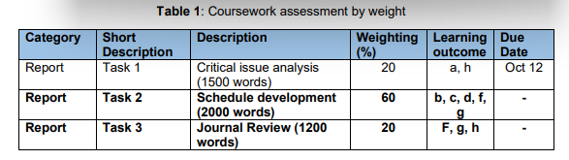

Individual Project

This assignment is to be completed individually and submitted on canvas. Each task submission must be accompanied by a turn-it-in report which demonstrates the submission’s originality. Also, each report should have a minimum of 10 references presented according to the Harvard referencing style used by the faculty and MUST be completed using a referencing 3 3 manager such as ENDNOTE. All submissions exceeding a 20% similarity using Turn-it-in will automatically fail.

1. Re-Engineering the Past This task addresses the development of critical planning and scheduling skills by reengineering the activities to complete a project from start to finish. The project to be reengineered is the Botanic Playground, located adjacent to the sports complex.

The playpark consists of several play activities and infrastructure work that must be completed to have the park in its current functional state.

See figure 2. In this project, assume that you are the construction manager and that the site has not been previously developed.

a) Develop all documentation to establish the scope baseline for the project. (No more than 4 pages)

b) Determine the list of activities that must be executed to complete the park. Determine a logical sequence of the activities and create a network diagram representing your project.

c) Estimate the time taken to complete each task. Consider the client’s request to have the project completed in 28 days from mobilisation on-site.

d) Draw the activity on the node network using the PERT methodology, indicating each activity’s early start, early finish dates, late start, and late finish dates to create the play park and highlight the critical path.

e) Determine the free float and total float for all activities. Interpret the meaning for both the free and total float for the asphalt paving works.

4 4 f) If the client wishes to fast-track the project and complete it in 16 days or less, what is the probability of completion? Use statistics to advise the client on this request.

g) Determine the 95% probable project duration and interpret its practical meaning.

h) Assuming that all paths through the network are independent but interactive, determine the probability of completing the project by the time on the critical path if interaction only occurs between the critical path and the second longest path provided by your network diagram. That is, evaluation should be done between the critical and nearcritical paths.

i) State three (3) assumptions in formulating your solution and critically evaluate these assumptions giving practical and theoretical merits and criticisms.

j) For one item of work, evaluate one critical HSE risk. Ensure mitigations and controls are provided for this risk.

k) For the network diagram drawn above, use Microsoft Projects or ASTA Powerproject to create a schedule and assign resources to ensure the project is complete within 28 days or less.

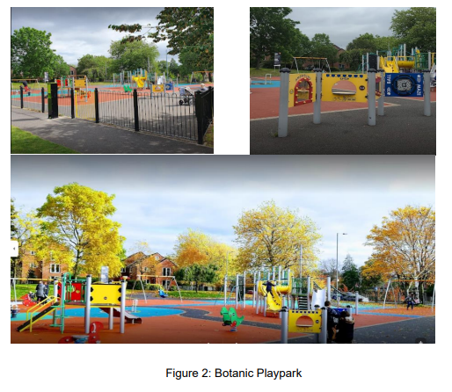

2. ASTA-Powerproject – Monitoring and progress reporting

