PROG 2370 Assignment-2

Points : 100 points

In this assignment you are going to create a Horse race in C# using the Visual studio.

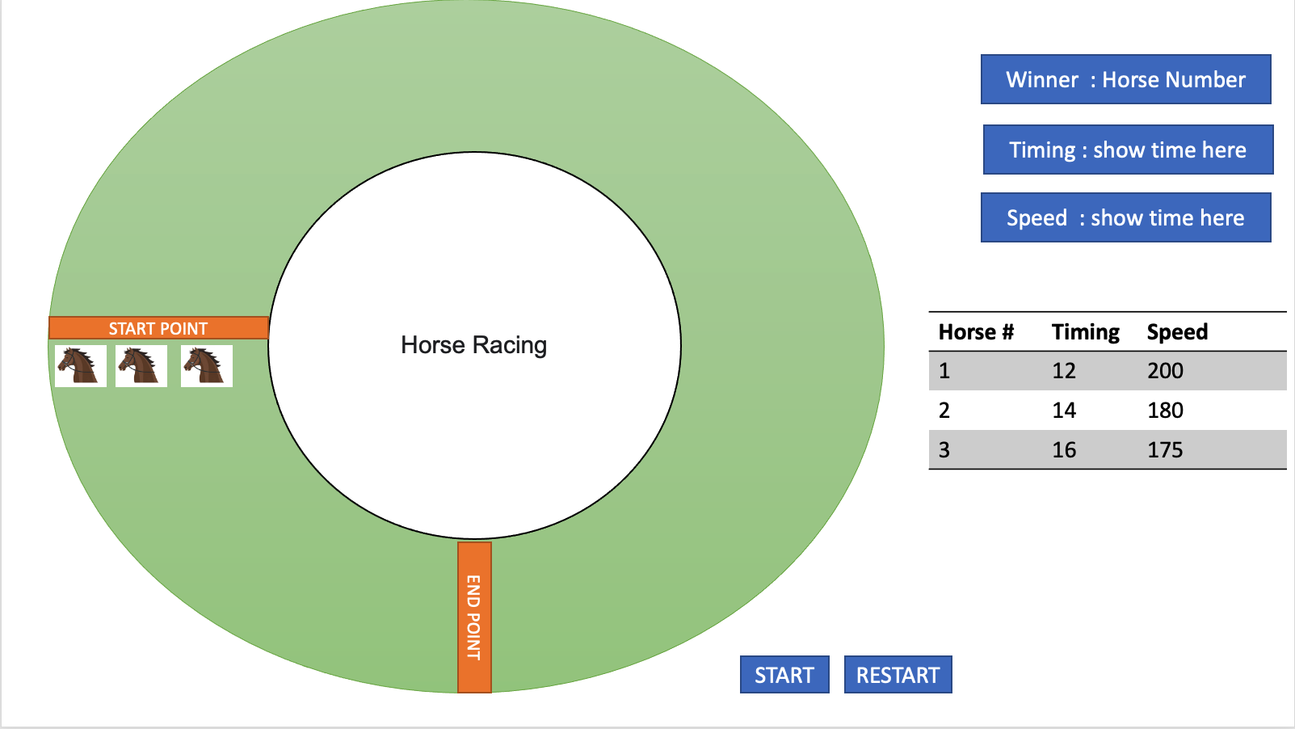

Details of the Game

- Each horse must have a number and show an image of the horse in the button.
- When the Player press the start button horses start the race.
- When horses touch the right side of the End Point horse stop.
- Horse move in a circular clockwise direction
- When the last horse touches the end point, race stop.
- At the end of the race show the result (three text boxes shows the details of the winner horse)
- Table show the tally of each horse in the race
- You have to show the timing and speed of the horse in the table.
- Each time there should be a random horse speed and Restart button restart the race.
- Horses should not touch each other.

The rubric of the Assignment

Tasks | Points
1 Design  Path and the horses -15 points  Table -10 points | 25
2. Functionality  Circular movement -30 points  Result (table) -10 points  Random speed -10 points  Start/ Restart button - 10 points  Start at the start point - 5 points  Stop at the end point -5 points  Show the result at the end of the race-5 points | 75

