# Osmosis and Diffusion Lab

## Objectives

*By the end of lab, students should be able to …*

* Explain the processes of diffusion and osmosis and describe the properties of molecules that can move freely across membranes.
* Describe the movement of water across a membrane when placed in a hypoosmotic, hyperosmotic or iso-osmotic environment.
* Calculate percent change.

## Introduction

Membranes are an essential part of every living cell: membranes separate the inside of the cell (intracellular environment) from the outside of the cell (extracellular environment). However, the cell membrane is not a solid and rigid barrier; it is fluid and allows some substances to pass through easily, while restricting the passage of other substances.

The movement of molecules across a membrane is driven primarily by the processes of osmosis and diffusion. When diffusion occurs across a plasma membrane, solutes may pass into or out of the cell in a process called dialysis. Each solute will move from the side where its concentration is higher to the side with a lower concentration down the concentration gradient. The solute movement will be independent of the movement of other solutes. In the special case of diffusion in which the substance diffusing across the membrane is water, the process is called osmosis. During osmosis water will flow from the side with the most water to the side with the least water. If you think about this, water moves from the solution that has the least amount of solute (hence most amount of water) to the solution that is more concentrated.

**Osmolarity** is described as the concentration of solutes (solid particles) per a volume of liquid. Solutions that are high in concentration of a solute (e.g. a 50% sugar water solution or a 40% saltwater solution) are said to have high osmolarity. The solution that has a stronger tendency to gain water (more solutes) is said to be hyper- osmotic with respect to another solution that gains water to a lesser extent. The solution that has a lower tendency to gain water (less solutes) is hypo- osmotic with respect to the first solution. Pure water is the most hypo- osmotic solution possible, since it can never gain water. Two solutions with exactly the same tendency to gain water are ISO-osmotic with respect to each other.

The osmolarity of a solution affects the tonicity of a cell that it surrounds. **Tonicity** is described as the ‘tone’ or shape / morphology of a cell. The osmolarity of a solution has a huge impact on the tonicity of a cell.

In today’s lab, you will conduct an experiment that will help you to understand which molecules can cross a semi-permeable membrane, and which molecules cannot cross. You will also investigate properties that affect diffusion and osmosis.

**Exercise 1: Diffusion at Varying Temperatures**

**Materials**

Computer Simulation: <http://lab.concord.org/embeddable.html#interactives/sam/diffusion/1-dropping-dye-on-click.json>

**Procedure**

1. Set the temperature slider to low
2. Click on the simulated area to introduce the dye
3. Stop the simulation when the dye molecules have reached the edges of the chamber which we will consider to be a homogenous solution (dye is distributed throughout the chamber)
4. Record the time
5. Reset the simulation and adjust the temperature to the middle of the slider and repeat
6. Reset the simulation to high and repeat

**Table 1. Observations of Diffusion in Liquids with Varying Temperatures**

|  |  |  |  |
| --- | --- | --- | --- |
| Observations | **Low** |  | **Boiling** |
| Time to homogenous solution |  |  |  |

***At which temperature did diffusion to a homogeneous solution happen the quickest? Explain why. Keep this information in mind when addressing the Diffusing Skittles and Ballooning Gummy Bears challenge.***

**Exercise 2: Simulating Osmosis**

**Procedure**

1. Go to the [Diffusion and Osmosis simulation](https://www.biologysimulations.com/diffusion-osmosis) on Biology Simulations and complete the worksheet  
   * 1. Simulation Background:
2. In the simulated solution, what is representing the solvent?

|  |
| --- |
|  |

1. In the simulated solution, what is representing the solutes?

|  |
| --- |
|  |

*2. Run the simulation with all three molecules present.* Based on observation, determine if the membrane separating sides A and B is permeable to each molecule and record (yes/no) in the table below.

|  |  |
| --- | --- |
|  | Permeable? |
| Large |  |
| Medium |  |
| Small |  |

1. *Set the large molecule on both sides to 2%, and the other molecules to 0%.*
2. If 2% of the side A starting solution is large molecule, what percent is water?

|  |
| --- |
|  |

1. *Run the simulation and observe for 60 seconds (then click Pause).*
2. How much did the solution concentration fluctuate? Record the greatest change in % over the 60 seconds (hover the mouse over the graph to see the values).

|  |
| --- |
|  |

1. What molecule is moving between sides A and B during the simulation?

|  |
| --- |
|  |

1. *Reset the simulation and set the large molecule concentration on side A to 5% and side B to 0. Set all other molecules to 0.*
2. If 5% of the side A starting solution is large molecule, what percent is water?

|  |
| --- |
|  |

1. *Run the simulation for 60 seconds.*
2. What was the ending concentration of the large molecule on side A?

|  |
| --- |
|  |

1. What is the ending concentration of water?

|  |
| --- |
|  |

1. Based on the results, what happened to water molecules during the simulation?

|  |
| --- |
|  |

1. How do these results compare to the results from #3?

|  |
| --- |
|  |

1. *Reset the simulation and set the medium molecule concentration on side A to 5% and side B to 0. Set all other molecules to 0.*
2. If 5% of the side A starting solution is medium molecule, what percent is water?

|  |
| --- |
|  |

1. *Run the simulation for 60 seconds.*
2. What was the ending concentration of the medium molecule on side A?

|  |
| --- |
|  |

1. What was the ending concentration of the medium molecule on side B?

|  |
| --- |
|  |

1. How do these results compare to the results from #4?

|  |
| --- |
|  |

1. *Reset the simulation and set the small molecule concentration on side A to 5% and side B to 0. Set all other molecules to 0.*
2. If 5% of the side A starting solution is small molecule, what percent is water?

|  |
| --- |
|  |

1. *Run the simulation for 60 seconds.*
2. What was the ending concentration of the small molecule on side A?

|  |
| --- |
|  |

1. What was the ending concentration of the small molecule on side B?

|  |
| --- |
|  |

1. How do these results compare to the results from #4 and #5?

|  |
| --- |
|  |

8. Write an explanation of osmosis using data from the simulation.

|  |
| --- |
|  |

**Exercise 3: Osmosis in Potatoes**

**Materials**

* 1 medium to large white potato
* 1⁄4 cup table salt
* 3 clear glasses
* Metric ruled graph paper OR ruler

**Procedure**

1. Prepare two salt solution:
   1. Measure 1.5 teaspoons (tsp) of salt and dissolve it in 3 cups of room temperature water. Stir for a few minutes to get as much salt dissolved as possible. Transfer the solution into a clear glass big enough to hold 1 potato slices (~4 cm deep).
   2. Measure 1⁄4 cup of salt and dissolve it in 3 cups of room temperature water. Stir for a few minutes to get as much salt dissolved as possible. Transfer the solution into a clear glass big enough to hold 1 potato slices (~4 cm deep).
2. Transfer some room temperature tap water to a third glass, at least 4 cm deep.
3. Label the three cups (No salt, low salt, high salt).
4. Carefully cut a white potato into three equal pieces approximately 1 cm X 1 cm X 5 cm. The size doesn’t have to be exact, but it is critically important that all 4 slices are exactly the same length. Record the length of each slice in Table 4.
5. Transfer one potato slice into each glass.
6. Immediately note your observations of both glasses.
7. Don’t get the slices mixed up. Allow the slices to stay submerged for 2 hours then remove them and compare their lengths. Using a ruler, measure to the closest mm. Record the length of each slice in Table 4.
8. Place the slices back into their glasses and leave them overnight (approximately 12 hours). The next day measure again. Record the length of each slice in Table 4.Also, note how each slice feels (soft, hard etc.).
9. Calculate the percent change in length of all 4 slices at each time point and record your results. To calculate % change as follows:

**[(length (mm) after overnight – original length) / original length] x 100%**

*For example. After overnight length = 63 mm. Original length = 60 mm.*

*% change = [(63 mm – 60 mm) / 60 mm] x 100% = [3 / 60] x 100% = 5%.*

**Table 4. Potato Experiment Observations and Calculations**

|  |  |  |  |  |
| --- | --- | --- | --- | --- |
|  | **Water** | | | |
| **Start (time 0)** | **2 Hours** | **~ 14 Hours** | **Observations** |
| Potato Slice Size (mm) |  |  |  |  |
| % Change | 0 |  |  |
|  | **Low Salt** | | | |
| **Start (time 0)** | **2 Hours** | **~ 14 Hours** | **Observations** |
| Potato Slice Size (mm) |  |  |  |  |
| % Change | 0 |  |  |
|  | **High Salt** | | | |
| **Start (time 0)** | **2 Hours** | **~ 14 Hours** | **Observations** |
| Potato Slice Size (mm) |  |  |  |  |
| % Change | 0 |  |  |

***Q1. Which solution is considered to be ...***

1. ***Isotonic(ish) compared to the potato cells?***
2. ***Hypotonic compared to the potato cells?***
3. ***Hypertonic compared to the potato cells?***

***Q2. Explain with reference to your experimental data how you determined the tonicity of each solution with reference to the potato.***

**Exercise 4: Candy Challenge**

**Part 1: Diffusing Skittles**

In this demonstration, you will observe the diffusion of the sugary coating and dye of skittles into three different solutions. The three solutions are as follows:

Warm tap water at 32oC,

Warm sugar water at 32oC (8 sugar cubes were dissolved in half a cup of water),

and Hot tap water at 42oC.

Watch the video and determine which demonstration (1, 2, or 3) corresponds to which of the solutions and explain how you know.

**Part II: Ballooning Gummy Bears**

Gummy Bears have a selectively permeable coating which allows water molecules to diffuse across the coating but inhibits other larger molecules from crossing. In this demonstration, you will see the results of an experiment in which gummy bears were immersed into one of three solutions: 1% salt water, 10% salt water and tap water. I repeated the experiment for orange, red, green and yellow gummy bears, such that 1 bear of each colour was immersed in each of the solutions in individual glasses. Glasses containing bears of one colour were placed in the fridge for 24 hours. The other three colours were kept at room temperature. All the bears weighed 2 g before being immersed into the solutions. On the following page you can see the photos and weights of the bears after 24 hours. Determine which gummy bears were placed into which solutions (0%, 1% and 10% salt) and which colour (orange, red, green and yellow) was placed in the fridge. Explain how you know with reference to the process of osmosis.

Figure 1. Gummy Bears after being immersed in three different solutions for 24 hrs. Which bears (3, 2, or 1) were placed in the 10%, 1% or 0% salt solution? Which colour set (orange, red, green or yellow) was put in the fridge?

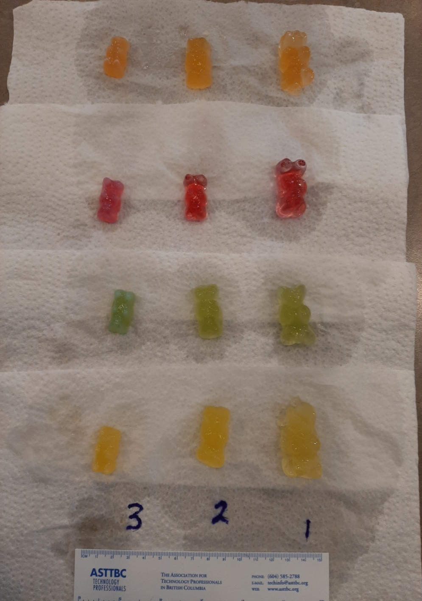

3 g

6 g

9 g

3 g

3 g

3 g

6 g

6 g

4 g

10 g

8 g

12 g

**Wrap-Up:**

**Individual Assignment:**

Once you have completed all of the laboratory exercises, complete the Blackboard quiz for the lab which is available in the folder for the Diffusion and Osmosis laboratory.

**Questions?**

* If you have any questions about the lab exercises, please send me an email or schedue a time to meet via Blackboard Collaborate.