

**9 - 521 -042**

R EV : D EC EM BER 2 0 , 2 0 2 1

R A J I V LA L

D A V I D J . C O LLI S A K I K O S A I T O

Komatsu and Smart Construction

During 2018, Tetsuji Ohashi, then President & CEO of Komatsu Ltd. (Komatsu), a leading Japanese construction machinery manufacturer, presented the Board a decision to invest $1.6 billion behind its mid-term management plan for 2019 to 2021. The main investment was to be in Komatsu’s Smart Construction business which combined the Internet of Things (IoT), artificial intelligence (AI), autonomous driving, and big data to offer a digitally integrated management solution for the entire construction process (**Exhibit 1**). The investment would support development of the software necessary to grow the business and roll out the business beyond Japan. With this plan, Komatsu aimed to increase Smart Construction sales from tens of millions of dollars in fiscal 2019 to $300 million by 2025.a

Pursuing President & CEO Ohashi’s strong belief that connectivity and automation was key to transforming productivity and safety at the construction site, Smart Construction would digitally connect the whole process of construction—a chain of (1) Survey, (2) Design, (3) Plan, (4) Construct, and (5) Inspect. Data about the site could be uploaded to a digital platform from drones, construction machines, from the internet and by third parties, such as surveyors; software applications would then design and continuously update daily work plans; while automated equipment would execute the tasks. Smart Construction would, therefore, go far beyond simply autonomous operation of Komatsu’s latest intelligent Connected Technology (ICT) machines - construction equipment with automated controls and sensors, such as an excavator that could dig with an accuracy of 30 mm using 3D GPS positioning and single-lever control – as it included the digital integration of all worksite processes (**Exhibit 2** which shows on the horizontal dimension the increasing autonomy of the equipment, and on the vertical dimension the degree of digital integration across the construction site. Smart Construction lies in the top right of the diagram).

To exploit this opportunity, Komatsu created a new division, Smart Construction Promotion Division, on January 1, 2015 and President Ohashi recruited Chikashi Shike to be its President. Shike had established his own 700 person construction machinery rental company before joining Komatsu as Chairman of its rental business. He was drawn to the Smart Construction Division by Ohashi’s commitment to the project and willingness to support Shike’s entrepreneurial approach to building the

a Komatsu’s fiscal year started April 1 and ended March 31.

Professors Rajiv Lal and David J. Collis and Senior Researcher Akiko Saito (Japanese Research Center) prepared this case with the assistance of Executive Director Nobuo Sato (Japan Research Center). It was reviewed and approved before publication by a company designate. Funding for the development of this case was provided by Harvard Business School and not by the company. HBS cases are developed solely as the basis for class discussion. Cases are not intended to serve as endorsements, sources of primary data, or illustrations of effective or ineffective management.

Copyright © 2020, 2021 President and Fellows of Harvard College. To order copies or request permission to reproduce materials, call 1-800-545- 7685, write Harvard Business School Publishing, Boston, MA 02163, or go to [www.hbsp.harvard.edu.](http://www.hbsp.harvard.edu/) This publication may not be digitized, photocopied, or otherwise reproduced, posted, or transmitted, without the permission of Harvard Business School.

business even though he was warned by Ohashi of, “possible resistance” because management needed to be convinced this was a real business, and to be “quick and nimble. Don’t set too high aim so even if we fail, we won’t lose too much”. In turn, Ohashi evaluated Shike as “someone who has ideas that many Komatsu people could not come up with”1 and looked to work closely with him on the business.

Since its establishment Komatsu had invested around $30 million developing Smart Construction and had supported its sales by placing three hundred consultants in dealerships throughout Japan. By the March 2019, Smart Construction had been used at more than 10,000 jobsites cumulatively in Japan, with a current market penetration of 2%.

Ohashi was not satisfied with this result and asked operating officers and managers to go forward with his plan to grow the Smart Construction business. But was this a worthwhile investment?

# Komatsu Ltd.

## History and Performance

Komatsu Ltd. was established in May 1921, succeeding Takeuchi Mining Co. which manufactured “machine tools and mining equipment for in-house use.”2 The company grew rapidly before WWII and soon became the construction equipment industry leader in Japan.3 Komatsu produced Japan’s first crawler-type farm tractor in 1931, and also manufactured mining equipment, tunneling machines, forestry machines, and forklift trucks.4

When Caterpillar—the world’s largest construction equipment manufacturer—entered the Japanese market in 1963, it immediately posed a threat to Komatsu, whose product quality lagged behind. However, Komatsu rapidly responded with a series of initiatives to improve product reliability and, under the slogan “Maru-A” (encircle Caterpillar), to expand globally.

In spite of its success becoming Caterpillar’s main international rival, the company struggled towards the end of the 20th century after the bursting of the Japanese “bubble” economy. In response, then President Masahiro Sakane started a business strategy within Komatsu in 2001 titled “Dantotsu (unique and unrivaled) project,” which focused on developing high-quality “Dantotsu products” that no other competitor could catch up to for years5. Dantotsu continued to be the spirit of Komatsu, through 2019. As part of the initial Dantostu project, Sakane developed KOMTRAX which used GPS technology to enable users to check information, such as fuel consumption and hours of operation for Komatsu equipment online. Sakane recalled that data collected through KOMTRAX helped Komatsu increase its competitiveness6. In 2013 the firm launched its ICT machines as the first step to automation of the physical operation of equipment, such as a bulldozer or excavator.

By 2019 Komatsu remained the leading Japanese construction equipment manufacturer with market shares in Japan of 28% for hydraulic excavators (followed by Hitachi and Caterpillar at 23% and 18%, respectively).7 Globally, Komatsu’s 11.9% market share ranked second after Caterpillar (16.4%) in 2018 (**Exhibit 3**).8

Of its fiscal 2018 net sales totaling ¥2,725.2 billion ($25 billion), 87% came from overseas with 90.5% from construction, mining, and utility equipment, (**Exhibit 4**).9 Operating income that year was ¥397.8 billion, a 48.2% increase from the previous year, and return on equity was 14.7%.10

## Culture of Mono and Koto

When Ohashi took over as President & CEO in 2013, he was concerned that Komatsu had become too product-centric, priding itself on winning in the marketplace by having the best quality and most reliable products. Ohashi believed that Komatsu was less focused on customers and needed to learn how to “put oneself in the shoes of the customer.” In 2007, Komatsu had launched its “brand management” activities, with the philosophy of facing the customer and empathizing with their problems. Ohashi hoped to build on this by combining elements of product-centered and customer- centered approaches, to generate both manufacturing (“MONO,” tangible) and service (”KOTO,” intangible) solutions.11

Shike believed that the balance between MONO and KOTO was particularly important for Smart Construction, noting:12

Each person who works for Komatsu should understand both MONO and KOTO elements and act accordingly, as if one has MONO in one pocket and KOTO in the other and could use either one or both. Komatsu should not be transformed completely into a KOTO company nor make a paradigm shift to KOTO; the company should remain a manufacturing company. Having the two pockets of MONO and KOTO is Komatsu’s ultimate goal.

Shike observed that the main differences between MONO and KOTO were:13

First, MONO businesses are required to have a full-fledged 100% quality product that meets customers’ requirements as soon as it is delivered into the market. In contrast, KOTO businesses adjust the content of the service even after it is on sale in the market. We continuously make progress or upgrade the product and/or service offering. Second, the product-out approach of MONO businesses means that the value created by the products is known in advance, but not so for KOTO. For manufacturing, once the products are released or delivered to customers, how to use the products is basically up to the customers. However, KOTO businesses are required to “go along” with the customers who are using the services. Third, the KOTO part of Smart Construction provides a wider scope of customer support. Smart Construction includes technology and services that were not originally provided by Komatsu, such as drones that are used for surveying the construction site.

Penetration of the KOTO mindset within Komatsu was, however, not easy, especially among those lifetime employees who typified the company’s workforce and had been exposed only to the MONO culture. Shike recalled that one of the important tasks for the Smart Construction Promotion division was to promote a KOTO mindset within the company.

# Construction Industry

The construction process at a building site could be categorized into five major tasks: (1) surveying,

(2) designing, (3) planning, (4) constructing, and (5) inspecting (**Exhibit 5**).

In Japan, construction work, especially public works, was managed by one general contractor and divided into tasks, which were contracted out to specialized subcontractors such as surveyors, architectural and engineering designers, dump truck operators, 14 and inspectors each of which historically had their own plans and ways of operating.

Smart Construction provided both an accurate 3D map of the site that could be regularly updated and shared by all those working on the project, and project management tools for controlling the complete set of operations, including a visual representation of the entire “work flow.”

**Survey:** Surveying the topography of a construction site traditionally “required people to walk through the site and perform measurements every 20 m. with theodolites on tripods or with tape measures, which was time-consuming and inaccurate.15” The process included nailing flags to marks, which could also be dangerous, and so surveys of the site were done periodically – often only monthly. With Smart Construction, aerial drones could survey the land daily and employed Edgebox software, developed by Komatsu, to accurately clean the data, such as eliminating trees and houses on the plan.16 By 2019, Smart Construction had partnerships with 91 out of the 10,000 Japanese surveyors.

**Design:** Data gathered from a site survey would be incorporated into the architect’s or engineer’s design and overlaid with other relevant inputs, such as underground pipework. Smart Construction enabled the creation of 3D data that could be viewed and shared on multiple devices, such as computers, smartphones and tablets, even without CAD software. Komatsu’s support center in Japan could also “create 3D data from non-convertible hardcopy architectural design drawings and save them on the Smart Construction App.17” The map could then be used throughout the construction process, including inspections, to compare the current state with the initial condition of the site and the overall design.

**Plan:** Planning what site work needed to be done, when, required, among others, calculations on soil volume, area, and distance to be moved. This would be used to identify, for example, the optimal routing for a bulldozer on the site; the number and timing of dump trucks to be available to move earth offsite; as well as coordinating material supplies and labor requirements. Sophisticated software applications could even incorporate weather into the plans - since wet earth was heavier, excavators were limited in how much they could move in each bucket load - and could track, from daily surveys, where puddles had formed that needed to be levelled. All of this, could be compiled and viewed on the app dashboard which users could access at the site.

**Construction:** Execution at the construction site included loading, embankment, excavation, dirt transport, among other tasks. The specific set of activities would depend on the project – road building, for example, would be more excavation intensive than building a skyscraper – and the cost structure of a project would vary accordingly (**Exhibit 6**). Komatsu’s ICT equipment, especially excavators and bulldozers, helped to eliminate or automate some of the manual work, such as marking the height and digging the position of finishing stakes, as the machine’s movements could be based on the 3D design data. While executing the construction process, updated topography and relevant data could be gathered from positional sensors beneath the track shoe of the equipment and shared among the stakeholders on the platform.18

**Inspect:** Public works construction was required to have regular inspections that were traditionally conducted on-site using paper maps. Smart Construction’s 3D-design data and mapping, simplified the task and could generate a color-coded heat map showing what aspects needed to be corrected.

# Japanese Construction Industry

Japan’s domestic construction investment in fiscal 2018 was ¥62.9 trillion of which 66% was by the private sector and 34% by government. Architectural buildings accounted for 66.5% of the investment, the majority of which was from the private sector, and 33.5% was civil engineering – roads, sewerage,

hospitals etc - the majority of which was from the public sector. Of the total volume of public works, about 27.7% was from central government and 72.3% was from local governments.19

Japanese construction companies could be divided into two categories: (1) general contractors who had direct contracts with the project owners and received a mandate for the entire construction work, and (2) specialized subcontractors, who bid for and received part of the project at a site (**Exhibit 7**). General contractors were responsible for the entire construction process, overseeing planning, quality management, schedule management, cost management, and coordination with the clients/owners.20 However, they subcontracted most work to other companies, which then subcontracted their part of the work to other companies. The layers on any one site, with the general contractor at the top, could be four to six levels deep, each one of whom had their own way of working and their own, usually manual, management system.

All companies required a specific license from the Ministry of Land, Infrastructure, Transport and Tourism (MLIT) or a prefectural government for each of 29 categories of construction work. Participating in bidding for public works required completing a registration process which was scored on criteria including financial and management information and past record to determine a winner. For large projects of more than ¥1 trillion only a limited number of about five “super general contractors” were eligible to bid.21 Determining a bid price was difficult given the approximations involved with manual plans and surveys, and the variability of work site conditions and weather. Construction companies typically planned on a 10 - 30% allowance in their estimation and relied on rules of thumb for the prices they expected to pay subcontractors that built a profit margin into their total bid.

Of all construction companies in Japan, 0.1%—equivalent to 284 companies—were large companies, in which general contractors were included, and 95.3% were categorized as small companies with fewer than 20 people. This percentage, was higher than those of other industries in Japan, such as manufacturing (85.7%), and retail (78.9%).22

The structure of construction industry in other countries was different. The United States featured large companies who did the majority of construction work themselves and had their own internal project management systems and software. Other, smaller companies doing local work also tended to operate the entire site themselves. Companies similar to Japanese general contractors existed in the U.S., but the size of those companies was small and not in the mainstream. Other countries in Western Europe, such as the United Kingdom and Germany, had a system similar to the one in the United States. Only France had a similar system to Japan’s.23

## Concerns and Government Policies

Japan was confronting a substantial forecast labor shortage in the construction industry as the population aged (**Exhibit 8**). While the total number of construction workers had been declining since 2000, the demand for construction work remained, even after excluding temporary demand increases from the 2020 Tokyo Olympics and recent natural disasters, like the 2011 Tohoku earthquake and tsunami. By 2025 it was estimated that there would be a shortage of 1.3 million construction workers since people over age 55 currently made up 34% of the workforce, compared to only 11% under age 29.24

Recognizing the future labor shortage, MLIT introduced a policy on “i-Construction” in November 2015. This aimed to encourage the use of ICT equipment for construction projects in order to improve productivity by 20% by the year 2025 and also encouraged the use of technology in tasks from surveying to inspecting. I-Construction also supported development of an open platform for the construction industry on which all participants could access and share information.

In March 2016, MLIT went further announcing implementation of a “full utilization of ICT in civil engineering” policy that included fifteen new standards including for 3D data. The government also issued guidelines that allowed construction companies a 20% higher price when using ICT and gave preferential scores to companies that used ICT equipment. Partly as a result of MLIT’s policies, in 2016, 584 out of 1,625 government construction projects involved ICT equipment which was claimed to shorten construction time by about 30%25. MLIT also established a 2018 budget of ¥1.18 billion to promote the use of new technologies at construction sites.26

# Smart Construction

Komatsu’s Smart Construction business was launched in February 2015 under the leadership of Ohashi, to improve labor productivity and so ease the forecast worker shortage, and to increase safety by mitigating hazardous work at construction sites. Ohashi had seen an example of ICT equipment in the United States in 2010 and realized that “information-based construction” could be a key to addressing these issues. He also had strong views on the importance of “connectivity” from his previous experience at Komatsu factories. He saw that improving efficiency in one part of the process, such as using ICT construction equipment, however automated that might become, was not sufficient, since a “bottleneck” in other parts of the construction process would still negatively affect productivity. Regardless of how fast and accurate the excavator became, for example, if the correct number of dump trucks did not show up at the right time, productivity would stall.

To support this vision, Komatsu also launched a cloud-based platform, KomConnect, in which data—such as topography data gathered by drones, construction plans, measurements, and movements of machines—was stored and visualized. Because KomConnect contained data gathered at a construction site throughout the construction process, it included more data than just from Komatsu equipment.

Smart Construction was introduced to Komatsu and customers alike at a presentation in 2015. Accompanying the launch was a video that outlined the vision of what Smart Construction might be able to offer (**Komatsu Smart Construction: Launch Video,** HBS Video Short No. 521-707). As Shike noted, the video was entirely aspirational, since little of the technology demonstrated had yet been built. Nevertheless, Shike saw the presentation as motivational – “to unite the company behind the vision” - and putting a stake in the ground to show Komatsu and then President & CEO Ohashi’s commitment to the business.

Developing the hardware component for Smart Construction – primarily ICT construction equipment - remained the responsibility of the traditional Komatsu organization. Here machine control engineers worked on fully automated machines, like excavators, by incorporating GPS technology, measurement sensors, autonomous controls etc. By 2019 Komatsu had three types of ICT hydraulic excavators and six types of ICT bulldozers, domestically. ICT equipment was still not fully automated in 2019 (**Exhibit 9**). However, ICT hydraulic excavators, for example could automatically excavate at the position and to the depth previously set by the program.

In Japan, ICT machines were initially only rented to users by the dealer network rather than sold as capital equipment since Komatsu wanted to retain access to the data. Typical rental prices were two to three times higher than for a traditional machine because of the value they created for the customer. By 2019, Komastu had been selling ICT machines for three years, and was about to release an upgrade kit for ¥700 k. that would retrofit an existing machine. ICT machines had higher functionality, but the upgrade kit would enable existing machines to meet the requirements for “i-Construction” work by

MLIT. Komatsu had sold around 400 products as of December 2019, due to their high price of ¥25 m. as opposed to ¥15 m. for a comparable non-ICT machine.

In order to cover the whole process from surveying to inspecting at construction sites, Komatsu complemented the technologies they did not have by partnering with other companies. Drones were one of them. Komatsu also used third-party products and services to develop other ICT equipment.

Selling Smart Construction, was the responsibility of the traditional dealer network, Komatsu Customer Support Japan Ltd. (KCSJ),b under the supervision of the Japanese Domestic Marketing division. In Japan about 60% of the country was served by this in-house network of more than 4,700 salespeople, and 40% by third party franchised dealers. Traditional salespeople would not always promote Smart Construction to their customers, with many of whom they had long-term relationships of more than 10 years. Susumu Ueno, President of Japanese Domestic Marketing, for construction equipment observed the challenges faced by KCSJ’s salespeople “because KCSJ’s salespeople put themselves in the shoes of customers’ and understood their needs and situations well; they promoted Smart Construction only if it seemed beneficial for the customers. It was especially difficult, due to the higher price of ICT equipment/machines, compared with non-ICT ones.”27 Ueno also observed that Komatsu’s dealers “initially seemed to be surprised as they were only dealing with selling and doing the after-service of the products. Dealers thought of their new role providing solutions as “beyond their scope.” However, those dealers recognized the trends in society and started to support customers.”28

To support the traditional salespeople who were used to selling capital equipment on its product features, Smart Construction had placed 300 consultants in dealerships. Their role was to sell customers on the use of the broader Smart Construction technology. Around 100 of these consultants came from outside, mainly from construction companies, since they needed to have deep knowledge of how a building site functioned if they were to convince customers of its value. They were responsible for the “last mile solution” and supported the application of Smart Construction in the field by showing how to use various applications, ensuring data was adequately input etc. To support the consultants, Smart Construction also had a support center in Tokyo manned by 15 personnel, who could similarly help customer’s usage of the software.

The Smart Construction division was responsible for developing the required software, but outsourced most of that to third parties around the world. In the spirit of KOTO the applications available as part of Smart Construction were in continuous improvement. While Shike believed that proof of concept had been established for the business with successful examples of it in use cases around the world, he acknowledged there were still gaps. Users, for example, still had to go outside the system to complete arrangements with other subcontractors as there was no communication application inside Smart Construction. Indeed, most of the investment that the Board was being asked to approve was for software developments, including the daily scheduling program due in 2020. As of December 2019, 53 individual projects were planned, from AI machine learning, to 3D geospatial data, nearly all of which were contracted to software companies in the US and all of which were being managed and monitored every two weeks by the Smart Construction systems integrator.

In Japan, revenue for Smart Construction was generated by the dealers, but credited to the division. In 2019, it had revenue that came from renting ICT equipment to Smart Construction customers and monthly fees for Smart Construction Service (including the support centre, telecommunication costs, and an ICT equipment software maintenance fee). Offsetting this was the cost of the ICT equipment,

b KCSJ was established on April 1, 2018, by merging exited Komatsu Rental and Komatsu Lift to Komatsu Construction Equipment Sales and Service Japan Ltd., which was dissolved and changed to KCSJ

the sales cost of the consultants, R&D and divisional SG&A so the Division suffered “losses”. The Smart Construction Promotion Division had started with about 20 staff, which grew to about 60 by 2019, of whom 40 were hired from the construction industry outside Komatsu.

## LANDLOG Platform

To expand the range of possible user benefits, as well as to address concerns from machinery owners about the wide range of information and data that could potentially be captured by Komatsu, the firm decided to make KomConnect open29 by transferring its functions to an outside platform and adding partners. Komatsu, supported by the government, led the initiative to found the company LANDLOG with NTT DOCOMO, Inc., OPTiM Corp., and SAPc— (**Exhibit 10**) as an open platform, in July 2017, although Komatsu remained the major owner. After its launch, LANDLOG took over Komatsu’s core software for which it paid an ongoing lease fee to Komatsu, these included functions like dump truck navigation and work schedule management which were all relevant to work on construction sites.

By 2019, LANDLOG had 60 partners covering those who might use the platform for industries including construction; who would provide consulting, solutions, and data off the platform; or who would sell IoT devices or their own apps on LANDLOG. The contents of apps varied from smart glasses, fuel optimization and building material scheduling, to devices such as cameras, and services such as insurance. These partners paid a monthly fee of $100–$200 for access to the LANDLOG platform. In addition, if the apps, products, or services were sold, LANDLOG received 9% from partners and 20% from non-partners. LANDLOG partners had a nonexclusive arrangement with both parties and could set the price of apps as they liked.

Who owned the data was the subject of the contract between the user and LANDLOG. If the user of Smart Construction wanted to keep the data themselves, they could do so. If, instead, they wanted to share it with third parties, perhaps to be able to benchmark against each other, they could do so. “The arrangement is different according to the providers’ needs,” noted Kousaku Igawa, President of LANDLOG.

LANDLOG had 13 staff at the end of 2019, of whom 10 were from Komatsu. LANDLOG used its own sales agents, including a construction company trading house that listed construction-related products from thousands of providers. Komatsu Smart Construction and Komatsu itself also helped to promote LANDLOG.

# Benefits of Smart Construction

Komatsu’s ultimate objective was to “achieve the digital transformation of construction by advancing products (such as automation and autonomous operation), and processes (such as optimization) to help create safe, highly productive, smart, and clean workplaces of the future.”30 The goal was to “automate everything that could be automated” Shike explained (**Komatsu: Video of Future Building Site,** HBS Video Short No. 521-708). One conservative use case developed by Komatsu showed a 14% overall cost saving on six month, $1 m. project.

Smart Construction contributed to improvements in productivity and safety at construction sites by increasing efficiency and accuracy. With an analog approach to operations, it took around 90 days to

c NTT DOCOMO Inc. was the largest telecommunications company in Japan. Optim Corp. was a software company that developed platform software for LANDLOG. Komatsu already had a business relationship with SAP and SAP had been the first to show interest in this aspect of Komatsu’s business.

prepare for bidding, 45 days to generate plans, and 630 days for execution. By utilizing ICT and “digital” processes, it took two days to prepare for bidding, zero days to generate plans, and 440 days for execution. During the execution period, as the level of jobsite visualization improved, the operation process could be managed daily instead of weekly or monthly. While in a traditional site, the path of a bulldozer moving earth would be a straight line following a route marked out with stakes which had to be repositioned after very pass, Smart Construction could optimize the route around the site and so reduce the time to clear and level a site by up to two thirds and increase volume/man hour moved by 32%.

Smart Construction also allowed young, inexperienced construction workers to achieve the same results as experienced workers. For example, a traditional work site that employed six older workers who had taken many years to learn how to effectively operate the machinery, could be replaced by an ICT machine operated by two younger workers (paid about one half of their elder’s wage) and two experienced workers. The ICT machine would allow the unskilled worker to operate it with one lever since actuators, hydraulic motors and sensors actually controlled the bucket’s movement.

# Atos an Early Adopter

Atos Co., Ltd. (Atos), a first-tier subcontractor, was one of Komatsu’s top three Smart Construction customers using ICT machines, Smart Construction, and LANDLOG. Atos was founded in 2015 by Naoya Watanabe, a “black sheep” of the industry who previously worked for a general contractor but saw opportunities for innovation in the construction industry. Atos’s primary business was on river embankments for flood control. The company started with four full-time equivalent (FTE) employees and grew to 50 FTEs by December 2019.

Watanabe saw the benefits of Smart Construction as: first, efficiency. “Maybe two young and two older people could do the same job that used to be done by six people before,31” Watanabe noted. The improved efficiency at a construction site also enabled Atos to increase the number of construction sites it worked on at one time. Accurately scheduling in advance when a bulldozer was needed on a site, rather than just leaving it onsite for the entire project in case it was needed on any particular day, allowed Atos to increase its capacity threefold. Second, as government policy encouraged the use of ICT at construction sites, general contractors had a strong incentive to hire subcontractors that used ICT equipment. Third, 70% of Atos’s employees were in their 20s and 30s, which was “rare among other construction firms, and it was the younger generation that taught older workers how to use the ICT equipment and apps”32.

Komatsu shared Atos’s aspiration to grow the business and expected Atos to become a 10,000 FTE company as well as a general contractor. Komatsu therefore supported Atos as a proof of concept use case for Smart Construction, and rented ICT equipment to Atos at discounted rates.

However, there were limitations in what Atos itself could do to improve productivity at construction sites. Watanabe observed: “As Atos is a subcontractor that receives only a part of the whole construction process, the bottlenecks in the different parts of the process would affect the pace of Atos’s work even if Atos improved efficiency and productivity with their own work. Perhaps we use the ICT capability one quarter of the time.”33

# Caterpillar

Caterpillar, Komatu’s main global competitor (**Exhibit 11**), began investing in digital startups on the West Coast of the United States in 2002, which was earlier than Komatsu. However, the financial crisis occurred in 2008 and a change of top management made Caterpillar focus more on the hardware business.34 Komatsu, on the other hand, started the Smart Construction business in 2015, when new technologies started to appear and the economic situation surrounding the construction industry was better.

Caterpillar also provided ICT machines as well as an ICT management system, CAT CONNECT SOLUTION, a customized version of Caterpillar’s service/products that was launched in April 2016 in Japan, after an earlier launch in the United States. CAT CONNECT SOLUTION allowed users to monitor, manage, and to “improve in four areas, equipment management, productivity, safety, and sustainability, of customer’s activities,” 35 and was consistent with MLIT’s i-Construction policy enabling customers to monitor and manage their work.

While Caterpillar’s digitalization and ICT-relevant business paralleled that of Komatsu, Caterpillar focused on individual product development rather than product integration. Komatsu, on the other hand, excelled in creating a decentralized customer-based product platform. Caterpillar’s accelerated investments in ICT-related manufacturing and business indicated a strategic shift that had the potential to grow into a larger competitive threat. In 2019, Caterpillar hired a former chief digital officer from Nissan Motor Corporation. Caterpillar also established an in-house development group of 90 people in Chicago.36

# Issues

Komatsu faced several challenges growing the Smart Construction business. Penetration of the market remained low among all construction sites in Japan. Perhaps because deployment of ICT equipment was expensive and also the longevity of construction equipment which enables construction companies to use the equipment for 15 to 20 years with regular maintenance, total sales and rentals of ICT equipment had reached only 2% of Japanese installed base of construction equipment by the end of 2019. Some believed the problem might be just that, “technology penetration takes time,” or that, “perhaps the marketing strategy has been poor.”

How to educate customers on the benefits of Smart Construction and how best to use the range of applications, was another issue. Although companies in the lower tiers of the construction industry would appear to need to improve productivity and reduce costs, Shike observed that “those small and medium sized companies’ priorities just wanted to keep their current workforce busy, and there were no incentives for using Smart construction to gain productivity.”37 If the “culture of the worksite is a problem,” noted Ohashi, it needed a “transformation of business processes to change people’s mindsets.” Nonetheless, Shike believed that “if penetration in the market reached a certain level, say 15%, the number of users would increase exponentially. Komatsu has not yet reached this inflection point.”38

Who to target was still unclear: government or private projects? Building sites or public works projects? Which level and size of construction company? All such choices were all still up for discussion.

The company’s monetization method was unclear. Smart Construction could demonstrate a huge potential for cost savings at construction sites. How to capture that value from customers was still under discussion. Shike had a vision to reduce the cost of renting or purchasing ICT

equipment/machines in return for, perhaps a subscription fee for access to the platform and customers’ use of apps, but Smart Construction was not yet complete enough to justify this. Shike, also understood that “it is hard for users to recognize the benefits of using Smart Construction and actually make them split the benefit with Komatsu.”39 Moreover, charging on an output basis, which was how other businesses, like GE jet engines (hours in the air), was difficult since moving a cubic meter of earth was not an accurate measure of work performed.

With Smart Construction, Komatsu could potentially become a general contractor. Komatsu, however, had no intention of doing so, as it meant becoming a competitor of Komatsu’s customers. This move had been discussed several times internally, including at Management Meeting, but the decision to not become a general contractor had been agreed before the launch of Smart Construction, and had not been changed.

There were also challenges for LANDLOG. Igawa recognized the need to increase the number of apps on the platform and recognized that had not happened to the extent expected. LANDLOG also was struggling to upload “meaningful” data to the platform, which would expand potential applications as well as users. “It is like a chicken and egg situation,” Igawa observed. Furthermore, as a platform, with many stakeholders, Igawa observed that LANDLOG had “too many layers of stakeholders. How to approach and respond to different layers is difficult.”40

# What Would Be the Next Step?

Timing was critical for making the decision about the Smart Construction investment that would complete development of the platform (**Exhibit 12**) and roll out the business to the US and Germany. This was to be the main investment of Komatsu’s mid-term management plan, which totaled $1.6 billion over the next three years. Smart Construction had been launched and supported for the last four years with strong leadership by Ohashi but was still at a proof-of-concept stage, with only a limited amount of investment so far. As Ohashi approached retirement from President and CEO, he reflected on his commitment to Smart Construction and trusted there would be a future return on the additional investment.

**521-042**

**Komatsu and Smart Construction**

**Exhibit 1**

Entire Construction Process and Smart Construction

**12**

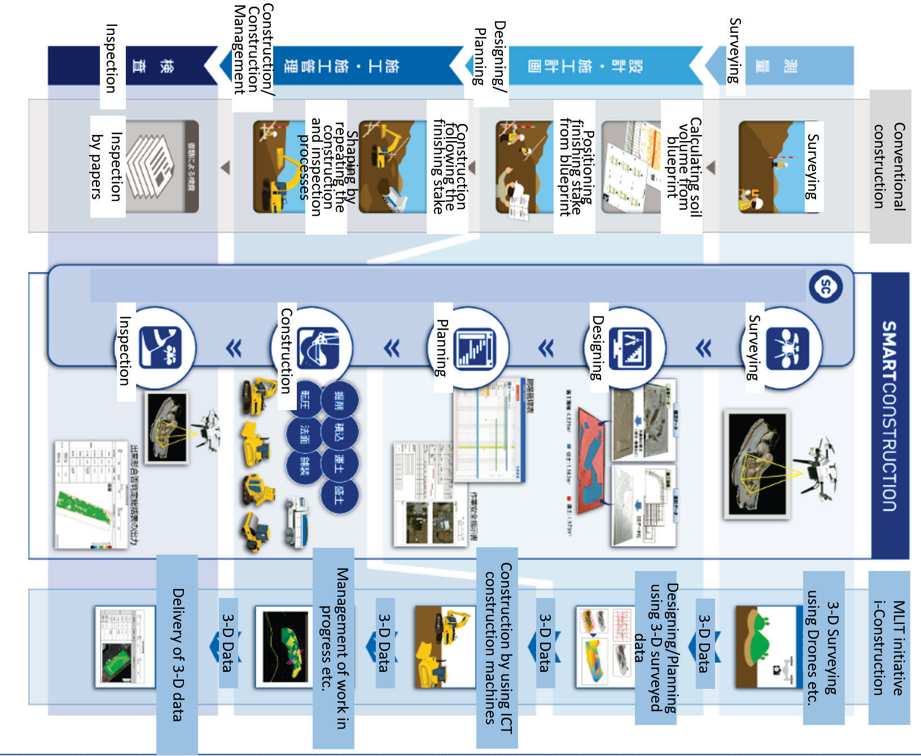

Source: Komatsu website, https://smartconstruction.komatsu/process.html, modified by HBS Japan Research Center.

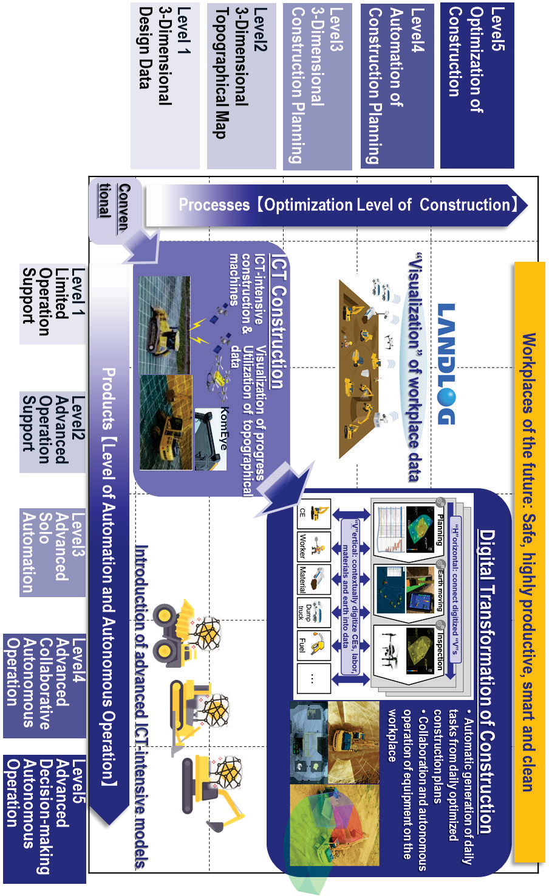

**Komatsu and Smart Construction**

**521-042**

**Exhibit 2**

Komatsu’s Roadmap to Construction Workplaces of the Future

Source:

Komatsu material.

**13**

**Exhibit 3** Global Construction Equipment Market Share (by percentage)

**16.4**

**36.4**

**11.9**

**2.7**

**2.8**

**3.5**

**3.7 3.8**

**4.6**

**4.3**

**5.1**

**4.8**

**Caterpillar Komatsu Hitachi Construction Machinery Volvo Construction Equipment Liebherr XCMG Doosan Infracore Sany**

**John Deere JCB Terex Others**

Source: The 2018 Yellow Table, KHL, adapted by HBS Japan Research Center.

**Exhibit 4** Komatsu’s Financial Statement (in millions JPY)

|  |  |  |  |  |  |
| --- | --- | --- | --- | --- | --- |
| **Fiscal Year** | **2014** | **2015** | **2016** | **2017** | **2018** |
| Ending | Mar-31-2015 | Mar-31-2016 | Mar-31-2017 | Mar-31-2018 | Mar-31-2019 |
| Total Revenue | 1,978,676 | 1,854,964 | 1,802,989 | 2,501,107 | 2,725,243 |
| Gross Profit | 577,483 | 539,191 | 516,565 | 755,866 | 862,718 |
| Total Assets | 2,798,407 | 2,614,654 | 2,656,482 | 3,372,538 | 3,638,219 |
| Total Liabilities | 1,199,907 | 1,026,894 | 1,007,967 | 1,628,948 | 1,735,351 |
| Total Equity | 1,598,500 | 1,587,760 | 1,648,515 | 1,743,590 | 1,902,868 |

Source: Standard & Poor’s Corporation Capital IQ database, accessed February 13, 2020 Note: As of February 13, 2020, the conversion rate was: ¥1 JPY = $0.0091

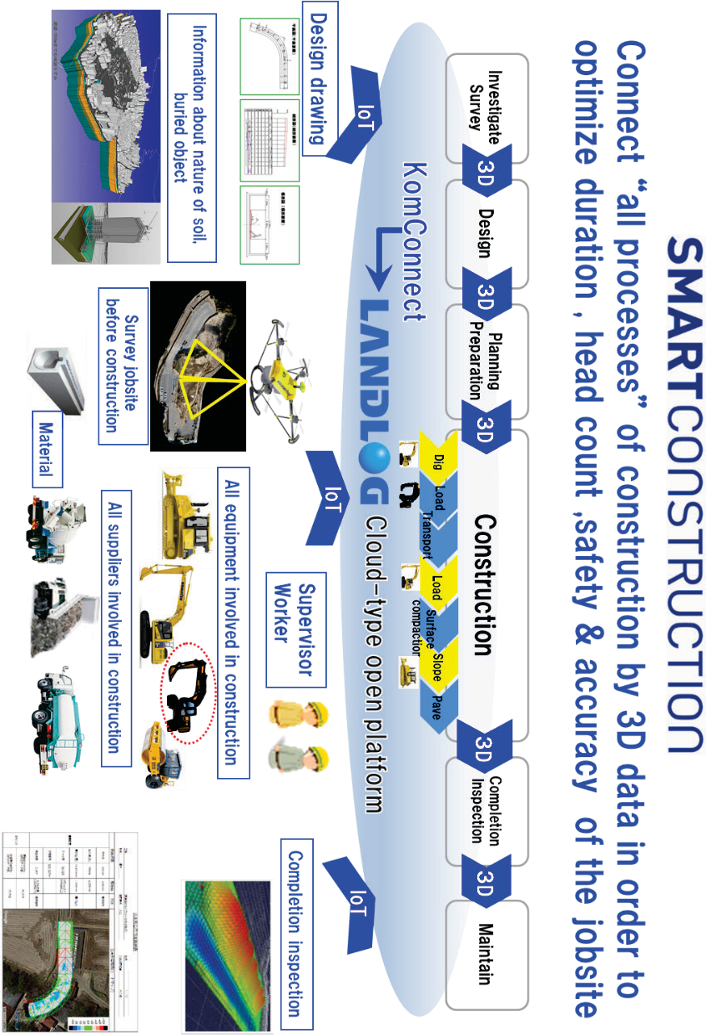

**Komatsu and Smart Construction**

**521-042**

**Exhibit 5**

Major tasks of Construction Site and Smart Construction

Source:

Komatsu material.

**15**

**Exhibit 6** Costs for Construction Work

Costs (labor, material, equipment) for types of constructions (in percentage)

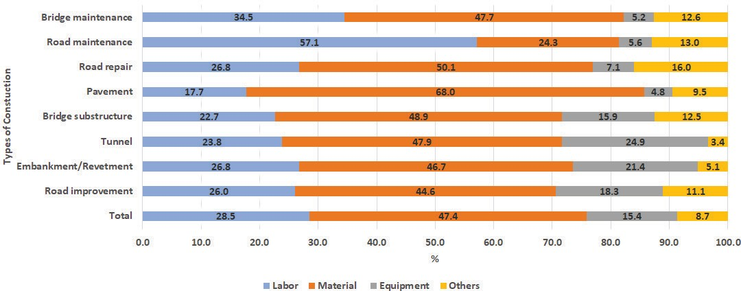

Costs (labor, material, equipment) for types of segmented work (in percentage)

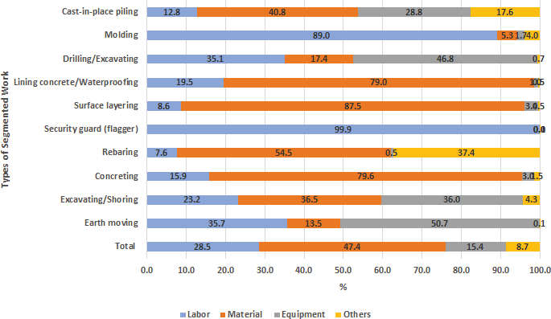

Source: Research by MLIT’s research center, [http://www.nilim.go.jp/lab/pbg/result/result/H30.04.pdf,](http://www.nilim.go.jp/lab/pbg/result/result/H30.04.pdf) adapted and translated by HBS Japan Research Center.

**Komatsu and Smart Construction**

**521-042**

**Exhibit 7**

Komatsu’s Segmentation of Construction Company by Sales Size

Source: Komatsu material.

**17**

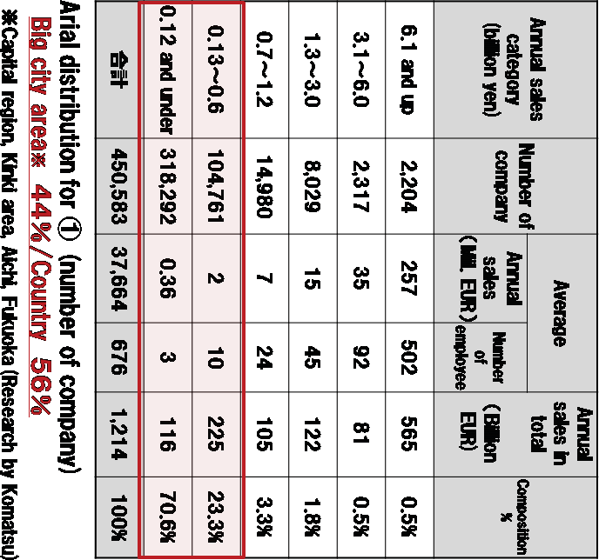

**Exhibit 8** Trend of Construction Skilled Workers

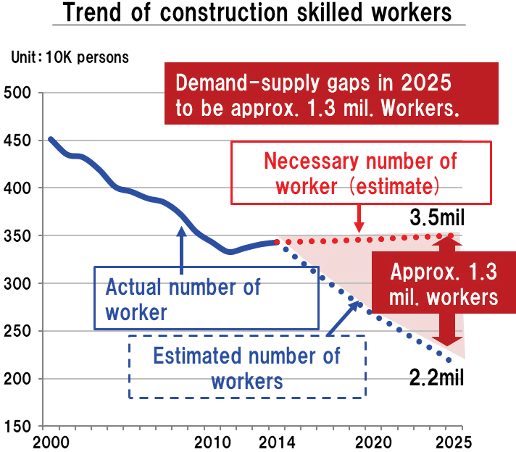

Source: Komatsu material, created based on Labor force survey by Ministry of Internal Affairs and Communications and Long- term vision of construction industry by Japan Federation of Construction Contractors.

**Komatsu and Smart Construction**

**521-042**

**Exhibit 9** Komatsu’s ICT equipment

Hydraulic Excavator

Source: Komatsu website, https://smartconstruction.komatsu/catalog_en/lineup.html.

**19**

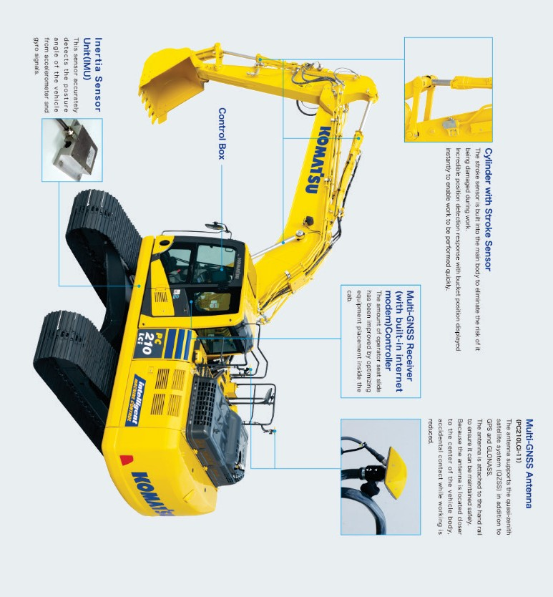

**Exhibit 10** LANDLOG Platform

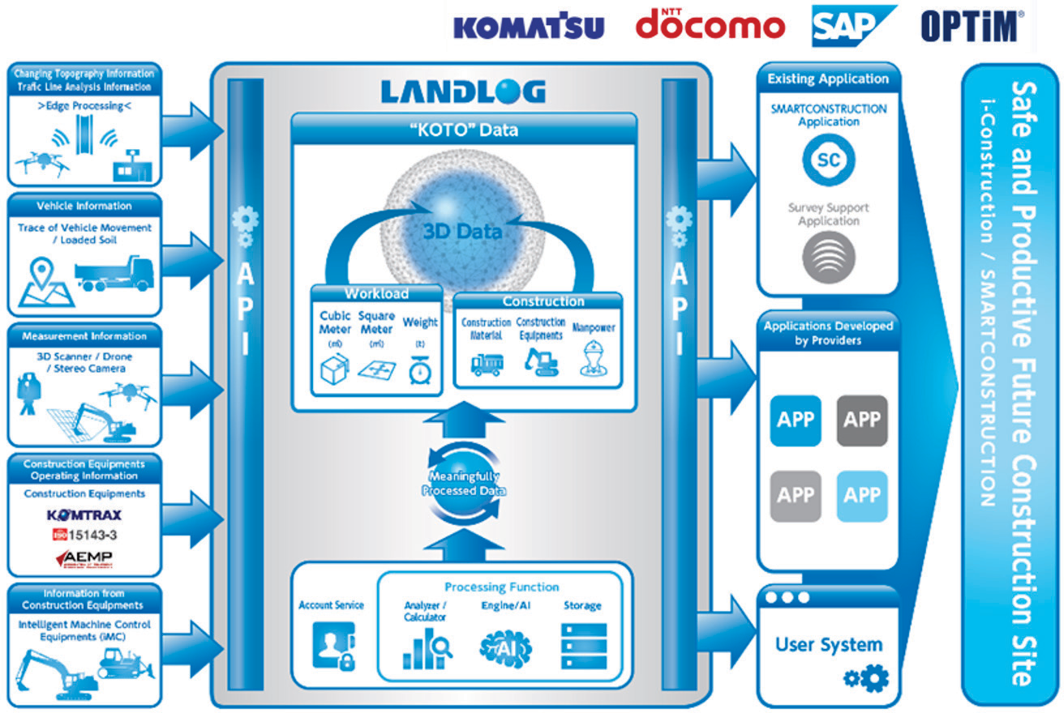

Source: Komatsu material.

**Exhibit 11** Caterpillar’s Financial Statement (in million USD)

|  |  |  |  |  |  |
| --- | --- | --- | --- | --- | --- |
| **Fiscal Year** | **2014** | **2015** | **2016** | **2017** | **2018** |
| Ending | Dec-31-2014 | Dec-31-2015 | Dec-31-2016 | Dec-31-2017 | Dec-31-2018 |
| Total Revenue | 55,184 | 47,011 | 38,537 | 45,462 | 54,722 |
| Gross Profit | 11,996 | 11,114 | 8,135 | 11,824 | 14,903 |
| Total Assets | 84,681 | 78,342 | 74,704 | 76,962 | 78,509 |
| Total Liabilities | 67,855 | 63,457 | 61,491 | 63,196 | 64,429 |
| Total Equity | 16,826 | 14,885 | 13,213 | 13,766 | 14,080 |

Source: Standard & Poor’s Corporation Capital IQ database, accessed February 13, 2020.

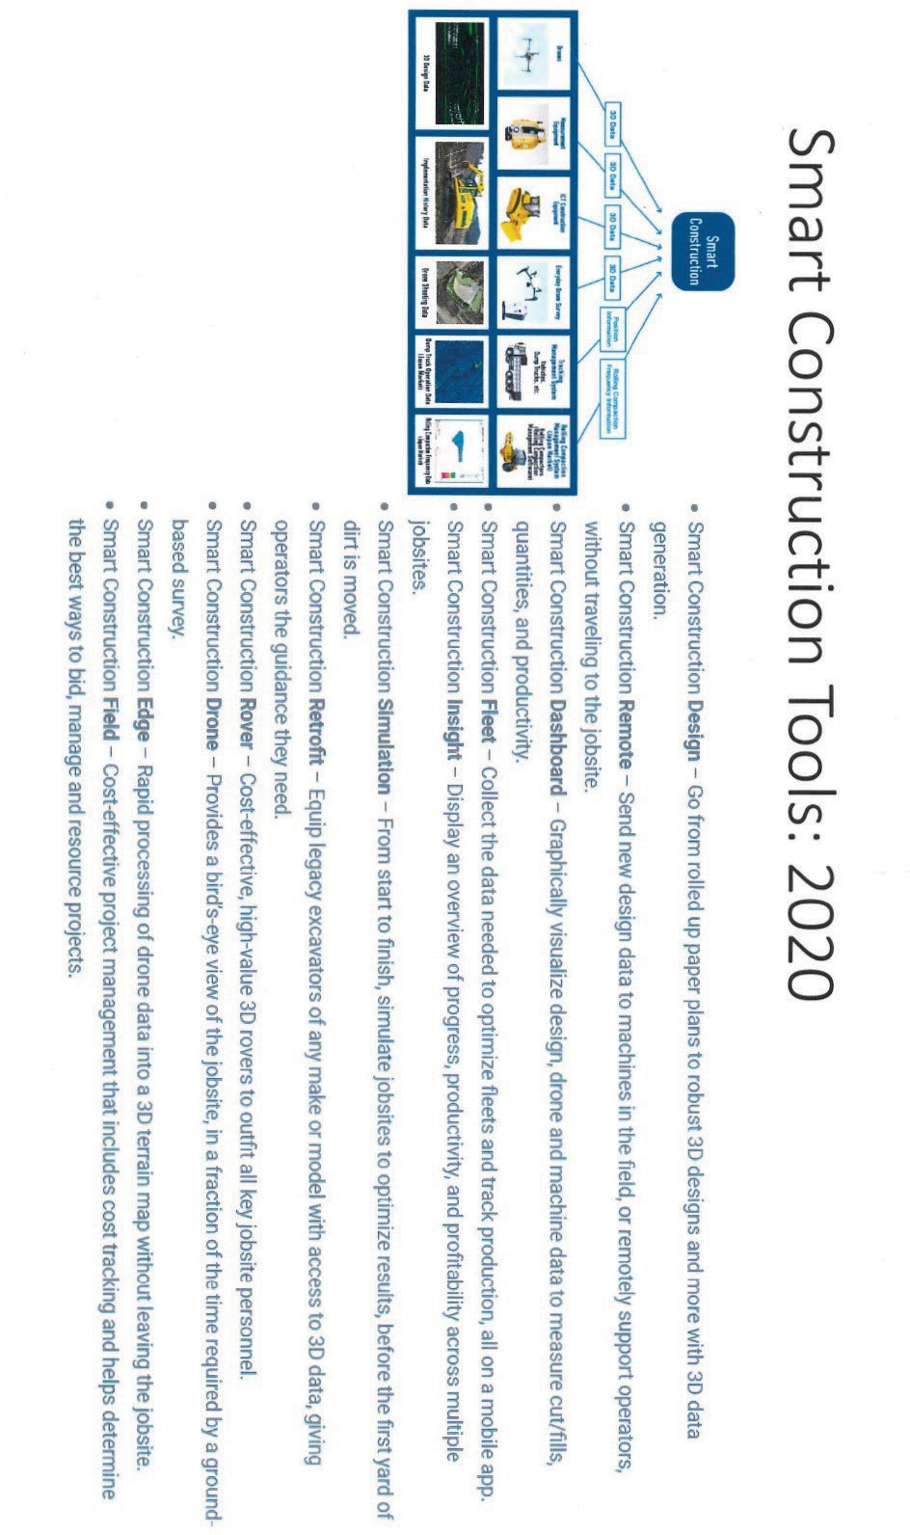

**Komatsu and Smart Construction**

**521-042**

**Exhibit 12**

2020 Tools

Source:

Compiled by casewriters, based on data from https://[www.equipmentjournal.com/tech-news/komatsu-smart-](http://www.equipmentjournal.com/tech-news/komatsu-smart-) construction/ and Komatsu material.

**21**

# Endnotes

1. Tetsuji Ohashi, interview with the casewriters, December 9, 2019.
2. Komatsu website, [https://home.komatsu/en/company/history/,](https://home.komatsu/en/company/history/) accessed February 13, 2020.
3. Krishna Palepu, Akiko Kanno, Nobuo Sato (2014). Komatsu in China, HBS Case No. 114-004.
4. Komatsu website, [https://home.komatsu/en/products/construction-machine/,](https://home.komatsu/en/products/construction-machine/) accessed February 13, 2020.
5. Takushi Asada et.al (2016) “Komatsu no Keiei Kaikaku to Kanri Kaikei (Komatsu’s management reform and account management)” Genka Keisan Kenkyu 40.2. pp. 154-166, [https://www.jstage.jst.go.jp/article/jcar/40/2/40_154/_pdf,](https://www.jstage.jst.go.jp/article/jcar/40/2/40_154/_pdf) accessed February 13, 2020.

6 iX Careercompass website, [https://ix-careercompass.jp/article/28/,](https://ix-careercompass.jp/article/28/) accessed February 13, 2020.

1. SMBC report on construction industry in Japan (January 2018) [https://www.smbc.co.jp/hojin/report/investigationlecture/resources/pdf/3_00_CRSDReport054.pdf,](https://www.smbc.co.jp/hojin/report/investigationlecture/resources/pdf/3_00_CRSDReport054.pdf) accessed February 13, 2020.
2. Warranty Week (October 24, 2019) [https://www.warrantyweek.com/archive/ww20191024.html,](https://www.warrantyweek.com/archive/ww20191024.html) accessed February 13, 2020.
3. Komatsu business result for FY 2018,

[https://home.komatsu/en/ir/library/results/](https://home.komatsu/en/ir/library/results/__icsFiles/afieldfile/2019/05/16/epresentation184Qver2.pdf) February 13, 2020.

1. Komatsu business result for FY 2018,

[icsFiles/afieldfile/2019/05/16/epresentation184Qver2.pdf,](https://home.komatsu/en/ir/library/results/__icsFiles/afieldfile/2019/05/16/epresentation184Qver2.pdf) accessed

[https://home.komatsu/en/ir/library/results/ icsFiles/afieldfile/2019/05/16/epresentation184Qver2.pdf,](https://home.komatsu/en/ir/library/results/__icsFiles/afieldfile/2019/05/16/epresentation184Qver2.pdf) accessed February 13, 2020.

1. Chikashi Shike, interview with the casewriters, July 10, 2019. 12 Chikashi Shike, interview with the casewriters, July 10, 2019. 13 Chikashi Shike, interview with the casewriters, July 10, 2019.
2. Chris Hendrickson, Department of Civil and Environmental Engineering, Carnegie Mellon University (1998) [https://www.cmu.edu/cee/projects/PMbook/05_Cost_Estimation.html,](https://www.cmu.edu/cee/projects/PMbook/05_Cost_Estimation.html) accessed February 13, 2020.
3. Komatsu Smart Construction General Catalogue.
4. Komatsu Smart Construction General Catalogue.
5. Komatsu Smart Construction General Catalogue.
6. Komatsu website, [https://home.komatsu/en/company/tech-innovation/report/pdf/190329_07e.pdf,](https://home.komatsu/en/company/tech-innovation/report/pdf/190329_07e.pdf) accessed February 13, 2020.
7. Nikkenren construction industry handbook 2019

[https://www.nikkenren.com/publication/pdf/handbook/2019/2019_03.pdf,](https://www.nikkenren.com/publication/pdf/handbook/2019/2019_03.pdf) accessed February 13, 2020.

1. EU-Japan Centre for Industrial Cooperation [https://www.eu-](https://www.eu-japan.eu/sites/default/files/publications/docs/sustainableconstruction_final.pdf) [japan.eu/sites/default/files/publications/docs/sustainableconstruction_final.pdf,](https://www.eu-japan.eu/sites/default/files/publications/docs/sustainableconstruction_final.pdf) accessed February 13, 2020.
2. MLIT presentation material, [https://www.mlit.go.jp/common/001149561.pdf,](https://www.mlit.go.jp/common/001149561.pdf) accessed February 13, 2020.
3. The Small and Medium Enterprise Agency, [https://www.mlit.go.jp/common/001149561.pdf,](https://www.mlit.go.jp/common/001149561.pdf) accessed February 13, 2020.
4. Fund for Construction Industry Promotion report (December 1998), [https://www.kensetsu-](https://www.kensetsu-kikin.or.jp/database/pdf/199812_%E6%AC%A7%E7%B1%B3%E3%81%AE%E5%85%AC%E5%85%B1%E5%B7%A5%E4%BA%8B%E3%81%A8%E5%BB%BA%E8%A8%AD%E6%A5%AD%E7%B5%8C%E7%90%86.pdf) [kikin.or.jp/database/pdf/199812_欧米の公共工事と建設業経理.pdf.](https://www.kensetsu-kikin.or.jp/database/pdf/199812_%E6%AC%A7%E7%B1%B3%E3%81%AE%E5%85%AC%E5%85%B1%E5%B7%A5%E4%BA%8B%E3%81%A8%E5%BB%BA%E8%A8%AD%E6%A5%AD%E7%B5%8C%E7%90%86.pdf), accessed February 13, 2020.
5. MLIT presentation material (February 15, 2018), [https://www8.cao.go.jp/cstp/gaiyo/yusikisha/20180215/siryo7.pdf,](https://www8.cao.go.jp/cstp/gaiyo/yusikisha/20180215/siryo7.pdf)

accessed February 13, 2020.

1. MLIT presentation material (February 15, 2018), [https://www8.cao.go.jp/cstp/gaiyo/yusikisha/20180215/siryo7.pdf,](https://www8.cao.go.jp/cstp/gaiyo/yusikisha/20180215/siryo7.pdf)

accessed February 13, 2020.

**Komatsu and Smart Construction 521-042**

1. MLIT presentation material (April 17, 2018), [https://www.kantei.go.jp/jp/singi/keizaisaisei/miraitoshikaigi/suishinkaigo2018/infla/dai3/siryou6.pdf,](https://www.kantei.go.jp/jp/singi/keizaisaisei/miraitoshikaigi/suishinkaigo2018/infla/dai3/siryou6.pdf) accessed February 13, 2020.
2. Susumu Ueno, interview with the casewriters, December 10, 2019.
3. Susumu Ueno, interview with the casewriters, December 10, 2019.
4. Komatsu press release (July 19, 2017) [https://home.komatsu/jp/press/2017/others/1193601_1593.html,](https://home.komatsu/jp/press/2017/others/1193601_1593.html) accessed February 13, 2020.
5. Komatsu presentation material.
6. Naoya Watanabe, interview with the casewriters, December 9, 2019. 32 Naoya Watanabe, interview with the casewriters, December 9, 2019. 33 Naoya Watanabe, interview with the casewriters, December 9, 2019. 34 Chikashi Shike, interview with the casewriters, December 10, 2019.
7. Caterpillar website, [https://www.nipponcat.co.jp/ict/,](https://www.nipponcat.co.jp/ict/) accessed February 13, 2020.
8. Chicago Tribune (Feb 08, 2019) [https://www.chicagotribune.com/business/ct-biz-caterpillar-digital-team-relocates-](https://www.chicagotribune.com/business/ct-biz-caterpillar-digital-team-relocates-20190207-story.html)

[20190207-story.html,](https://www.chicagotribune.com/business/ct-biz-caterpillar-digital-team-relocates-20190207-story.html) accessed February 13, 2020.

1. Chikashi Shike, interview with the casewriters, December 10, 2019. 38 Chikashi Shike, interview with the casewriters, December 10, 2019. 39 Chikashi Shike, interview with the casewriters, December 10, 2019. 40 Kousaku Igawa, interview with the casewriters, December 9, 2019.

**23**