bank and bank accounts

# Class diagram

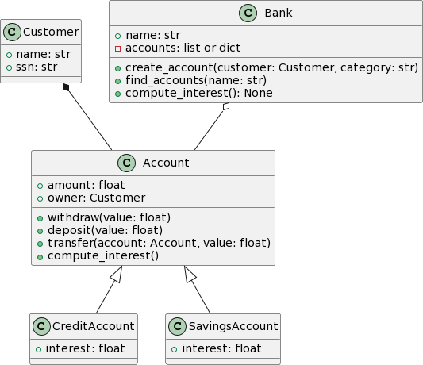

1. Use the Customer class

A customer has:

a name

a SSN (Social Security Number)

The code for this class is already provided.

# Build the Account class

A bank account has:

"owner": a Customer instance

an amount (float, default value: 0)

a method deposit

it receives a float argument: the amount to be deposited. If the argument is negative, raise a

AttributeError exception.

it adds the deposited amount to the account amount a method withdraw

it receives a float argument: the amount to be withdrawn. If the argument is negative, raise a

AttributeError exception.

it removes the amount provided from the account a method transfer , to make transfers between accounts

it has two arguments: account and amount

it must raise a TypeError exception if the account is not an instance of Account

the method withdraws amount from the current instance and deposits it into the account a method compute_interest , used to compute the interest over the account

this method does nothing on regular accounts

# Build child classes

## CreditAccount

The credit account inherits from Account . Its amount is usually negative.

Its constructor receives an additional argument interest_rate (a number between 0 and 100). This is the interest rate in %. Store it in the interest attribute of the class.

The compute_interest method, **if the amount is negative**:

charges the interest to the account: amount = amount * (100 + interest_rate) / 100 then charges $10 to the account (administration fees)

## 3.3. SavingsAccount

The savings account inherits from Account .

Its constructor receives an additional argument interest_rate (a number between 0 and 100). This is the interest rate in %. Store it in the interest attribute of the class.

The compute_interest method adds the interest to the account: amount = amount * (100 + interest_rate) / 100

The withdraw method must raise an UserWarning exception if someone tries to withdraw more money

than available on the account.

# Build the Bank

A bank has a name (received by the constructor)

create_account : creates an account in the bank. Receives two mandatory arguments

category : can be either "account", "credit", or "savings"

owner : a Customer instance

and an optional argument: interest_rate (default value = 0)

credit and savings accounts must use this value for the interest rate

this method creates an account of the specified type, associates it with the provided owner

the method **returns** the account created, but you need to make sure your bank keeps track of the accounts (you could use a dictionary, or a list)

compute_interest() : computes interest on all accounts of the bank.

find_accounts() : receives one argument

first argument is a string: the name of a customer

the method returns the list of account(s) associated with the given customer

# Grading rubric

1 mark for each test that passes

3 marks for PEP8 syntax, docstrings, and encapsulation (use of property and setter ) TOTAL = 18 mar

Customer.py

class Customer:

    """

    A simple class that represents a customer at the bank.

    """

    def __init__(self, name, ssn):

        if type(name) is not str or len(name) < 2:

            raise AttributeError("Invalid name for the account.")

        if type(ssn) is not str or not ssn.isnumeric():

            raise AttributeError("Invalid SSN for the account.")

        self.name = name

        self.ssn = ssn