**CSE 572: Data Mining**

Project 1: Extracting Brain boundaries from rs-fMRI data

# Purpose

In this project you will extract the brain boundaries from the resting state functional magnetic resonance imaging (rs-fMRI) scans

# Objectives

Students will be able to:

* Extract brain slices from the data set.
* Extract the brain boundary (periphery) from those slices.

# Technology Requirements

Python 3.6 to 3.9

# Project Description

In this project we will work on rs-fmri data. rs-fMRI is a **functional magnetic resonance imaging** which is done to evaluate the functional connectivity in the brain networks when the patient is in **resting state**. Patient’s brain evaluation is done based on the blood consumption activations (shown as **red clusters** in figure 1) in different regions of the brain. These clusters reflect the changes in brain’s activity which are driven by the active areas of human body. The fMRI data is usually a 4D data and it is further decomposed into spatial independent components (ICs) using MELODIC software. In this project, you will be provided with a patient’s rs-fMRI scan’s spatial independent components (ICs), which are nothing but the images like Figure 1. These images will show the brain changes over a period of time. A patient usually has 100 such images and the red cluster’s locations will differ in all these images based on the current active part of the body.

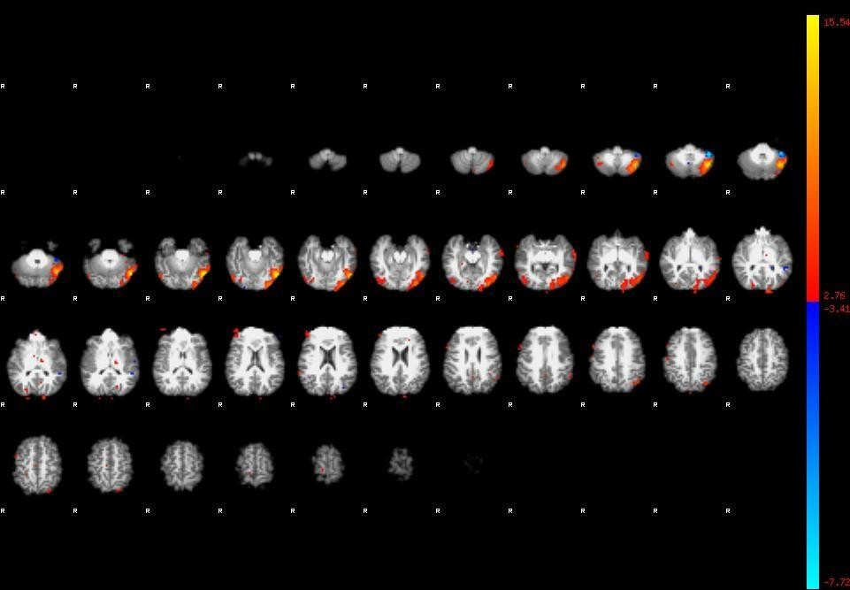

Figure 1

# Directions

## Dataset:

You will be given one patient’s dataset which will contain approximately 100 spatial ICs images of that patient’s

rs-fMRI scan. All the scans will look like figure 1 (except the blood activation (red/blue clusters) part).

## Analysis Procedure:

Given the spatial images of patients, your task will be divided into two parts:

1. **Brain slice extraction**: Given a spatial IC, automate the brain slices extraction process. For example, the IC in figure 1 will have brain slice images like figure 2. So, if a patient has N such images, your task is to automate the slice extraction for all the N images.

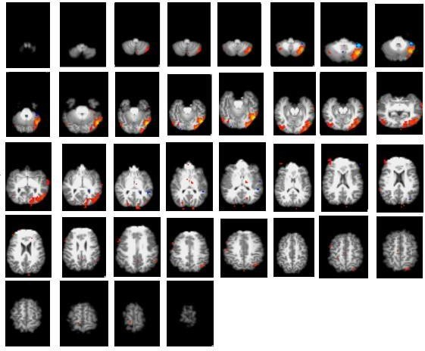

Figure 2

1. **Brain boundary extraction**: Once you have extracted the brain slices, the next task is to extract the boundary of the brain in every extracted slice (will be discussed in class).

# Submission Directions for Project Deliverables

Submit your Python code in a zip file on the Canvas. Please submit a zipped file containing your code files as “**yourfirstname_lastname_Assignment1.zip**". Do not create an additional folder; just zip the files directly.

Submit two python files,

* 1. brainExtraction.py
  2. test.py

The brainExtraction.py reads all the images (images those end with word “thresh”) from the given data and perform the brain slice extraction and brain boundary extraction. The test.py reads a folder named **‘testPatient’** and outputs two folders. One folder named “**Slices**” and another folder named ‘’**Boundaries**’. ‘Slices’ folder will further have ‘N’ number of folders where N is number of images that ends with “thresh”. for example, in the given data we have N=112 (‘testPatient’ will have different ‘N’). Every image folder should contain the brain slices

images of that IC_thresh image. Similarly, another folder “Boundaries” will also have N number of folders and every folder will have boundary highlighted images of that IC_thresh image.

Note**: You are not required to submit any images for the provided data**. All you need to submit is just the two python files which should do as asked. ‘testPatient’ folder will have all the files as you have in your “Data” folder of provided “PatientData”. So, before submitting run your ‘Data’ file through your test.py and make sure it produces everything which has been asked above (you do not need to submit this result though, this is just for your own validation).

# Evaluation

We will run your **test.py** on a new patient’s data (‘**testPatient’**). Your code should output two folders “Slices” and “Boundaries” which should further have N number of folders. Each folder will further have brain slices images in case of Slices folder and brain boundaries images in case of boundaries folder.

Successful execution of your code will result in 70 points The remaining 30 points will be based on:

1. Number of brain slices reported by your code = number of non-empty slices in the image
2. Visual comparison of brain boundary from your code with the actual brain boundary in the image.