**TATA ACQUIRES BIG BASKET**

After Tata Sons announced the acquisition of [BigBasket](https://www.business-standard.com/topic/bigbasket), the e-grocery player’s co-founder and Chief Executive (CEO), Hari Menon, said it is going to be business as usual at the company.

“Everything is going to be the same and all the founders will continue to be in the company,” Menon said.

Cementing its foray into the [online grocery](https://www.business-standard.com/topic/online-grocery)market, Tata Sons, through its subsidiary Tata Digital, has acquired a majority stake in [BigBasket.](https://www.business-standard.com/topic/bigbasket) While the company declined to comment on valuations, reports suggest Bigbasket’s valuation at $2 billion.

The Competition Commission of India had last month approved Tata Digital’s acquisition of up to 64.3 per cent of the total share capital of BigBasket’s parent company Supermarket Grocery Supplies.

“Grocery is one of the largest components of an individual’s consumption basket in India, and BigBasket, as India’s largest e-grocery player, fits in perfectly with our vision of creating a large consumer digital ecosystem. We are delighted to welcome [BigBasket](https://www.business-standard.com/topic/bigbasket)as part of Tata Digital,” said Pratik Pal, CEO, Tata Digital.

It actively took around six months for both the [companies](https://www.business-standard.com/companies)to close the deal. With this acquisition, majority shareholders — Alibaba and Actis LLP — have exited the company. Other investors such as Ascent Capital and serial entrepreneur K Ganesh have also made an exit.

“Trifecta is proud to be a partner in the journey of BigBasket thus far. This investment from the [Tata Group](https://www.business-standard.com/topic/tata-group)is truly a testament of the Indian startup ecosystem coming of age, and interest in category leaders not just from the global investor community but also large strategic partners,” said Nilesh Kothari, managing partner at Trifecta Capital.

According to a report by RedSeer and BigBasket, India’s e-grocery market is expected to grow from $1.9 billion in 2019 to $3 billion by the end of 2020. At an annual growth rate of 57 per cent, it is expected to touch $18 billion by 2024.

“We are excited about our future as part of [Tata Group.](https://www.business-standard.com/topic/tata-group) We would be able to build stronger consumer connect and accelerate our journey,” said Menon, who started the company from a small Bengaluru office along with four partners V S Sudhakar, Vipul Parek, Abhinay Choudhari and V S Ramesh in 2011.

Currently, the company fulfils around 15 million orders per month in 30 cities across India. It has also reached the milestone of $1 billion in annual revenue.

Tata Digital is also raising Rs 5,000 crore through a commercial paper. Analyst tracking the group said the company would need access to capital as it prepares its digital development and operational expenses.

The acquisition of BigBasket is part of Tata Group’s strategy to build a digital consumer ecosystem. The salt-to-software conglomerate is making inroads in new-age digital markets such as online pharmacy and online fitness, according to reports. While it has signed a deal to acquire a majority stake in e-pharma player 1mg, reports say the conglomerate is also in talks to acquire a stake in Mukesh Bansal’s fitness start-up CureFit.

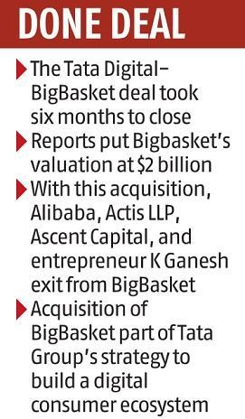

QUESTIONS:

1. What theories of mergers can be applied in this case?
2. List out other businesses which TATA is considering for investment?
3. Is this a successful Acquisition and why?
4. Identify the Merger Process and duration.
5. “India’s e-grocery market”. Comment on this.