# Assignment 1 – Project Management

**Weight: 30%**

**Rationale:**

The purpose of this assignment is to demonstrate your ability to apply the concepts of planning and project management to a practical scenario involving a business information system.

**Groups:**

Being able to collaborate on tasks, especially in virtual environments, is an important skill to master to ensure your success at university and in your later careers. To facilitate your development of communication and collaboration skills, you will be undertaking this assignment in a team of exactly two (2) people.

**Task:**

You have been contracted by a company to develop an information system for $100,000. During this assignment, you will provide a project management plan for the proposed system.

The business that you design the information system for is of your own choosing. Preferably develop a system for an area that you are interested in, have had prior experience, or perhaps for a company you work for.

You cannot design the system for the same company that another student has chosen, nor can you reproduce a design for an existing well-known company. The information system you chose should be of small to medium size/complexity.

You are required to deliver the following specifications before the project can commence:

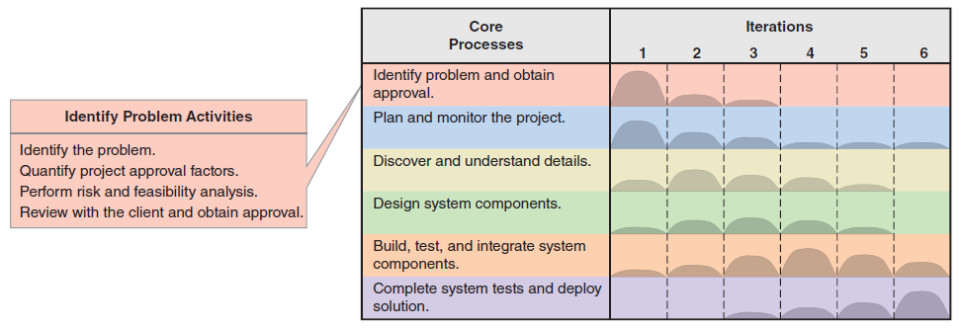

1. ***Identify the Problem –*** Provide a one-page *system vision document* that outlines the problem description, system capabilities, and the expected business benefits (minimum 300 words, maximum one A4 page).
2. ***Quantify Project Approval Factors –*** Complete the following tasks (minimum 500 words):
   1. Provide a table with a breakdown of the estimated time for project completion using Excel or a similar program.
   2. Provide a table with a summary of the development costs for the project and system using Excel or a similar program (use Australian dollars).
   3. Provide a table with a summary of the estimated annual operating costs using Excel or a similar program (use Australian dollars).
   4. Undertake a cost/benefit analysis:
      1. Describe the anticipated benefits from the deployment of the new system (outline *tangible* and *intangible* benefits).
      2. Provide a table with a summary of estimated annual benefits.
3. ***Perform a Risk and Feasibility Analysis –*** Complete the following tasks (minimum 500 words):
   1. Determine organisational risks and feasibility.
   2. Evaluate technological risks and feasibility.
   3. Assess resource risks and feasibility.
   4. Identify schedule risks and feasibility.



1. ***Establish the Project Environment –*** Complete the following tasks (minimum 500 words):
   1. Provide a table outlining information that will be captured during system development, the tools and software that will be used to develop the system, and outline who can update / view the information.
   2. Describe the work environment.
   3. Describe the processes and procedures that will be used.
2. ***Schedule the Work –*** Complete the following tasks (minimum 300 words):
3. Provide a *work breakdown structure* (WBS) for one (1) of the subsystems.
4. Provide a *Gantt chart* showing the WBS project activities timeline. Ensure you include task IDs, descriptions, start and end dates, durations, predecessors and show the critical path. You **must use one of the follow software options** and provide a screen capture:
   * 1. MS-Project (available on all campus computers)
     2. Gantt Project (<https://www.ganttproject.biz>)
     3. Project Plan 365 (<https://www.projectplan365.com>)
     4. LucidChart (table-based template, requires manual editing)
     5. Diagrams.net (table-based template, requires manual editing)

**You must use one of the software options listed above for the Gantt chart, otherwise your answer will not be marked. All diagrams must be part of a single file. Additional files and attachments will not be marked.**

All tables, diagrams, and charts must be accompanied by a **one paragraph description** (minimum 100 words) to help explain your rationale and logic. Note that presentation, spelling, and grammar are extremely important aspects of your document. Be sure to proofread your work prior to submission.

**Submission Information:**

1. Compile all the diagrams and specifications professionally into a single **MS Word document**. (Do not submit a pdf file.)
2. Use the following format for the Word document’s filename:

*LastName_FirstName_sNumber.docx*

(e.g., Simpson_Homer_s12349876.doc)

1. Use the “Assignment Submission Instructions” document, which contains a final checklist, to ensure your work is complete.
2. Carefully review the assignment marking criteria.
3. All students must submit a copy of their Assignment, i.e., both team members  
   must submit a copy of their assignment file.
4. Do not compress (i.e., zip) your assignment file.
5. Submit your assignment online by going to the “Assignment” section of the course web site.
6. Enter your filename (not including .docx) into the “Submission Title” field of the upload screen.