|  |  |
| --- | --- |
| Manual  Technical Support Training | Abstract  This manual contains step by step instructions on how to set up, maintain, and enhance your professional presence on the social media platform LinkedIn. |

# Table of Contents

Table of Contents 1

Table of Figures 3

Welcome to LinkedIn 1

Getting Started 2

Creating an Account 4

Creating an account box 4

Filling Out Your Location Information 4

Employment Information / Student Information Box 5

Creating a student profile 6

Validating Your E-mail Address 7

Finding Contacts through your e-mail address 7

Adding Contacts You May Know 9

Adding Your Profile Photo 10

LinkedIn Phone Application 10

Your New Account Has Been Made! 11

Profile Home Page 11

Using the Navigation Bar 12

The “Me” section dropdown 12

Notifications 14

Messaging 15

The Jobs Tab 16

My Network Tab 17

Editing your profile 18

Profile Strength Bar 18

Edit Intro / Introduction Card 19

Update Your Contact Information 21

Advanced Tip: 21

Adding Profile Sections 22

Using Search Filters and Connecting with Others 23

Privacy and Settings 25

Account Tab: 27

Privacy Tab: 28

Ads Tab: 29

Communications Tab: 29

LinkedIn Job Search Features 29

Bibliography 33

Index 34

# Table of Figures

Figure 1 – The Home Page 2

Figure 2 – The “Sign in” Bar 2

Figure 3 – The Create an Account Box 3

Figure 4 – Find a colleague box 3

Figure 5 – Create an Account Box Filled Out 4

Figure 6 – Location Info 5

Figure 7 – Employment Information 5

Figure 8 – I’m a Student Option 6

Figure 9 – Validate Your Email 7

Figure 10 – Connecting to your E-mail Contacts 8

Figure 11 – Invite your e-mail contacts 8

Figure 12 – People You May Know 9

Figure 13 – Adding a Profile Photo 10

Figure 14 – Get the LinkedIn App 10

Figure 15 -Your Home Page 12

Figure 16 - Navigation Bar 12

Figure 17 – “Me” Dropdown 13

Figure 18 - Notifications Tab 14

Figure 19 - Messaging Tab 15

Figure 20 - Jobs Page 16

Figure 21 - My Network Tab 17

Figure 22 - View Profile 18

Figure 23 - Profile Strength Bar 18

Figure 24 - Edit Pencil 19

Figure 26 - Summary Example 20

Figure 25 - Edit Intro Box 20

Figure 27 - See Contact Info 21

Figure 28 - Edit Contact Info 21

Figure 29 - Edit Contact Info Window 21

Figure 30 - Add sections 22

Figure 31 – Section 23

Figure 32 - Search 24

Figure 33 - Advanced Search 25

Figure 34 - Settings & Privacy 25

Figure 35 – Settings and Privacy Tabs 26

Figure 36 Jobs Tab Home Page 30

Figure 37 - Saved Job Bar in Jobs Tab 30

Figure 38 - Job Search Page 31

# Welcome to LinkedIn

L

inkedIn is a professional social media platform in which its users network and build their professional business profile. LinkedIn has become the world’s largest professional network with over 562 million users which are located in over 200 countries and territories around the world.

Its vision and mission are to “Create economic opportunity for every member of the global workforce.” (LinkedIn, 2018) and “connect the world’s professionals to make them more productive and successful.” (LinkedIn, 2018) This is upkept with the many features within LinkedIn that can be used to enhance your profile features and create a bountiful network which can boost your employability and professional standing.

Its co-founder Reid Hoffman invented the social media concept in his living room in 2002, which lead to an official launch of the platform on May 5, 2003. Jeff Weiner, its CEO and companies such as Yahoo!, Google, Microsoft, TiVo, PayPal, and EA also form the management of the company which bring diversified business economy to the platform- creating revenues from membership subscriptions, advertising, and recruitment solutions. (LinkedIn, 2018)

Users of LinkedIn are able to create free accounts to which all of the following information pertains. For more exclusive features of the website, aforementioned “Premium” member subscriptions are available from which you can choose from the areas of “Career”, “Business”, “Sales” and “Hiring”. These specific plans give users access to features which enhance their employability, business growth, outreach and talent acquisition. The provided manual covers features only from the free version of LinkedIn and how to boost and maximize your free professional account.

The following steps can be followed by proceeding to LinkedIn’s webpage by typing the following URL into a web browser of your choice.

<https://www.linkedin.com>

# Getting Started

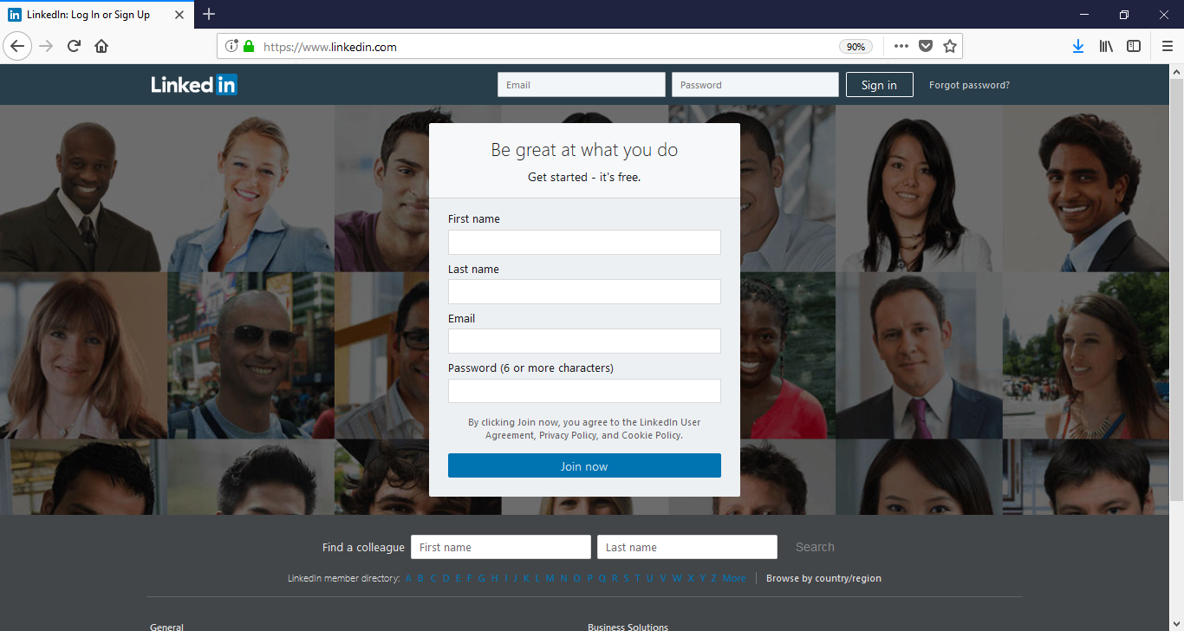In this section, you will learn how to create your account, and sign in/out of your account after creation. After proceeding to LinkedIn’s webpage by following the above-mentioned URL, you will come across the following home page shown in figure 1. Here is where you can search for colleagues on LinkedIn before making an account, create a new account, and also where you will sign into your account after it has been made.

**3**

**2**

**1**

Figure 1 – The Home Page

Figure 2 shows a close up of the “sign in” bar at the top of figure 1 (red box #1). This is where you will use your log in credentials to log in after you have created your account. Simply type in your email address that you will use to create your account, your password, and click “Sign In”. If you forget your password, you can click the “Forgot password?” link, which will prompt a password reset link to be sent to your email.

**1**

Figure 2 – The “Sign in” Bar

Figure 3 shows a closer look at the “create an account” box (red box #2) in Figure 1, these are the fields you will be entering to create a new profile on LinkedIn. By filling out the fields and clicking “Join Now” you will being the registration process to create an account.

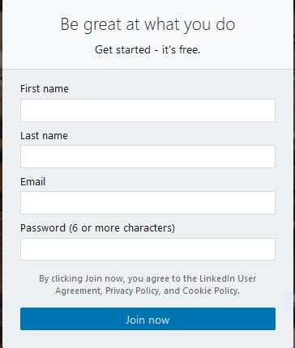

**2**

Figure 3 – The Create an Account Box

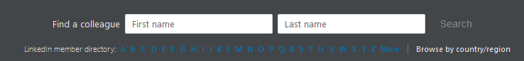Figure 4 below shows a close up of the “Find a colleague” box (red box #3) in Figure 1, you may use this feature without signing in or creating an account first. This is used as an incentive to sign up, by letting you search for people and showing only partial information you can use this as a quick look into who may have an account already that you know.

Figure 4 – Find a colleague box

**3**

# Creating an Account

## Creating an account box

Creating an account is easy, the first step in the process is to fill out the “create an account box” (Figure 3) as shown below (Figure 5), and click “Join”. The demo account information I have used is Technical Support, you should enter your own name, email, and a password of your choice.

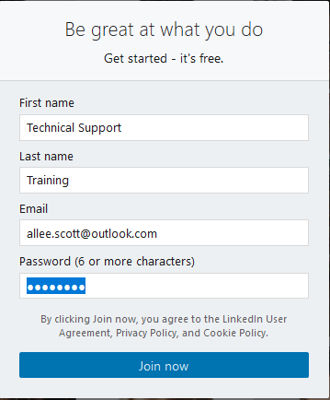

Figure 5 – Create an Account Box Filled Out

## Filling Out Your Location Information

After clicking “Join”, you will be navigated to the next page in the creating an account process. Here you will choose which Country/Region you are in by clicking the drop down in Figure 6, as well as entering your postal code. After you have entered these fields, proceed to clicking the “Next” Button.

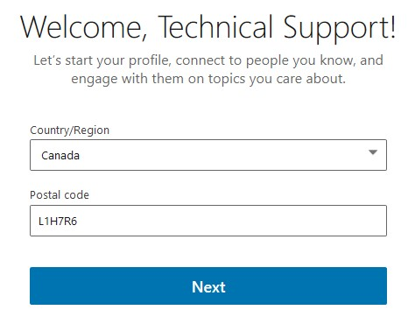

Figure 6 – Location Info

## Employment Information / Student Information Box

After clicking “Next”, you will proceed to the next step which is to enter your current employment information. Provide your job title, and company name in the following boxes in Figure 7.

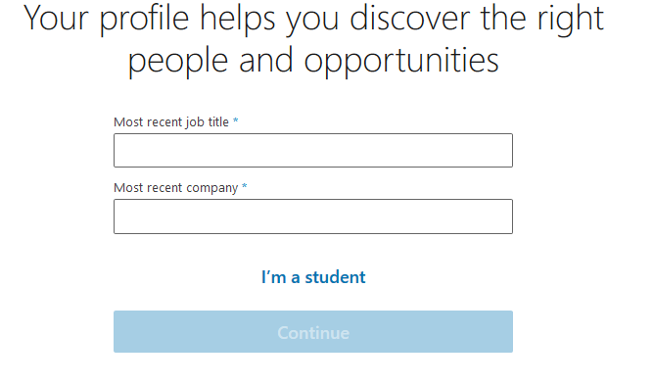

Figure 7 – Employment Information

## Creating a student profile

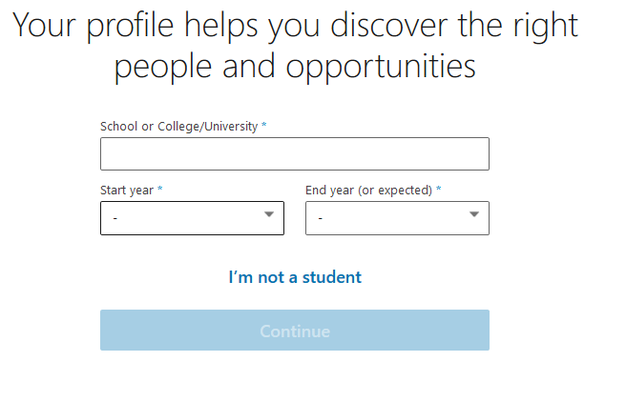If you do not have a most recent job title and company, or if you are still in school, you can choose to click “I’m a student” which will lead you to enter your schooling information instead.

Figure 8 – I’m a Student Option

## Validating Your E-mail Address

After clicking “continue” you will be lead to a page where you are prompted for a code. This code will have been sent to the e-mail address you listed on the sign-up page. You will have to log into your email to retrieve the code, and input it into the fields provided. (See figure 9) After this step has been completed, click the “Agree & Confirm” button to continue with the registration.

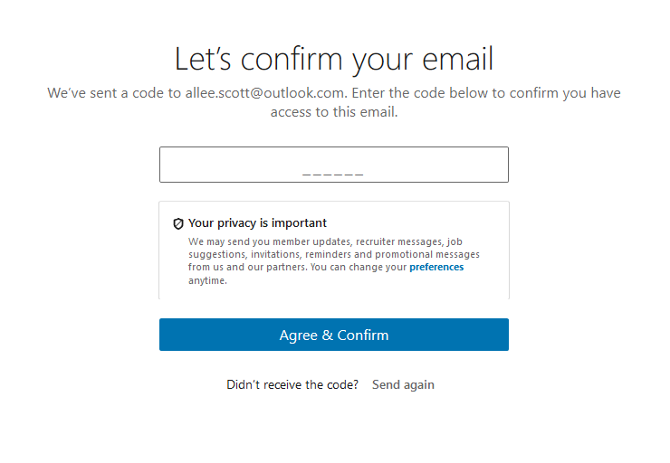

Figure 9 – Validate Your Email

## Finding Contacts through your e-mail address

In the next step, you have the option to give LinkedIn access to your e-mail contacts to see who of them are on LinkedIn. This is an easy way to gain friends when being new to the platform, or press you can “Skip” this step. See figure 10 on the next page.

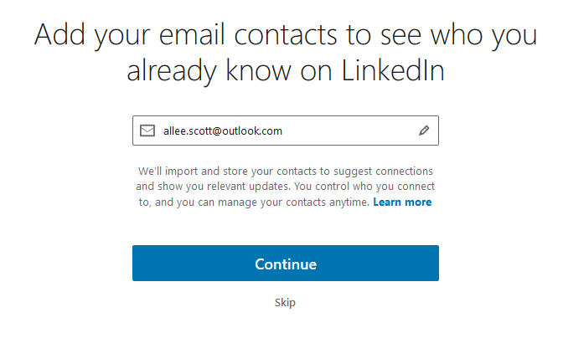

Figure 10 – Connecting to your E-mail Contacts

If you decide to click continue on this step, a pop-up window advanced by outlook (or whichever email provider you use) will prompt you to click which e-mail account you wish to use. Choose which email address has the contacts you wish to find on LinkedIn, and the next page will follow. (see figure 11) This page has the results of which contacts were pulled from the search and gives you the option to invite them to add you on LinkedIn.

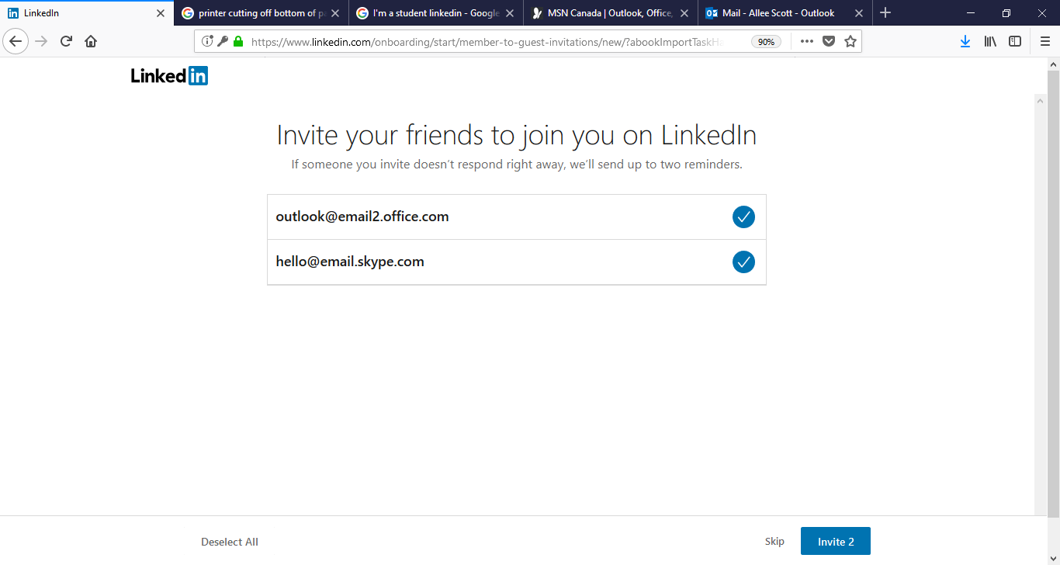

Figure 11 – Invite your e-mail contacts

## Adding Contacts You May Know

Because you gave your school or work information; LinkedIn will find connections you may know, you can either choose to add them by selecting specific persons profile tiles, select “Select All” In the bottom left-hand corner, or select “Skip” in the right-hand corner.

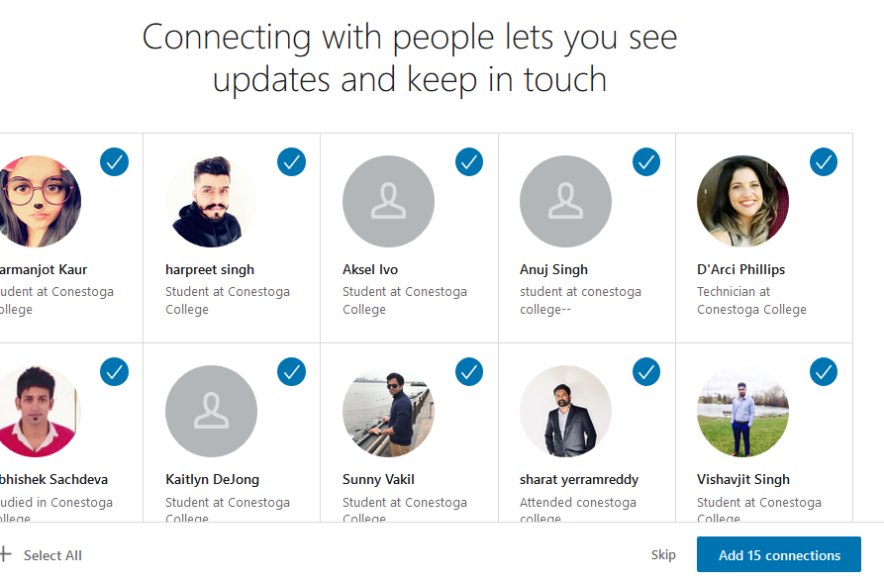

Figure 12 – People You May Know

## Adding Your Profile Photo

In the next step of creating your profile, you will be prompted to add a profile photo. You can choose to browse your computer for a Profile Picture at this time; or skip. If you have a professional headshot; this is the best pick. If not; anything that shows your full face with a blank background. (see figure 13)

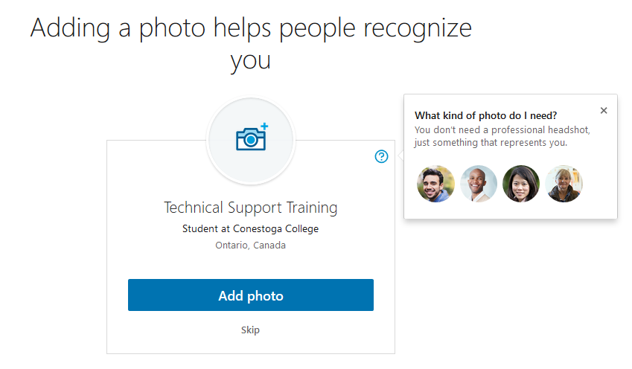

Figure 13 – Adding a Profile Photo

## LinkedIn Phone Application

In this step, you can choose to put your mobile number in the provided field if you are interested in a receiving a link to download the mobile LinkedIn App on your device, if not, press “skip” at the bottom.

Figure 14 – Get the LinkedIn App

## Your New Account Has Been Made!

After downloading or skipping the LinkedIn Mobile App section, you will be navigated to the Home page of your profile. This completes the account creation process. (Figure 15)

# Profile Home Page

Your home page is the center hub for all activities on LinkedIn. From this page you can access:

* Edit your profile picture
* Share a post – article, photo, video, or idea
* View other account holders’ recent posts and news
* View popular LinkedIn articles that are trending
* View “Who’s viewed your profile”
* View an overview of your network connections
* 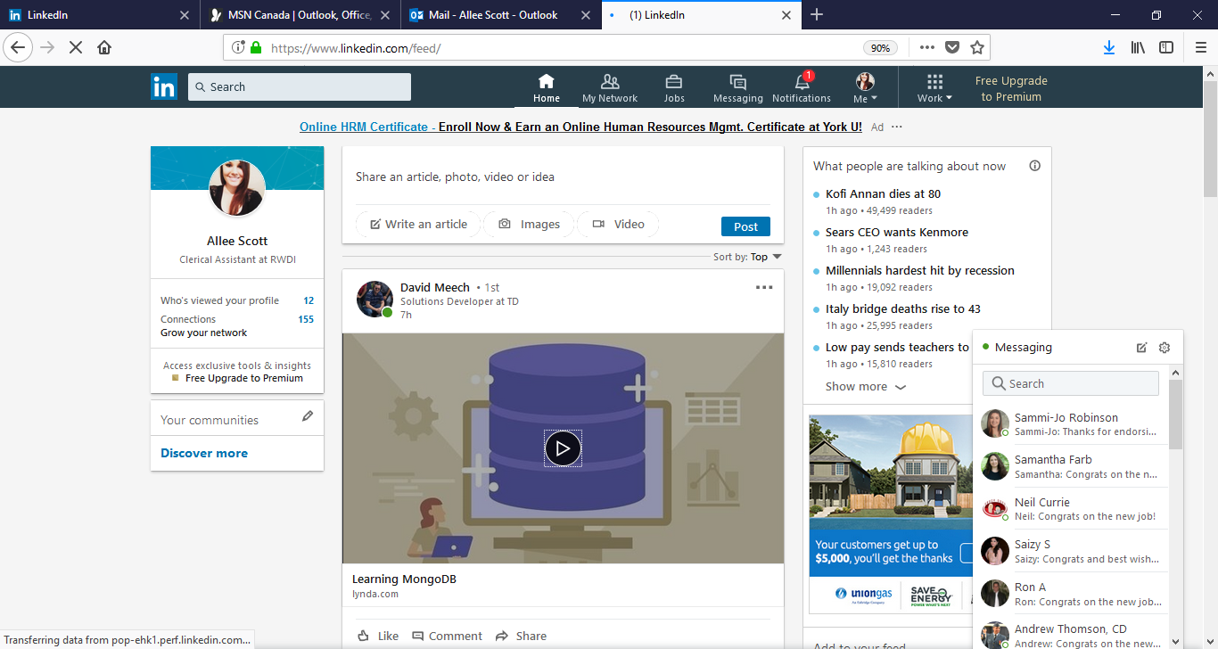Edit “your communities”

Figure 15 -Your Home Page

# Using the Navigation Bar

The navigation bar at the top of your LinkedIn profile is used to navigate through different sections of the website. Use this as your main guide when using the platform.

Figure 16 - Navigation Bar

## The “Me” section dropdown

The “Me” dropdown- to the far right of the navigation bar (figure 17) contains links to manage your profile, account, job postings, and security settings. This is also where you can sign out if needed.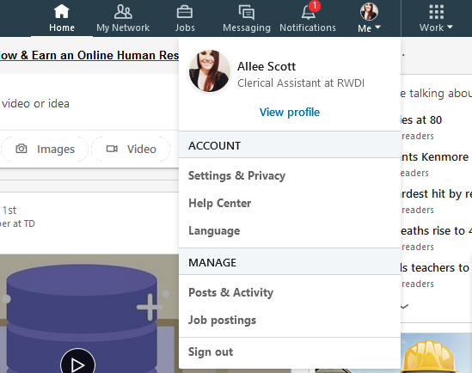

Figure 17 – “Me” Dropdown

## Notifications

To the left after the “Me” dropdown menu, the next button in the Navigation Bar is “Notifications” (see figure 18). You will be notified of any new activity on your profile or network with a red callout above this tab with the number of occurrences you have waiting for you. You can be notified of thing like:

* New posts from your connections
* Birthdays
* Job changes within your network
* Recommendations of people to follow
* Work anniversaries
* Skill Endorsements from your peers
* Who’s viewed your profile… and much more!

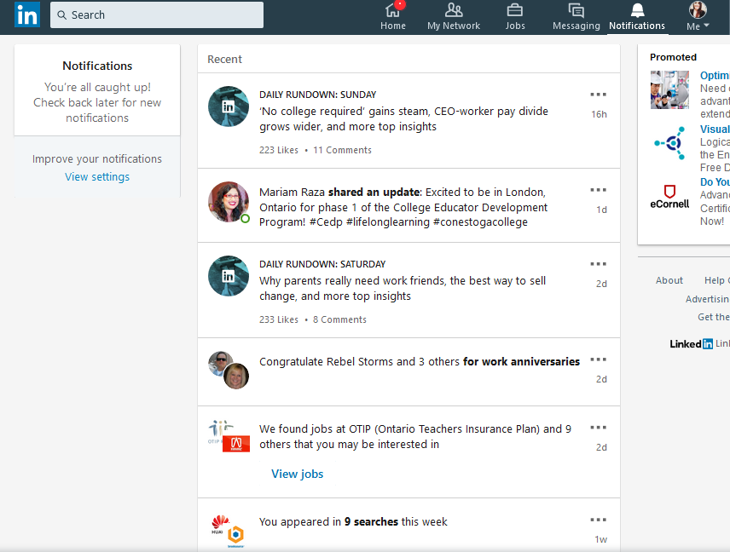Notifications can be turned off and on/ changed at your convenience by clicking on the “View Settings” link under the Notifications Box OR by going to “Settings” under the “Me” dropdown > Connections > Channels > Notifications on LinkedIn.

Figure 18 - Notifications Tab

## Messaging

The messaging feature within LinkedIn is a great tool to network to your potential connections and market yourself in the business world. From here you can compose a new message to one of your connections, read your received messages, and reply to those who have contacted you.

Reply to received messages

Create a new message

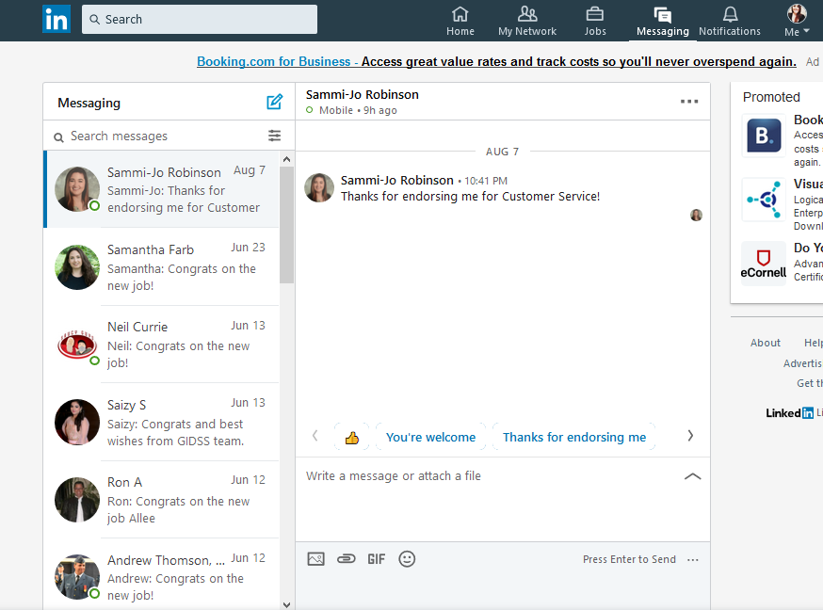

Figure 19 - Messaging Tab

## The Jobs Tab

The next tab moving to your left would be the “Jobs” tab. LinkedIn has its own job search engine that lets you search for jobs posted by businesses, recruiters, and employers on LinkedIn. This will be further explained in the “Job Search” section of this manual. Clicking this tab will bring you to the following page shown in figure 20.

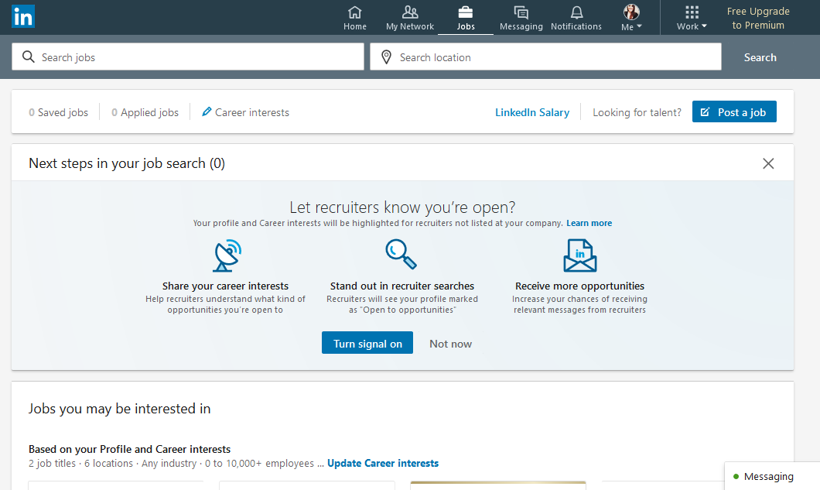

Figure 20 - Jobs Page

## My Network Tab

The My Network tab houses all of the information about your connections or “Friends” on LinkedIn. From this page you can see how many friends you have made, add contacts from different outlets such as your e-mail or other social media sites, review and accept who has invited you to connect with them, and connect with suggested people you may know.

* Click on “Manage All” to view a list of invitations from potential connections
* Click on “See All” to view your connections or “Friends List”
* To invite people from different social media sites, click “More Options” on the Add Personal Contacts box
* Click “Connect” to send someone a friend request

Figure 21 - My Network Tab

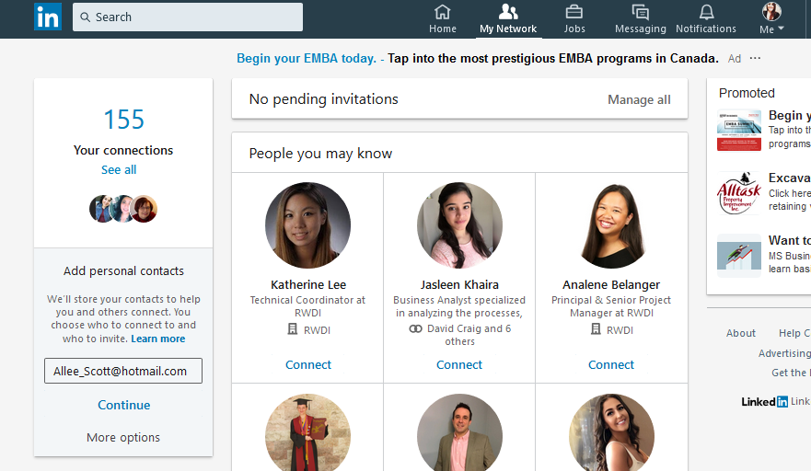Now that you know how to navigate the website, proceed to the next section in the manual for information on how to edit your profile fields.

# Editing your profile

Figure 22 - View Profile

To edit the contents that your profile conveys to its viewers, go to “Me” dropdown within the navigation bar, and select “View Profile”. This will bring you to an overview of what your profile currently looks like. Any editing changes you make to your profile will show up here.

## Profile Strength Bar

If you are new to the site and have followed the previous instructions to create a profile, when you scroll down your profile, you will see a “Profile Strength” Bar (see figure 23). The Profile Strength bar is a good way to guide you through making changes to your account that will maximize its professional presence.

There are three stages in which your profile can measure; Beginner, Intermediate, and All Star. The goal is to complete all of the steps on the profile strength bar in order to reach All Star status. To view how many steps are completed/ to be completed, hover over the colored status bar. To start making changes using the Profile Strength Box walk through, click the **blue button** in the bottom right hand corner of the box. To skip a step in the walk through, click “Next” in the bottom left. If you skip a step, you can press “previous” on the profile strength box to go back to it at any time.

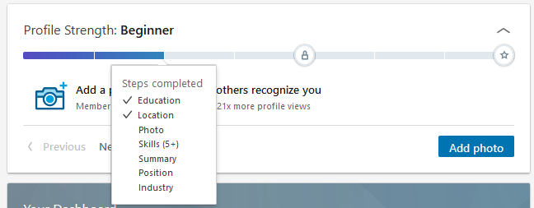

Figure 23 - Profile Strength Bar

## Edit Intro / Introduction Card

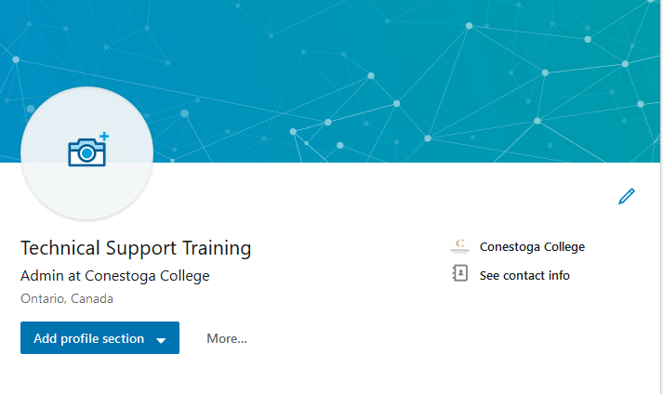To edit the top part of your profile, you can click the pencil tool on the top right of your profile (see figure 24). This is called “The Introduction Card”, it is what will be seen first when your profile is viewed, and is also considered your “hook” for employers.

Figure 24 - Edit Pencil

From the “Edit Intro” box (see figure 25 on next page) you can change:

* Your profile picture
* Your background or “cover” photo
* First name, and last name
* Headline (Experienced Marketing Professional, or Clerical Assistant at RWDI)
* Country/ Region & ZIP code & Locations
* Industry
* Contact Info (Profile URL, Email, WeChat ID)
* Summary (see figure 26) – You should write a profile summary to market yourself
* Media (Add or link to external documents, photos, sites, videos etc.)

Remember to press “Save” at the bottom right when you are finished!

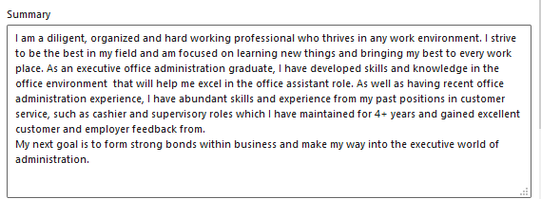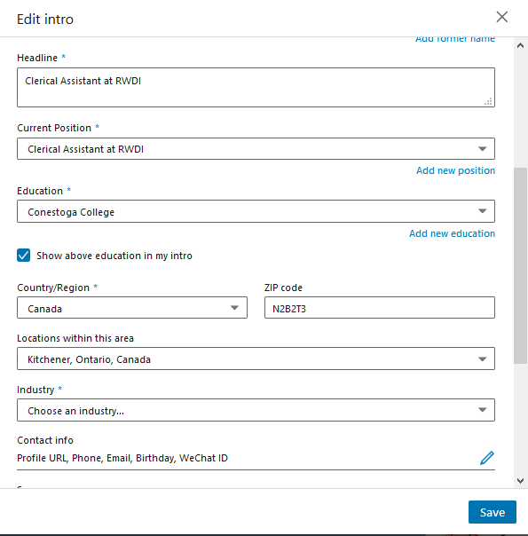Figure 26 - Summary Example

Figure 25 - Edit Intro Box

## Update Your Contact Information

To add a phone number, address, website, new email address, or birthday to your profile click the “See Contact Info” link on your introduction card then click the pencil on the pop up.

Figure 27 - See Contact Info

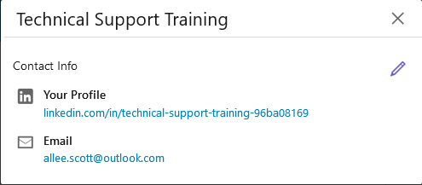

Figure 28 - Edit Contact Info

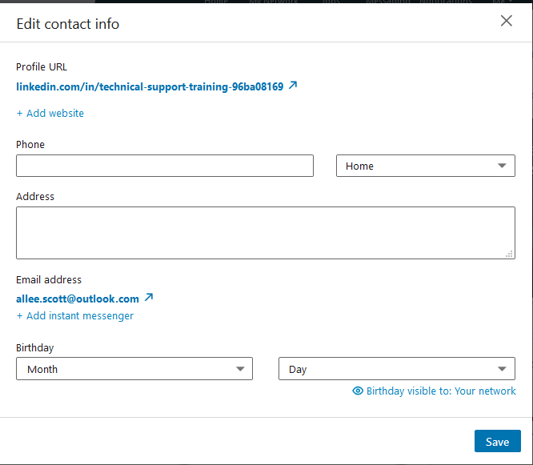

### Advanced Tip:

Figure 29 - Edit Contact Info Window

To make a unique Profile URL, click the Profile URL Link then click the pencil under “Edit URL” at the top right-hand corner of the “Public Profile Settings” page.

## Adding Profile Sections

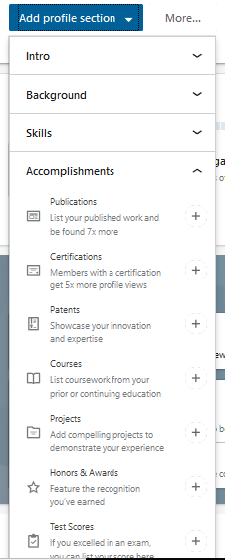To add more sections to your profile simply click the “Add Profile Sections” button Under your name and profile picture. From the drop down, you can choose several different things to add to your profile such as:

Background

* Work Experience
* Education
* Volunteer Experience

Skills

* Choose to add skills that can be endorsed by your connections to your profile

Accomplishments

* Publications
* Certifications
* Patents
* Courses
* Projects
* Honors & Awards
* Test Scores
* Languages
* Organizations

Additional Information

* Request a Recommendation from a connection

Supported Languages

* Add any above sections to your profile in another language to make finding you easier

Figure 30 - Add sections

You can edit these individual sections as well once they are added to your profile by clicking once again, on the pencil icon.

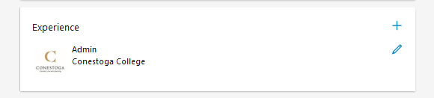

Figure 31 – Section

# Using Search Filters and Connecting with Others

Using the search bar, you can search for People, Jobs, or even Content, but to find connections, you should click “People” from the drop down or type in a name you are looking for. If you find who you are looking for, you can click “connect” beside their name, or from their profile.

Remember – 3rd degree connections (friends of friends) may not allow for the “connect” option- send them an “in-mail” or “message” to ask them to connect.

To filter your results, you can edit the dropdown filters provided on the search page (see figure 32) and click “apply” or click “All Filters” to bring up an advanced filtering system. (see figure 33)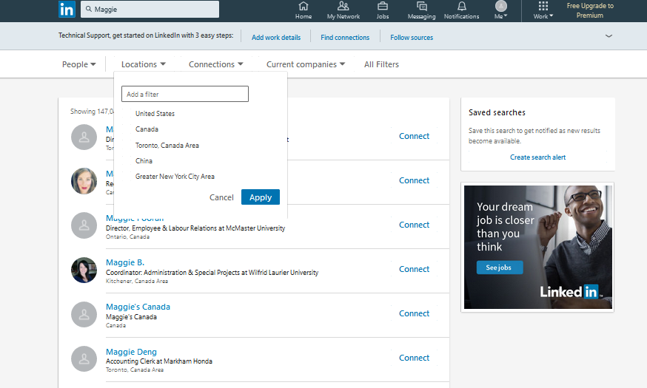

Figure 32 - Search

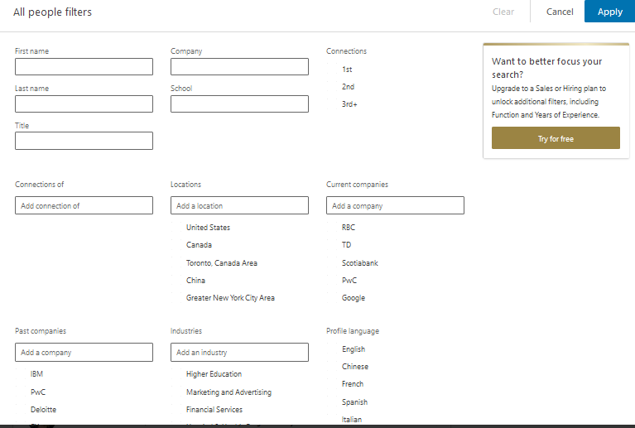

Figure 33 - Advanced Search

# Privacy and Settings

Figure 34 - Settings & Privacy

In order to modify your security settings on your account, navigate to the “Me” dropdown menu on the navigation bar and click “Settings & Privacy”.

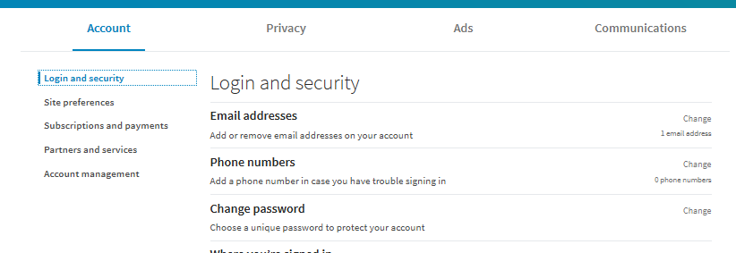

Figure 35 – Settings and Privacy Tabs

## Account Tab:

From this page, you can modify:

* Login and Security Settings
  + Add or Remove Email Addresses
  + Phone Number Security
  + Changing Password
  + Where and When you’re signed in - View Active Sessions
  + Enabling Two- Step Verification for Log In
* Site Preferences
  + Language Preferences
  + Autoplay Video Preferences
  + Profile Photo Visibility
  + News Feed Preferences
  + Name, Location, and Industry Visibility
* Subscriptions and Payments
  + Upgrade to Premium and View Purchase History
* Partners and Services
  + Third party services (Linked Accounts)
* Account Management
  + Closing your account

(LinkedIn, 2018)

Click “Change” on the right, to change any of these settings.

## Privacy Tab:

From this page you can modify:

* How others see your profile and network information
  + Edit your public profile – choose how your profile appears to non- logged in users or via search engines like google
  + Who can see your email address
  + Who can see your connections
  + Viewers of this profile also viewed – choose who can see who’s profile you’ve viewed
  + Who can see your last name on your profile
  + Representing your organizations and interests – choose if LinkedIn mentions you in content regarding your employer
  + Profile Visibility off LinkedIn
* How others see your LinkedIn activity
  + Profile viewing options
  + Managing active status – who can see when you’re online
  + Sharing profile edits – who can see when you edit
  + Notifying connections when you’re in the news
  + Mentions by others- choose whether other members can mention you
* How LinkedIn Uses your data
  + Manage your data and activity- review data that you’ve provided to LinkedIn
  + Download Data you’ve provided to LinkedIn
  + Manage who can find your profile by your email or phone number
  + Search history… and more.
* Job Seeking Preferences
  + Share that your open to work opportunities
  + Sharing your profile when you apply to jobs
  + Saving Job application answers
* Blocking and hiding
  + Choose who can follow you and see public updates
  + See who you’ve blocked on LinkedIn and Block People
  + See who you’ve unfollowed

(LinkedIn, 2018)

## Ads Tab:

On this page you can modify:

* General Advertising Preferences
* Data Collected on LinkedIn
* Third Party Data

## Communications Tab:

On this page you can modify:

* Channels
  + Notifications on Linked In
  + Email Frequency
* Preferences
  + Who can send you invitations
  + Messages from members and partners
  + Read Receipts and typing indicators
  + Messaging reply suggestions
* Groups
  + Group Invitations
* LinkedIn messages
  + Participate in research options

(LinkedIn, 2018)

# LinkedIn Job Search Features

LinkedIn has its own job search which you can use to connect with employers on the platform who are recruiting for job openings in their companies. Employers with a LinkedIn account can post a job to the site from their profile or from their companies’ profile, and any applications you make towards the job posting will share your information and profile with them directly as well as any application form from the posting that has been filled out. This is a great way for you to research the employer before applying, view their profile, and determine whether the posting could be a good fit.

By going to the “Jobs” tab in the navigation bar mentioned earlier in this manual, you can view suggested jobs you may be interested in according to your skills, industry, and experience, or search using the search bar. You can also use the home page search bar to look for jobs by clicking the down arrow and selecting “jobs”.

On the next page, (see figure 36) you will learn how to search, apply, and save jobs.

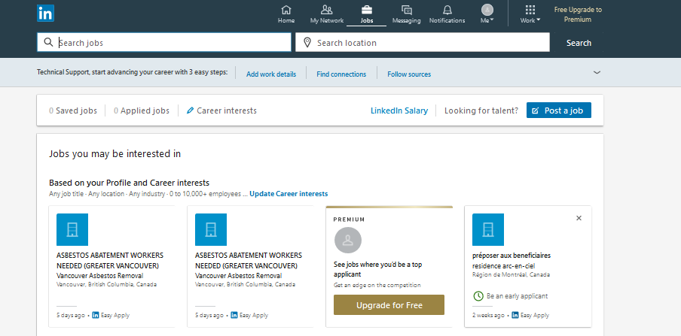Simply click a tile to view the Job description and apply if one of the suggested jobs catches your eye.

Figure 36 Jobs Tab Home Page

OR

Click the search bar- Type in a job name and location and click “Search”

Figure 38 on the next page shows an example of searching for “Executive” in Guelph, ON.

Click on a job from the populated list – in the side pane you can click “easy apply” which lets you upload a resume directly and your contact information only into a dialogue box populated from the LinkedIn site. Otherwise, you will be navigated to the job posting on the company website to apply.

To save for later- simply click save on the job posting from which you can then access from the jobs tab in the navigation bar later. (see figure 37)

Figure 37 - Saved Job Bar in Jobs Tab



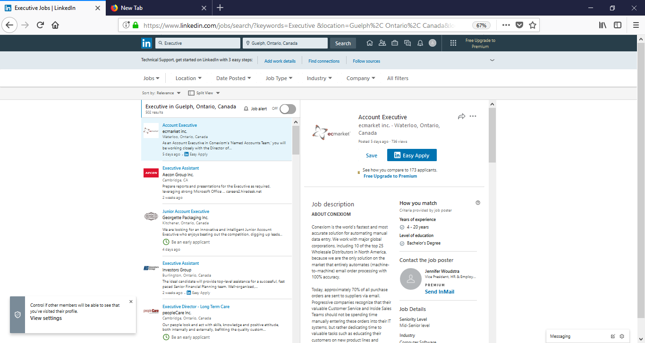

Figure 38 - Job Search Page

This concludes the LinkedIn manual. Please use the Bibliography and Index as references to text within this document.

# Bibliography

*APA @ Conestoga*. (2014). Retrieved from Conestoga College: https://apa.conestogac.on.ca/

LinkedIn. (2018, 08 15). *LinkedIn - About*. Retrieved from LinkedIn: https://about.linkedin.com/

# Index

account, 1, 2, 3, 4, 8, 11, 12, 18, 25, 27, 29

Adding, 1, 3, 9, 10, 22

Background, 22

connections, 9, 11, 14, 15, 17, 22, 23, 28

Contact, 1, 3, 19, 21

filter, 24

Intro, 1, 3, 19

Introduction Card, 1, 19

Languages, 22

messaging, 15

Notifications, 1, 3, 14, 29

phone, 21, 28

sign in, 2

Tip, 1, 21

URL, 1, 2, 19, 21

Work Experience, 22

Training Session Lesson Plan

|  |  |  |  |
| --- | --- | --- | --- |
| **Bridge-in:** Explain what LinkedIn is and its importance for professional development, introduce the topic by giving business statistics related to LinkedIn and the current job market. | | | |
| **Objective**: By the end of the training session, students will be able to modify and edit their own LinkedIn account to maximize their professional social media presence. Students will perform 3 different profile edits in order to demonstrate their knowledge by following training session instruction with 90% accuracy. | | **Topic**: LinkedIn Corporation  **Date**: July 31, 2018  **Aides Required**: PowerPoint Presentation, LinkedIn Website (Internet Browser), How to Create a Professional Profile (Reference / Take Home Handout), Post Test (Instruction Handout) | |
| **Pre-Test:** Ask class which social media they currently use and determine how many students currently have their own account on LinkedIn currently. | | | |
| **Instructor**  Show slide + Introduce topic + Explain facts and their importance (B)  Clarify Objective and ask for/respond to questions regarding objective (O)  Ask about social media and LinkedIn experience (P)  Using slides 5-7 on PowerPoint, explain how to log in and provide credentials to students without accounts  Show students how to complete profile fields (Photo, Headline, Introduction card, and Summary)  Show students how to search, and manage connections  Show students how to update background, skills, accomplishments section to boost professional presence (Handout reference included)  Show students how to modify their privacy settings  Have students create 3 different profile edits to their profile based on handout instructions  Go around class critiquing students end result, have student explain their edits (P)  Ask for questions, restate learnings of the lesson and thank participants (S) | **Learner**  Listen and Observe  Ask Questions/ Comment remarks  Share experience with Social Media  Follow along with each step  Follow along with each step, ask questions  Follow along  Reference Handout, Follow Along  Follow along, ask questions  Follow along  Create desired edits as per instruction  Display and explain edits  Listen and Observe | | **Time**  45 s  30 s  1 m  2 m  4 m  3m  2m  2m  1m  3m  1m  30s |
| **Post-test**: Students will perform 3 different profile edits in order to demonstrate their knowledge by following training session handout instructions. | | | |
| **Closure and Connection:** Discuss learnings of todays lesson and thank students for their time. | | **Next time:** Next time we will be talking about how to use the job search function in depth. | |