**INSTITUTE OF HOTEL MANAGEMENT, BANGALORE**

**A STUDY ON HEALTH BENEFITS OF FERMENTED FRUITS AND VEGETABLES IN RESPECT TO PROBIOTIC ENZYMES PRESENT IN THEM**

**A PROJECT REPORT**

**SUBMITTED IN PARTIAL FULFILLMENT OF THE REQUIREMENTS FOR THE AWARD OF THE DEGREE OF**

**BACHELOR OF SCIENCE**

**(Hospitality & Hotel Administration)**

**SUBMITTED TO**

NATIONAL COUNCIL FOR HOTEL MANAGEMENT & CATERING TECHNOLOGY, NO I D A



**SUBMITTED BY**

**GURSIMER SINGH** NCHM&CT ROLL NO:1641101063

**SUPERVISED BY**

###### SAMUEL SANTHOSH KUMAR

Lecturer April 2019

**INSTITUTE OF HOTEL MANAGEMENT, BANGALORE**

**ACKNOWLEDGEMENT**

###### I would like to place on record my deep sense of gratitude to my Principal **Mr. V.R. Venkatadri** for being a constant inspiration to all the students of the institute. I would also like to thank **Dr. S. Kannan,** Head of the department of the institute and lastly**, Chef Samuel Santhosh Kumar** Lecturer (Food Production) of Institute of Hotel Management, Bangalore, for his useful suggestions, help and generous guidance. I express my sincere gratitude for his stimulating guidance, continuous encouragement and supervision. I am extremely thankful to Chef Samuel Santhosh Kumar for providing infrastructural facilities to work in, without which this work would not have been possible.

**(Signature of Student)**

# CERTIFICATE

I, hereby, certify that the work which is being presented in the B.Sc. research project report entitled **" A STUDY ON HEALTH BENEFITS OF FERMENTED FRUITS AND VEGETABLES IN RESPECT TO PROBIOTIC ENZYMES PRESENT IN THEM ",** in partial

fulfilment of the requirements for the award of the **Bachelor of Science in Hospitality & Hotel Administration** and submitted to Institute of Hotel Management, Bangalore, is an authentic record of my own work carried out during a period from December, 2018, to March, 2019 under the supervision of Chef Samuel Santhosh Kumar

The matter presented in this Project Report has not been submitted by me for the award of any other degree elsewhere.

**Signature of student**

This is to certify that the above candidate has been examined by us during the viva-

voce and project presentation

**Signature of Internal Examiner Signature of External Examiner**

**Date: Date:**

**Name & Designation Name & Designation**

**TABLE OF CONTENTS**

**ACKNOWLEDGEMENT .................................................................................................................................**

**LIST OF FIGURES..........................................................................................................................................**

**LIST OF TABLES ........................................................................................................................................**

**ABSTRACT......................................................................................................................................................**

1. INTRODUCTION 1
   1. RESEARCH HYPOTHESIS 3
   2. RESEARCH METHODOLOGY 4

1.LITRATURE REVIEW 5

* 1. INDIGENOUS FERMENTED FOODS 5
  2. CLASSIFICATION OF FOOD FERMENTATIONS 6
  3. TYPE OF FOOD FERMENTATION 10
  4. FERMENTATION OF FRUITS AND VEGETABLES BY LAB 11
  5. TRADITIONAL FERMENTED FRUITS AND VEGETABLES IN INDIA 34
  6. TRADITIONAL FERMENTED FRUITS AND VEGETABLES IN OTHER ASIAN COUNTRIES 38

2.6. OTHER FERMENTED VEGETABLES AND FRUITS 45

3.0 BENEFITS OF FERMENTED FOOD 49

* 1. ADVANTAGES OF HAVING FERMENTED FOODS IN DAILY DIET 49
  2. PROBIOTIC MICROORGANISMS 52
  3. DEFINITION AND MECHANISM OF ACTION OF PROBIOTICS 53
  4. SELECTION AND APPLICATION OF PROBIOTICS 54
  5. ROLE OF INGREDIENTS USED IN FERMENTATIONS OF FRUITS AND VEGETABLES 55
  6. BENEFICIAL EFFECT OF FERMENTED FRUITS AND VEGETABLES 57
  7. IMPORTANCE OF PROBIOTICS 62

4.0 SURVEY 84

4.1. QUESTIONNAIRE 84

5.0 RESULTS AND DISSCUSIONS 86

5.1. SURVEY RESULTS 86

6.0 RESEARCH PROSPECTS AND FUTURE APPLICATIONS 94

7.0 CONCLUSION 95

8.0 REFERENCE 96

9.0 BIBLOGRAPHY 97

**LIST OF FIGURES**

|  |  |  |
| --- | --- | --- |
| **FIGURE** | **TITLE** | **PAGE NO** |
| 1 | The principal fermentation and their product. | 10 |
| 2 | Overall fermentation process of fruits and vegetables. | 21 |
| 3 | Basic characteristics of selection of a probiotic strain. | 55 |
| 4 | Beneficial effects of probiotics | 60 |
| 5 | Health Benefits of probiotics for human body | 62 |

**LIST OF TABLES**

|  |  |  |
| --- | --- | --- |
| **TABLE** | **DESCRIPTION** | **PAGE** |
| 1 | Examples of traditional fermented fruits and vegetables, which are used in various parts of Asian subcontinent. | 11 |
| 2 | Nutritive values and scientific names of fruits and vegetables mostly used for lactic acid fermentation. | 24 |

### ABSTRACT

As world population increases, fermentation is expected to become an important role in preserving fresh vegetables, fruits, and other food items for feeding humanity in developing countries. However, several fermented fruits and vegetables products (Sauerkraut, Kimchi, Gundruk, Khalpi, Sinki, etc.) have a long history in human nutrition from ancient ages and are associated with the several social aspects of different communities. Among the food items, fruits and vegetables are easily perishable commodities due to their high-water activity and nutritive values. These conditions are more critical in tropical and subtropical countries which favour the growth of spoilage causing microorganisms. Fermentation increases shelf life of fruits and vegetables and also enhances several beneficial properties, including nutritive value and flavours, and reduces toxicity. Fermented fruits and vegetables can be used as a potential source of probiotics as they harbour several lactic acid bacteria. As a whole, the traditionally fermented fruits and vegetables not only serve as food supplements but also attribute towards health benefits. This review aims to describe some important Asian fermented fruits and vegetables and their significance as a potential source of probiotics.

# INTRODUCTION

Fermented foods and beverages have heterogeneity of traditions and cultural preferences found in the different geographical areas, where they are produced. Fermentation has enabled our ancestors in temperate and cooler regions to survive during the winter season and those in the tropics to survive drought periods. Fermentation is a slow decomposition process of organic substances induced by microorganisms or enzymes that essentially convert carbohydrates to alcohols or organic acids. In many instances, production methods of different traditional fermented foods were unknown and passed down to subsequent generations as family traditions. Drying and salting are common fermentation practices in the oldest methods of food preservation. Fermentation processes are believed to have been developed in order to preserve fruits and vegetables for times of scarcity by preserving the food by organic acid and alcohols, impart desirable flavour, texture to foods, reduce toxicity, and decrease cooking time.

World Health Organization (WHO) and Food and Agriculture Organization (FAO) recommended intake of a specific dose of vegetable and fruits in daily food to prevent chronic pathologies such as hypertension, coronary heart problems, and risk of strokes. The consumers tend to prefer the foods and beverages which is fresh, highly nutritional, health promoting and ready to eat or ready to drink. Lactic acid (LA) fermentation of vegetables and fruits is a common practice to maintain and improve the nutritional and sensory features of food commodities. A great number of potential lactic acid bacteria (LAB) were isolated from various traditional naturally fermented foods. Asian traditional fermented foods are generally fermented by LAB, which are considered as the probiotic

source of the food practice. Availability of certain specific nutrients such as vitamins, minerals, and acidic nature of fruits and vegetables provides conducible medium for fermentation by LAB.

Probiotic is a relatively new word meaning “for life” and it is generally used to name the bacteria associated with beneficial effects for humans. Probiotics are defined as live microbial feed such as Lactobacillus plantarum, L. casei, L. acidophilus, and Streptococcus lactis which are supplemented by food that beneficially affect the host by improving its intestinal balance. Several studies have shown that supplementation of probiotics to food provides several health benefits such as reduction of serum cholesterol, improved gastrointestinal function, enhanced immune system, and lower risk of colon cancer. This review provides an overview on the current research prospects of fermentation of fruits and vegetables with regard to human nutrition and health.

Fermentation is one of the important and ancient processes that contribute to the nutritional requirements of millions of individuals. A number of microorganisms and enzymes play an important role in the fermentation process, by the effective utilization of available natural food/feed stocks and transformation of waste materials, thereby, contributing to meet the world’s food problems. Fermentation is the most economical methods of producing and preserving foods (including the production of alcoholic beverages. The word “fermentation” is derived from the Latin word fermentum meaning “to boil,” since the bubbling and foaming of early fermenting beverages seemed closely akin to boiling. It is the chemical transformation of organic substances into simpler compounds by the action of enzymes, the complex organic catalysts which are produced by microorganisms such as molds, yeasts, or bacteria, and due to the enzymatic activity various by-products are formed. It is an energy-yielding process, whereby organic molecules serve

both as electron donor and electron acceptor. It covers a wide range of microbial and enzymatic processing of foods and their ingredients to achieve desirable characteristics. The traditional fermentation of foods serves several functions. Food fermentation involves all those processes where either the ultimate product is used directly as a food or as an additive to food, or is a basic ingredient in the food.

### RESEARCH HYPOTHESIS

The fermentation is seen widely throughout the food production either in home or in the industry, but the nutritive qualities of food are often not looked as prominently as the taste of the food. So, the question arises about how aware are the people about the health benefits of fermented food which becomes the first part of the hypothesis for the research and then comes the second part of hypothesis is in which ways the fermented fruits and vegetables benefits the human body and which bacteria it includes that causes different health advantages in the human body.

Taking into consideration that in today’s time, the people having the access to the world-wide information can truly get into the parts of nutritive value of the food, and to find out are people aware about the benefits of fermented fruits and vegetables and if they are, do they know about how the fermented fruits and vegetables eaten benefits them.

Fermented fruits and vegetables do benefits through different mechanisms and bacteria’s, the probiotics bacteria which came out as micro researched name that provide health benefits through fermented fruits and vegetables, these bacteria are to be known as how they work as in human control regulate and commission the health benefits.

### RESEARCH METHODOLOGY 1.2.1RESEARCH METHOD USED

Information was gathered using a variety of methods to gain a better understanding of the situation, issues, perspectives and priorities. Data collection methods included document/literature review, Surveys and observation.

### RESEARCH OBJECTIVES

The primary of the research includes

* + - * To find the level of awareness among people about the health benefits of fermented fruits and vegetables.
      * To determine which fruits and vegetables are fermented and used for consumption.
      * To learn about how these fermented fruits and vegetables cause health benefits to human body.
      * To find out what kind of effects does the fermented fruits give, which provide beneficial changes in body.
      * To recognize the type of microorganisms which provide health benefits through fermented fruits and vegetables.

### RESEARCH SCOPE

The research spreads through different aspect of the subject, from the indigenous fermentation, different types of fermentation used in cooking and coming to different health benefits which involves probiotic enzymes providing those health benefits.

This research shows how those fermented fruits and vegetables will have effects on different life system of human body if these are included in daily diet. This also proposes different future aspect which can be researched and widen the horizon on taking fermented fruits and vegetables as basis.

# 1.LITRATURE REVIEW

#### Indigenous fermented foods

The growth and activity of microorganisms plays an essential role in the biochemical changes in substrates, such as plant, dairy, meat, and fish products, during fermentation. The microbiota— which may be indigenously present on the substrate, or added as a starter culture or may be present in or on the ingredients and utensils, or in the environment—are selected through adaptation to the substrate and by adjusting the fermentation conditions. There are four main fermentation processes, namely, alcoholic, lactic acid, acetic acid, and alkaline fermentation. Three major types of microorganisms, namely, yeast, bacteria, and fungi, are associated with traditional fermented foods and beverages. In many of the indigenous fermented foods, yeasts are predominant and functional during fermentation. The diversity of indigenous fermented foods ranges from nan to idli to alcoholic beverages, such as rice and palm wine. Basically, food fermentation can take place if there is a suitable substrate, appropriate microorganism(s) either from nature or by inoculation of specific microorganism, and the necessary environmental conditions for the fermentation to take place. Environmental conditions, like temperature and moisture, need to be optimum for a specific fermentation, as well as the intrinsic factors of fermentation, including the pH, type of

sugar, nutrients, availability or otherwise of oxygen, etc. The composition and quality of the raw materials, the microflora involved, the amount of water, type of raw material, and time also influence the fermentation. Preservation of foods by fermentation depends on the principle of oxidation of carbohydrates and related derivatives to generate various products (generally acids, alcohol, and carbon dioxide). These end-products determine the growth of food spoilage microorganisms, and because the oxidation is only partial, the food retains sufficient energy potential to be of nutritional benefit to consumers

#### Classification of Food Fermentations

Food fermentations have been classified in a number of ways: by categories such as

1. Alcoholic beverages fermented by yeasts;
2. Vinegars fermented with Acetobacter;
3. Milks fermented with lactobacilli;
4. Pickles fermented with lactobacilli;
5. Fish or meat fermented with lactobacilli
6. Plant proteins fermented with molds with or without lactobacilli and yeasts.

These fermentations can also be grouped by the type of product such as:

1. Alcoholic beverages;
2. Cereal products;
3. Dairy products;
4. Fish products;
5. Fruit and vegetable products;
6. Legumes;
7. Meat products.

Attempts have been made to classify the food fermentations by the type of commodity namely:

1. fermented starchy roots;
2. fermented cereals;
3. alcoholic beverages;
4. fermented vegetable proteins
5. fermented animal

12 indigenous fermented foods of south asia protein; and by commodity (Kuboye, 1985): (1) cas sava based; (2) cereal; (3) legumes; and, (4) beverages. Steinkraus (1983a, 1996, 2002) classified the food fermentations in detail according to the following categories:

#### Fermentations producing textured vegetable protein meat substitutes in legume/cereal mixtures. Examples are Indonesian tempe and ontjom.

1. **High salt/savory meat-flavored/amino acid/peptide sauce and paste fermentations.**

Examples are Chinese soy sauce, Japanese shoyu and Japanese miso, Indonesian kecap, Malaysian ki-cap, Korean kanjang, Taiwanese inyu, fish sauces: Vietnamese nuocmam, Malaysian

budu, fish pastes: Philippine bagoong, Malaysian belachan, Vietnamese mam, Cambodian prahoc etc. These are predominately oriental fermentations.

#### Lactic acid fermentations.

Examples of vegetable lactic acid fermentations, such as: sauerkraut, cucumber pickles, olives in the Western world, In dian pickled vegetables and Korean kimchi, Chinese hum-choy. Malaysian pickled vegetables and Malaysian tempoyak. Lactic acid fermented milks include: yogurts in the Western world, Russian kefir, Middle-East yogurts, liban (Iraq), Indian dahi, Egyptian laban rayab, laban zeer, Malaysian tairu (soybean milk) and fermented cheeses in the Western world, yogurt/wheat mix tures: Egyptian kishk, Greek trahanas, Turkish tarhanas. Lactic acid fermented cereals and tubers (cassava): Mexican pozol, Ghanian kenkey, Nigerian gari; boiled rice/raw shrimp/raw fish mixtures: lactic fermented/leavened breads: sour dough breads in the Western world; Indian idli, dhokla, khaman, Sri-lankan hoppers, and Ethiopian enjera.

#### Alcoholic fermentations.

Examples are wines and beers, Mexi can pulque, honey wines, South American Indian chichi, and beers in the Western World; wines and Egyptian bouza in the Middle East; palm and jackfruit wines in India, Indian rice beer, In dian madhu, Indian ruhi; palm wines, Kaffir/bantu beers, Nigerian pito, Ethiopian talla, Kenyan busaa, Zambian maize beer; in the Far East, sugar cane wines, palm wines, Japanese sake, and Malaysian tapuy.

#### Acetic acid/vinegar fermentations.

Examples are apple cider and wine vinegars in the West; sugarcane and jamun vinegar in india, palm wine vinegars in Africa and the Far East, coconut water vinegar in the Philippines.

#### Alkaline fermentations.

Examples are; Nigerian dawadawa, Ivory Coast soumbara, African iru, ogiri, Indian kniema, Japanese natto, etc. 7. Leavened breads. Examples are Western yeast and sour dough breads; Middle East breads. 8. Flat unleavened breads. The above classes of fermented foods are found around the world. It may be noted that the lines between the various classifications are not always distinct.

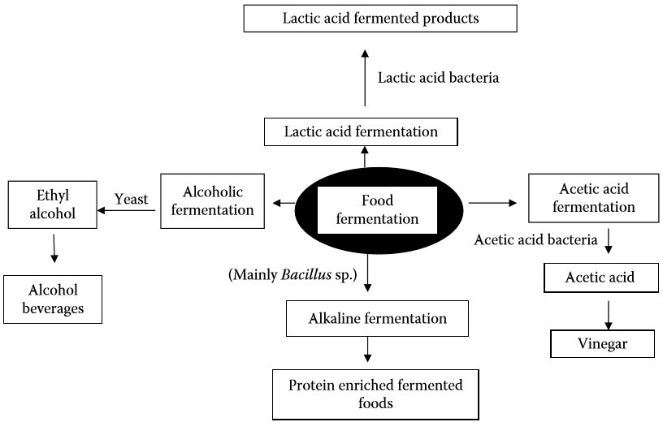

Figure 1: The Principal Fermentation and their product

## Type of Food Fermentation

The principal fermentations, their products and types of microorganisms are depicted in Figure above.

## Fermentation of Fruits and Vegetables by LAB

Shelf life of the perishable food can be improved by fermentation which is considered as the oldest technology compared to the refrigeration. Fermentation is one of the oldest processing techniques to extend the shelf life of perishable food and was particularly important before refrigeration. LA fermentation of cabbage to produce sauerkraut has been widely studied for many years. Basic outline of the fruit and vegetable fermentation is given in Figure 2. With the popularity and success of sauerkraut, fermentation of many other vegetables has emerged, such as cucumbers, beets, turnips, cauliflower, celery, radishes, and carrots. (Table 1).

Table 1: Examples of traditional fermented fruits and vegetables, which are used in various parts of Asian subcontinent.

|  |  |  |  |  |  |
| --- | --- | --- | --- | --- | --- |
|  | | | | | |
| **Fermente d food product** | **Country** | **Fruit and vegetables** | **Other ingredien ts** | **Microorganis ms** |  |
|  | | | | | |
| Burong mustala | Philippines | Mustard leaf | Rock salt | L. brevis Pediococcus cerevisiae |  |
|  | | | | | |

|  |  |  |  |  |  |
| --- | --- | --- | --- | --- | --- |
| Ca muoi | Vietnam | Eggplant |  | L. fermentum  L. pentosus  L. brevis |  |
|  | | | | | |
| Dakguadon g | Thailand | Mustard leaf | Salt | L. plantarum |  |
|  | | | | | |
| Dhamuoi | Vietnam | Cabbage, various vegetables |  | Leuconostoc mesenteroides  L. plantarum |  |
|  | | | | | |
| Dua muoi | Vietnam | Mustard or beet | Onion, sugar, and salt | L. fermentum  L. pentosus  L. plantarum  P. pentosaceus |  |
|  | | | | | |

|  |  |  |  |  |  |
| --- | --- | --- | --- | --- | --- |
| Gundruk | Nepal, India | Cabbage, radish, mustard, cauliflower | No | Pediococcus and Lactobacillus spp. |  |
|  | | | | | |
| Inziangsang | India | Mustard leaf | No | L. plantarum  L. brevis, Pediococcus acidilactici |  |
|  | | | | | |
| Jiang-gua | Taiwan | Cucumber | Salt | Weissella cibaria  W. hellenica  L. Plantarum Leuconostoc lactis Enterococcus casseliflavus |  |

|  |  |  |  |  |  |
| --- | --- | --- | --- | --- | --- |
|  | | | | | |
| Khalpi | Nepal | Cucumber | No | L. plantarum  P. pentosaceus |  |
|  | | | | | |
| Kimchi | Korea | Cabbage, radish, various vegetables | Garlic, red pepper, green onion, ginger, and salt | Leuconostoc mesenteroides  L. brevis  L. plantarum  L. sakei |  |
|  | | | | | |
| Nozawana- Zuke | Japan | Turnip |  | L. curvatus |  |
|  | | | | | |
| Olive | Spain, Italy | Olive | Salt | L. plantarum  L. brevis  L. pentosus |  |

|  |  |  |  |  |  |
| --- | --- | --- | --- | --- | --- |
|  |  |  |  | P. cerevisiae  L. mesenteroides |  |
|  | | | | | |
| Pak-Gard- Dong | Thailand | Mustard leaf | Salt and sugar solution | L. brevis  P. cerevisiae  L. plantarum |  |
|  | | | | | |
| Pak-sian- dong | Thailand | Leaves of Pak-sian (Gynadropsis pentaphylla) | Brine | L. brevis  P. cerevisiae  L. plantarum |  |
|  | | | | | |
| Paocai | China | Cabbage, celery, cucumber, and radish | Ginger, salt, sugar, hot red pepper | L. pentosus,  L. plantarum Leuconostoc mesenteroides  L. brevis |  |

|  |  |  |  |  |  |
| --- | --- | --- | --- | --- | --- |
|  |  |  |  | L. lactis  L. fermentum |  |
|  | | | | | |
| Pobuzihi | Taiwan | Cummingcord ia | Salt | Lactobacillus pobuzihii,  L. plantarum W cibaria W.  paramesenteroide s  P. pentosaceus |  |
|  | | | | | |
| Sauerkraut | Internation al | Cabbage | Salt | L. mesenteroides  L. plantarum  L. brevis  L. rhamnosus  L. plantarum |  |

|  |  |  |  |  |  |
| --- | --- | --- | --- | --- | --- |
|  | | | | | |
| Sayur asin | Indonesia | Mustard, cabbage | Salt,  Liquid from boiled rice | L. mesenteroides  L. confuses  L. plantarum  P. pentosaceus |  |
|  | | | | | |
| Sinki | India, Nepal, and Bhutan | Radish | No | L. plantarum  L. brevis  L. fermentum  L. fallax  P. pentosaceus |  |
|  | | | | | |
| Soidon | India | Bamboo Shoot | Water | L. brevis  L. fallax  L. lactis |  |
|  | | | | | |

|  |  |  |  |  |  |
| --- | --- | --- | --- | --- | --- |
| Suan-tsai | Taiwan | Chinese cabbage, cabbage, Mustard leaves | Salt | P. pentosaceus Tetragenococcus halophilus |  |
|  | | | | | |
| Sunki | Japan | Leaves of otaki-turnip | Wild apple | L. plantarum  L. brevis  P. pentosaceus Bacillus coagulans |  |
|  | | | | | |
| Tempoyak | Malaysia | Duriyan (Durio zibethinus) | Salt | L. brevis  L. mesenteroides Lactobacillus mali  L. fermentum |  |

|  |  |  |  |  |  |
| --- | --- | --- | --- | --- | --- |
|  | | | | | |
| Yan-dong- gua | Taiwan | Wax gourd | Salt, sugar, and fermented soybeans | W. cibaria W.  paramesenteroide s |  |
|  | | | | | |
| Yan-jiang | Taiwan | Ginger | Plums, salt | L. sakei Lactococcus lactis subsp. Lactis  W. cibaria  L. plantarum |  |
|  | | | | | |
| Yan-taozih | China and Taiwan | Peaches | Salt, sugar, and pickled plums | L.  mesenteroides,  W. cibaria,  L. lactis subsp. |  |

|  |  |  |  |  |  |
| --- | --- | --- | --- | --- | --- |
|  |  |  |  | lactis, W.  paramesenteroide s,  E. faecalis,  W. minor  L. brevis |  |
|  | | | | | |
| Yan-tsai- shin | Taiwan | Broccoli | Sugar, soy sauce, and sesame oil | W.  paramesenteroide s  W. cibaria  W. minor Leuconostoc mesenteroides  L. Plantarum  E. sulfurous |  |
|  | | | | | |

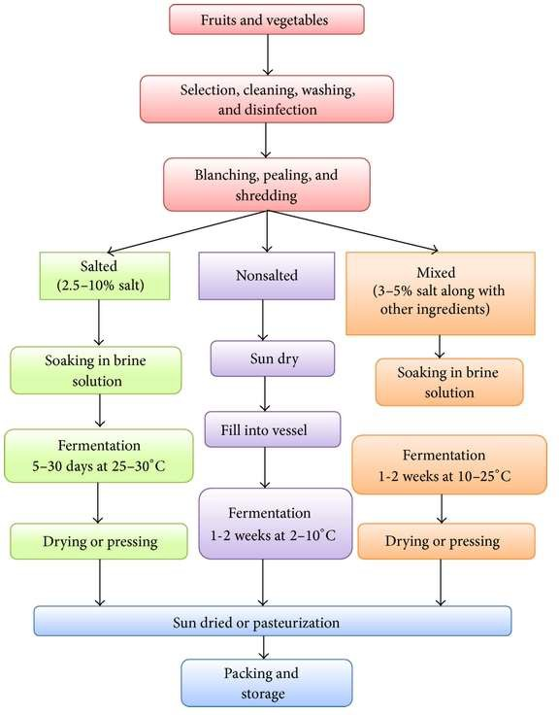

###### Figure 2: Overall fermentation process of fruits and vegetables

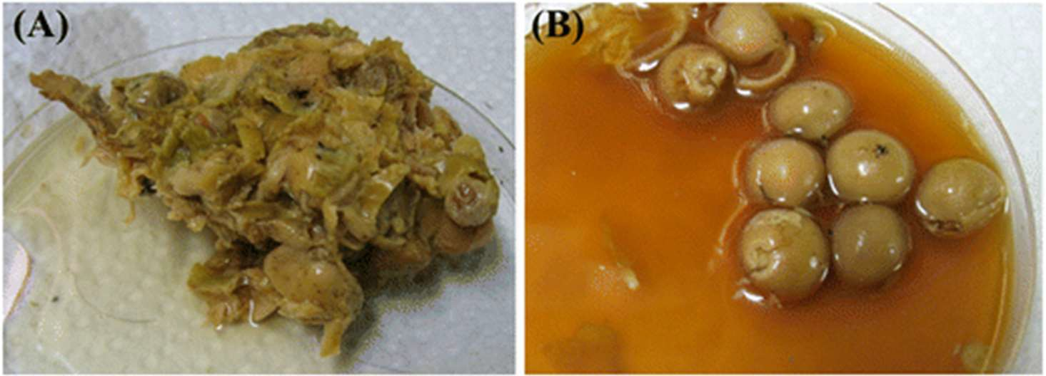 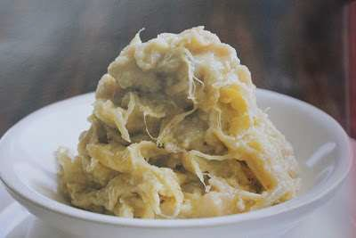

Pobuzihi Tempoyak

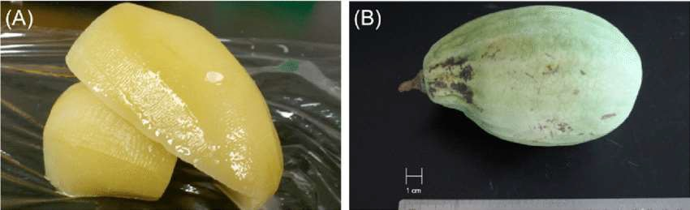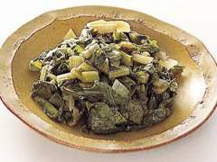

Yan-taozih Sunki

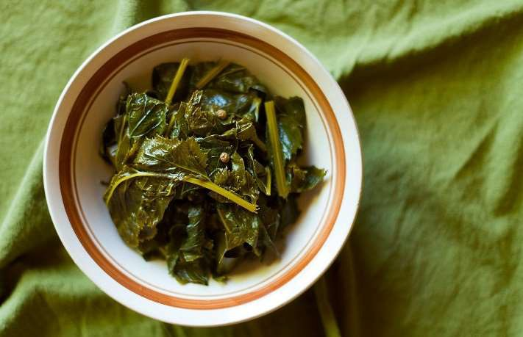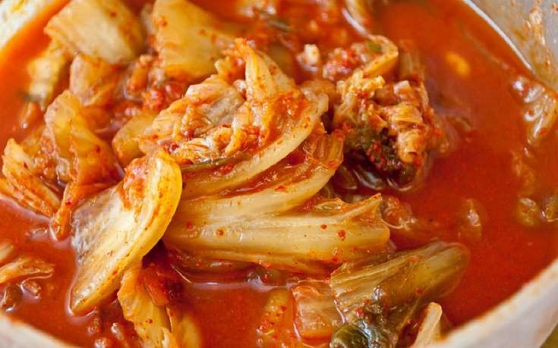

Burong mustala Kimchi

Pictures: Fermented fruits and vegetable’s used in Asian Subcontinent.

Depending on the type of raw materials in final fermented products, vegetable fermentation is characterized accordingly. Sauerkraut, fermented cucumbers, and kimchi are the most studied lactic acid fermented vegetables mainly due to their commercial importance. Canning or freezing is often too expensive method in food preservation which cannot be affordable by millions of world’s economically deprived people and lactic acid fermentation.

Fermented fruits and vegetables (Table 2) have an important role in feeding the world’s population on every continent today. They play an important role in preservation, production of wholesome nutritious foods in a wide variety of flavours, aromas, and textures which enrich the human diet and remove antinutritional factors to make the food safe to eat. Fermentation serves many benefits, which include food security, improved nutrition, and better social well-being of the people living in marginalized and vulnerable society. Fermentation-based industries are an important source of income and employment in Asia, Africa, and Latin America. Fermentation of fruits and vegetables can occur “spontaneously” by the natural lactic bacterial surface microflora, such as Lactobacillus spp., Leuconostoc spp., and Pediococcus spp.; however, the use of starter culture such as L. plantarum, L. rhamnosus, L. gasseri, and L. acidophilus provides consistency and reliability of performance.

Table 2: Nutritive values and scientific names of fruits and vegetables mostly used for lactic acid fermentation

.

|  |  |  |  |  |
| --- | --- | --- | --- | --- |
|  | | | | |
| Common name | Nutrient composition | Botanical name | Used for | Country |
|  | | | | |
| Leafy vegetables | | | | |
| Broccoli | Carbohydrate s 6.64%,  Sugars 1.7% Protein 2.82%  Fat 0.37%  Dietary fiber 2.6% | Brassica oleracea L. var. italica | Yan-tsai- shin | Taiwan |
| Cabbage | Carbohydrate s 5.8%, | Brassica oleracea | Dhamuoi Gundruk | Vietnam India |

|  |  |  |  |  |
| --- | --- | --- | --- | --- |
|  | Sugars 3.2% Protein 1.28%  Fat 0.1%  Dietary fiber  2.5 g |  | Kimchi Paocai Sauerkraut Suan-tsai | Korea China Internationa l  Taiwan |
| Chinese cabbage | Carbohydrate s 3.08%,  Protein 0.75%  Fat 0.01%  Vitamin K and Molybdenum | Brassica rapa, subsp. Pekinensi s | Suan-tsai | Taiwan |
| Mustard leaf | Carbohydrate s 4%  Protein 5%  Total fat 1% | Brassica juncea | Burong mustala Dakguadon g  Dua muoi | Philippines Thailand Vietnam India |

|  |  |  |  |  |
| --- | --- | --- | --- | --- |
|  | Dietary fiber 9% |  | Inziangsang Pak-Gard- Dong  Suan-tsai | Thailand Taiwan |
|  | | | | |
| Root and tubers | | | | |
| Beet | Carbohydrate s 9.96%  Sugars 7.96% Protein 1.68%  Fat 0.18%  Dietary fiber 2.0% |  |  |  |
| Carrots | Carbohydrate s 9.6%,  Sugars 4.7% Protein | Daucus carota | Kanji | India |

|  |  |  |  |  |
| --- | --- | --- | --- | --- |
|  | 0.93%  Fat 0.24%  Dietary fiber 2.8% |  |  |  |
| Ginger | Carbohydrate s 71.62%,  Sugars 3.39% Protein 8.98%  Fat 4.24%  Dietary fiber 14.1% | Zingiber officinale Rosco e | Yan-jiang | Taiwan |
| Radish | Carbohydrate s 3.4%  Sugars 1.86% Protein 0.68%  Dietary fiber | Raphanus sativus | Gundruk Kimchi Paocai Sinki | India Korea China India |

|  |  |  |  |  |
| --- | --- | --- | --- | --- |
|  | 1.6%  Fat 0.1% |  |  |  |
| Turnip | Carbohydrate s 5%  Protein 1.5%  Fat 0.9%,  Dietary fiber 5% | Brassica  rapa subsp. Rapa | Nozuwana- Zuke Sunki | Japan Japan |
|  | | | | |
| Vegetables | | | | |
| Bamboo Shoot | Carbohydrate s 5.2%  Sugars 3%  Protein 2.6%  Fat 0.3%  Dietary fiber 2.2%  Potassium | Bambusa tulda | Soidon | India |

|  |  |  |  |  |
| --- | --- | --- | --- | --- |
|  | 11%  Zinc 12% |  |  |  |
| Cauliflower | Carbohydrate s 5%  Sugars 1.9%  Protein 1.9%  Fat 0.3%  Dietary fiber 2% | Brassica oleracea | Gundruk | Nepal |
| Cucumber | Carbohydrate 2.7%  Protein 0.67%  Fat 0.13%  Dietary fiber 0.8% | Cucumis sativus | Jiang-gua Khalpi Paocai | Taiwan Nepal, India China |
| Eggplant | Carbohydrate 2% | Solanum melongena | Ca muoi | Vietnam |

|  |  |  |  |  |
| --- | --- | --- | --- | --- |
|  | Protein 2% Dietary fiber 12%  Vitamin C 3% |  |  |  |
| Green onion | Carbohydrate s 6%  Protein 3%  Fat 1% Dietary fiber 7% | Allium wakegi | Kimchi | Korea |
| Wax gourd | Carbohydrate s 3%  Protein 2%  Fat 0.5%  Dietary Fiber 7% | Benincasa hispida Thunb. | yan-dong- gua | Taiwan |
|  | | | | |

|  |  |  |  |  |
| --- | --- | --- | --- | --- |
| Fruits | | | | |
| Cummingcordi a |  | Cordia dichotoma  G. Forst. | Pobuzihi | Taiwan |
| Durian | Carbohydrate s 27.09%  Protein 1.47%  Fat 5.33%  Dietary fiber 3.8% | Durio zibethinus | Tempoyak | Malaysia |
| Olive | Carbohydrate s 3.84%  Sugars 0.54% Protein 1.03%  Fat 15.32% | Olea europaea L. | Olive | Spain, Italy |

|  |  |  |  |  |
| --- | --- | --- | --- | --- |
|  | Dietary fiber 3.3% |  |  |  |
| Pak-sian |  | Gynandropsis pentaphylla | Pak-sian- dong | Thailand |
| Peaches | Carbohydrate s 9.54%  Sugars 8.39%  Protein 1%  Fat 0.25%  Dietary fiber 1.5%  Vitamin C 8% | Prunus persica (L.) Stokes | Yan-taozih | China and Taiwan |
|  | | | | |

Fruits and vegetables are exclusive sources of water-soluble vitamins C and B-complex, provitamin A, phytosterols, dietary fibres, minerals, and phytochemicals for the human diet. Vegetables have low sugar content but are rich in minerals and vitamins and have neutral pH and thus provide a natural medium for LA fermentation. LA fermentation enhances the organoleptic

and nutritional quality of the fermented fruits and vegetables and retains the nutrients and colored pigments. LA fermentation of vegetable products applied as a preservation method for the production of finished and half-finished products is considered as an important technology and is further investigated because of the growing amount of raw materials processed in the food industry, and these foods are well suited to promoting the positive health image of probiotics. The consumption of LA fermented fruits and vegetables helps to enhance human nutrition in several ways such as the attainment of balanced nutrition, providing vitamins, minerals, and carbohydrates, and preventing several diseases such as diarrhea and cirrhosis of liver because of probiotic properties. Some of the fermented fruits and vegetables contain colored pigments such as flavonoids, lycopene, anthocyanin, β-carotene, and glucosinolates, which act as antioxidants in the body by scavenging harmful free radicals implicated in degenerative diseases like cancer, arthritis, and ageing. Lactic acid fermentation of vegetables has an industrial significance only for cucumbers, cabbages, and olives. In Italy, the industrial production of fermented vegetables is limited to sauerkrauts and table olives.

According to Kim et al. the Chinese cabbage, cabbage, tomato, carrot, and spinach provide relatively higher fermentability than other vegetables (okra and gourds) because they have more fermentable saccharides. The most reported fermented fruits and vegetables are categorized as follows.

1. Root vegetables: carrots, turnips, beetroot, radishes, celeriac, and sweet potato.
2. Vegetable fruits: cucumbers, olives, tomatoes, peppers, okra, and green peas.
3. Vegetables juices: carrot, turnips, tomato pulp, onion, sweet potato, beet, and horseradish.
4. Fruits: apples, pears, immature mangoes, immature palms, lemons, and fruit pulps such as banana.

## Traditional Fermented Fruits and Vegetables in India

In eastern Himalayan regions of India, a wide range of fermented vegetable products are prepared for bioprocessing the perishable vegetable for storage and further consumption. Lactic acid fermentation vegetables such as gundruk, sinki, and khalpi are fermented vegetable product of Nepal, Sikkim, and Bhutan.Lactobacillus brevis, L. plantarum, Pediococcus pentosaceus, P. acidilactici, and Leuconostoc fallax are the predominant LAB involved in ethnic fermented vegetables. Predominant functional LAB strains associated with the ethnic fermented tender bamboo shoot products, mesu, soidon, soibum, and soijim of the Himalayas, were identified as L. brevis, L. plantarum, L. curvatus, P. pentosaceus, L. mesenteroides subsp. mesenteroides, L. fallax, L. lactis, L. citreum, and Enterococcus durans. Some of the LAB strains may also possess protective and functional properties that render them as interesting candidates for use as starter culture(s) for controlled and optimized production of fermented vegetable products.

#### Gundruk

Gundruk is a nonsalted, fermented, and acidic vegetable product indigenous to the Himalayas. During fermentation of gundruk, fresh leaves of local vegetables known as rayosag (Brassica rapa subsp. campestris var. cuneifolia), mustard leaves (Brassica juncea (L.) Czern), cauliflower leaves (Brassica oleracea L. var. botrytis L.), and cabbages (Brassica sp.) are wilted for 1-2 days. Wilted leaves are crushed mildly and pressed into a container or earthen pot, made airtight and

fermented naturally for about 15–22 days. After desirable fermentation, products are removed and sun-dried for 2–4 days. Gundruk is consumed as pickle or soup and has some resemblance with other fermented acidic vegetable products such as kimchi of Korea, sauerkraut of Germany, and sunki of Japan. The predominant microflora of Gundruk includes various LAB such as L. fermentum, L. plantarum, L. casei, L. casei subsp. pseudoplantarum, and Pediococcus pentosaceus.

#### Sinki

Sinki, an indigenous fermented radish tap root food, is traditionally prepared by pit fermentation, which is a unique type of biopreservation of foods by LA fermentation in the Sikkim Himalayas. For sinki production, a pit was dug with 2-3 ft diameter in a dry place. The pit is cleaned, plastered with mud, and warmed by burning. After removing the ashes, the pit is lined with bamboo sheaths and paddy straw. Radish tap roots are wilted for 2-3 days, crushed, dipped in lukewarm water, squeezed, and pressed tightly into the pit, covered with dry leaves and weighted down by heavy planks or stones. The top of the pit is plastered with mud and left to ferment for 22–30 days. After fermentation, fresh sinki is removed, cut into small pieces, sun-dried for 2-3 days, and stored at room temperature for future consumption. Pit fermentation has been practiced in the South Pacific and Ethiopia for preservation of breadfruit, taro, banana, and cassava. Sinki fermentation is carried out by various LAB including L. plantarum, L. brevis, L. casei, and Leuconostoc fallax.

#### Khalpi

Khalpi or khalpi is a fermented cucumber (Cucumis sativus L.) product, commonly consumed by the Brahmin Nepalis in Sikkim. It is the only reported fermented cucumber product in the entire Himalayan region. Ripened cucumber is cut into suitable pieces and sun-dried for 2 days, and then put into a bamboo vessel and made airtight by covering with dried leaves. It is fermented naturally at room temperature for 3–5 days. Fermentation after 5 days makes the product sour in taste. Khalpi is consumed as pickle by adding mustard oil, salt, and powdered chilies. Khalpi is prepared in the months of September and October. Microorganisms isolated from Khalpi include L. plantarum, L. brevis, and Leuconostoc fallax.

#### Inziangsang

In Northeast India, especially the people of Nagaland and Manipur consume Inziangsang, traditional fermented leafy vegetable product prepared from mustard leaves and similar to gundruk. Preparation process of inziangsang is like of gundruk. Mustard leaves, locally called hangam (Brassica juncea L. Czern), are collected, crushed, and soaked in warm water. Leaves are squeezed to remove excess water and pressed into the container and made airtight to maintain the anaerobic condition. The container is kept at ambient temperature (20°C–30°C) and allowed to ferment for 7–10 days. Like gundruk, freshly prepared inziangsang is sun-dried for 4-5 days and stored in a closed container for a year or more at room temperature for future consumption. Nagaland people consume inziangsang as a soup time with steamed rice. In resident meal, the fermented extract of ziang dui is used as a condiment. This fermentation is also supported by set of LAB which includes L. plantarum, L. brevis, and Pediococcus.

#### Soidon

Soidonis a widespread fermented product of Manipur prepared from the tip of mature bamboo shoots. Main source of fermentation is the tips or apical meristems of mature bamboo shoots (Bambusa tulda, Dendrocalamus giganteus, and Melocanna bambusoides). Outer casings and lower portions of the bamboo shoots were removed and whole tips are submerged in water in an earthen pot. The sour liquid (soijim) of a previous batch is added as starter in 1: 1 dilution, and the preparation is covered. Fermentation was carried out for 3–7 days at room temperature. Leaves of Garcinia pedunculata Roxb. (family: Guttiferae), locally called heibungin in Manipuri language, may be added in the fermenting vessel during fermentation to enhance the flavor of soidon. After 3–7 days, soidon is removed from the pot and stored in a closed container at room temperature for a year.

#### Goyang

Goyang, a prominent traditional fermented vegetable foodstuff of the Sikkim and Nepal, leafs of magane-saag (Cardamine macrophylla Willd.), belonging to the family Brassicaceae, are collected, washed, cut into pieces, and then squeezed to drain off excess water and are tightly pressed into bamboo baskets lined with two to three layers of leaves of fig plants. The tops of the baskets are then covered with fig plant leaves and fermented naturally at room temperature (15°C– 25°C) for 25–30 days.

#### Kanji

Abundant with probiotics from the fermentation process, kanji makes an excellent daily restorative. Drink about half a cup first thing each morning to awaken your body, mind and spirit to another glorious day.

This kanji gets its gorgeous deep violet hue from beets. The many health benefits of both the beets and the carrots are amplified through the culturing process. Along with them you receive a beneficial dose of probiotics to help balance gut function and improve digestion.

Kanji made with golden beets becomes a golden elixir with a milder beet flavor. Perfect for those of you who shy away from beet’s distinctive earthiness**.**

Kanji is rendered to be the best probiotic dink which contains more than 17 probiotic strains are seen in this probiotic drink and it is one of the most searched on the internet as fermented probiotic drink, which helps in enriching immune system and our food on the table.

## Traditional Fermented Fruits and Vegetables in Other Asian Countries

#### Kimchi

Kimchi is a Korean traditional fermented vegetable made from Chinese cabbage (beachu), radish, green onion, red pepper powder, garlic, ginger, and fermented seafood (jeotgal), which is traditionally made at home and served as a side dish at meals. Kimchi is a generic term indicating a group of traditional LA fermented vegetables in Korea. The major raw materials (oriental cabbage or radish) are salted after prebrining, blended with various spices (red pepper, garlic, green onion, ginger, etc.) and other minor ingredients (seasonings, salted sea foods, fruits and vegetables,

cereals, fish, and meats, etc.), and then fermented at low temperature (2–5°C). Kimchi fermentation is temperature-dependent process. It ripens in one week at 15°C and took three days at 25°C. But low temperature is preferred in kimchi fermentation to prevent production of strong acid, overripening, and extended period of optimum taste. Kimchi is characterised particularly by its sour, sweet, and carbonated taste and differs in flavour from sauerkrautand pickles that are popular fermented vegetables. The classical identification of bacterial isolates from kimchi revealed thatLeuconostoc mesenteroides and Lactobacillus plantarum were the predominant species. Several results suggested that LAB contributing to kimchi fermentation include L. mesenteroides, L. citreum, L. gasicomitatum, Lactobacillus brevis, L. curvatus, L. plantarum, L. sakei, L. lactis, P. pentosaceus, W. confusa, and W. koreensis. Some important species thought to be responsible for kimchi fermentation are Leuconostoc mesenteroides, L. pseudomesenteroides, and L. lactis, as the pH gradually falls to 4.0.

Kimchi contains various health-promoting components, including β-carotene, chlorophyll, vitamin C, and dietary fibre. In addition, antimutagen, antioxidation, and angiotensin-converting enzyme inhibition activities of kimchi are thought to protect against disease. Bacteria isolated from kimchi produce beneficial enzymes, such as dextransucrase and alcohol/acetaldehyde dehydrogenase. Because of these beneficial properties, kimchi was nominated as one of the world’s healthiest foods in a 2006 issue of Health Magazine. Optimum taste of kimchiis attained when the pH and acidity reach approximately 4.0–4.5 and 0.5-0.6, respectively. Vitamin C content is maximal at this point.

#### Sauerkraut

Sauerkraut means sour cabbage. In sauerkraut fermentation, fresh cabbage is shredded and mixed with 2.3–3.0% salt before allowing for natural fermentation. Sauerkraut production typically relies on a sequential microbial process that involves heterofermentative and homofermentative LAB, generally involving Leuconostoc spp. in the initial phase and Lactobacillus spp. and Pediococcus spp. in the subsequent phases. The pH of final product varies from 3.5 to 3.8. At this pH, the cabbage or other vegetables will be preserved for a long period of time. Sauerkraut brine is an important byproduct of the cabbage fermentation industry and can be used as a substance for the production of carotenoids by Rhodotorula rubra or for β-glucosidase production by Candida wickerhamii for commercial applications.

#### Paocai

The most favored customary tableware of Chinese is Paocai, a lactic acid fermented vegetable with saltish palate. In certain places of China, the surplus vegetables such as cabbage, celery, cucumber, and radish were retained during superfluous season. Usually Paocai is served as an accompaniment with the chief meal and occasionally used as a Nipple. Paocai is a type of pickle, varies in terms of taste and method of preparation in different areas. Taiwanese paocai has crunchy texture and tangy taste, which is made with many kinds of vegetables, spices, and other ingredients by anaerobic fermentation in a special container. Paocai fermentation is initiated by various microorganisms presented in the raw materials, and LAB become the dominate bacterial finally. Lactobacillus pentosus, L. plantarum, L. brevis, L. lactis, L. fermentum, and Leuconostoc mesenteroides are the LAB isolated from paocai.

#### Yan-Dong-Gua

In Taiwan, the extensively used customary fermented nutriment is Yan-dong-gua, prepared using wax gourd. Harvested wax gourd is washed and sliced into little pieces, dried in sunlight, combined with salt, sugar, and fermented soybeans, and layered in a bucket. Usually, minor mass of Mijiu (Taiwanese rice wine) is mixed in the earlier stage of fermentation and the bucket was sealed. The time of fermentation process is for one month, but it may be elongated even more than two months. Yan-dong-gua is usually used as a seasoning for fish, pork, meatballs, and various other foods. Weissella cibaria and W. Paramesenteroides are the bacteria responsible for fermentation.

#### Tempoyak

Tempoyak is a traditional Malaysian fermented condiment made from the pulp of the durian fruit (Durio zibethinus). Salt is sometimes added to proceed fermentation at ambient temperature. Seeded durian is mixed with small amount of salt and left to ferment at ambient temperature in a tightly closed container for 4–7 days. The acidity of tempoyak was reported as approximately 2.8 to 3.6%. The sour taste of tempoyak is attributed to the acid produced by lactic acid bacteria (LAB) during fermentation. LAB were the predominant microorganisms including Lactobacillus brevis, L. mali, L. fermentum, L. durianis, Leuconostoc mesenteroides, and an unidentified Lactobacillus sp.

#### Sayur Asin

Sayur asin is a fermented mustard cabbage leaf food product of Indonesia. A similar product, hum choy, is produced in China and other South East Asian countries. Mustard cabbage leaves (Brassica juncea var. rugosa) are wilted, rubbed, or squeezed with 2.5%–5% salt. Liquid from boiled rice is added to provide fermentable carbohydrates to ensure that sufficient acid is produced during the fermentation. Fermentation was characterized by a sequential growth of the lactic acid bacteria, Leuconostoc mesenteroides, Lactobacillus confusus, Lactobacillus curvatus, Pediococcus pentosaceus, and Lactobacillus plantarum. Starch degrading species of Bacillus, Staphylococcus, and Corynebacterium exhibited limited growth during the first day of fermentation. The yeasts, Candida sake and Candida guilliermondii, contributed to the fermentation.

#### Salam Juice

Shalgam juice is prepared from the mixture of turnips, black carrot bulgur (broken wheat) flour, salt, and water by lactic acid fermentation. Shalgam is widely used in Turkey. Shalgam juices were prepared by two methods for commercial production, which are the traditional and direct methods. Traditional method has two stages of fermentation that includes sour-dough fermentation (first fermentation) and carrot fermentation (second fermentation). The direct method has only second fermentation. The shalgam juice fermentation was mainly carried out by LAB that belong to the genera Lactobacillus, Leuconostoc, and Pediococcus. The LAB species predominantly include Lactobacillus plantarum, L. brevis, L. paracasei, L. buchneri, and Pediococcus pentosaceus.

#### Yan-Taozih

Yan-taozih (pickled peaches) is a popular pickled fruit in China and Taiwan. Fresh peaches (Prunus persica) are mixed with 5%–10% salt and then shaken gently until water exudes from the peaches. The peaches are then washed and mixed with 5%–10% sugar and 1%-2% pickled plums. All of the ingredients are mixed well and then allowed to ferment at low temperature (6–10°C) for

1 day. Chen et al. isolated Leuconostoc mesenteroides,L. lactis, Weissella cibaria, W. paramesenteroides, W. minor, Enterococcus faecalis, and Lactobacillus brevis from Yan-taozih.

#### Pobuzihi

Pobuzihi is a widely used traditional fermented food prepared with cummingcordia in Taiwan. Two types of Pobuzihi are mainly available that can be easily differentiated from the appearance of the final products. Caked or granular pobuzihi is prepared by boiling cummingcordia for several minutes and mixing it with salt. The caked pobuzihi is prepared by filling up the boiled cummingcordia into containers and after cooling removed from the containers. Chen et al. isolated novel Lactobacillus pobuzihii, L. plantarum, Weissella cibaria, W. paramesenteroides, and Pediococcus pentosaceus from fermented pobuzihi.

#### Nozawana-Zuke

Nozawana-zuke is a low-salt pickle prepared by using field mustard, locally called Nozawana, a leafy turnip plant. It is majorly consumed by Japanese people. The pickle is manufactured by lactic

acid fermentation after adding various inorganic salts and red pepper powder containing spicy components to nozawana. The fermentation is achieved by various plant-derived genera of lactic acid bacteria (LAB), including Lactobacillus and Leuconostoc. These LAB contribute to generating the sensory properties of Nozawana zuke and preventing its contamination from disadvantageous bacteria by producing organic acids. The fermentation was carried out by Lactobacillus curvatus.

#### Yan-Jiang

Yan-jiangis a traditional fermented ginger widely used in Taiwan. It is prepared by two methods, such as with addition of plums and without addition of plums. The ginger was washed, shredded, mixed with salt (NaCl), and layered in a bucket for 2–6 h. After the exuded water is removed, the ginger is mixed with sugar, and pickled plums are added only in method P. Salt and sugar are added to a final concentration of approximately 30–60 g kg−1. Fermentation usually continues for 3–5 days at low temperature (6–10°C), but some producers maintain a fermentation time of 1 week or even longer. Initial fermentation was carried out by Lactobacillus sakei and Lactococcus lactis subsp. Lactis and this species are replaced by Weissella cibaria and L. plantarum at the final stages of fermentation.

#### Yan-Tsai-Shin

Yan-tsai-shin is a fermented Broccoli (Brassica oleracea) stem, which is belonging to cabbage family. It is widely used in Taiwan. Harvested broccoli is washed, peeled, cut, mixed with salt

(NaCl), and filled in a bucket for approximately 6 h. After the exuded water is removed, fermented broccoli is mixed with various ingredients, including sugar, soy sauce, and sesame oil. Some producers also add rice wine or sliced hot pepper to obtain a unique flavour. The ingredients were mixed well and then fermented at low temperature (6–10°C) for 1 day. The most common bacterial species include Weissella paramesenteroides, W. cibaria, W. minor, Leuconostoc Mesenteroides, Lactobacillus Plantarum, and Enterococcus sulphurous.

#### Jiang-Gua

Jiang-guais a popular traditional fermented cucumber in Taiwan that can be served as a side dish or a seasoning. Harvested cucumbers are washed, cut, mixed with salt (NaCl), layered in a bucket, and then sealed with heavy stones on the cover. This process usually continues for 4-5 h, but some producers maintain a longer processing time. After the exuded water has been drained off, the cucumbers are mixed with sugar and vinegar. In addition, soy sauce is added optionally depending on the recipe. Fermentation usually continues for at least 1 day at low temperature (6–10°C). Fermentation depends uponWeissella cibaria, W. hellenica, L. Plantarum, Leuconostoc lactis, and Enterococcus casseliflavu.

## 2.6. Other Fermented Vegetables and Fruits

Pickles from various vegetables and fruits such as mango and amla are dietary supplements and used for culinary purposes in several parts of the world. Pickling of cucumber is made in Africa, Asia, Europe, and Latin America. Khalpi is a cucumber pickle popular during summer months in

Nepal. Although, a variety of methods are used, placing the cucumbers in 5% salt brine is a satisfactory method. The cucumbers absorb salt until there is equilibrium between the salt in the cucumbers and the brine (about 3% salt in the brine). When the pH attains at about 4.7–5.7, the brine is inoculated with either L. plantarum or Pediococcus pentosaceus or a combination of these organisms for a total cell count of 1–4 billion cells/gallon of brined cucumbers. The final product has an acidity of 0.6–1.0% (as LA) and a pH of 3.4–3.6 in about two weeks, depending upon the temperature. Similarly, sweet potato lacto-pickles may serve as an additional source of pickle with usual beneficial probiotic properties.

Different varieties of onions such as sweet, white and yellow storage were used for LA fermentation. White and yellow storage onions are typically used for processing due to their high solid content, so they were chosen for fermentation. Sweet onions are a spring/summer variety with low solids and mild flavour and are often consumed fresh.

Sweet cherry is one of the most popular of temperate fruits. Italy, together with United States, Iran, and Turkey, is one of the main world producers of sweet cherries.

The fermentation of beetroot and carrot juices, with addition of brewer’s yeast autolysate, was also carried out by various workers like Rankin et al. A mixture of beetroot and carrot juices with brewer’s yeast autolysate (fermented bio product) has optimum proportions of pigments, vitamins, and minerals. This balanced material represents a valuable product as far as nutrition and health are concerned. Red beets were evaluated as a potential substrate for the production of probiotic beet juice by four species of lactic acid bacteria (Lactobacillus acidophilus, L. casei, L. delbrueckii, and L. plantarum).

Spontaneous cauliflower fermentation is commonly encountered in many countries with local variations depending mainly upon tradition and availability of raw materials. L. plantarum and Leuconostoc mesenteroideswere isolated from the cauliflower fermentation.

The consumption of LA fermented vegetable juices (lacto-juice) has increased in many countries. Lacto-juices are produced mainly from cabbage, red beet, carrot, celery, and tomato. They can be produced by either of the following procedures:

1. usual way of vegetable fermentation and then processed by pressing the juice (manufacture from sauerkraut)
2. fermentation of vegetable mash or juice.

There are three types of lactic fermentation of vegetable juices:

1. spontaneous fermentation by natural microflora.
2. fermentation by starter cultures that are added into raw materials. (iii)fermentation of heat-treated materials by starter cultures.

During the manufacture of lacto-juices, the pressed juice can be pasteurized at first and consecutively it is inoculated by a culture of selected LAB at a concentration varying from 2 × 105 to 5 × 106 CFU/mL. For fermentation of juices of highest quality, it is imperative to use commercially supplied starter cultures such as L. plantarum, L. bavaricus, L. xylosus, L. bifidus, and L. brevis. The criteria used for finding out suitability of a strain are as follows:

1. the rate and total production of LA, change in pH, loss of nutritionally important substances.
2. decrease in nitrate concentration and production of biogenic amines (BAs). (iii)ability of substrate to accept a starter culture.

(iv)type of metabolism and ability of culture to create desirable sensory properties of fermented products.

THE BEST BREAKFAST- IDLI

Before moving forward to the benefits of fermented foods, a study shows that idli is referred to one of healthiest breakfast in the world. They are light and doesn't make you feel lethargic. Moreover, idlis are made with rice, so it is difficult to digest this staple south-Indian dish. Idlis are gluten-free because they are not made with wheat. So, if you are gluten to wheat, you can have idlis over rotis or paranthas for breakfast. Idli is nutritious as it is a rich source of carbohydrates, fibres and proteins. As idlis are fermented, it becomes more protein and vitamin rich. When fermented, the bio availability of proteins and vitamins B content in the food increases. Because of the good bacteria present in them. If not with rice sprouted moong beans and oats idli is an impeccable way to start a healthy day with a healthy breakfast. These idlis have healthy ingredients like sprouted green moong and oats instead of rice. So, this is an ideal breakfast and snack for diabetic and overweight people. Idli as breakfast with ultimate health advantage is recoganised by many international health organisation. Moong bean is the easiest bean to sprout. It has a nutty and crispy taste. Moong bean sprout is called a miracle food because of its high nutritional value. These sprouts are low in calories and rich in dietary fiber. Moong beans are a high source of nutrients like proteins, manganese, potassium, magnesium, folate, copper, zinc and vitamins B, C & K. These beans also protect us against several diseases like heart disease, diabetes and cancer

# 3.0 BENEFITS OF FERMENTED FOOD

#### Advantages of having Fermented foods in daily diet.

* + 1. **Improves Digestion**

Fermentation breaks down nutrients into more easily digestible forms. When lactobacilli in fermented foods proliferate, their vitamin levels increase and digestibility is enhanced. When it comes to soybeans, this protein-rich bean is indigestible without fermentation. Fermentation breaks down the soybean’s complex protein into readily digestible amino acids, giving us traditional Asian ingredients, such as miso, tamari (soy sauce) and tempeh.

Milk is also difficult for many individuals to digest. A type of bacteria present in fermented dairy products converts lactose, the milk sugar that many individuals cannot tolerate, into digestible lactic acid. In a study out of France on women who reported minor digestive problems, those women reported improved gastrointestinal digestive symptoms when fermented milk containing *Bifidobacterium lactis* was consumed.

#### Has Anticancer Effects

Cancer is caused by activation or mutation of abnormal genes, which control cell growth and division. Researchers believe probiotic cultures and fermented foods might decrease the exposure to chemical carcinogens by:

* + - * detoxifying the ingestion of carcinogens
      * altering the environment of the intestine and decreasing metabolic activities or populations of bacteria that may generate carcinogenic compounds
      * producing metabolic products that cause programmed cell death or apoptosis
      * producing compounds that inhibit the growth of tumor cells
      * stimulating the immune system to defend itself against cancer cell proliferation

There are several reports on the ways fermented foods can help treat cancer:

* + - * Large cohort studies in the Netherlands and Sweden have observed the effects of regular consumption of fermented dairy products in reducing the risk of bladder cancer.
      * Strains of bacteria called lactobacillus prevent toxicity of heavy metals by excreting harmful heavy metals and heterocyclic aromatic amines, carcinogens found in overcooking meat.
      * Kimchi, a fermented cabbage cuisine, contains strains that promote the degradation of organophosphorus pesticides, by breaking down a cancer-causing food preservative called sodium nitrate.

#### Enhances Bioavailability of Nutrients

Fermentation helps create new nutrients, like B vitamins, folic acid, riboflavin, niacin, **thiamine** and biotin, and has been shown to improve the availability, digestibility and quantity of some dietary nutrients. The bioavailability of fat and protein are enhanced by bacterial enzymatic hydrolysis, and the production of lactic acid, **butyric acid**, free amino acids and short chain fatty acids (SCFA) are increased by lactic acid bacteria.

When SCFAs are absorbed, they may help protect against pathological changes in the colonic mucosa. They play an important role in maintaining an appropriate pH in the colon, which is important in the expression of various of bacterial enzymes and in carcinogen and foreign compound metabolism in the gut.

#### Reduces Symptoms of Lactose Intolerance

Lactobacillus consumes lactose in milk and transforms it into lactic acid that may be easier for individuals to digest. Lactic acid in yogurt reduces **symptoms of lactose intolerance** in individuals who are lactase-deficient. This may be because the lactic acid bacteria in the milk causes an increase of lactase in the small intestine.

#### Improves Arthritis Symptoms

Most people know someone with arthritis. It is the leading cause of disability, with symptoms including aching, pain, stiffness and swelling of the joints. It is thought that inflammation associated with **rheumatoid arthritis symptoms** may be modulated by the consumption of

fermented foods.

A randomized, double-blind, placebo-controlled pilot study of probiotics in active rheumatoid arthritis found that “patients with at least four swollen and four tender joints and stable medications with no steroids for at least one month prior to and during the study, showed a significant improvement in the Health Assessment Questionnaire score after three months of probiotic treatment.”

## Probiotic Microorganisms

#### Lactic Acid Bacteria

The genus Lactobacillus is a heterogeneous group of LAB with important application in food and feed fermentation. Lactobacilli are used as probiotics inoculants and as starters in fermented food. The genusLactobacillus is Gram-positive organisms which produce lactic acid by fermentation and Lactobacillus are also considered in LAB group due to lactic acid production ability.

The genus Lactobacillus is a heterogeneous group of LAB with important implications in food and feed fermentation. Lactobacilli are currently used as probiotics, silage inoculants, and as starters in fermented food. The genus Lactobacillus belongs to the large group of LAB, which are all Gram-positive organisms which produce lactic acid by fermentation. Genera of LAB include, Lactococcus, Enterococcus, Oenococcus, Pediococcus, Streptococcus, Leuconostoc, and Lactobacillus. Lactobacillus is rod shaped, often organized in chain belonging to a large group within a family Lactobacillaceae. They grow well in anaerobic condition and strictly fermentative in nature. Lactobacillus is generally divided into two groups depending on the ability of the sugar fermentation: homofermentative species, converting sugars mostly into lactic acid and heterofermentative species, converting sugars into lactic acid, acetic acid and CO2. LAB can influence the flavour of fermented foods in a variety of ways. During fermentation, lactic acid is produced due to the metabolism of sugars. As a result, the sweetness tastes will likely decrease as sourness increases.

Lactobacilli prefer relatively acidic conditions ranges from pH 5.5 to 6.5 due to the main catabolite as lactic acid. It can be found in a wide range of ecological niches such as plant, animal, raw milks, and in insects. Due to the wide verity in habitat Lactobacillus possess a wide range of metabolites versatility in the LAB group. It has been used for food preservation, starter for dairy products,

fermented vegetables, fish, and sausages as well as silage inoculants for decades. Lactobacillus is proposed as potential probiotics due to its potential therapeutic and prophylactic attributes. L. paracasei, L. rhamnosus, and L. casei belong to the group of lactobacillus which are commonly found in food and feed as well as common inhabitants of the animal/human gastrointestinal tract (GIT). L. plantarum is considered a food-grade microorganism because of its long and documented history of safe use in fermented foods. L. fermentum, one of the best-known species of this group, has been isolated from vegetable and dairy fermentation.

The Weissella species are Gram-positive, catalase negative, non-spore-forming, heterofermentative, nonmotile, irregular, or coccoid rod-shaped organisms. Members of the genus Weissella have been isolated from a variety of sources, such as fresh vegetables and fermented silage.The genus Weissella encompasses a phylogenetically coherent group of lactic acid bacteria and includes eight Leuconostoc-like species, includingWeissella confuse (formerly Lactobacillus confuses), W. minor (formerly Lactobacillus minor), W. kandleri(formerly Lactobacillus kandleri), W. halotolerans (formerly Lactobacillus halotolerans), W. viridescens (formerlyLactobacillus viridescens), W. paramesenteroides (formerly Leuconostoc paramesenteroides), and W. hellenica.

#### Definition and Mechanism of Action of Probiotics

According to the Food and Agriculture Organization (FAO) Probiotics are defined as “living microorganisms which, when administrated in adequate amounts, confer health benefit on the

host”. Many studies supported that maintenance of health gut microflora provides protection against gastrointestinal disorder including gastrointestinal infections and inflammatory bowel diseases. On the other hand, probiotics can be used as an alternative to the use of antibiotics in the treatment of enteric infection or to reduce the symptoms of antibiotic associated diarrhea. Probiotic bacterial cultures support the growth of intestinal microbiota, by suppressing potentially harmful bacteria and reinforce the body’s natural defence mechanisms. Currently, much evidence exists on the positive effects of probiotics on human health.

#### Selection and Application of Probiotics

Lactobacilli are the most extensively studied and widely used probiotics within the LAB. Most Lactobacillusstrains belong to the L. acidophilus group. L. paracasei, L. plantarum, L. reuteri, and L. salivarius, which represent the respective phylogenetic groups, are known to contain probiotic strains. In order for a probiotic to be of benefit to human health, it must fulfil several criteria (Figure 3). It must survive passage through the upper GIT and reach its site of action alive, and it must be able to function in the gut environment. The functional requirements of probiotics include tolerance to human gastric juice and bile, adherence to epithelial surfaces, persistence in the human GIT, immune stimulation, antagonistic activity toward intestinal pathogens and the capacity to stabilize and modulate the intestinal microbiota.

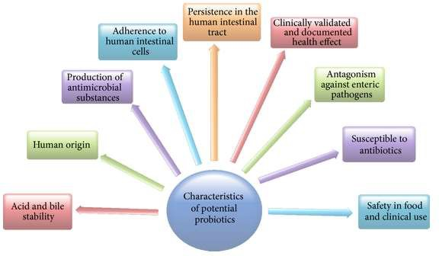

Figure 3: Basic characteristics of selection of a probiotic strain.

#### Role of Ingredients Used in Fermentations of Fruits and Vegetables

* + 1. **Addition of Salt**

LA fermentation of fruits and vegetables is mostly carried out in a salted medium. Salting is done by adding common dry salt (NaCl) with high water content or by soaking in brine solution. The optimum salt concentration depends on the type of vegetables or fruits. Substituting NaCl by KCl up to 50% in the preparation of kimchi from cabbage did not affect the sensory qualities (saltiness, bitterness, sourness, hotness, and texture). The main role of salt is to promote the growth of LAB

over spoilage bacteria and to inhibit potential pectinolytic and proteolytic enzymes that can cause vegetable softening and further putrefaction. Salt induces plasmolysis in the plant cells and the appearance of a liquid phase, which creates anaerobic conditions around the submerged product. Anaerobic conditions are more effective in the finely cut and shredded cut material.

#### Ingredients Favoring Bacterial Growth

Some ingredients when added to LA fermented vegetables or fruits seem to enhance the development of lactic flora. They have three major roles:

(i)they are a source of nutrients such as sugars, vitamins, and minerals which initiate fermentation; (ii)they add desirable aroma, flavour, and taste to the fermented product;

(iii)they help in combating the spoilage bacteria by lowering the pH.

For some vegetables with low nutrient contents, such as turnip and cucumber, the addition of sugar promotes bacterial growth, thereby accelerating fermentation. In Spanish-style olive fermentation, olives have undergone alkaline treatment to eliminate their bitterness, followed by repeated washings. They are then replaced with glucose on sucrose to improve LA fermentation. Whey is often recommended for use in traditional LA vegetable fermentation processes as it has high lactose content, which is a potential energy substrate for LAB. It also supplies minerals salts and vitamins necessary for the lactic flora metabolism.

#### Ingredients with Antiseptic Properties

Spices or aromatic herbs are added to most of the lactic fruits and vegetable fermentation to improve the flavour of the end products. Certain spices, mainly garlic, cloves, juniper berries, and

red chillies help to inhibit the growth of spoilage bacteria. There are many sulphur compounds with antibacterial properties in garlic which must be combined with other vegetables at ratios not higher than 150 g/kg of vegetables. Chemical preservatives such ascorbic on benzoic acid salts are sometimes used in industrial production of LA fermented sauerkraut, olives, or cucumbers. The role of essential spice oils such as thyme, sage, lemon, and dill are to inhibit the growth during fermentations of olives. Mustard seed contains allyl isothiocyanate, a volatile aromatic compound with antibacterial and antifungal properties, which inhibits the growth of yeast (Saccharomyces cerevisiae) and promotes growth of LAB.

#### Ingredients Modifying the pH and Buffers Effect of Brines

To promote the growth of LAB over yeasts, moulds and other pathogenic or unwanted bacterial strains, acids, or buffer systems (acid + acid salts) are often added to the fermentation medium. During the fermentation of fruits and vegetables with high fermentable sugar contents, the fermentation medium has to be buffered to slow down acidification, thus allowing the LAB to consume all the sugars. An acetic acid + calcium acetate buffer system has been reported to improve the LA cucumber fermentation process.

#### Beneficial Effect of Fermented Fruits and Vegetables

* + 1. **Enhancing Food Quality and Safety**

Nutritional quality of food can be enhanced by fermentation, which may improve the digestibility and beneficial components of fermented food. The raw materials have increased the level of vitamin and mineral content compared to its initial content. Several antimicrobial compounds such as organic acids, hydrogen peroxide, diacetyls, and bacteriocins are produced during the

fermentation process, which impacts unrequited bacterial growth and on the other hand increases the shelf life of the food.

Lactic acid content of fermented food product may enhance the utilization of calcium, phosphorus, and iron and also increase adsorption of iron and vitamin D. Fermented foods have a variety of enzymes and each enzyme can play a different role in increasing food quality. Lactase in fermented food product degrades the lactose into galactose. Galactose is an important constituent of cerebroside that can promote brain development in infants. Similarly, proteinases produced by LAB can break down the casein into small digestible molecules. Fermented foods are rich in globular fats which can be easily digested.

#### Removal of Antinutrient Compounds

Most of the fruits and vegetables contain toxins and antinutritional compounds. These can be removed or detoxified by the action of microorganisms during fermentation process. Plant foods contain a series of compounds, collectively referred to as antinutrients, which generally interfere with the assimilation of some nutrients and in some cases may even confer toxic or undesirable physiological effects. Such antinutrients include oxalate, protease, and α-amylase inhibitors, lectins, condensed tannins, and phytic acid. Numerous processing and cooking methods have been shown to possibly reduce the amount of these antinutrients and hence their adverse effects. It has been concluded that the way food is prepared and cooked is equally important as the identity of the food itself. Research is currently focused on identifying the antinutrient effect of several constituents rather than studying their fate during lactic acid fermentation.

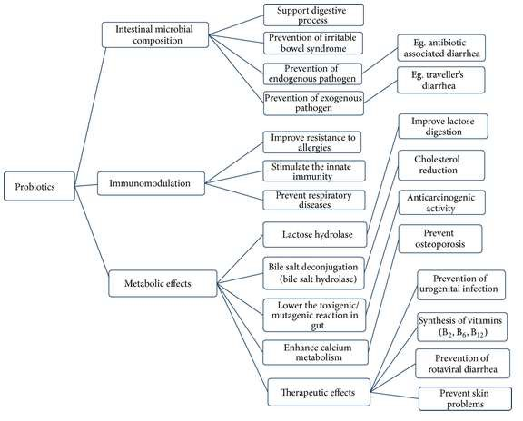

Figure 4: Beneficial effects of probiotics

#### Improving the Health Benefits of Humans

Several researchers have described the beneficial effects of LAB. This can modify

the intestinal microbiota positively and prevent the colonization of other enteric pathogens. LAB strains also improve the digestive functions, enhance the immune system, reduce the risk of colorectal cancer, control the serum cholesterol levels, and eliminate the unrequired antinutritional

compounds present in food materials. The overall health benefits of LAB are elucidated in Figure 4.

Your gut contains both beneficial and harmful bacteria. Digestive experts agree that the balance of gut flora should be approximately 85 percent good bacteria and 15 percent bad bacteria.

If this ratio gets out of balance, the condition is known as dysbiosis, which means there’s an imbalance of too much of a certain type of fungus, yeast or bacteria that affects the body in a negative way. By consuming certain types of probiotics foods and supplements, you can help bring these ratios back into balance.

Also, it’s important to understand that probiotics are not a new idea. Throughout history, cultures have thrived on probiotics found in fermented foods and cultured foods, which were invented for food preservation long before the refrigerator.

In fact, the refrigerator could be one of the worst inventions for your digestive health because now we don’t have to culture or ferment our foods to keep them from spoiling so we lose out on those vital probiotics and probiotics benefits.

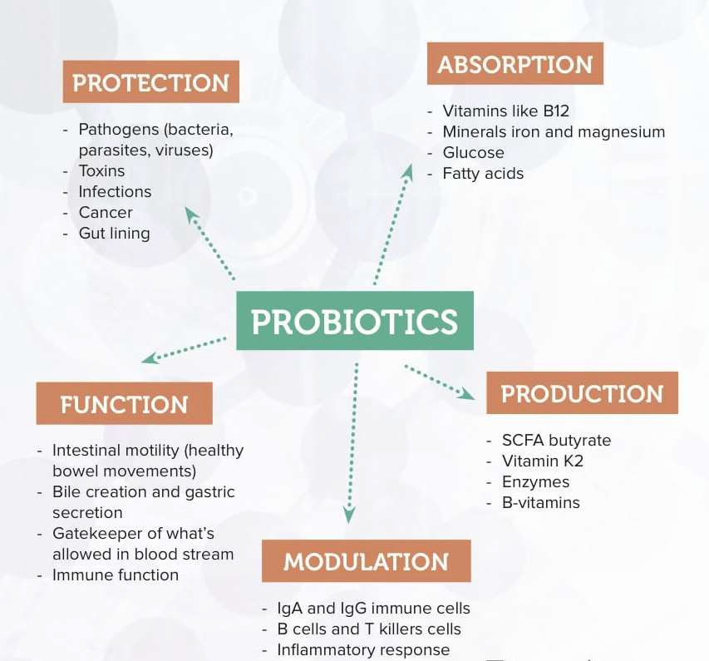

Figure 5: Health Benefits of probiotics for human body

#### Importance of Probiotics

Probiotics play a role in defining and maintaining the delicate balance between necessary and excessive defense mechanisms. The immune response is initiated when the body is exposed to foreign substances or a tissue injury. The immune system exerts a protective role as it tries to maintain homeostasis, and when the body senses a threat, it triggers adaptive immune responses that cause inflammation. It’s when there’s an unbalanced immune response that severe inflammation, uncontrolled tissue damage and disease develop.

According to research published in *Immunobiology: The Immune System in Health and Disease*, the immune system can be viewed as an organ that’s distributed throughout the body to defend us against pathogens, wherever they may enter or spread. Within the immune system, a series of distinct compartments can be distinguished, and each has the ability to generate a response to pathogens present in that particular set of body tissues.

The mucosal immune system includes the permeable surfaces of the body — the eyes, nose, mouth, throat, lungs, uterus, vagina and, the most important area for the discussion of probiotics, the gut. The gut acts as a portal of entry to a vast array of foreign antigens in the form of food, and the gut is heavily colonized by beneficial microorganisms that protect us against pathogenic bacteria by occupying the ecological niches for bacteria in the gut.

Our mucosal immune system plays a significant role in maintaining intestinal homeostasis and causing systematic protective responses. Large amounts of antigens pass through the gut daily, and 100 trillion bacteria are associated with the gastrointestinal tract. This rich gut microbial

community is referred to as the microbiome, which plays a vital role in the immune system. Current research indicates that microbial imbalance is associated with broad diseases that are not restricted to the gastrointestinal tract. Researchers have proved that probiotics are a powerful therapeutic strategy for manipulating our microbial composition and immune responses. Certain species of bacteria can have large effects on the gut immune system, and the balance of good and bad bacteria is necessary for the maintenance of homeostasis.

This is why manipulating the microbiome is an alternative approach for maintaining health and preventing or treating diseases. According to research published in *Current Opinion in Gastroenterology*, several beneficial effects of probiotics on our intestinal mucosal defense system have been identified. Probiotics work to:

1. Act as a barrier, lining the intestinal tract. They block bacterial effects by producing substances that kill bacteria and compete with pathogens and toxins to support the intestinal epithelium (the thin tissue forming the outer layer of the intestines).
2. Enhance mucus production so we have a thicker mucus layer, which protects us against invasive bacteria.
3. Promote the survival of intestinal epithelial cells that help remove foreign substances.
4. Enhance barrier function and stimulate protective responses from intestinal epithelial cells.
5. Enhance innate immunity and control pathogen-induced inflammation by secreting protective immunoglobulins and stimulating dendritic cells to make them slightly less responsive and less reactive to bacteria.

Probiotics are touted for strengthening immunity and maintaining a healthy gut, but one of the less emphasized health benefits is their positive impact on nutrition. Athletes are prone to flirting with

certain nutrient deficiencies because of exercise demands and – sometimes – less than optimal nutrient intake. Research suggests taking probiotics is an attractive dietary intervention to optimize nutritional intake.

Gut bacteria receive their nutrition for energy and growth from our intake of carbohydrate, protein and fat. While breaking down food, bacteria release different by-products that subsequently impact our health and metabolism – most importantly, short-chain fatty acids (SCFAs). Here we provide the evidence-based research on probiotics and how they impact our digestion and absorption of nutrients and how SCFAs enhance our health.

* + Synthesize some B vitamins and vitamin K
  + Increase absorption of calcium, iron and vitamin D
  + Alleviate symptoms lactose intolerance
  + Enhance dietary nitrate conversion to the vasodilator nitric oxide (e.g., beetroot juice)
  + Increase antioxidant activity
  + Lower cholesterol

Gut bacteria receive their nutrition for energy and growth from our intake of carbohydrate, protein and fat. While breaking down food, bacteria release different by-products that subsequently impact our health and metabolism – most importantly, short-chain fatty acids (SCFAs).

##### Vitamin-Producing Probiotics

We must obtain most vitamins through our diet because we can’t make them, but deficiencies still occur because of inadequate food intake and unhealthful or unbalanced eating habits. Some

vitamin-producing probiotic strains serve as a natural alternative to increase vitamin stores of some B vitamins and vitamin K.

B vitamins are found in many foods, but they can easily be destroyed during cooking and food processing. Vitamin K is found in two forms: phylloquinone (K1) – the main dietary form found in plants – and menaquinone (K2) – synthesized by beneficial gut bacteria and found in meat, dairy and fermented foods.

##### Riboflavin (Vitamin B2)

Riboflavin is essential in cellular metabolism, and it can be found in dairy products, meat and eggs. However, riboflavin deficiency still occurs, and exploiting certain bacterial strains that are riboflavin-producers is suggested for the fermented food industry.

A study explored the riboflavin-producing strains in different fermented milk products and found that *Lactobacillus fermentum* was efficient at producing riboflavin. Another study found that *L. lactis* produced riboflavin and was able to reduce the physiological consequences of riboflavin deficiency; however, this study was conducted in rats.

##### Folate (Vitamin B9)

Folate is involved in DNA replication and repair as well as synthesis of nucleotides, vitamins and some amino acids. Folate deficiency can lead to megaloblastic anemia (the number of red blood cells is lower than normal), neural tube defects (especially in pregnant women) and increased risk for heart disease because of elevated homocysteine levels. Certain strains of *Bifidobacteria* have

demonstrated folate biosynthetic properties. The high-level folate-producing strains include *B. bifidum* and *B. longum*.

Strozzi and Mogna conducted a pilot study using 23 healthy volunteers to evaluate the ability of three different *Bifidobacteria* strains to produce folate. The subjects were randomly assigned to one of three treatment groups with the specific probiotic strain at a dose of 5 x 10*9 colony forming units (CFU) per day. Fecal samples were collected from subjects for two consecutive days before treatment with probiotics and two consecutive days after 30-days of treatment. Subjects were instructed not to consume fermented dairy products containing *Bifidobacteria* – to prevent ingesting other sources containing *Bifidobacteria*. The study found that the three *Bifidobacteria* strains colonized the GI tract and produced significant amounts of folate.

##### Vitamin K

Even though our intake of green plants provides vitamin K, a deficiency can result from an out of balance gut microbiome. This may result from pathogenic bacteria that overtake the good bacteria or after antibiotic usage. We can’t store vitamin K so we need to have the right number of good bacteria to make vitamin K.

The amount of vitamin K produced by gut bacteria ranges from 10-50%. However, not all gut bacteria produce vitamin K. *L. lactis* has shown to produce high amounts of vitamin K, an amount that could even serve as a dietary supplement. Yet, the research on absorption and metabolism of bacterially produced vitamin K has not increased in the last two decades. We do know that maintaining a balanced gut microbiota will help ensure we’re getting vitamin K.

##### Increase Calcium Absorption

Calcium is one micronutrient that tends to be low among athletes. Athletes are at risk for developing calcium deficiency for many reasons. Calcium from food isn’t always absorbed, and the amount and bioavailability vary among foods. Some food components, such as oxalic acid (found in spinach) and phytates (i.e., an indigestible form of phosphorous – found in grains) can inhibit calcium absorption.

Also, exercise may increase calcium losses. A study found in nine male competitive cyclists that 10 weeks of intense endurance training increased urinary calcium excretion and lowered serum calcium levels, but these consequences were reversed after the tapering phase. Therefore, high intensity exercise may increase calcium excretion.

A study investigated calcium absorption and bioavailability from calcium-fortified soymilk containing seven strains of *Lactobacillus*, including *L. acidophilus*, *L. plantarum L. casei* and *L. fermentum*. The highest increase in calcium solubility after 24 hours came from *L. acidophilus* (89.3%) and *L. casei* (87.0%). The study concluded that some *Lactobacillus* species may improve calcium bioavailability.

Probiotics (such as the ones mentioned above) that have the enzyme phytase – which humans lack

* may increase the bioavailability of calcium because they can reduce the amount of phytates that bind to calcium.

##### Increase Iron Absorption

Iron supports more than 180 biochemical reactions in the body, including the transport of oxygen. Ischemia – an inefficient supply of blood to an organ or part of the body – during excessive training results in an increased demand for iron. Iron uptake increases through intestinal absorption, but only if there’s adequate dietary iron intake. Intense training can result in an increase in hepcidin (i.e., a protein that is the main regulator for iron absorption), which can block iron absorption and result in iron deficiency.

Iron deficiency is prevalent among athletes and may affect physical performance. This is especially seen in women of reproductive age, because they have high iron requirements, and among those on plant-based diets because of their intake of non-heme iron (which has a lower bioavailability compared to heme iron found in animal-based foods).

Ferritin is the main biomarker to evaluate iron deficiency. For healthy female and male athletes

>15 years old, the ferritin values are:

* + - * **Empty**: ferritin values <15 mcg/l
      * **Low iron stores**: 15-30 mcg/l
      * **Suggested cut-off**: 30 mcg/l

Therapeutic approaches to increase iron levels include a higher intake of foods high in iron or iron supplementation. However, probiotics is a dietary factor that serves as a potential therapy to enhance iron absorption.

L. plantarum has demonstrated an ability to increase iron absorption by over 100% from oats that have low iron bioavailability (because of the high levels of the phytates).

A recent single blind cross-over study using 22 young, healthy women found L. plantarum increased iron absorption from an iron-fortified drink by 50%. At breakfast for four consecutive days, the women drank either a 200-ml fruit juice with 5 mg of iron alone or an iron-fortified fruit juice with L. plantarum. The probiotic-containing drink had 10*9 CFU in Trial 1 and 10*10 CFU in Trial 2.

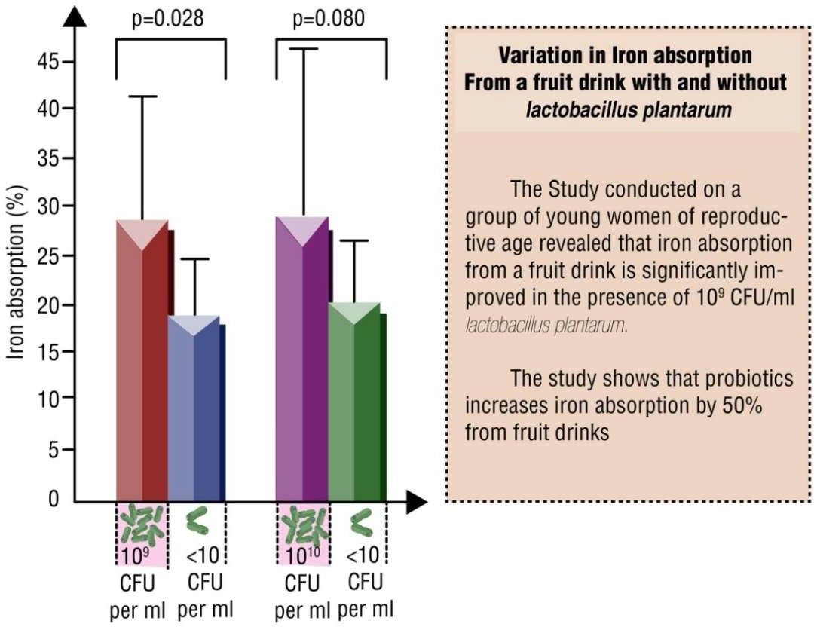

The results:

* **Trial 1**: Mean iron absorption from the drink with 109 CFU of *L. plantarum* was 28.6% compared to 18.5% for the control drink
* **Trial 2**: Mean iron absorption from the drink with 1010 CFU of *L. plantarum* was 29.1% compared to 20.1% for the control drink

The average iron absorption was 28.8% with *L. plantarum* when the absorption values for all subjects were combined, which was significantly higher than the iron absorption of 19.3% with the control drink. The study found iron absorption was 50% higher with non-heme iron from a fruit drink with *L. plantarum* than a similar fruit drink without the probiotic.

Details of the mechanisms by which probiotics can increase iron absorption are lacking. It is suggested that some *Lactobacillus* strains can increase the bioavailability of iron because they have the phytase enzyme that can break down phytates during fermentation. Yet, *L. plantarum* has minimal phytase activity and the amount of phytates was low in the fruit drinks in the study. Enhanced iron absorption may be the result of the strain’s ability to colonize the gut and increase mucin (the main component of the mucus layer that lines the gut) excretion. It is suggested mucins can bind to iron and prevent iron removal. Also, mucin may increase iron uptake because of its effect on iron transport proteins that bring iron into cells. Finally, another possible mechanism may result from the decrease in gut pH because of *Lactobacilli* growth. This creates a more acidic environment to change the iron (i.e., ferric iron) to a more absorbable form (i.e., ferrous iron).

##### Enhance Vitamin D Absorption

Vitamin D is critical for bone health, maintaining phosphate and calcium homeostasis – and maybe for physical performance. Yet, vitamin D levels are very low, with the greatest effects based on geographic location (e.g., northern latitude), season of the year and skin color. Even fortified

vitamin D milk is not sufficient enough to prevent vitamin D deficiency for all adults at every time of the year. It is suggested that athletes, compared to the general population, may be more susceptible to vitamin D deficiency, and possibly because of inflammation, muscle damage, increased immune activity and increased protein synthesis.

Before we delve into the research highlighting vitamin D-boosting probiotics, the importance of vitamin D for athletes requires emphasizing complications of vitamin D deficiency and the prevalence of vitamin D deficiency among athletes.

These precursors are transformed in the liver and kidneys to:

* + - * **25-hydroxyvitamin D (25(OH)D)**: the inactive storage form
      * **1,25-dihydroxyvitamin D (1,25(OH)2D)**: the biologically active form under tight regulation in the body

1,25-dihydroxyvitamin D interacts with vitamin D receptors found in every tissue of the body. This includes skeletal muscle, which suggests the important effect vitamin D may have on skeletal muscle.

The best indicator of vitamin D status is reduced blood levels of 25-hydroxyvitamin D [25(OH)D]. The three categories of vitamin D status based on serum 25(OH)D are:

* + - * **Risk of deficiency**: <30 nmol/L
      * **Risk of inadequacy**: 30-49 nmol/L
      * **Sufficiency**: 50-125 nmol/L

Low levels of vitamin D are prevalent in the general population. A low level is also a risk factor for: osteoporosis, cardiovascular disease, type 2 diabetes, and cancer. Vitamin D deficiency is also associated with depression, cognitive decline and neurological complications. More specific to athletic performance, vitamin D deficiency also may break down muscle and result in muscle weakness.

A few studies have suggested that a lower vitamin D intake may be associated with microbiome changes.,

A 2015 systematic-review and meta-analysis of 23 studies and ~2,300 athletes found that 56% of athletes had inadequate vitamin D levels.

A recent cohort study assessed vitamin D levels in 80 professional NFL players (the Pittsburg Steelers) and its association with race, history of broken bones and staying on the team during the 2011 offseason.

The results:

* + - * Mean vitamin D level was 27.4±11.7 ng/mL
      * Significantly lower levels for black players, which was 84% of the team, (25.6±11.3 ng/mL) compared to white players (37.4±8.6 ng/mL)
      * All athletes with vitamin D deficiency (<20 ng/mL) were black
      * 91% of athletes with vitamin D insufficiency (20-32 ng/mL) were black
      * 68.8% of the team had vitamin D levels lower than 32 ng/mL

The associated results:

* + - * Vitamin D levels were much lower in players who had at least one bone fracture compared to players who had no fractures
      * Players who were cut during the preseason as a result of injury or poor performance had significantly lower vitamin D levels compared to players who stayed for the regular season

Ultimately, athletes with vitamin D levels above 32 ng/mL played in more seasons than athletes with vitamin D deficiency. Vitamin D deficiency and insufficiency were prevalent among football players, especially black players. Those with a lower the vitamin D level had a higher risk for getting cut.

These results suggest the need to optimize vitamin D not just for NFL players, especially black players, but potentially all athletes. To address vitamin D deficiency, probiotics is an attractive nutritional intervention.

Jones, Martoni and Prakash published the first human data on probiotics increasing vitamin D absorption in humans. The randomized controlled trial found the probiotic strain *L. reuteri* may increase serum 25-hydroxyvitamin D by 25.5%.

The participants’ two-day dietary intake was measured at weeks 0 and 9 to evaluate calories, lipids, proteins, carbohydrates, vitamin A, retinol, carotenoids, vitamin E and vitamin D.

The study primarily measured the change in serum low-density lipoprotein-cholesterol (LDL-C) over the nine weeks. Fat-soluble vitamin analysis was conducted for weeks 0 and 9 following the intervention.

The results:

* + - * *L. reuteri* increased serum 25-hydroxyvitamin D by 14.9 nmol/L (25.5%) – a significant difference compared to placebo, which was 17.1 nmol/L (22.4%)
      * No differences in the absorption of other fat-soluble vitamins

Currently, this is the first study to show a probiotic supplement increased vitamin D levels. However, the mechanism is unclear. It may be the result of 1) an increase in vitamin D absorption or 2) greater synthesis of the vitamin D precursor. Yet, influencing the microbiome with the right probiotics signals a feasible approach to increase vitamin D.

##### Alleviate Symptoms of Lactose Intolerance

Dealing with lactose (i.e., the natural sugar in milk) intolerance as an athlete is frustrating, especially for those who want to use the fluid, protein and carbohydrate in milk or products with whey protein for recovery. Lactose intolerance results from a low amount of the lactose cleaving- enzyme β-galactosidase (i.e., lactase) in the mucosal layer of the small intestine. Secondary causes of lactose malabsorption result from other health complications (which can be reversible) including:

* + - * Inflammation of the small intestine
      * Protein-energy malnutrition (i.e., lack of protein)

Probiotics that have high β-galactosidase activity may help those who are lactose intolerant. This is why those who are lactose intolerant may be able to tolerate yogurt because the lactose is already partially broken down.

A randomized controlled trial investigated the effect of *L. reuteri* supplementation, compared to placebo, on symptoms of lactose intolerance in lactose intolerant people randomly assigned to one of three 20-subject treatment groups: tilactase (e.g., Lactaid) group, placebo group and *L. reuteri* group. Lactose maldigestion was assessed with the hydrogen breath test and GI distress symptoms. The study found that *L. reuteri*, compared to placebo, lowered the amount of excreted hydrogen and reduced GI symptoms following lactose intake.

Microbial β-galactosidase (also found in *L. bulgaricus* and *Streptococcus thermophilus*) may be an effective treatment to alleviate lactose intolerance symptom for lactose malabsorbers. In fact, the bacteria don’t need to be alive – just the cell walls need to be intact to protect the enzyme when it passes through the stomach. Lactose digestion may improve because the passage of lactose through the gut is delayed, which allows β-galactosidase more time to breakdown lactose.

##### Enhance the Conversion of Nitrate from Beetroot Juice to Nitric Oxide

Beetroot juice is the latest in functional foods for sport performance. The dietary nitrates in beetroot juice convert to nitric oxide (NO), a molecule that widens blood vessels and allows nutrients and oxygen to enter skeletal muscle. NO increases efficiency of oxygen uses in muscles during strenuous exercise. The entero-salivary nitrate-nitrite-NO pathway (i.e., GI system) starts with conversion of dietary nitrate to nitrite in the mouth, then the stomach and finally the small

intestine. Yet, the link in the conversion of nitrates to NO requires good bacteria throughout the entire GI tract.

Bacteria on the tongue that convert nitrate to NO (by using the enzyme nitrate reductase) can be destroyed by antibacterial mouthwash. Used seven healthy volunteers to investigate what impacts the ability of oral bacteria to metabolize inorganic nitrate to form nitrite and then bioactive NO. Notably, the bacteria in our mouth that convert nitrate to NO were destroyed by antibacterial mouthwash, which led to a lack of NO and no benefits from beetroot juice nitrates.

Beetroot juice (or other food containing dietary nitrate) is not the only way to generate NO. Our body can produce NO from the amino acid L-arginine and oxygen by using the enzyme nitric oxide synthase. This endogenous way of producing NO greatly impacts the GI tract.

To address this, a study investigated if specific gut bacteria, in humans and in rats, could produce NO. Fecal samples from eight healthy volunteers were used to measure the NO production by different bacteria. *Lactobacilli* and *Bifidobacteria* in human feces generated NO from nitrite, and a few of the bacteria strains generated NO from nitrate. Rats receiving *Lactobacilli* supplementation with nitrate present produced more NO in the gut than rats with no gut bacteria.

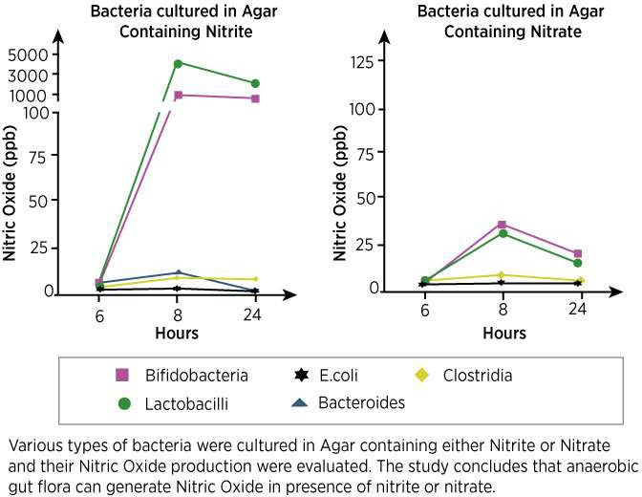

It’s suggested that some bacteria can capture NO by binding to specific proteins or by using nitrate reductase. Even though the study used rats and more human studies testing different bacterial strains are needed, the results suggest gut bacteria – not just oral bacteria – may have the capacity to generate NO.

* + 1. Increase Antioxidant Activity

We use oxygen to harness energy from food, which produces reactive oxygen species (ROS) (i.e., free radicals) and can lead to oxidative stress (an imbalance between oxidant and antioxidant levels). ROS can damage lipids, proteins and nucleic acids in cells. To neutralize ROS, both antioxidants from food and certain enzymes in our body make up the biological antioxidant barrier.

Intense exercise generates a high amount of ROS, especially during exhaustive and long-lasting exercise. Subsequently, the intense exercise and increased oxygen consumption (which also leads to oxidative stress) results in athletes with greater amounts of ROS circulating in their body.

Probiotics may be antioxidant suppliers that can facilitate better recovery from oxidative stress. Some studies suggest that certain probiotic strains may provide antioxidant activity and reduce oxidative stress.

The first study to investigate the effect of probiotics on exercise-induced stress used *L. rhamnosus* and *L. paracasei*. Male athletes were assigned to either the probiotic group (12 men) that consumed a mix of the two strains (1:1, ~10*9 cells/day) or the control group (12 men) that didn’t receive supplementation. All athletes received a personalized diet and underwent the same intense exercise training for four weeks. Blood levels of reactive oxygen metabolites (ROMs), which measure oxidative stress, and biological antioxidant potential (BAP), which measures blood levels of antioxidants, were determined pre- and post-supplementation.

The results:

* + - * Control group had much higher ROMs post-exercise compared to pre-exercise
      * Probiotics group did not have a significant difference in ROMs levels pre- and post- exercise, which suggests that probiotics neutralized the exercise-induced ROMs
      * Probiotics group had higher BAP levels post-exercise compared to pre-exercise
      * Probiotics group had higher BAP levels post-exercise compared to control group

The data showed that intense exercise led to oxidative stress and probiotic supplementation increased antioxidant levels, which neutralized the ROS and oxidative stress. Notably, all athletes

consumed antioxidants in their diet. Yet, because the gut microbiome regulates nutrient absorption, the higher BAP levels could be the result of greater antioxidant absorption by the probiotics.

Oxidative stress resistance measures the ability of bacteria to survive oxidative conditions because of their ability to combat ROS. The study found that *L. rhamnosus* and *L. paracasei*had high- oxidative stress resistance; thus, demonstrating their antioxidative capacity. The high level of antioxidant enzymes in the bacterial strains can target ROS in the GI tract.

##### Lower Cholesterol

Athletes with high cholesterol (hypercholesteromia) or athletes trying to optimize cholesterol levels have a reason to use probiotics, specifically *L. reuteri*. The high number of hypercholesteromic people who are unable to optimize their LDL-C still remains a concern and exploration of other cholesterol-lowing therapies are needed.

A randomized controlled trial found the cholesterol-lowering effects of *L. reuteri*. The 127 hypercholesteromic participants were randomly assigned to take the probiotic *L. reuteri* or placebo twice per day (at breakfast and dinner) for nine weeks. The *L. reuteri* capsules contained 2.9 x 10*9 CFU at baseline and 2.0 x 10*9 CFU at the end of the study. Blood samples were taken at six different visits to analyze serum levels of LDL-C, total cholesterol (TC), high-density lipoprotein-cholesterol (HDL-C) and non-HDL-cholesterol (non-HDL-C).

The results:

* + - * Compared to placebo, *L. reuteri* capsules lowered:
        + LDL-C by 11.64%
        + TC by 9.14%
        + Non-HDL-C by 11.30%
        + Ratio of LDL-C/HDL-C by 13.39%

Finally, a recent meta-analysis by Guo et al. used data from 13 lipid-lowering probiotic trials (including *L. acidophilus*, *L. plantarum, B. longum* and *B. lactis)* and found that people with high, borderline high and normal cholesterol levels who received probiotics, compared to controls, had beneficial effects on total cholesterol and LDL cholesterol. The average net change was:

* + - * **TC**: -6.40 mg/dL
      * **LDL-C**: -4.90 mg/dL

How do *Lactobacilli* reduce cholesterol? Bile – which is made from cholesterol – helps digest fat. These gut microbiotas can breakdown bile, which disrupts bile reabsorption and increases bile excretion. The lower amount of bile available for the body means more cholesterol is needed in the liver to make it.

Niemann-Pick C1-like 1 (NPC1L1) is considered the major protein for intestinal cholesterol absorption. NPC1L1 is highly expressed at the surface of the small intestine. Even though it hasn’t been confirmed in humans, NPC1L1 deficiency in mice has shown a considerable reduction in dietary cholesterol absorption.

Huang et al. found that the *L. plantarum* blocked cholesterol absorption by decreasing NPC1L1 after rats with high cholesterol were fed *L. plantarum* for four weeks at a dose of 10*9 CFU/day. Even though the study was conducted in rats, the results suggest the potential of *L. plantarum* for lowering cholesterol and the possible mechanism of how probiotics reduce cholesterol. The ability

to decrease NPC1L1 expression was also found in *L. rhamnosus*. These results suggest that some strains of *Lactobacillus* may control cholesterol levels through NPC1L1.

##### The Effect on Energy Regulation: Probiotics Produce Short-Chain Fatty Acids

Some nutrient digestion occurs in the stomach, but most nutrient digestion and absorption occurs in the small intestine. Absorption of all fats, ~85% of carbohydrates and 66-95% of proteins occurs before the large intestine.

Non-digestible carbohydrates and protein in the colon account for 10-30% of total caloric intake. These indigestible nutrients wouldn’t be further absorbed and instead would be excreted if it weren’t for gut microbiota. Gut microbiota can produce many metabolites that regulate our health

* specifically short-chain fatty acids (SCFAs), which have a positive impact.

Short-Chain Fatty Acids (SCFAs)

Anaerobic intestinal microbiota can produce SCFAs by fermenting non-digestible carbohydrate (e.g., soluble dietary fiber) and proteins (e.g., branched-chain amino acids). Many gut microbes can ferment unabsorbed carbohydrate because they have the enzymes required. SCFAs can:

* + Shape the gut environment
  + Impact the physiology of the colon
  + Serve as energy sources for human cells (e.g., intestinal) and gut microbiota
  + Interact with host-signaling mechanisms

SCFAs increase the acidity of the gut, which increases the absorption of certain nutrients (e.g., magnesium and calcium) and stops pathogenic microorganisms from invading.

The type and amount of SCFAs produced depends on our age, diet (e.g., availability of non- digestible carbohydrates), composition of gut microbiota, gut transit time and pH of the colon. The bacteria that produce SCFAs include:

* + *Bacteriodes*
  + *Bifidobacterium*
  + *Lactobacillus*
  + *Faecalibacterium*
  + *Ruminococcus*
  + And others

In the gut, 90-95% of the SCFAs are: acetate, propionate and butyrate.

Acetate gives *Bifidobacteria* the ability to stop the microorganisms that cause disease in the gut. SCFAs provide energy for colon cells and nearby tissues. Acetate is the main SCFA in the blood and serves as an important energy source for peripheral tissues. Butyrate provides energy for intestinal cells and increases mucin production. The increase in mucin could possibly lower the number of bad bacteria that attach to our gut and strengthen the gut barrier. These adaptations suggest SCFAs are critical in maintaining the function of our gut barrier.

Following absorption of SCFAs, we use SCFAs in different biosynthetic routes. Our gut cells use butyrate, and the remaining SCFAs go to the liver for further metabolism. In the liver, SCFAs integrate into different carbohydrate and lipid metabolic pathways:

* + Propionate is either used in gluconeogenesis (i.e., generation of glucose from non- carbohydrate sources) or regulates cholesterol synthesis
  + Acetate and butyrate are used in lipid and cholesterol synthesis

SCFAs have been associated with improving glucose tolerance by increasing the secretion of incretin hormone glucagon-like peptide (GLP)-1 and may increase the expression of vitamin D receptors on cells.

# 4.0 SURVEY

#### 4.1. QUESTIONNAIRE Fermented Fruits and Vegetables

Survey on the Fermented fruits and vegetables.

1. Have you heard about fermented foods? *

* Yes
* No

1. Have you ever eaten fermented foods? *

* Yes
* No

1. Where have you eaten fermented food?

* Home
* Restaurant
* Some other place

1. Which fermented foods you have eaten?

* Fruits
* Vegetables
* Dairy products
* Others

1. Have you included fermented fruits and vegetables in your daily diet? *

* Yes
* No

1. Why have you included fermented fruits and vegetables in your daily diet?

* Because of health benefits
* I read about its advantages
* Because i have it in my diet from childhood
* It has probiotic enzymes
* It is easily available in market

1. Did you know that fermented fruits and vegetables have health benefits? *
   * Yes
   * No
2. What kind of health benefits do you know that fermented fruits and vegetables have?
   * Improves Digestion
   * Provide Immunity Strength
   * Have cancer preventing probiotics
   * Helps in regulation of blood
   * All of the above
3. Do you know that probiotic bacteria are living bacteria which is good for human body?
   * Yes
   * No
4. Do you know that how probiotic bacteria provides health benefits to human body?
   * Increases calcium absorption
   * Helps in producing vitamins
   * Lower cholesterol
   * None of the above
   * All Of the above
5. What do you think about fermented fruits and vegetables? Should it be included in your daily

diet? *

o yes

* + No

# 5.0 RESULTS AND DISSCUSIONS

### 5.1. SURVEY RESULTS

The Survey results have been interpreted from 47 responses from the people who took this survey.

1. Have you heard about fermented foods?

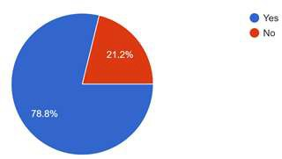

This shows us that majority of people have come across the term fermented food or have come across fermented foods, they might or might not know about what are fermented foods.

1. Have you ever eaten fermented foods?

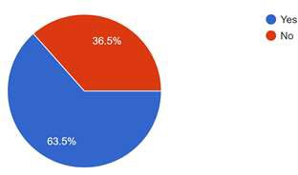

A majority of people who have taken the survey have eaten the fermented food even once or regular, this shows that fermented food is the known and consumed by many people.

1. Where have you eaten fermented food?

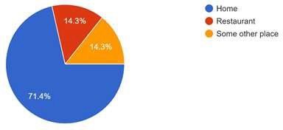

When the survey of this has answered that most people who have eaten the fermented foods, those have consumed fermented food majorly in their home and an equal percentage of have had fermented food in restaurant and some other place.

1. Which fermented foods you have eaten?

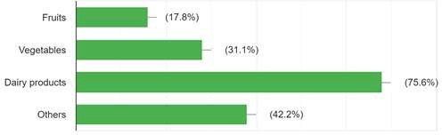

When we look at this bar graphs it depicts that most common fermented food eaten is dairy products and we as results of which the awareness about fermented fruits and vegetables is far less or the availability or practice of fermenting fruits and vegetables is far less than of dairy products.

1. Have you included fermented fruits and vegetables in your daily diet?

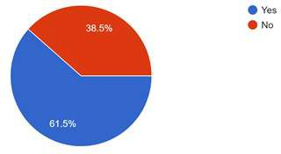

A majority of people who took this survey had included fermented fruits and vegetables in their diet which shows that people who knows about fermented fruits and vegetables have included in their diet.

1. Why have you included fermented fruits and vegetables in your daily diet?

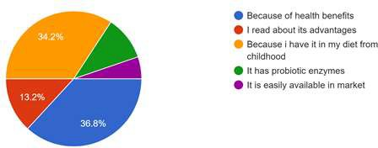

When asked about why they have included in daily diet as the figure depicts that 36.8% of people added the fermented fruits and vegetables in their daily diet because of health benefits and 34.2 % of people had included in their daily diet because they had in their diet from childhood and 13.2% read about the advantages of fermented fruits and vegetables then they added int their daily diet.

1. Did you know that fermented fruits and vegetables have health benefits? *

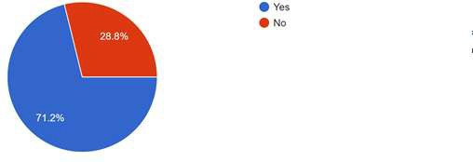

Above pie charts show the results about do people about the health benefits of fermented fruits and vegetables 71.2% of people who took this survey are aware of health benefits of fermented fruits and vegetables.

1. What kind of health benefits do you know that fermented fruits and vegetables have?

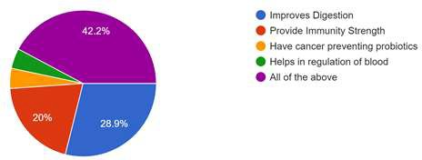

This graph depicts that what kind health benefits fermented fruits and vegetables have which improves digestion, provide immunity strength, have cancer preventing probiotics and helps in regulates of blood. 42.2% of people who took this survey selected all of the above option which is

accurate and 20% and 28.9% of people selected provide immunity strength and improves digestion respectively.

1. Do you know that probiotic bacteria are living bacteria which is good for human body?

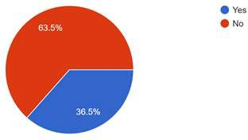

When asked about fermented fruits and vegetables have probiotic bacteria, a majority of people answered no which show that people are not aware about fermented fruits and vegetables having probiotic bacteria which are also known good bacteria and also is good for human gut.

1. Do you know that how probiotic bacteria provides health benefits to human body?

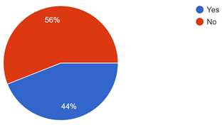

The graph depicts that 56% of people who took this survey are not aware that probiotic bacteria have health benefits or are beneficial for human body.

1. Do you know that how probiotic bacteria provides health benefits to human body?

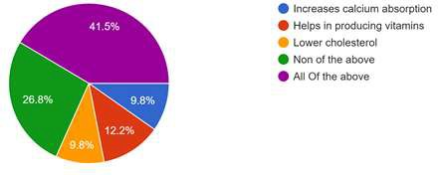

Those of the people who know about probiotic bacteria benefits to human body 41.5% answered all of the above and 26.8% of people answered none of the above which depicts the people these are not benefits which are given by probiotic bacteria.

1. What do you think about fermented fruits and vegetables? Should it be included in your daily diet?

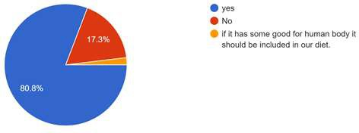

When asked about if fermented fruits and vegetables should be included in your daily diet 80.8% of people of who answered this question said yes to the inclusion in fermented fruits and vegetables in daily diet.

## 6.0 Research Prospects and Future Applications

Even though it has been broadly verified that dairy fermented products are the best matrices for delivering probiotics, there is growing evidence of the possibility of obtaining probiotic foods from nondairy matrices. Several raw materials (such as cereals, fruits, and vegetables) have recently been investigated to determine their suitability for designing new, nondairy probiotic foods. Generally existing probiotics belong to the genus Lactobacillus. However, few strains are commercially obtainable for probiotic function (Table 1). As the technology is there are new probiotic strains which are discovered from fermented fruits and vegetables, these need to be further researched and explored.

# 7.0 CONCLUSION

In Asian continent, fermented fruits and vegetables are associated with several social and cultural aspects of different races. Studies showed that fruits and vegetables may serve as a suitable carrier for probiotics and provide many health benefits as the fermented dairy products. Fermented fruits and vegetables contain a diverse group of prebiotic compounds which attract and stimulate the growth of probiotics. Basic understanding about the relationship between food, beneficial microorganism, and health of the human being is important to improve the quality of food and also prevention of several diseases. As the awareness about fermented fruits and vegetables and probiotics in them if increased, then humans can have benefits from as the fermented dairy products. Although challenges remain, it is possible that fermented foods, handed down for many generations, will play a major role in the global food industry. Detailed studies on the microbial composition and characteristics of fermented fruits and vegetables lead to the further application.

# 8.0 REFERENCES

1. Biotechnology Research International Volume 2014, Hindwai Read [12/02/19] 2.CHOICE: Fermented foods Article 2015 Australia

1. BBC Good Foods: Health Benefits of fermenting 2017
2. WebMD: Could Fermented Food Boost Your Health? By Matt MacMillan 2017
3. Dr Axe: Probiotics Benefits, Foods & Supplements — a Vital Part of Any Diet, Dr Josh Axe, 2019

#### Figures And pictures

1. Hindwai Journal Volume 2014
2. Research Gate: Heath Benefits of fermentation
3. Digital vertebrae
4. Kisoji: kiso area travel guide.
5. Sites-Google 6.The Splendid Table **TABLES**
6. Hindwai Journal Volume 2014
7. Dr Dr Axe: Probiotics Benefits, Foods & Supplements — a Vital Part of Any Diet, Dr Josh Axe, 2019

# 9.0 BIBLOGRAPHY

1.Biotechnology Research International Volume 2014, Hindwai Read [12/02/19] 2.CHOICE: Fermented foods Article 2015 Australia

1. BBC Good Foods: Health Benefits of fermenting 2017
2. WebMD: Could Fermented Food Boost Your Health? By Matt MacMillan 2017
3. Dr Axe: Probiotics Benefits, Foods & Supplements — a Vital Part of Any Diet, Dr Josh Axe, 2019
4. Fermeted foods Article, Owen Densel Michigan medicine, university of Michigan 2017.
5. Benefits of fermented foods, nutrition and fitness, The American College of Greece, authorized by Sophie Themelis and Christina Drakonakis.
6. Indigenous Fermented foods M.J. Robert Nout Article, Wageningen & Research, January 1983.
7. Indigenous Fermented Foods of South Asia, Chapter, Antonio Galvez (Universidad De Jea) January 2017.
8. Health Benefits of fermented foods article in Critical Reviews in food science and nutrition, September 2017.
9. Foods: Nutritional Guidelines And fermented food framework, Victoria Bell, Jorge Ferrao and Tito fernandes, University of Coimbra, University of Pedagogica and Lisbon University respectively, June 2017.