Home Furniture Decor Application using AR

*Aditya* Sawant, *Pranay* Usatkar, *Sejal* Somkuwar and *Puja* Padiya Computer Department, RAIT, Nerul, Navi Mumbai, India.

**Abstract:** ”If you change the manner in which you check out things, the things you take a gander (look) will change.” When illustrations or advancements in technology will help to improve the development of portable gadgets and fantasy looks of the products for product experience. As a rule, purchasing items without contact and feeling inconveniences the actual business and prompts time and exertion for working on the clients. The improvement and the advancement in the innovation will help to improve the development of portable gadgets and fantasy looks of the products for product experience with the help of Computer vision and object detection.

# Introduction

A major topic of interest in the software development world for many years, Augmented Reality has recently gained renewed attention and focus. This technology is based on computer vision algorithms to enhance images, sounds and video using the camera of your device. By looking at the objects virtually, we are able to gain a composite view of the physical world. In order to enable users to try on virtual furnishings in their actual environments before buying them, we are going to develop an augmented reality system. From this it will be easier for the user to choose a furniture. The customer will not have to go to a store and spend a great deal of time searching for furniture or taking measurements to see if the furniture fits in the room. In this project, the main goal is to develop an application that contains various furniture items like in furniture stores virtually, so that the user can purchase them and check if they meet their needs before buying them with augmented reality, thereby reducing the time and energy spent on searching. This application will conveniently help the user to do online shopping of furniture items. By trying out furniture items in their own space, the user will be able to see how it will look after furniture has been placed in it. There are already a couple of furniture apps in the market but they use only 3D models, they don’t display in a real environment. This app offers a solution to this problem because the objects made by us can be placed in real-world situations, and this app will offer the benefits to the user. In current market applications, image capture is slow and the image resolution is low, which negatively impacts user experience, making it difficult and disrupting the user's life. Even if furniture graphics are low resolution, the user still faces difficulty and is waiting for the processing of the images. Instead of physically going to a store, the user can

view furniture virtually in their home environment. Users face the basic challenge of taking measurements and checking whether the furniture will fit into their living space, our application will help and allow the customer to view the furniture and check if it fits or not before buying. The user can use this application by using their phone camera and capture the live feed of the room and place the furniture they want. Application uses a marker based algorithm. The reality is that the use of smartphones and tablets has blown up the last couple of years and is significant and makes AR more practical for online shopping. At the same time, the increase in spreading technology all over the world makes the branded company use advanced technology like AR. With this research paper, we will explore the implementation and evaluation of designing virtual furniture in the real world using marker-based augmented reality applications. In this way, the application will be beneficial to both the company and the user as it saves time and money by not visiting the shop physically.

# Literature Survey

Today's Augmented Reality, as we know it, is a result of advances in handheld and mobile devices. The first augmented reality device, called a Head Mounted Display (HMD), was invented in the 1960s by a professor named Ivan Sutherland. It was the first display to implement Augmented Reality, though the features were primitive.

Virtual data, information, or objects that appear real can be used to enhance the actual world of the user through augmented reality. In terms of Wikipedia, augmented reality (AR) refers to a direct or indirect view of a

physical, real-world environment that is augmented with computer-generated perceptual information, such as video, audio, graphics, or GPS.

AR has been around for a very long time. Among the uses of this technology are educational, where text and graphics are overlaid on real-time images of students, in the medical field for displaying patient data, in fighter jets for displaying flight paths, and in tourism, to provide real- time information about monuments based on the location and/or picture of the monument.

AR is a powerful tool for interior design. A brief overview of the current methods used to visualize furniture in the real world is presented in this section.

In this research paper on the Home Decor Furniture app using Augmented Reality Technology we will see how augmented reality works in various fields by applying unity 3D. Kaikini has developed a process called "Marker less augmented reality primarily based Interior Design System" which employs marker less augmented truth.

"Marker Less Augmented Reality primarily based Interior Designing System" [1] has been proposed by Yash Kaikini, Parth Bhodia, Santosh Sharma, Sonali Vaidya as a method of enhancing user experience and perception of things. This has the advantage of not requiring markers within the area, but the disadvantage is that objects are aligned with a camera so they change when we change cameras as it is not good for object placement.

Using augmented reality, Neeraj Singh, Nabil Phansopkar, Safwaan Mujawar, and Snehal Mangle have created a method titled "Virtual Furniture Using Augmented Reality",[2] where users have to place a marker in a room where they wish to experiment with furnishings. A live feed of the room will be captured via the user's webcam . A range of colors and other properties are used as inputs for the image processing techniques to detect the mark . From the 2D image frame of this webcam, furniture objects can appear as if they are actually placed in the real world, and users can access how the world looks when the furniture is placed in their space.

As per our survey of various applications having similar Home décor features such as Ikea, Pepperfry it has observed that the AR feature is available but not very concise only based on 3D models. These 3D models display only in a virtual environment, not in a real environment. For overcoming this problem we have created Home Décor Furniture App using AR in which we can display objects i.e. Furniture in a real world environment. In this app, we can rotate, move and expand the objects in every angle like table, chair, sofa, etc. in a real time environment. Through setting up concurrent mapping algorithms, it is possible to determine a current

pose of the electronic device as well as to update the map of the environment to localize the estimate. As a result, it helps the buyer to have the idea of how the object placement looks in real place using AR.

# Proposed Methodology

The user-friendly android application, especially when it comes to furniture retailing, is likely to be a valuable tool for customers.An Augmented Reality application will be used here where the user can view the virtual object from the perspective of his or her home using the front/rear camera. The user can select the product he/she wants to purchase from the rear camera.

Using Marker Based Augmented Reality Methodology, the proposed device makes use of the will of role and publicity of an item as a guide for user experience enhancement and for making better sense of things. Marker less monitoring also makes use of the will power of role and publicity. AR's power lies in this functionality, which makes it possible to realize the field of the user and to act accordingly if the augmented item's location matches the real one. The ease proposition of the application overlays 3D virtual models on pinnacle on material things by the usage of digital digicam.

Marker Based Augmented Reality application usually includes image recognition, images are already predefined in the application that need to be recognized. It tries to find the target (marker). After detecting the marker , it is used for the location of virtual items.

This application will use Augmented Reality promoted smartphones for experimenting the dwelling region and show the furniture which are augmented items to check whether it fits as per the user’s requirement space or not. Virtual Items which are also called Augmented Items (3D Model) which are near to the furnishing device augmented by using Unity3D.

Unity 3D is a software program which helps a complete progressive function for 3d modeling, animation

,rendering , simulation ,etc.

The next phase includes showing up of light , digital digicam ,shadow placing the models by the usage of diverse additives using Unity 3d. Follow up, the furniture model is chosen and the named version is gone to be reused and rendered which has to be loaded backside with a useful resource of AR Core by Google.

Mapping of the 3D version models onto the mobiles shows the vicinity which comes to the decision the scale of the version that’s then rendered and displayed onto the screen.

With the camera built into the cell phone, Augmented Reality can capture views and display them as real views as humans from a distance. As a first step, we create the scenes for the User Interface, such as text areas, buttons, and virtual objects.

After building 3D fashions such as a chair, sofa, and so forth. utilizing Vuforia, we import them into Unity 3D. Using Android Framework, we built the software as the phone has a touch screen interface, and we could position the fittings model with the aid of sliding it.

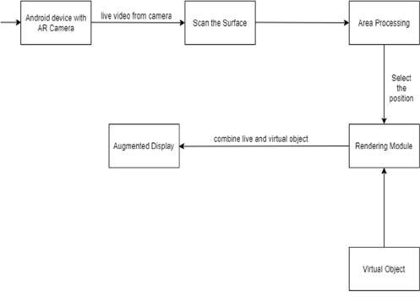

Fig. 1. System Design of application

Scan surface - This module scans the given surface and detects the positional tracking using image processing techniques. To place the object in the real world, marker position is determined.

Area processing - The location of the detected position is provided to the area processing which is but tracking which is the heart of augmented reality.systems. It calculates the relative pose of the camera in real time.

Rendering Module - The Rendering Module has two inputs. First is the calculated pose from the Area processing Module and the other is the Virtual Object to be augmented. This module combines the unique photo and digital components. It shows the augmented view on the display screen of the Android handset.

Augmented Display - On the screen, a translucent, digital layer of high-definition photographs and movies plays,

while the touchscreen capabilities of the display enable customers to interact and connect with your goods.

Virtual Object - A group of points that could be considered a source of light rays for a segment of an optical system but do not really serve that purpose. Furniture objects, such as sofas, will be viewed as virtual objects.

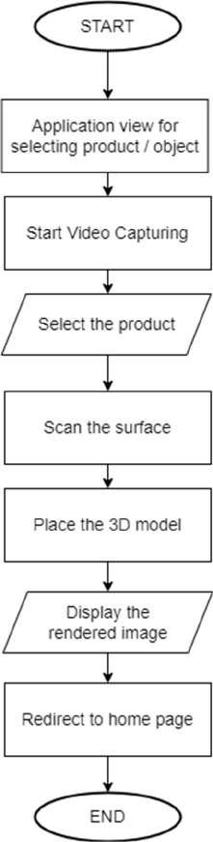

Fig. 2. Flowchart of the proposed system

# Implementation and Discussion

The following steps give the complete flow of the implemented product.

As a first step, we create a platform to integrate all the different entities and accomplish the goals described in the

paper. This platform contains the user interface for the application. A script will be deployed to the basic object which will be followed by a Unity object designed specifically for Augmented Reality applications.

In step two, the script will consist of divergent functionalities to provide a variety of viewpoints for the user to choose from.

In step three, to make things easier for the new user, a few presents will be provided to show the abstraction and flow of the application.

In step four, algorithms for plane detection and 3D object recognition are implemented to mark the target points ie. Marker less AR.

The modules are then integrated and developed into the engine. EG. Unity3d, android studio.

In step six, the project is extended to VR by using the same script and Google Cardboard SDK.

Step seven involves making a simulation world available to developers of interior design software. By doing so they will be able to see the blueprint of the project in a different light.

In step eight, A module is created to select the choice of the scenario. This will also include the option to switch the project course,i.e. AR, VR. The plan and design can be saved and exported to the interior developer’s personal device.

This project uses ARCore platform for virtually displaying the object. Google's ARCore platform allows developers to create augmented reality experiences. With ARCore, your phone is able to sense its environment, understand the world, and interact with information using different APIs. A number of the APIs are available on Android and iOS platforms to enable AR experiences.

Basically, ARCore uses a technique called Concurrent Odometry and Mapping (COM) and ARKit uses a technique called Visual-Inertial Odometry (VIO) to understand where the smartphone is relative to the real environment around it.

At first stage – Motion Tracking – each smartphone combines visual data coming from RGB camera sensor (at 60 fps) and motion data coming from accelerometer and gyroscope sensors (at 1000 fps) to compute a position of a high-contrast feature points using parallax formula. That information allows ARCore and ARKit to get a position and orientation of a virtual camera in six degrees of freedom (6 DoF).In order for ARCore to know exactly where your phone is in relation to the world around it, it

uses a method known as simultaneous localization and mapping (SLAM). When capturing a camera image, ARcore searches for visually distinct features called feature points, and calculates its location changes based on these. As the camera draws images, its inertial measurements (position and orientation) are combined with the visual information from the device's IMU to estimate its pose (position and orientation).

The next stage – Scene Understanding – helps ARCore and ARKit understand where several feature points (a.k.a. sparse point cloud) are coplanar – thus, letting a smartphone find out where a detected plane will be.

The last ARCore's stage is Light Estimation and the last ARKit's stage is Rendering.

Data / 3D models collection: In order for a product in the catalog to be displayed, it needs a 3D model in .glb format. At the moment, the objects are physically stored in the sample Data folder.Currently the objects are stored physically in the sample Data folder. Namely models of chair, lamp, table, tv etc. were obtained for testing of various categories of furniture.

User Interface creation : The user interface of the application consists of many pages - Login page, Registration page, Home page, profile page, products page, Cart page ,etc. Designing the UI for the application took into consideration the modern requirements for design and the appeal needed for its customer base.

Following are the results of our system.

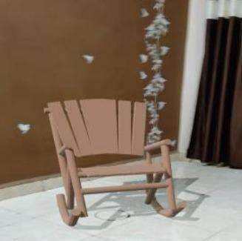

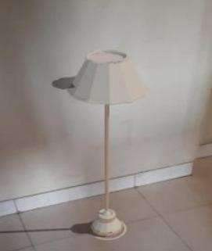

# Conclusion

The fundamental aim of “Home Furniture Decor Application the use of AR” is to make use of Augmented Reality to offer furnishings versions in the real world. Augmented Reality (AR) Technology that permits the clients to determine and engage the furnishings with the actual world, supplying new opportunities for furnishings on-line shopping. This System will assist and help the client to study the furnishings item honestly in real world before shopping for the furniture objects. Due to this, clients will come to recognize how their home shape would appear after buying and putting the furnishings item with multi-color option. This allows the purchaser to figure out how to set up the furnishings of their domestic shape. This proposed device could allow the person to adopt a couple of combos of items honestly without transferring or moving the furnishing objects.

# References

1. E. Carvalho, G. Mac¸ a˜es, I. Varaja˜o, N. Sousa and P. Brito, *Use of Augmented Reality in the furniture in- dustry,* 2011
2. Tang, J.K.T., W. Lau, K. Chan, K. To, ”*AR Interior Designer: Automatic Furniture Arrangement using Spatial and Functional Relationships”*, **345-352**, 2014.
3. K Khairnar, K Khairnar, S Mane, R Chaudhari. *Furniture Layout Application Based on Marker Detection*. p-ISSN: **2395-0072**, e-ISSN: **2395- 0056**. 2015.
4. S Mangale, N Singh, S Mujawar, N Phansopkar. *Virtual Furniture Using Augmented Reality*. eISSN: 2278- 0661, p-ISSN: 2278-8727, pp.42- 46. 2016.
5. M Mori, H Takemura, K Kiyokawa, J Orlosky. *A Transitional AR Furniture Arrangement System with Automatic View Recommendation,* 21(3).pp.21-24. ISBN: 978-1-5090-3740-**7.22** , 2016
6. Viyanon, Waraporn & Songsuittipong, Thanadon & Piyapaisarn, Phattarika & Sudchid, Suwanun. *AR Furniture: Integrating Augmented Reality Technology to Enhance Interior Design using Marker and Markerless tracking*, **1-7**. 10.1145/3144789.3144825, 2017
7. S. Sharma;Y. Kaikini, P. Bhodia, S. Vaidya, *International Conference on Smart City and Emerging Technology (ICSCET),* 2018
8. N. Moparthi, P. Vidya Sagar, G. Balakrishna, *7th International Conference on Smart Structures and Systems (ICSSS),*2020
9. N.M. Jayagoda, O.R Jayawardana, W.W.T.P Welivita, L Weerasinghe, T Dassanayake, *SMARKET - Shopping in Supercenters (Hypermarkets) with Augmented Reality,* 2021
10. N. Rao Moparthi, P. Vidya Sagar, G. Balakrishna, *Usage for Inside Design by AR and VR Technology*, 2020