Name:_____________________

Case Study Assignment - Nestlé: The Infant Formula Controversy

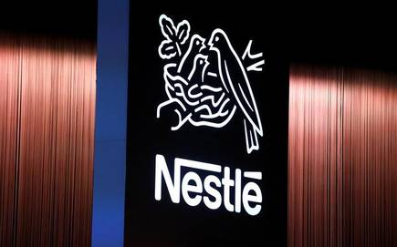

* [How The Nestlé Baby Formula Cost Many Children's Lives](https://www.youtube.com/watch?v=_BSwiLA0c3M)
* [Nestle Infant Formula U.S. Senate hearing 1978](https://www.youtube.com/watch?v=ME6U-zIv6SA)

Read the Nestle case study and watch the videos. Then provide answers to the questions below:

1. What are the responsibilities of companies in this or similar situations?
2. What could Nestlé have done to have avoided the accusations

“killing Third World babies” and still market its product?

1. After Nestlé’s experience, how do you suggest it, or any other company, can protect itself in the future?
2. What are your thoughts on the new report about Nestle’s marketing in the Philippines? Do you think they are unfair or should Nestle be held accountable?

* [Baby Formula in the Philippines: Investigating dubious marketing practices](https://www.youtube.com/watch?v=9fSlkoLdDmI)

