An Analysis of Project management methodologies (PMMs) used in start-ups for success.

Gurajala Jairam Goud

Research Proposal

APRIL 2022

**Table of Contents**

Contents

Abstract 3

1. Introduction 4

2. Background 5

3. Research Questions 7

4. Aim and Objectives 7

5. Research Methodology 8

6. Expected Outcomes 10

7. Requirements 10

8. Research Plan 11

References: 11

# Abstract

The growth and development of startups is a challenging hurdle to be accomplished. While there are companies that have successfully made up the ladder and accomplished wonderful numbers in revenue, improved the customer satisfaction and met the set goals and objectives of the company, it is set to achieve, it is still a challenge for startups to maintain its consistency and deliver successful projects. The Research has shown that around 50% of Project Management practitioners or Project Managers viewed the PMMs as not important to their Projects but generally the use of PMMs do help in improving the success rate of the Projects deliverables. The purpose of the study is to understand the impact of different Project Management Methods (PMMs) used in the startups and also look at which method is widely used. In order to understand the widely used Project Management Methodologies in a startup, a survey by using a Non-Probabilistic sampling would be conducted by targeting the several industries. The Data analysis will determine the various PMMs that are used in startups and their impact in delivering success of a project. The findings would also explicitly point out if the usage of Project Management Methodologies in startup yield positive results for success of Project or not.

**Keywords:** Project Management, PMMs, Startups, Project Management Methods.

# 1. Introduction

Do the Startups of India really use Project Management Methods? How large is the impact of Project Management Methods in a company that is still growing where PMMs are used. As per the Startup India, India has the 3rd major startup system in the world, comprising a total of 50,000 startups in India in 2018 and it is expected to witness a YoY growth of 12-15% every year (Startup India, 2022). Also refer below (Figure: 1) to understand the year wise startup recognized in India. Keeping in mind the expected growth and introduction of new companies in the industry as startups their success is determined by various factors. Among them, the project management methods followed by a company plays an important role for business development and also the stakeholder satisfaction. The importance of Project Management methods is rated highly by Project Management Institute (PMI). PMI had presented in their report ‘’Pulse of the Profession’’ that the success percentage of developments are improving every year and the amount of money spent on improper Project performance is decreasing over years as well.

Although the growth of startups and introduction in companies in various industries is expected to grow at a rapid pace, a study done by (Sarika, Mrinal and Tanya, 2016) indicates that the startups in India still face various problems and hindrances in terms of marketing, technological, finance and other important resources. There is a definite requirement to resolve these issues and to tackle them with the usage of Project management methodologies would be a helpful one. This project will analyze the application of various Project Management Methodologies in a startup from India.

Figure: 1 (MOSPI, 2021)

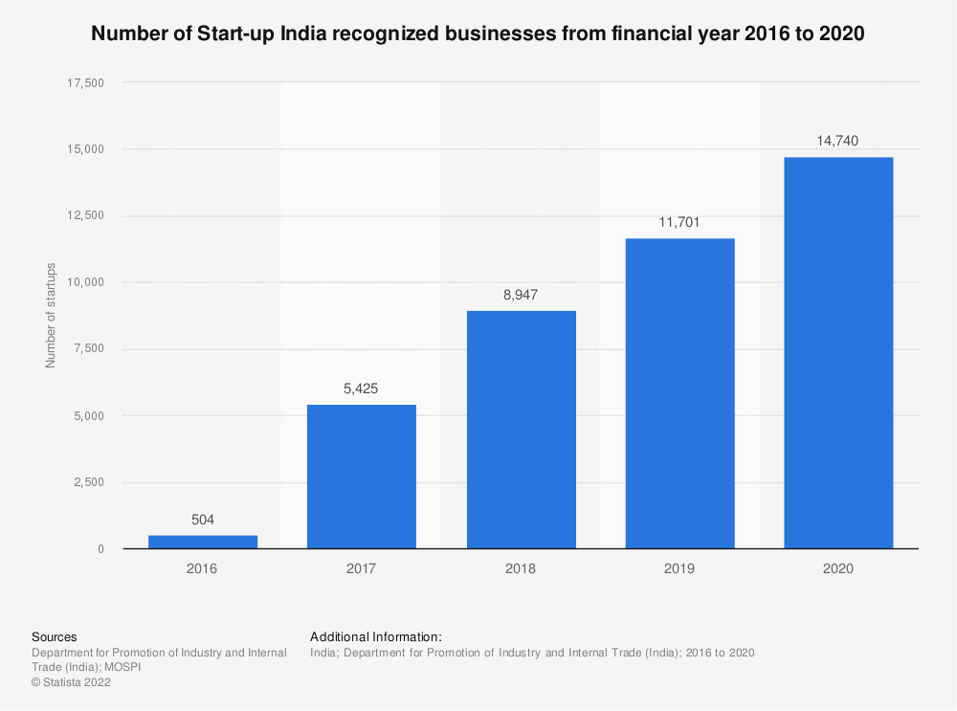

# 2. Background

The Human race in the last couple of years have faced major setbacks due to Pandemic and all the different aspects of a human life have been challenged and such experiences call for rapid changes. Incidentally, such is the Project Life cycle when an unforeseen situation or circumstances are to be faced by an organization the Project goes through multiple challenges and ultimately could end up with the Project being a failure.

As per (Paulo and Samira, 2018) the companies which use the Project Management in Canada have gathered that only 22.7% of the companies had success in more than 80% of their projects and it is also considered as per the findings that the use of standard Project

Management Methods doesn’t give a guarantee of success. (Anabela et al., 2018) stated that the data collected from construction, services and manufacturing industry suggests that the most PMMs are in fact used as tool sets by practitioners who are not duly trained on handling the PMMs. The Research done on Portuguese startups by (Anabela, 2019) suggested that companies or startups use the concepts of invention, threat and tractability as the definition of what it means to be a startup. Such defined companies need to adapt the innovative ability to create the value for stakeholder and customer satisfaction. The companies whose Project Management Body of Knowledge (PMBOK) constructed PMMs had been providing superior than 90% on the allotted and financial plan through all their developments (Steve, 2020). The research also defined the PMMs as an organization's progression for supervising the complete growth of its projects. The study from Italy and Egypt (Esraa Abdellatif and Abdellatif Khafagy, 2019) suggested that most of the companies or entrepreneurs who apply the Project Management Methodologies use Agile Project Management method because of its flexibility and time efficiency. Additionally, as per (Mahmoud, Haleema and Almamlook, 2018) quantified that the project management success and project success can only be achieved when the documentation of project success conditions and critical success aspects are identified at the commencement of the project. The study by (Michael, 2019) indicates that there is a lean correlation between PMM and process success, where the PMMs might play a role in the success of a project but there are different variables which play an equally important role. By conducting the survey for three consecutive years (Pavel, 2018) have identified that there is a positive development of the implementation of PMMs from the Czech Republic companies. (Llorens and Viñoles 2020) stated that the designated Project Managers use more tools and PMMs 40% when compared to the chemical engineers 26%.

The above researches have been conducted in various geographies by targeting the companies that are using PMMs for fulfilling Project deliverables and goals. The purpose of the study is to determine and understand the various PMMs used by the start-ups in India to achieve Project success and deliverables. The current research would include companies from India which haven’t been touch based by the previous researches with a hope to determine the importance of PMMs in start-ups.

# 3. Research Questions

The following are the research questions outlined based on the Aims and Objectives of the research:

1. Do PMMs used by Startups help in achieving Project goals and success and what are the benefits of using PMMs?
2. What is the most used Project Management Methodology in a Startup and why is it widely used among all the available PMMs in the industry?
3. At what stages of a startup the companies are most likely or keen on implementing the PMMs?
4. Is it that the implementation of PMMs secure a guaranteed success of the Project goal and success?

# 4. Aim and Objectives

The main aim of this research is to determine and analyze the importance of Project Management Methodologies used by the Startup and do they help in achieving successful closure of a Project.

Objectives of this research are listed below:

* To analyze the importance of PMMs used by startups in India.
* To determine the impact of PMMs used by startups in India for achieving Project goals and objectives.
* To investigate the various PMMs used and what is the most used by startups and understand the reasons for the same.
* To critically assess the implementation of PMMs in startups during different stages.
* Finally to evaluate the performance of PMMs in achieving Project success and if they are essential or correlate success of a Project.

# 

# 5. Research Methodology

The Research Methodology would be conducted in an Empirical research on PMMs and their importance in startups for the success and achieving Project deliverables and goals. A research comprising primary data was conducted by (Esraa Abdellatif and Abdellatif Khafagy, 2019) with the help of data analysis tests such as Levene’s test and Anova test. The above research was conducted by targeting the founders and chief executive officers of the startups from Italy and Egypt. As the majority of the respondents were from the top management the accuracy of the results were considered with confidence due to abilities and knowledge base of the respondents. The Empirical research conducted by (Pavel, 2018) also considered surveying the Project Management Method Practitioners from Czech Republic where the software tools used were XL Statistics and MedCalc software by setting the p-value at 0.05. The Hypothesis was set for two research questions and were formulated to H10 and H1A. Following the above research methodology and use of the Data Analytics tools the numbers and the findings retrieved were considered appropriate as well. Research by (Paulo and Samira, 2018) suggested that use of a similar sampling method but a different survey design i:e; surveying in four parts were able to retrieve the required information for the research problem and come to the conclusion of the research. (Looi Theam Choy, 2014) stated that the evaluation of a research could be conducted in either of the ways i:e; by choosing qualitative or quantitative approach. Both the approaches have been given equal amounts of importance as per the critics and various debates which were gathered during the research conducted in form of a case study analysis.

**Qualitative or Quantitative:**

The above being said, the research is to be conducted on the various Project Management Methodologies used in startups and their impact on the success of a Project and deliverables of a Project. The important problem to evaluate here is to understand if there is any one PMM that is widely used or do the Project Management practitioners follow a mixed approach in the process of a complete Project to attain success. The Qualitative approach study is considered the best practice to arrive at the Research conclusion.

**Data Collection and Source of Data:**

The Research would be conducted in an Empirical way as this method attributes to collecting data in a specific and an objective way. This process of collection of data would ensure that whatever information that is collected is adhering to Ethical practices and also doesn’t encounter any plagiarism, bias and gives accurate information on conducting study. The Method used to collect data would be through Surveys or Interviews based on the availability and feasibility of the respondent and the questionnaire for the respondents through two channels would remain the same to eradicate any bias. The Primary data would be collected by reaching out to the Startups and mainly targeting the Project Management Practitioners with the aim of collecting a sample of at least 90 – 100 respondents through the Google Forms or Microsoft Forms. Research would be choosing primary data only as it would ensure to determine the strong and accurate views of the current trends in the Industry. The respondents are likely to be Managers, Senior Managers, Program Managers, Senior Program Managers, Project Managers, Senior Project Managers, CEO’s, Founders and any other designated professional who play an important role in the companies Project deliverables and closure. The Data collection would be conducted only after the successful approval of the Ethics form submission on upGrad platform.

**Data Analysis:**

The Data Analysis would be conducted after careful examination of the data collected and perform data cleaning and removal of duplicate data for accurate analysis of the results. The collected data would be considered as Primary data and if required during the course of the Research, we would use other resources such as Books, Articles and Journals as the secondary data. The first and foremost Analyzing of data would be done using the Google Forms or Microsoft Forms tools itself by filtering out the majority variables that the respondents have selected. Once we have the complete information and collect the variables, it is important to define the variables into dependent and independent variables for further process.

* Ho: Negative Accept or Reject – There is No Significant impact of PMMs on success of a Project Completion or Achieving success in a Project
* H1: There is significant impact of PMMs on success of a Project Completion or Achieving success in a Project.
* Dependent Variable here could be: Project or Startup Company’s success
* Independent Variable here could be: Use of Project Management Methodologies

There could be additional dependent and Independent variables in order to determine the aims and objectives of the Research and also answer the Research questions. Data Analysis would also be conducted based on the usage of SPSS software such as ANOVA test which is an shortening for ‘’Analysis of Variance’’ is applied to data in order to know if there is a substantial dissimilarity among the means of two or more than two independent groups. It confirms or cancels a hypothesis. The null hypothesis states that there is no substantial dissimilarity among mean which means that the variables are independent.



(Esraa Abdellatif and Abdellatif Khafagy, 2019)

Where, μ is the mean of a group and k is the number of groups

Similarly Chi-Square independence test would also be used to evaluate the connection between two firm variables in a sample.

# 6. Expected Outcomes

At the time of conclusion of this research, we are expected to retrieve by performing the data analysis of gathered data through surveys whether the PMMs in Startups add value to their lifecycle and make a difference in achieving the goals and objectives of Startup. We should also be able to discover the role of PMMs in project success and the various benefits provided by using the PMMs during the Projects. The expected outcome will help the corporate industries in taking a decision of implementing PMMs for their company’s lifecycle and it will also help the designated founders and cofounders of the organization to add it to their business.

# 

# 7. Requirements

The important resources required for performing this research are listed as below:

* Access to Turnitin (Plagiarism Detection)
* Google Forms/Microsoft Forms
* Software to perform data analysis
* Access to LJMU e-library, Research papers
* Project Management experienced candidates or candidates using PMMs at their employer and their views
* Updated software such as Microsoft Word, Microsoft Excel, and Microsoft PowerPoint and Adobe Acrobat reader.
* Laptop (Windows 10 - OS) with 16 GB RAM and 11th Gen Intel® Core™
* Offline stationery – Pen, Notepad
* Video editor or Video recorded for presentation preparation

# 8. Research Plan

The below figure shows the Research Plan for the completion of the Thesis Submission and the timelines mentioned in the Gantt Chart are tentative. These dates could be changed as per feasibility or any changes to timelines by university or upGrad.

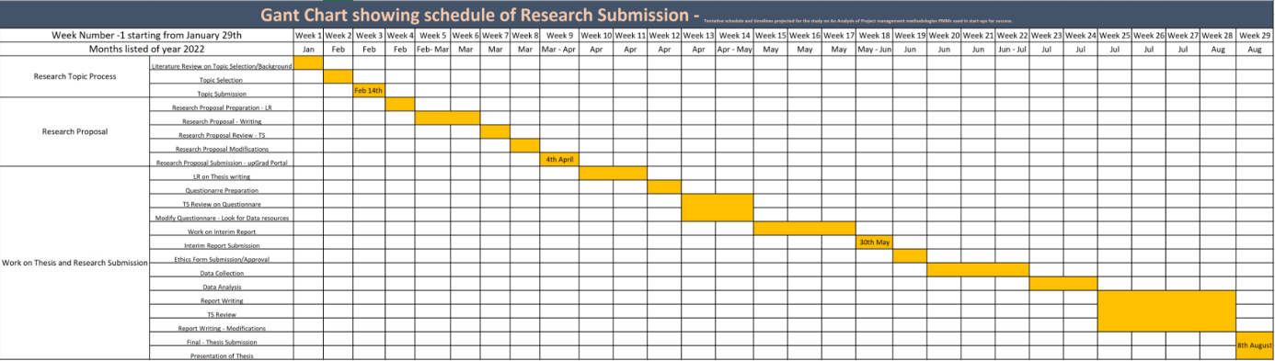

* The Ethics approval could be submitted earlier than mentioned data or later as per the universities takes on acquiring data.
* The Research plan (Gantt Chart) would be added to the ZIP file separately for better review.

# 

# References:

Tereso, A., Leão, C.P. and Ribeiro, T., 2019, April. Project management practices at Portuguese startups. In World Conference on Information Systems and Technologies (pp. 39-49). Springer, Cham.

De Marco, A., Soliman, E.A., Demagistris, P.E. and Khafagy, A., Investigating the Application of Project Management in Startups.

Taraba, Pavel. “Application of Project Management Methods in the Czech Republic.” MATEC web of conferences 210 (2018): 2028–. Web.

Andrade, P.R.M.D. and Sadaoui, S., 2018, September. An Analysis of IT Project Management Across Companies in an International Scenario. In European Conference on Software Process Improvement (pp. 95-107). Springer, Cham.

Bierwolf, R., Romero, D., Pelk, H. and Stettina, C.J., 2017, June. On the future of project management innovation: A call for discussion towards project management 2030. In 2017 International Conference on Engineering, Technology and Innovation (ICE/ITMC)

Frefer, A.A., Mahmoud, M., Haleema, H. and Almamlook, R., 2018. Overview Success Criteria and Critical Success Factors in Project Management. Ind Eng Manage, 7(244), pp.2169-0316.

Tereso, A., Ribeiro, P., Fernandes, G., Loureiro, I. and Ferreira, M., 2019. Project management practices in private organizations. Project Management Journal, 50(1), pp.6-22.

McGrath, S. and Whitty, J., 2020. Practitioner views on project management methodology (PMM) effectiveness. Journal of Modern Project Management, 8(1), pp.188-215.

Pace, M., 2019. A correlational study on project management methodology and project success. Journal of Engineering, Project, and Production Management, 9(2), p.56.

Llorens, B. and Viñoles-Cebolla, R., 2021. The influence of the use of project management tools and techniques on the achieved success. In Project Management and Engineering Research (pp. 159-171). Springer, Cham.

Startup India (n.d) Indian Startup Ecosystem. Startup India [online], 29 March 2022 Available at <https://www.startupindia.gov.in/content/sih/en/international/go-to-market-guide/indian-startup-ecosystem.html> [Accessed: 29th March 2022]

Sharma, S., Raj, M. and Gandhi, T., Challenges and Issues Faced by Startup Companies in India. In Sixteenth AIMS International Conference on Management ISBN (pp. 978-1).

Project Management Institute (n.d) Pulse of the Profession 2018 [online], 21 March 2022 Available at <https://www.pmi.org/learning/thought-leadership/pulse/pulse-of-the-profession> 2018 [Accessed: 21st March 2022]

Choy, L.T., 2014. The strengths and weaknesses of research methodology: Comparison and complimentary between qualitative and quantitative approaches. IOSR journal of humanities and social science, 19(4), pp.99-104.

MOSPI, 2021. Number of Start-up India recognized businesses from financial year 2016 to 2020 [online], Statista [viewed 12 July 2018]. Available from: <https://www.statista.com/statistics/1155602/india-start-up-recognized-businesses/>

**Refer: Harvard Referencing Guide**