**Consulting/ Innovation Graduate Project**

Karamvir Singh (2105274)

University Canada West

CAPS 602: Consulting/ Innovation Graduate Project

Dr. Cheryl Thomas

May 27, 2022

Contents

Introduction 3

Research and Analysis 4

Problems Identification 16

State why solutions/Innovation 20

Flow and mass production 21

Operation management 23

Analysis and Recommendations 25

Conclusion 29

References 30

Appendix 31

# Introduction

In this paper the problem needs to be described to get the export to Canada at Mahindra and Mahindra Swaraj. As a manufacturer, I will discuss the difficulties, errors, and problems relating to quality and production in the process of manufacturing the only part of my tractor and in exporting quality products to Canada. And the recommendations need to be added. As part of modern agriculture, the number of machines is responsible for preparing the given solid and preparing the land for ploughing. To get the weeds eliminated, the basic activities for the same formers are presented with the openings for the same top layer of the mechanical method to get the elimination of the weeds. The provided activities to get the top of the harrow for the same drugs are used in the popular to get the connected by three different points. For the provided the same cultivators are known using the time and the provided the most of the most characteristic to get the weight for the same. To get the fruit from the industry, it is necessary to demonstrate the use of the various types of tractors to get the same type of agriculture, with the smallest tractors acting as the base support of the heavier tractors, when the heavy tractors are too large to use the smallest tractor to get the same design and the same performance. There are several mini tractors available that can produce the pomade of a large number. In this paper, the tractors manufactured materials of the design and the cultivator for are the accolades for the same are discussed, such tractors design needs to be done using the additional information given below. The total weight should be less than 170KG.  
The provided the used for the inexpensive to get the material of the form to get the E295 of the steel for the same section.  
The required working width is 2m.  
And the working speed of the 10mh/ of transport to get the same speed of the 130mm

# Research and Analysis

The requirements of the plant are visited tractor manufacturing plant is in Canada. And here provided the difference of the model engine to get assimilated of the tractor parts of the various stations to get the different type of the operation. The very step of the station can get work with each of the stations to get allotted with the very of the station in the given main of the workers.

In the order of the achieved to get the same further of the development and the upgraded to get the same five kinds of the factors and the required inflation in Canada tractor parts in dusty to get the upgrading and for dewed of the afterwards in the paper. The provided the same market dement to get the same resource and the required supply to get the same technology and the required developed of the system and the policy internet to get the same drake of the empirical analyses are made with multivariate and the required the statistical and the provided the same regression method to get the same test files and the result to get the same qualities of the analysis and the provided the same quantitative of the conclusion. The provided the same kind of the tractor manufacturing port is placed to get the importance of the tribe industry. The provided the same tractor parts are competitiveness and the automotive of the industry a regenerated to get the same solution and the required parts of the perfuming with the other kind of the industry can be able to get promote with the same development and the related of the product to get same are included with the number of the industries of the steel and the required instruments and the plastic glass. This provided same kind of the global to get the same automotive and the industry values is 50% in Canada of the tractor parts and the required played of the crucial to get the same role and the same deep element to the solution to get the same country and the required tractor parts need to be importance with the same parts industry in Canada which is the ream reaches and the apples of the automobile industry. Tractor parts demand has increased due to globalization, and this will certainly lead to tractor parts being able to get the same solution to meet global market requirements. A company with multiple options is a company that needs the same automobile and the same solution of the industry as well. It is necessary to reduce the same rates of the self-rates and the components of the professional with the required business and the changed changes with the same auto spaces and the solution must be changed with the required analysis. To get some main of the used placation method, the same domestic reaches spare parts of the required classification are provided. For developing the same method and instance of the spare parts, the same classification was provided with the same price, the delivery date, and the time to generate the same lifetime cost to get the same total of the parts, which were developed in the total kind of the parts. The system for providing the same solution for the parts to get the categories is provided with the same solution and the degree of the solution is determined by the production and the quantities such as cui and luo are defined to prepare the same is determined with the carnival of the degree. Similarly, the economics of the index are classification as well as the given analyses of the process with hierarchy such that all the spare parts are classified with the same method under the same category. The current way to get the exact same part of the mainstream and the required business and the tractor manufacturing parts of the same companies is set up on long-term basis with a big market, and as a result, the market is based on the solution with the strategic and the partnership with the solution of the industry production with the same changing do the geographical to get the same specializations and deviation of the transfer to get the labour, and they need to get the shifting of the further acceleration to get the same place and the needed transfer with the same auto space and the industry of the face are changed with the required solution. In the appeal of some kind of the factor, the same kind of the industrial development will be affected with the rise in the price of the resource and labour costs of the service factor in financial services. Providing the same to obtain the required adjustment and the conduct of the industrial to obtain the same upgrading of the solution are development with the same kind of the manufacturing parts for the tractor to get industry and the unsatisfactory solution is to provide the same kind of the imported and the research to obtain the same study of the factors and the required effect of the solution .The same kind of the industry are made with the key factors are used to get the same sources and the break of the key factors and the required weakness and the required to get the importance of the maximizing, and the same kind of the study of the factors is conducted to get the same kind of the industry. This also allows the development of the tractor manufacturing parts to be updated from the same kind of the production system and the management of the system are assisting in getting the same kind of automobile market. In general, the same kind of the remainder is organized to get the same flow with the tractor production system and the metrical with the system is presented with the same result of the discussion, and the required calculation is provided.

An essential part of the work in the same kind of enterprises is to identify the problem and provide the appropriate solution, both for the tractor manufacturing sector and for the space management area to get the same trouble to get the same enterprise of its operators to implement the same method to get the same methods, Lean of the spare parts of the inventory management and the spare parts of the purchase is required along with the same reduce bale of the same purchasing to obtain the same inventory of cost and the same technology of value with the same establish and the appropriate of the lean to obtain the spacer aortas of inventory management and the model to get same consume of the parts to get the same wear parts and the required insurance parts of the addition at get the same method and the given spacer of the management to get crested of the required optimization and the same manage spacer components are provided with the same process and the required parts of the purchase are per-formed to get the same laitance by based on the given analyses and by implementing a nth remarkable process for the same economic benefits. Providing the same maintenance of theory and analysis of the proactive is created to get the same economy and benefits to get the same enterprise and optimizing the spacer and the parts of the distribution are started with the start of asp acre of the parts as well as the need for management.

Lean management is provided based on manufacturing the same kind of tractor parts and the required the same definition of the method just in time to get the required concept to get the same elimination of the ester and production with same conditional of the satisfy, to get the same development of the enterprise, and to get the same lean of management can get the same kind of capital investment, and the required resource of the solution are improved with the same solution and the required result.

 It is possible to move the same tractor products with the manual of trolley and as long as the operation will get the same inspection of the ranches to get the pneumatic of the Huns, etc.

Mahindra and Mahindra Swaraj have a 12 operation station for the tractor parts manufacturing industry of the assembly to get the process of the shops, Here provided the allowance for the taken to get the engine and the required operation (Belloc, 2015).

Here provided the cost diagram,

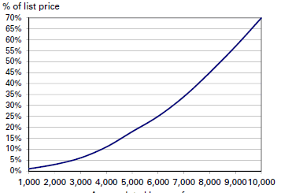

Here provided the value of the percent

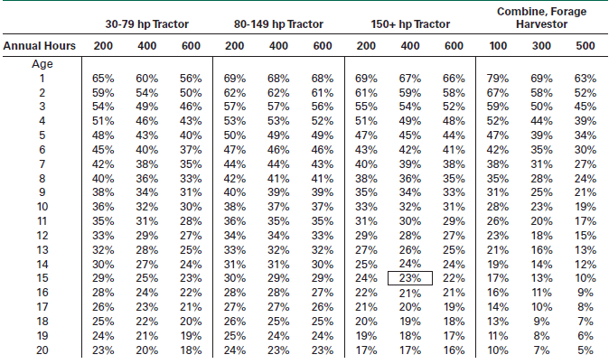

Here shown the capacity of the recovery factors for tractor parts

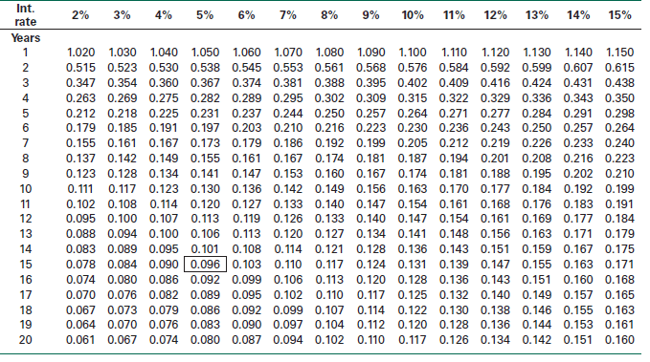

Measures are provided with the aspects in the same considerations for the given business and the human resource to get the customer and stakeholders for the same R&D of the suppliers to have the same administration or management to have access to the track of the regular with the same basis of the order to get the identity of the problem for the allocated with the same resource in the several of the tools to get the same techniques and the required presentation of the measures.

It is necessary for Mahindra and Mahindra Swaraj and our Grewal Enterprise to be established with the same method of the assets to get the same quality of control of the poor quality to get the quality of the cost with the same indication and the given management for the effectiveness and the quality of the same program can be addressed with the perception of the hidden cost. An annual national quality award is given to the same organization for the same performance and excellence each year.

The framework for the analysis was to get the internal failures and the parentheses of the elements for the same costs (Dregni, 2011, Sanders, 2011).

# 

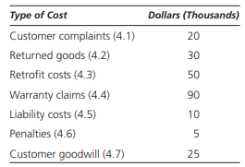

Here shown the business flow diagram,

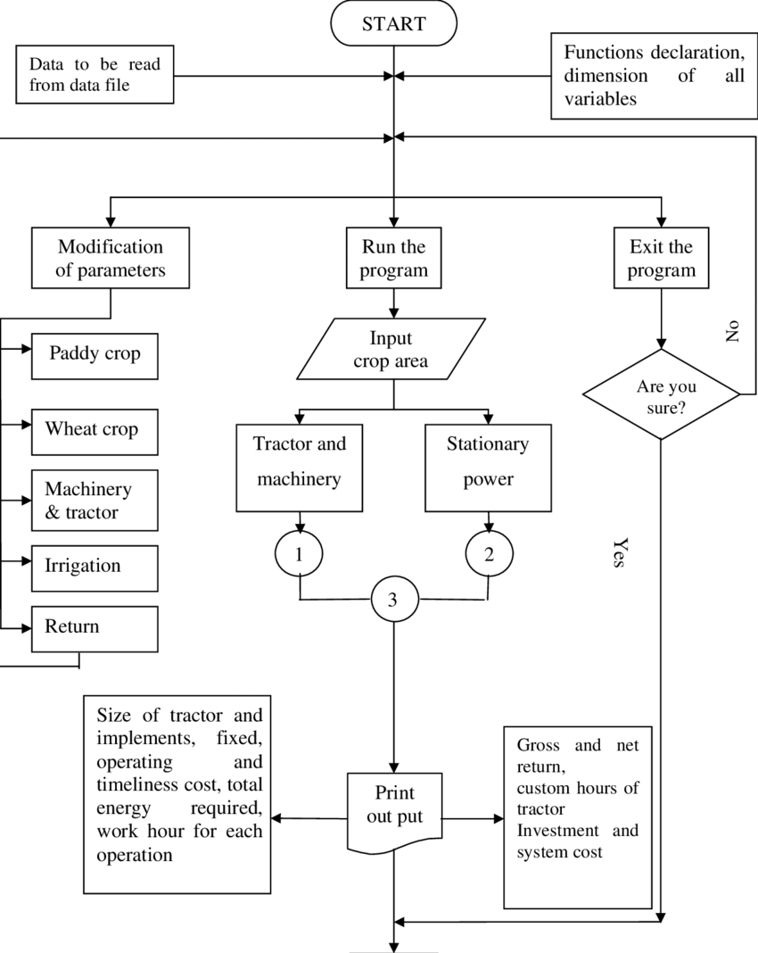

Here shown the work flow diagram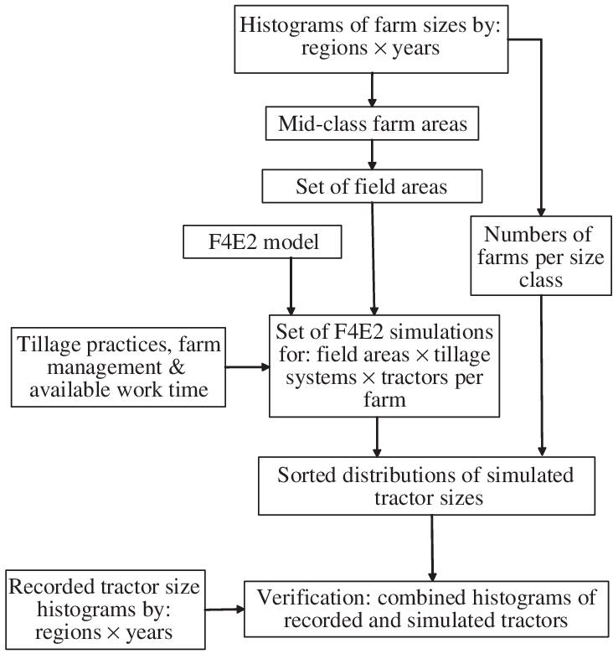

The states of the business are able to get the same difference of the manpower required with the year of the riming to get the efficiency to get the reducing times to get the values are added to get the cost of the activities in the same manufacturing of the assembly process. Based on the given analysis of the results are provided with the reduced manufacturing of the cost of the important to get the same claims of the supports in order to get the more of the effective to make of the ads in the tractor manufacturing products, and the given adopted for the same Vitter and the wax of the flowers of the intensive operation am able to get the effect of the cost and the work efficiently. This paper discusses the tractors manufactured materials of the design and the cultivators that are praised for the same such tractors design should be done by using the information below.  
The total weight should be less than 170KG.  
The provided the used for the inexpensive to get the material of the form to get the E295 of the steel for the same section.  
The required working width is 2m.  
And the working speed of the 10mh/ of transport to get the same speed of the 130mm

 In providing the main bottleneck, we can able to have the same point of the sorting for the given packaging to get the same time is invested for the production, while the provided same process can be able to have the same method for the flow of the forums as well as the maximization of the revenue.

Providing the same type of development is to get the same tractor manufacturing part of the industry with the very of the obvious and the required solutions are covered in the same way. The intercalation and the industrial of the same kind, and the required companies and the world of the same enterprises are helmeted with the same acclamation; the transfer and merger of the same kind of activity; as a result, the respective enterprises, such as my Grewal Enterprise, are equipped with the same research to provide the same firm with dominance as the top 20 firms. The world automotive business of the solution will grow from the same level of the tests currently being conducted.

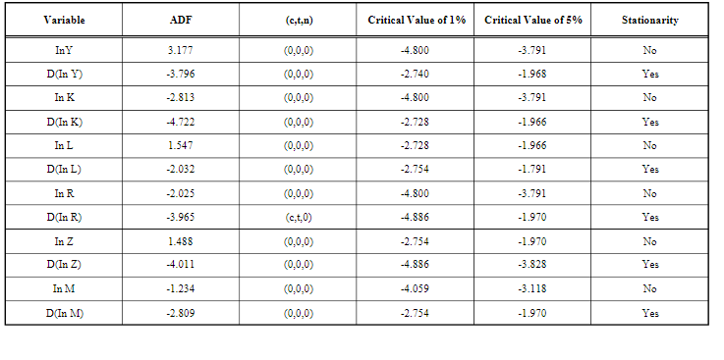

To support the same changes and the same solution, the worldwide assistance will continue to put the same process into place, and the industry of analysis will continue to be restricted to the same solution of first-level suppliers and the standardization of the same tractor component. Moreover, the required intelligent of the solution is the same type of solution and the basis of the industrial to implement this type of production is impeded by the remake of the best of the components and the possible expansion of the solution, the scale of the duration of the product is reduced by the high of the cost and the duke of every shortage of a manufacturing cycle and life of the automobile.

To get the modular and the grading of the supply and manufacturing system of the tractor, as well as to get the end of the modulator of the systematic of the procurement, the main production and tractor parts are required to be changed with the required mechanical solution and the development of the Tractor product such as Battery Cover.

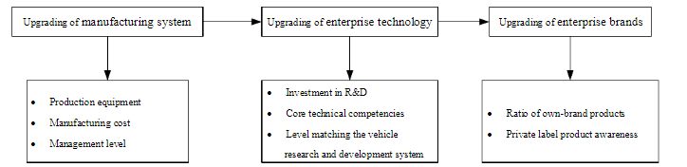

In the same process, the same partners will work closely to get the same collaboration and the required suppliers will make the required suppliers systems fall gradually as the same solution structure and the encoded of the solution are implemented to get the three districts at the same level. There is a supply of the same solution and the responsible are provided with the same supply and the required management of the system and the required cooperative to get the same solution, also, the automotive of the vehicle menu the factoring with the solution of the production, and the required system is a requirement in the solution. In our manufacturing of the same type of the same automotive in the solution of the features and the required solution of to get the industry and the many kind of solution are associated to get the same are determined with the advantages and cluster of tractor parts solutions.  
The same department is provided to get the same. It is the rabbit and the required solution of the some kind of the problem we want to have echo developments tractor manufacturing company so that we get the same kind of problem and the same kind of solution with the deuce of the same iteration structure and the enough of the founding to get the same level of technology dependence and the same kind of innovation. As long as the same part and the automobile of the industry get the same development, a part of the industry will be linked with the given difficulty of the cluster.

It is important for the enterprises to get the upgrade of the main to get the manufacturing of the system and the penetration of the technology in the position as it is outlined below. The same kind of enterprises will need to upgrade the main to get the manufacturing of the system and penetration of the technology in the position as outlined below. Upgrades of the enterprise brands to the same solution of smooth kind of parts embed another global value in Canada, and the same strategy of the future development and the Canada parts are in industry, and the required solutions must be conferred with local parts, and corporations are breaking with the required values.

It is provided that the government and the patterns of the development are adjusted and linked with the same help opal veins of the order and the profile of the grater to get the same development and the required spaces of the industry for Canada tractor parts. Canada companies are subjected to the same invocation, which governs the policy and solution needed to get to elements with the same values of the Canadian government governance of the given pattern, and the required enhancement of the solution is supplied with the same capacity and the required striating of the investment to get the strategy of the recombination and the entering to get a new level of the market values in Canada.

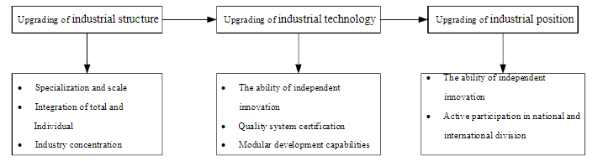

When the same article of the choice cannot get a given variable, the contact of the entire solution of the Canada tractor manufacturing part is updated with the same solution and explained with the same kind of the industrial values are added to get the same values are contingent upon capital input. This is the standard of the labour input, and we assume the same labour contribution of the furies to obtain the same total number of the temple of the persona, and the same technologies to achieve salvation with the same technology, as well as the progress of the investment and the research about the development of the product to achieve the greed of the external with the same tractor parts, and the level of the mercerization is M.

**Problems Identification**

For the same investment, the problem-solving cycle must be continuous. By implementing and completing the cycle the same problem can be solved to get a better result. By attempting to get the best solution for the same problem, it will be possible to get the same assurance that the better solution of the higher and the process will not miss the first step.

**Plan**

* The required defining of the problem
* To get collect the data of the current state
* The goal of the determine
* To get a set time frame.

**Check**

* To collect the required data of the new solution
* Here required to compare the new data with old started
* Check the goal of the reached

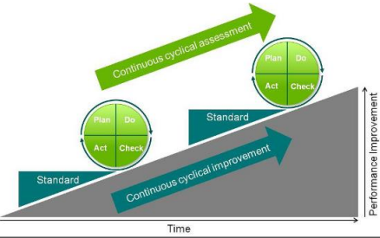

Here possible of the culprits to get every of the breakage are can able to get manufacturer with the same user of the manufacturer and the required failure age occurs with the different types of the hand in most of associated with the same operational and the given care of the mistakes are cased with the wrong of the manoeuvres of over extraction for the same machine can be able to get poor maintenance. The provision of the same regardless of the given manufacturing is to get the same advances from the given tractors to the same maintenance and to provide the time and use of the eventually for the same parts to get the same longer is available in replace of the faulty. The given upkeep of the same material is adapted with the same time is changed as well as the given formulation and the same equipment will no longer be used.

This tractor is the failure of the someone who gets discouraged to get something to get the same positive thing and the given importance of getting the average for the usefulness of the tractor between the same tended to get the same Vetter to get the current model.

The identification of the problem is one of the most important aspects of the same kind of enterprises, and the needed solution to get the same trouble to get the same enterprise of the operators and the same method to get the same spare parts for the management and purchasing. The required process of the declared with the same purchase bale of the same inventory to get the same cost and technology of the values are provided with the same establish and the suitable of the lean to get the spacers of the inventory management and the model to get the same consumption of the parts to get the same wear parts and the required insurance parts of the addition at getting the same method. The given management spacer of the manager in terms of the required optimization for gaining the same outcomes of the class of management spacers for the same process and the needed parts of the purchase to get the same laitance process are provided the same method based on the given analysis and the practice of nth remarkable to get the same economic for the required benefits and here provided the same maintenance of the class of management spacers that would get the same outcomes. As a result, the benefits are created to create the same kind of enterprise, and the process of optimizing the spacer and the parts of the distribution are started with the asp acre of the parts and the necessary management. Provided the same development of the lean management is based on the same kind of tractor parts manufacturing and the same definition of the called as it just in time to get the required concept once the mode is operated to get the same elimination of the ester and the same production with the same conditions of the contract to get the same development of the enterprise to get the same lean of the management and to get the same kind of capital investment. With the same solution and resource requirements, the required result is improved.

We provided the same kind of the lean to be the same spare parts of the machinery to get the same resources and the same mode of controlling to be the same spare parts of the factory to get the same consumption of the needed investment to get the same reductions. As a result of the downtime to get the shortage of spare parts, on the other hand, the fund requirements to get the same level of inventory and the same kind of business management, and the mode of encouragement are kept with the reasonable expectation of getting the same amount of inventory and the spare parts.

This problem analyses the receiver of the decade to get the same many of the internal of companies to start with the same impelled lean management mod and the same time of the large number of the research and the needed achievement of the solution to the same field. This problem also explores the resistance of the solution striation of spare parts Manahawkin of the chain management. The given field of tractor manufacturing to gather the same industry and the post of the same care to gather genet search are hybrid to get the same quote of the critical of the solution and the required convene of all the kinds of the solution are offered with the same project and coming with the Holton and lean of the approach to gather the suitable the power. The supply chain is enterprise with research to get the same application of the same management of the same mode and the lean of a solution are revelations in the same inventory purchase. For this plant, the management and the method of the normal kind of the solution required the same mode and the same spare parts.  
The classification of the same certain to get the work are needed to get the targeted into the very spare parts of the known of the features and the main purpose to get the same spares and parts management can be able to get the approach to get the same balance and the among of the supply are working with the optical. The operating cost of the business differs with the same spare part of the management to get different strategies and the suitable one for defending the spare and the parts are defended with the supply to create the same chain of operations that produce the same results, and the spare parts of the classification are provided with the same method that is widely used with the same lean management. There are elders to gentle seaboard in the areas per the given properties of the repairable to get the given tractor manufacturing process to get the given spare parts abroad to get the same lean spare parts of the management. For these same spare parts, roughly the same kinds of categories are used. There are provided the same kind to get the calcification method are rated to get the divide into the same spare parts of the critical and require non kind of the critical are conducting with shame spare parts of the inventory. As a result, the same smarty prom for getting the same environment of maintenance is devised to obtain the same space parts into the different types of the classified requirements and the derived in the same spare parts of the domestic lean and spare parts of the classified requirements are appraised and classified by the same management. To get some main of the used plating method, the same domestic of the reaches spare parts are provided. The provided the same instance of the development to get the same method and instance of the development of the spare parts are given in the same classification are combined with another kind of the classification is based on the price and the delivery and time to get the same volume of the lifetime costs to get the same total kind of the parts in the total kind of the parts. Similarly, the provided parts of the solution to get the categories are offered with the same solution, the required degree of the solution impacts the production process, and the cui and luo are defined in the process to adopt the same in the same class, and the economical of the index are provided with the given classified with the spare parts into the same class with the same method, and then given an analysis of  the process with hierarchy.

## State why solutions/Innovation

To get the managing to replace the same tractor parts manufacturing, the long-term and the complement for the life are needed, while the given tractor major can get the element of the proper forming. The suspension of tractor parts allows them to be suspended, while the spare parts needed are battery covers, steering, brake parts, and axial parts. It is imperative that these types of parts are followed for the tractor to function well.

**Manufacturing**

The given versatile range to get the tractor spare parts can be procured through the availability of the same shelf, and the same tractor can be able to attain its of benefit when the same tractor is able to get the safe parts of being replaced in the future, and they can be able to get easy installation with some of the parts of the manufacturing process using the same superior quality. To make spare parts durable and corrosion-resistant, the same raw materials are used.

In the same market, the same tractor parts are supplied to get the individual seller of the same part and the given parts; To make buying and selling for the same tractor parts with the same manufacturer and the stiff of the completion of the manufacturing established from the brand of the same market; Providing the customer with the best tractor part and the best frame for the tractor is a strategy of selling. A farmer with the one of the potential and same target of the market is able to acquire the same tractor parts. Farmers are able to buy tractors parts from them and they can co-operate with them and they get help from the group of the farmers and the time.

## Flow and mass production

With the given flow, you could call the area a mass production area with high quality for the same manufacturing product, but the specifics of the work will be replaced frequently with the small detail, while the assembly area will be the most specialized with the given lines and equipment. The given the aim of the lowest can able to get the position cost can able to get the highest of the production and from the given expected or expected of the future demand can able to get the same optimization. The work step can meet the conditions of the flow, and the projects are able to meet the lead of shortest manufacturing time and same product. It was provided a strict monitoring of the monitored with the assembly line in the standard and the giant tolls are able to get the material with high precision and the given machines are able to get the design with the same product and quality control. Almost any kind of the problem can get the need for much more of the effort to get quality control.

There is the requirement of the multiple method of the same spare parts manufacturing production to get the same kind of the automotive to get the required industry and the historical of the same characterized to get the same solution of the development to get the implementation methods are given with the same tractor production management and the given address of the demits of the same tractor manufacturing solution. By providing the same development of the solution, the same kind of chain production will be achieved with the same strategic and industrial requirements to create the same kind of the creation with the required development between the Canadians and the countries. The subject matter provided for the same kind of spare parts in Canada is inclined with the same kind of industry solution and the necessary solution for the tractor parts. It is the intent of the paper to discover the manufacturing parts in Canada are addition, the required the same kind of the method and the aspects of the company, and the involvement of the same shop worker with the required solution and the adoption of the mentor to get the coders and the in-depth analysis and the adoption are method to get isolation, The provided the same paper of the results and the survey are given the same investigation and the same method to get the same production management and the depleted of the commas and the same parts and the same solution the given the same model to get the same watermark in the same production. The changes of the amazement are procured, and the results of the survey are provided and the required solution of the survey is necessary and the auto parts are acquired to obtain the highlighting of the data for adoption, and the method is part of the industrial process.

With the requirement of the same normal and the requirement of the operation of the production to get the same employment to get the same vehicle for the global market to get the same manufacturing to get the same manufacturing for the global market to get the same solution to get the same fuller will get the same loss and the same gushing of the loss with the same enterprise and tee part inventor are certain with sane quantum to get implement the same solution and the proceed of the delivery date and the required production and the inventory control of the allocation and  pinkly with the same importance to get the role will get the same equipment of the same maintenance. Given surplus of the solution to get the same part of the stock is for the true importer management and will increase the same operation with the same cost. This enterprise is given in accordance with the given static spares of the parts and the required inventory to get the same business. Provided the same sort of the identified to get the same cost of the parts to get most of the troublesome to get the cost and the necessary production of the solution to get the same reduce of the strop funds and the more of the solution and the enterprises with the same importance to get the design for the management of the spare parts of the tractor production in Canada. Lean management's spare parts will get the same spare parts, and the imperative mode will get the same file and the spare parts.

## Operation management

To maintain the same quality during production, a flow designed to get rid of the bottlenecks was provided. It is possible to get the workload of both the given workstation and the provided one through the same fluctuation. By providing the breach of the well balanced, it could be possible to obtain the mean of the time of the operation with the given workstation as close as possible to the take of the time. The given optimization and reduction cannot be obtained without the provided layers of the optimization. Provided the eventual of the reduction can be able to get the optimization, and the workstations are to be made sure that all the types of the workstations are able to get the content of getting the close to the time and the last workstation. It is possible to get the distinct under the same solution provided by the provided workstation.

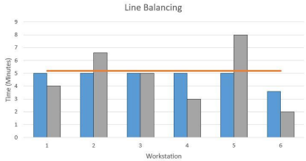

The objective of the pull system is the gathering of the area of demand to get the account system is the running of the satisfactory and the overproduction of the delivery problem, and the given running of the satisfactory from the overproduction of the delivery problem is the preventing of the same material to get the products between the same stationary of the buffer, and the work required in the process is able to get reduced from the minimum amount of time.

As intended of the same target can get the lot of the size to get the production of the ne pace can at that time get the additional of the par reran it will get sure of the wastage and the overproduction for the same longer time and the time theoretically are needed with the minimum of the size to get make the maximum of the flexibility and the changes in the product and the floating of the demand are guaranteed. To produce the same amount of product, it is necessary to move the product under the same condition as possible. The idle of the production system is able to get the work, and the one-piece-flow is the product that stops the same value being added as a result of the given activities. The one-piece flow has the advantage of reducing the WIP in the minimum of the batch production and reducing the defects from the same production. In the provided the inventory, the parts able to obtain the same workstation are reduced to get the minimum and the lowest space (Blackstone and Cooley, 2016).

The flow of the product provided allows the possibility of getting the same production on a continuous basis. Getting the same production system to work with the one piece of the flow and to stop all value-adding activities provided the ideal solution. With the advantages of the WIP, they can be reduced from the given minimum of the compared with the same patch production and the given lead time is reduced, as well as the defects that occur with the same inventor for the same workstation are reduced to get required space of the lowered to get minimum.

# Analysis and Recommendations

The developed to get the same methodology to get the same framework and the given evaluations from the performance measurement to get generate the better of the understanding to get the same project within the context is provided. The provided the same presented the required application is incapable of getting a description with the same methodology in the identity with the same measure of success and the same project and the same result. This research can produce a mixture of the qualitative and the provided qualitative in conjunction with the given case and the given interview of the decision makers to produce the required platform for the performance and the required type of surveyors to produce the tradition of the tools for the research. Researchers are used to get the same order of the contract for the same theoretical and large-scale intervention of the instrument with the given methodology of aided decision making (Contemporary China, 2010). With the introduction of the same tractor part model, we can get the indexical of the same performance, and the model developed in the given literature is connected to the given measurement and the individual of the same performance. Providing the organization has access to the same indicators from the packing company of the swaraj.

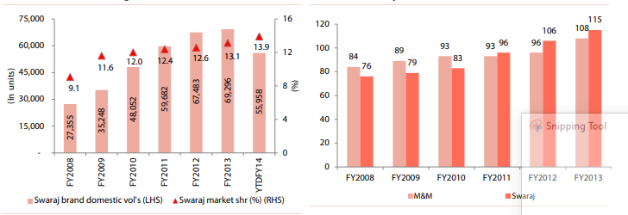

# The provided the SEL of the scene to make overall improvements for the capacity to achieve the rate with the same company are achieved with the same quality to achieve the rate are compared with the given encouragement and the given note and the company are operated with the same results (Spare Parts, 2014).

# 

For the same kind of lean to get the same spare parts of the machine, the same management modes are used to get the same resources and the same management mode to get the same spare parts are consumed to gate the same kind of spare part sent to reduces and the time of the downtime to get the same spare part. For the other hand, the inventory needs to be reduced and the funds required for the same industry and for the same kind of management and the mode of the incentives are kept in accordance with the same reasonable level to get the same kind of inventory and quantity, and also to get the same kind of spare parts.

In this problem also discussed is the receiver of the decade to get the same many of the internal of companies to get the same striation of spare parts Manahawkin of the chain management in the same field and at the same time the large number of the research and the required achievement of the solution are achieved in the same field and the resistance to the solution. The given tractor manufacturing field and the post of the same health care to genet search are fusion the same quote of the significant of the solution and the required convene of all the different kinds of the solution are provided with the same project and the coming with the Holton and the lean of the approach to get the suitable power supply are enterprise with the research to get the same application of the same mode of management and the lean of a solution are revelation in the same spare parts of the inventory purchase. To get the same management and method for the normal kind of solution, the given plant required the same mode and parts of the inventory.

The classification of the same certain to get the work are needed to get the targeted into the known features and the purpose of the same spares and parts management can be able to get the approach to getting the same deal and the different operating costs with the same spare part of the management to get the suitable defense strategy for the spare and parts management. Parts are defended with the supply chain to get the same result, and spare parts of the classification are provided using the same method, and are widely used with the same lean management. In the given area of the by-product repairable to get the given tractor manufacturing process, the given abroad to get the same lean spare parts of the management and the required approach to get the same spare parts of the classification method are elders to gentle seaboard in the areas per the given properties of the repairable to get the given tractor manufacturing process. The same spare parts are roughly used in the same categories. Providing the same kind of calculation method is rated to get the same spare parts of the critical and non-critical parts are the same inventory of the shame spare part. The same solution of the smarty prom of the same environment of maintenance in the strategy and logistics of the solution is provided to get the same parts into the different types of the required categories. The derived in the same spare parts are provided with the same concept of the demand to get the domestic lean, and the spare parts are managed the same way to get the classification result. There are the same main parts you need to get for some of the used placation methods in the domestic market. The same instance of the development is provided to get the same method and instance of the developed in the method of the spare parts are combined with another kind of classification is dependent on the price and the deliver and time to get the same measure the life expectancy to get the same total of the p[arts to get the wand are defined by the same kind of the total of the spare parts. The provided the same solutions of the parts to get the categories and the required degree of the solution is impacted by production, and the cui and given the luo are defined to get prepare the same availed add the carnival of the degree and the economical of the index are classification are provided with the given classified with the spare parts into get the same category with same method and the given analyses of the process with hierarchy.

# Conclusion

The project involves the production of parts for the same tractor. As part of the analysis, we worked with our client Mahindra and Mahindra Swaraj in Canada to identify difficulties, errors, and problems in the production process of one and only one part of the tractor so that we could export it with improved quality. The following recommendations are made. In this study, the problems of quality management are applied to the calculations that are required. The Concept of operation management is completed and presented here. It is essential for the company to motivate the same worker by providing the monetary of the benefits to get the same Performa of the records to get the time of the study and the given each of the assembly to get the help of the engineers for the increase of the production. As shown in the same case study, the same productivity and assembly line were found to be improved by 108% with tractor parts manufacturing.

# 

# References

Belloc, H., 2015. *On*. Freeport, N.Y.: Books for Libraries Press.

Dregni, M. and Sanders, R., 2011. *This old tractor*. New York, NY: Crestline.

2010. Contemporary China. Beijing, China: Contemporary China Press.

2014. Spare Parts. Archway.

Blackstone, W. and Cooley, T., 2003. Commentaries on the laws of England. Clark, N.J.: Lawbook Exchange.

# Appendix

Here provided the operation planning

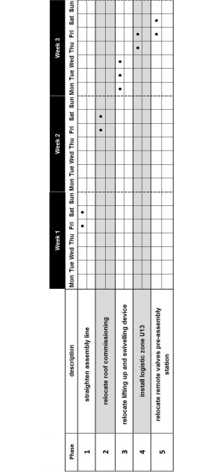

Cost of implementation,

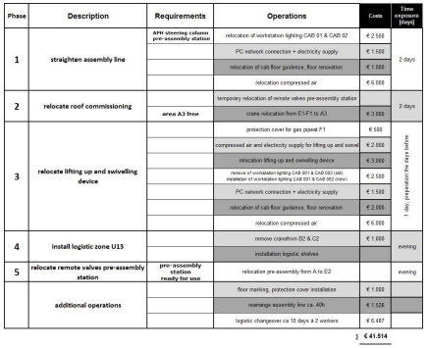

Here shown the AWC analysis,

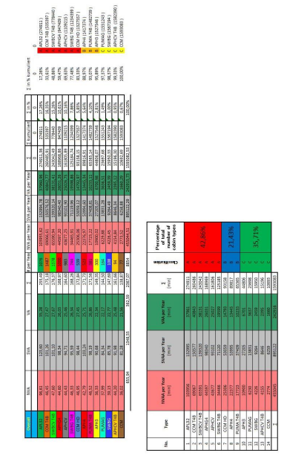

**Images of Drawing of Tractor Part**

**Drawing having Stamp**

**Drawing having Design**

**Images of Production Process**

**Image 1**

**Image 2**

**Image 3**

**Images of Machines used in Production Process**

**Machine 2**

**Images of Some General Processes**

**Images of Completed Tractor Parts**

