

**Bilateral Trade Relations between India and Hong Kong**

-Zufar Hussain (21-bba-fr-035)



**Bilateral Trade Relations between India and Hong Kong**

**HISTORY:**

India’s relations with Hong Kong are historical and date back to the 1840s when Hong Kong became a British colony after the Treaty of Nanking as the result of the First Opium War. From trading ties established in the middle of the 19th century (1840 onwards), relations today span sectors such as investment finance, services, maritime, shipping, logistics, culture, education and trade.

The Commission for India, set up in 1951, was re-designated as Consulate General of India on October 15, 1996, in advance of China’s assumption of sovereignty over Hong Kong, which took place on July 1, 1997. The Consulate also has accreditation to Macau, which reverted from Portuguese rule to China on December 19, 1999.

Recent years have witnessed keen interest in Hong Kong in India’s economic growth and its status as one of the fastest growing economies in the world. Expectations here are that with deepening of economic reforms in India in the coming years, India-Hong Kong relations should deepen and trade and economic ties should expand.

Donald Tsang, the then Chief Executive of Hong Kong along with the Governor of Guangdong province led a business delegation on a visit to India in October 2010. The visit was more in nature of a business visit, while he met Governor of Maharashtra, MOS(PK) for External Affairs & Finance Minister during his visit.

In order to increase the level of economic engagement between India and Hong Kong and provide boost to the business, investment and people-to-people links, the then Chief Executive (CE) of Hong Kong, CY Leung paid an official visit to India from February 2-5, 2016 at the invitation of Chief Minister of Maharashtra. It was the first official visit to India of a Hong Kong Chief Executive. He led a 40 strong multi-sectoral business delegation, the largest one accompanying Chief Executive amongst his official overseas visits. During his visit, CE called on Hon’ble Prime Minister, Finance Minister and External Affairs Minister. He also addressed the business events organised by Indian and Hong Kong Chambers of Commerce.

Hong Kong has always acted as a “Gateway to China” for the companies in rest of the world. With the rapid growth in engagement between the Chinese and Indian economies, Hong Kong presents a great opportunity to act as a “Gateway to India” for the mainland companies and become an important stakeholder and a beneficiary of this huge opportunity.

Finance Minister Shri Arun Jaitley visited Hong Kong on September 19-21, 2015. During the visit, he called on Chief Executive of Hong Kong and also addressed the investors at the India Capital Markets and Institutional Investors Summit. Chief Minister of Telangana Shri K. Chandrashekhar Rao led a high-level delegation to Hong Kong on September 14-16, 2015. Chief Minister of Gujarat Smt. Anandiben Patel, visited Hong Kong from May 19-20, 2015. An official delegation led by Chief Minister of the Haryana Shri Manohar Lal Khattar visited Hong Kong from 23-25 May 2017. Sh. Raghuvar Das, Chief Minister of Jharkhand led a 7-member delegation to Hong Kong on a familiarisation visit from 6-7 September 2018. Sh. K. J. Alphons, Minister of State (Tourism) visited Hong Kong on a familiarisation visit on 10th May 2018. Sh. Ashwani Kumar Choubey, Minister of State (Health and Family Welfare) visited Hong Kong from 26-27 May 2018. In November 2016, a business delegation from Confederation of Indian Industry (CII) led by its President Dr. Naushad Forbes visited Hong Kong. This was a return visit to that of the business delegation which had accompanied Hong Kong Chief Executive CY Leung (CE) during his visit to India in February this year. CE met with delegation to exchange views on strengthening business and commercial ties between India and Hong Kong. 9. With effect from January 23, 2017, Hong Kong government has made Pre-Arrival Registration a compulsory requirement for all Indian nationals who intend to visit Hong Kong visa-free for 14 days.

**Bilateral agreements:**

**Agreements concluded with Hong Kong include:**

• Agreement on Reciprocal Enforcement of Judgements (1968), [which was re-notified by Government of India in July 2012 due to a change in the nomenclature of Hong Kong courts following handover of sovereignty to China in 1997],

• Agreement Constituted by Exchange of Letters Between the PRC and India on matters related to the Consular Convention (December 1991),

• Air Services Agreement (1996), and an MoU on Air Services Agreements pursuant to the Air Services Agreement (February 2012),

• Customs Cooperation Agreement (1997),

• Surrender of Fugitive Offenders (1997), and

• Agreement on Mutual Legal Assistance in Criminal Matters (September 2009).

• Agreement for Mutual Recognition Arrangement in respect of Authorized Economic Operation (AEO) programs between Central Board of Excise and Customs (CBEC) of Government of India and the Customs and Excise Department of the HKSAR Government (November 2013).

The Following MoUs have been signed between India and Hong Kong:

• MoU between Hong Kong Monetary Authority (HKMA) and Reserve bank of India (RBI) on Supervisory Cooperation and Exchange of Information signed on July 17, 2014.

• Agreement on Transfer of Sentenced Persons was signed on January 20, 2015 and has since come into effect.

• India Trade Promotion Organisation (ITPO) signed an MoU with Hong Kong Trade Development Council (HKTDC) to strengthen the economic partnership and increase bilateral commerce between India and Hong Kong, especially for small and medium sized enterprises in 2016.

• National Research Development Council (NRDC) signed a MoA for establishing Bilateral Strategic Business Partnership between NRDC and Hong Kong Trade Development Council (HKTDC) on 07.12.2018

India and Hong Kong signed Double Taxation Avoidance Agreement (DTAA) on 19th March 2018. The relevant procedures have been completed by both sides and the agreement has entered into force on Nov 30, 2018. This Agreement will stimulate flow of investment, technology and personnel from India to HKSAR & vice versa, prevent double taxation and provide for exchange of information between both the sides. It will improve transparency in tax matters and will help curb tax evasion and tax avoidance. The Agreement has also been the long pending demand of Indian community in Hong Kong.

Negotiations are in progress include the Bilateral Investment Promotion & Protection Agreement between India and Hong Kong and the proposal by Hong Kong to open an Economic and Trade Office in Mumbai.

**Commercial relations:**

Recent years have seen relations between India and Hong Kong expand rapidly. Hong Kong companies also have been increasingly looking at India as an investment destination. Many Hong Kong companies have huge presence in India. This includes China Light and Power (CLP), Li & Fung, Shangri La Kerry Logistics and PeakRe to name a few.

Hong Kong is host to a large number of Indian professionals in banking, IT and shipping. Eleven public sector banks and three private sector banks from India are currently operating in Hong Kong. Numerous global financial majors, investment institutions and fund managers operating in India have their regional headquarters in Hong Kong. Hong Kong is also a major sourcing centre for Indian companies. It has emerged as a major re-exporter of items it imports from India to Mainland China. The regional office of Air India is located in Hong Kong.

Hong Kong is major hub for exhibitions and conferences. Trade fairs in Hong Kong are an important opportunity as they provide a platform for the buyers and sellers across the globe to come together and interact. Annually, more than 60 fairs are held in Hong Kong. India also participates in many of these exhibitions to promote its strengths, mainly through export promotion councils and sectoral promotion boards. Hong Kong Trade and Development Council (HKTDC) had made India as its focus point for promoting business and trade linkages, and conducts regular field trips to various parts of India. In 2018, the Indian Export Promotion councils organised the Indian Pavilion for over 23 different trade fairs.

**Bilateral Trade:**

. India was Hong Kong’s 3rd. largest export market destination (after China, US) in 2017 (Jan-Dec) and Hong Kong was India’s 3rd largest export market (after US, UAE) (April-Nov 2017). India-Hong Kong trade in 2017 was US$ 34.11 billion (growth of 27.0%). Exports from India to Hong Kong were worth US$ 13.77 billion, an increase of 15.8%. About 90% of our exports are gems and jewellery related. (Value additions in India, since 56 % of imports are also from this sector). Our imports from Hong Kong also increased by 35.9% to US$ 20.34 billion, the balance of trade during this period was in Hong Kong’s favour amounting to US$ 5557 million. During 2017, India continued to retain its position as the 7th largest trading partner of Hong Kong

Indian exports to Hong Kong primarily include Pearls, precious & semi-precious stones, mineral fuels, Electrical Machinery, Leather, Iron & Steel, Fish & crustaceans, Cotton, Organic Chemicals, Machinery and Articles of apparel while Indian imports from Hong Kong include Pearls, precious and semi-precious stones, Electrical machinery, Machinery, Optical & medical instruments, Clocks & watches, Plastic and articles thereof, special woven fabrics, Miscellaneous manufactured articles, edible fruits & nuts and paper.

**Trade and Investments:**

Hong Kong occupies the 12th position in FDI equity inflows into India with cumulative FDI amount of US $ 3.67 billion (April 2000 to December 2018) with close to 632 million investments in 2018. With the entry into force of DTAA between India and Hong Kong, investments from Hong Kong to India are expected to increase.

Start-ups are emerging as an important sector of collaboration between India and Hong Kong. Keeping this in view, Consulate General of India Hong Kong in association with Asia Society Hong Kong Centre conducted a two-day start-up event on November 20-21, 2018. The event included sessions at HKSTP, panel discussions on India and Hong Kong’s start-ups scenario and four workshops on the start-up cultures of India and Hong Kong, their challenges and the opportunities in the coming times. Given the positive feedback received, we shall continue to promote collaboration in the future and are looking at hosting an event on similar lines in 2019-2020

**Comparison of trade between the time period (1/1/2019- 31/12/2020)**

I have selected the years 2019 and 2020 because I wanted to compare the trade relations one year before covid and the year during covid.

Since India and Hong Kong deal with trading with more than 80 products every year, I have decided to take only 3 products with the most trade value over the time period

**Exports from India to Hong Kong (2019)**

1. Precious metals, gems, and Jewellery ($9.92 billion)
2. Electrical machinery and equipment ($322 million)
3. Instruments and apparatus ($59.4 million)

**Exports from Hong Kong to India (2019)**

1. Electrical machinery and equipment ($8.77 billion)
2. Precious metals, gems, and Jewellery ($4.79 billion)
3. Instruments and apparatus ($229 million)

**Exports from India to Hong Kong (2020) (pandemic)**

1. Precious metals, gems, and Jewellery ($7.37 billion)
2. Instruments and apparatus ($51.8 million)
3. Electrical machinery and equipment ($284 million)

**Exports from Hong Kong to India (2020) (pandemic)**

1. Electrical machinery and equipment ($6.97 billion)
2. Precious metals, gems, and Jewellery ($3.99 billion)
3. Instruments and apparatus ($309 million)

**India’s exports to Hong Kong in the year 2020**

In 2020, India exported $9.18B to Hong Kong. The main products exported from India to Hong Kong were Diamonds ($4.92B), Jewellery ($2.19B), and Frozen Bovine Meat ($631M). During the last 25 years the exports of India to Hong Kong have increased at an annualized rate of 6.38%, from $1.96B in 1995 to $9.18B in 2020.

**Hong Kong’s exports to India in the year 2020**

In 2020, Hong Kong exported $14.2B to India. The main products exported from Hong Kong to India were Integrated Circuits ($2.64B), Diamonds ($2.31B), and Telephones ($1.7B). During the last 25 years the exports of Hong Kong to India have increased at an annualized rate of 13.6%, from $586M in 1995 to $14.2B in 2020.

**Analysis:**

I have used a clustered bar diagram to make an individual comparative trade analysis of the three most traded products, and from this I can incur that

1. **Jewellery** is the most traded product because Hong Kong is the 5th top trading partner of India **with a share of 4.63% (924 thousand US$)**
2. **Electrical machinery and equipment** are the second highest traded commodity, Hong Kong imported Electrical machinery and equipment’s to India most on 2020 compared to the year 2019
3. **Instruments and apparatus** are least traded comparatively among the three Hong Kong exported almost $309 million in instruments and apparatus in the year 2020

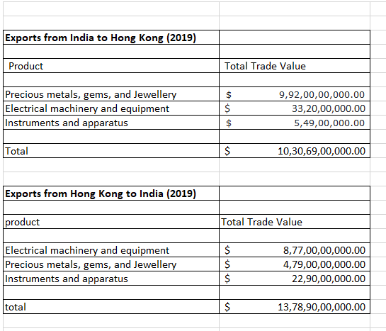

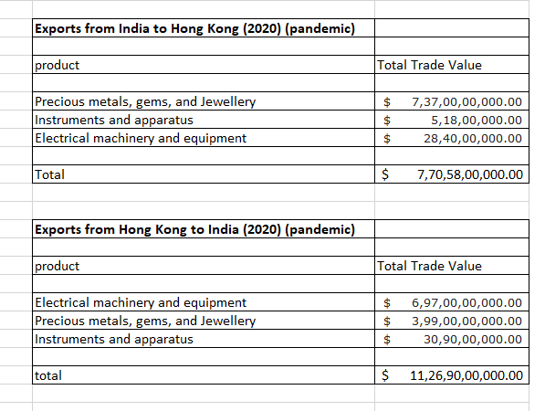

I used the data I got from OCE world and used Microsoft Excel to compare the data between the exports and imports from Hong Kong and India pre-covid (2019) and during covid (2020) and from this I can derive that the exports from Hong Kong to India (2019) had the highest trade value compared with the all the imports and exports that happened between them over a period of one year with a total value of $13,78,90,00,000.00 billion

The following graph is a comparison of the total trade value over the last year

**Analysis:**

1. The exports from India to Hong Kong was more in the year 2019 compared to the year 2020
2. The exports from Hong Kong to India was more in 2019 compared to the year 2020
3. India’s Imports in the year 2020 was comparatively more than Hong Kong’s imports from India in the year 2020 from from this I can incur that India was more dependant on Hong Kong during the pandemic

**Conclusion:**

In Conclusion from my research, I can say that, India and Hong Kong have a trading history from the British period and both the countries share a healthy relationship with each other. And from the products I have chosen I have come to a conclusion that India has imported a lot of machinery from Hong Kong during covid to help the country sustain from the pandemic.

(I will be presenting more data on my presentation)

**BIBLOGRAPHY**

**History and facts:**

<https://cgihk.gov.in/index.php>

**Data:**

<https://oec.world/en/profile/bilateral-country/hkg/partner/ind>