

**NATIONAL INSITUTE OF FASHION TECHNOLOGY, KANGRA**

**GRADUATION PROJECT**

**Topic:** To Optimize the Vendor Evaluation Criteria at Continuum Buying House

**Submitted By:**

**Nishtha Verma(BFT/18/331)**

**Acknowledgement**

The success and the final outcome of this project required a lot of guidance and assistance from many people. I am extremely privileged to have got this all along. I would like to thank and Ms. Chavi Goyal for providing me with the help and guidance required to carry out this project. I would also like to thank my industry mentors Ms. Vaishali Arora and Mr. Pankaj Joshi for their constant support and guidance throughout the duration of my internship.

I am really grateful that I got an opportunity to intern at Continuum buying Agency. It was a really engaging and great learning experience.

**Introduction of the Firm**

**Continuum Buying Agency**

Continuum is a buying agency that provides sourcing and design consultancy to Scandinavian and US based brands. The company was started by CEO and creative director Linda Augustsson. The company is design oriented and product driven. The company tries to follow ethical trading in this fast-paced environment.

The vision is to create a modern buying agency by adding value to both customers and the local supply chain across India, and to shorten the communication gap and improve the vendor relationships.

* Nature of business – Export
* Product category- Apparel, Leather apparel and accessories, bags and home products.
* Founded - 2002

**Clientele**

The company caters to a variety of clothing, lifestyle and accessories from buyers around the US, and Europe. Provide design and sourcing solutions to established brands like Timo, Downeast and Urban Outfitters which are women centric brands from the US.

Another major client of Continuum is About You which is a German e-commerce brand that houses over 2000s brands and has premium subsidiary brands as well. Leger, GMK , Dan Fox, Alvaro Soler are a few of the subsidiary brands of About You.

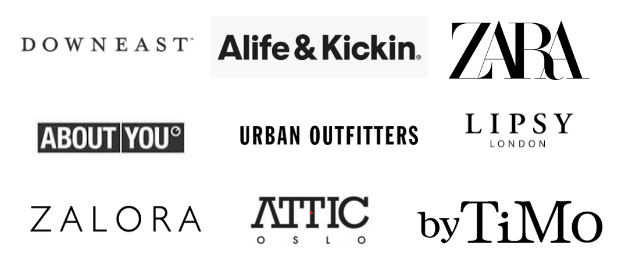

**Departments at Continuum Buying Agency**

1. **Continuum Design Studio** 
   * Forecasting and trend analysis
   * Development of Original print artworks and embellished concepts using in house artisans.
   * Develop brand specific and commercial design range.
2. **Fabric** 
   * New fabric development
   * Sourcing according to different buyers
   * Liaison with Mills
   * Quality
3. **Product Development**
   * Development of samples
   * Confirming all the accessories and trims for the garment.
   * Conforming the fit of the garment.
   * Generate more orders from buyers.
4. **Production**
   * Liaise with the clients
   * Analyse orders
   * Vendor interface
   * Price and delivery
   * Follow up all the process of production
5. **Logistics**
   * Acquiring and managing the allocation of finished goods at their final destination.
6. **Quality**
   * Product quality
   * Packaging quality
   * Production processes
   * Audit failure analysis
7. **Finance**
   * Manage finance for buying and new appliances or improving the infrastructure of the firm.
8. **Accounts**
   * The management of all employee’s accounts, salaries, bonuses, promotions. etc

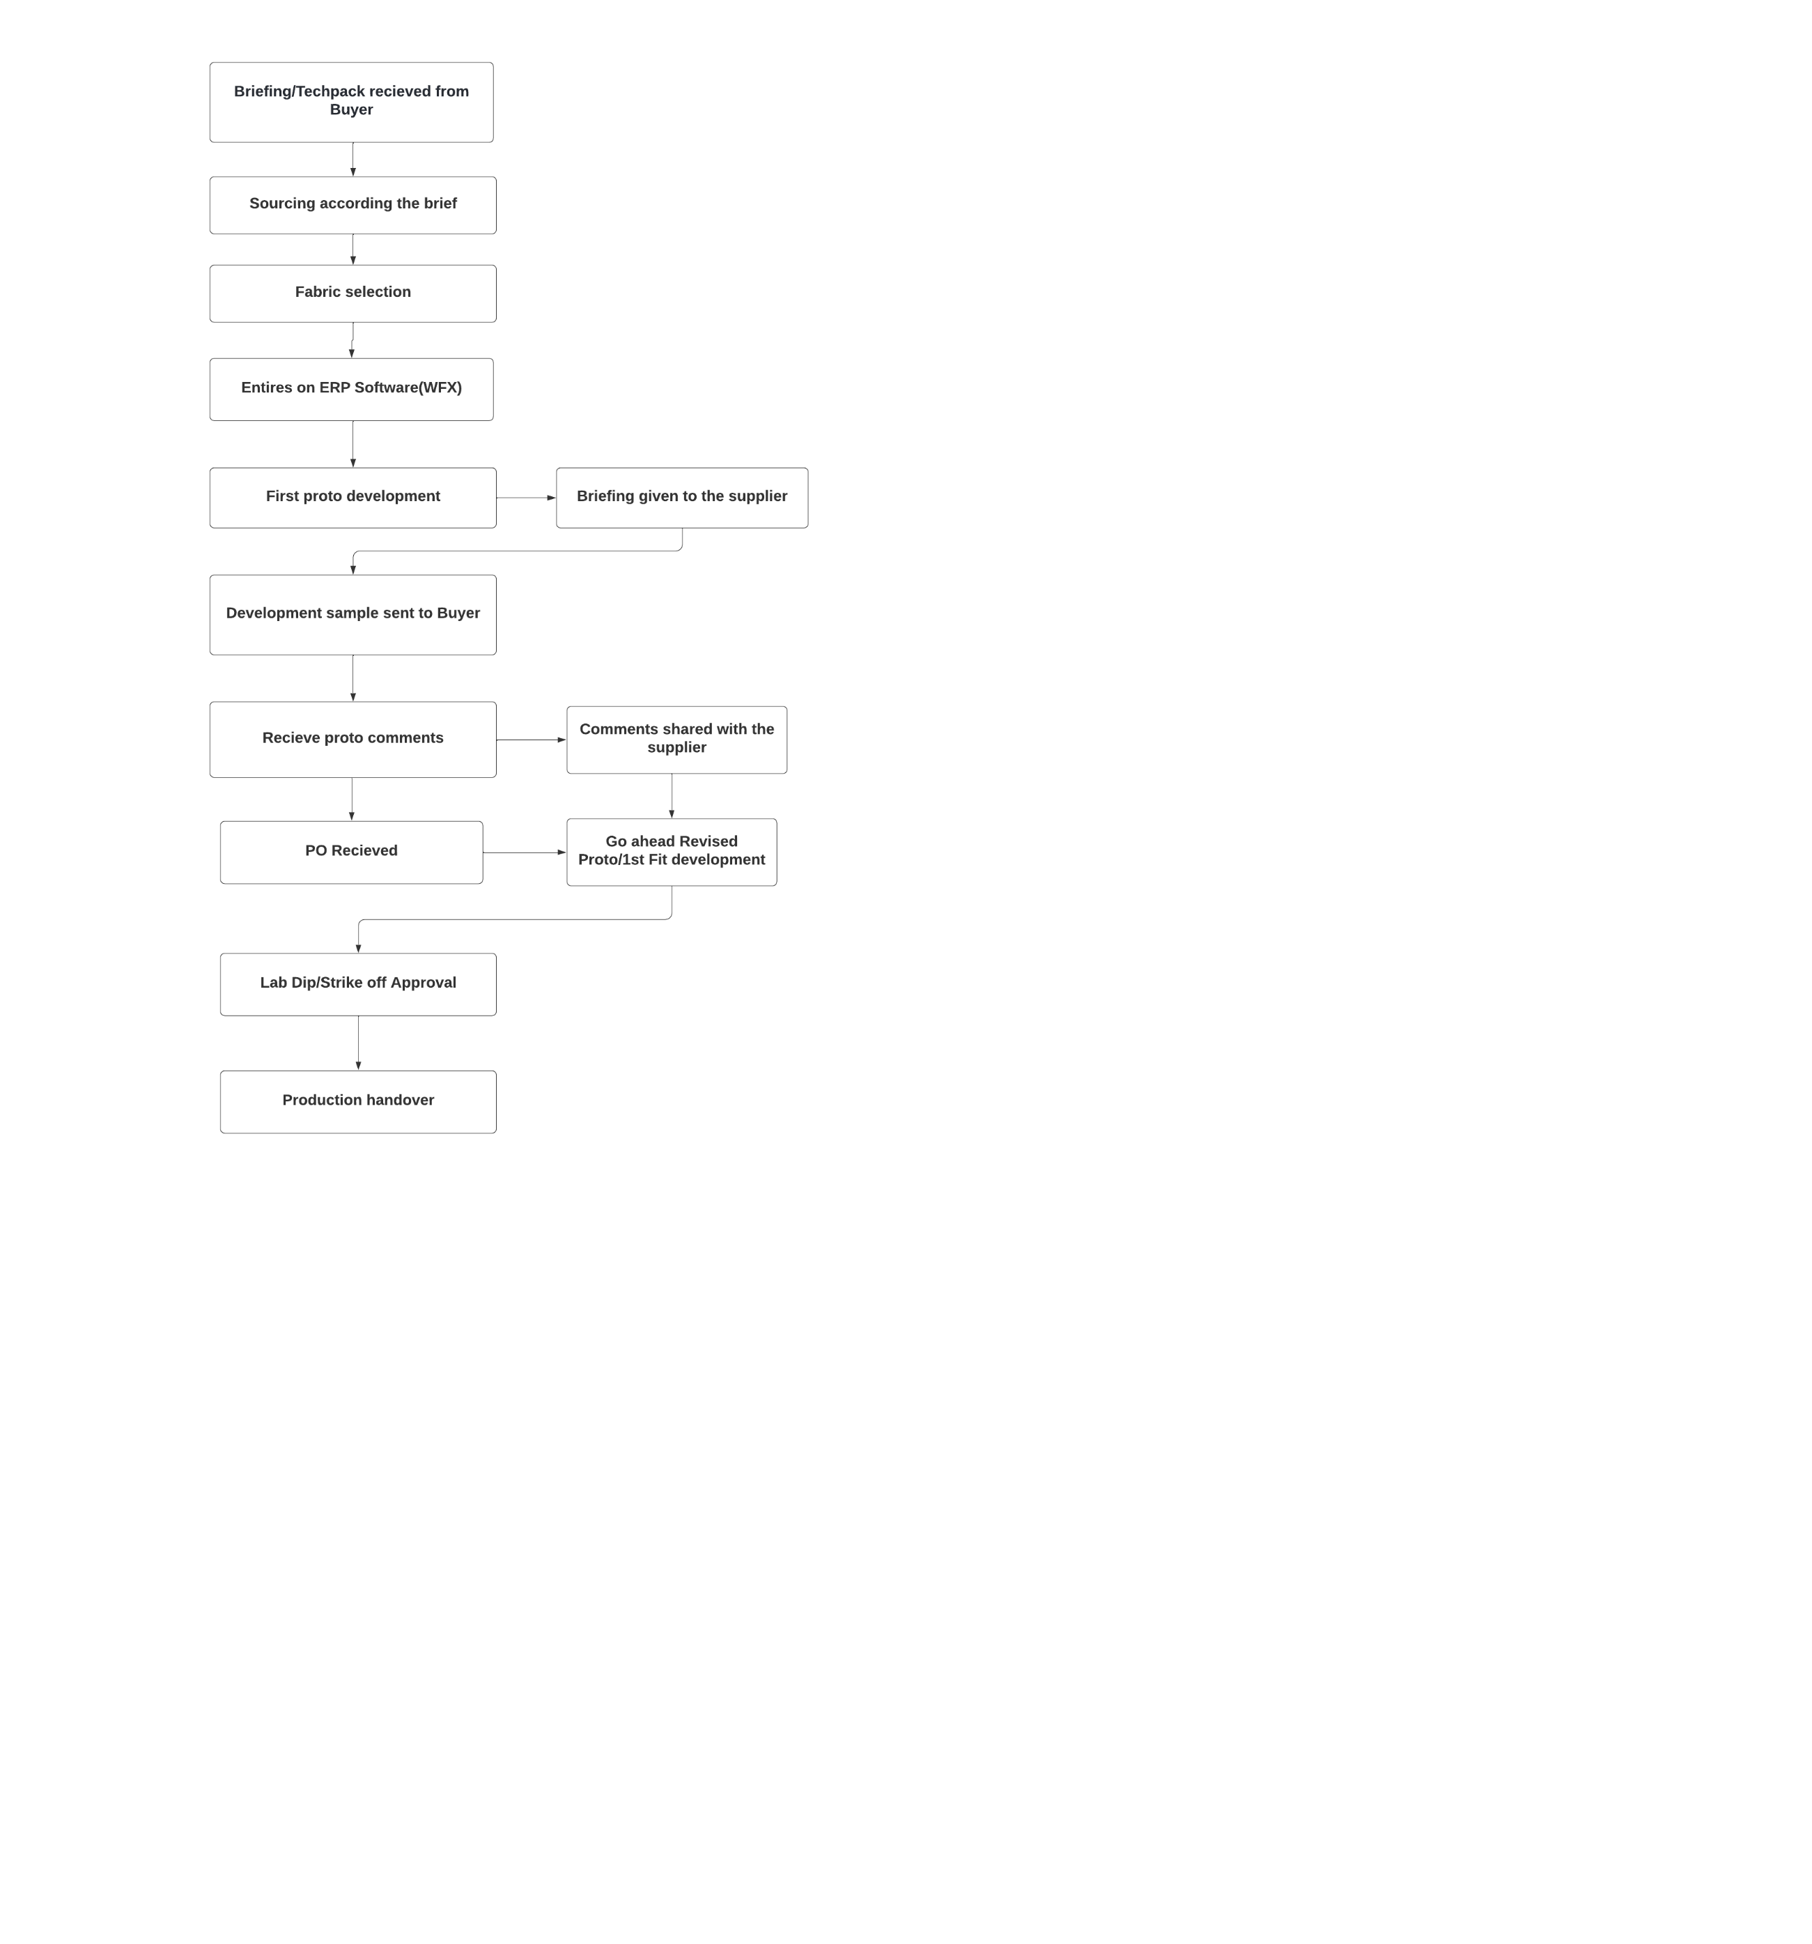**Product Development standard operating procedure**



**Standard Operating procedure in Production**

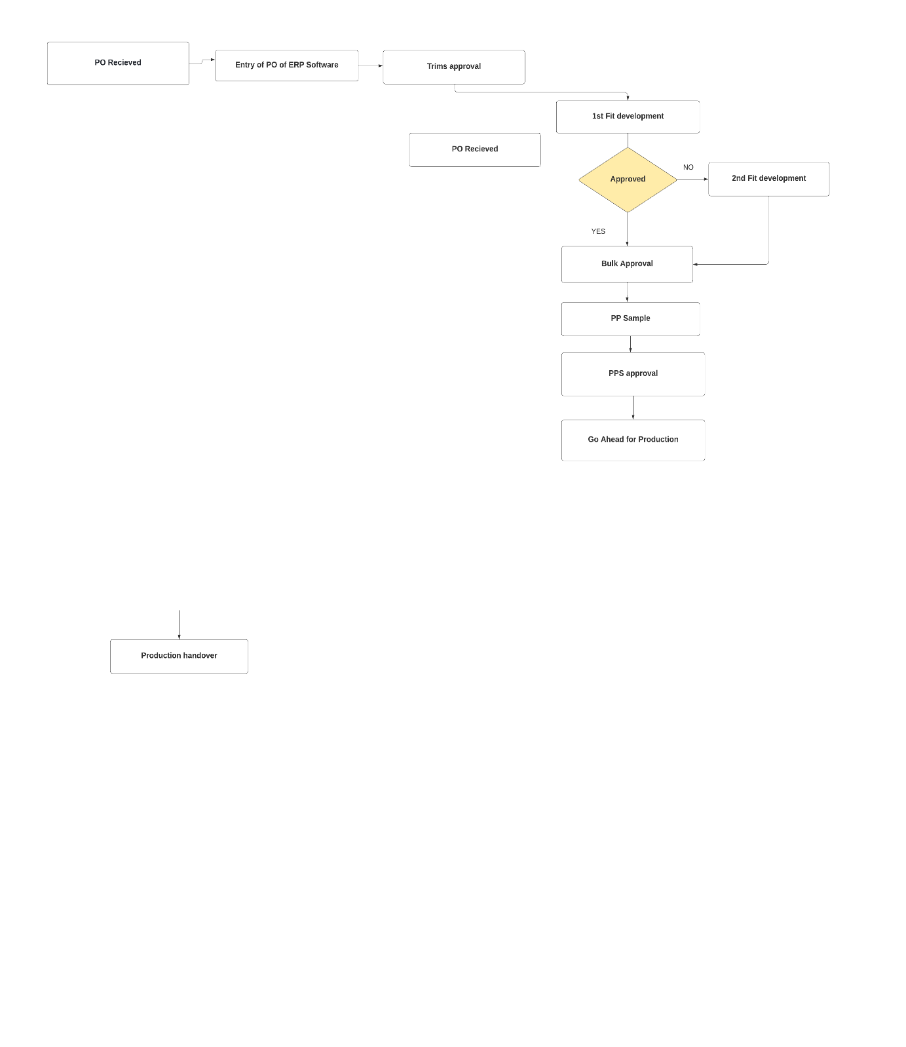

**Literature Review**

In today’s world economy the vendors play a major role in the apparel industry. The vendors occur as middlemen between the buying offices and the retailers. The industry is highly competitive and a key role in the supply chain is the supplier. If an organization develops good relationships with the supplier, it has many benefits in the aspect of quality, time, innovation and sustainability. Vendor performance evaluation is the process of measuring the vendor’s performance and helps nurture a long-standing relationship with the vendor.

Vendors are selected on the basis performance relating to meeting of deadlines, the orders they have handled and the reputation in the market, lead time, production capacity, the man power, financial condition, and the unique selling point the vendor is offering. Vendors are a depiction of buyer’s operating capacity.

The world economy is moving fast and so are the buying agencies and exporters. To be the best in business, all the vendors need to be integrated and controlled really well. Companies need to continuously improve their supply chains and ensure that the vendor performance is improving. Organizations are becoming more informed, and more selective of vendors in terms of price and quality. It is essential for the buyer to provide the best quality and competitive price, in order to retain customers.

Buyers are looking for shorter lead times, because this implies that there will be lower indirect costs. However, shorter lead times require highly skilled and motivated workers, excellent working conditions and highly motivated workers, excellent working conditions, and good top management. Companies need to improve their supply chain and an essential part of the supply chain are the vendors.

The main priority should be quality of goods and but often times the firm focuses on the prices. The main goal should be to notice the value addition the vendor is bringing on board.

There are many complexities involved whilst onboarding a vendor, a few of the factors are

* Emphasis on quality at the source
* Design competency
* Declining work-in-process (WIP), lead time, space, flow distance
* Operators cross-training, doing preventive maintenance
* Low startup time
* Equipment/labor flexibility
* Production capacity
* Production and process innovation
* Infrastructure

In the competitive global business environment of the 21st Century, the demands of the customers must be met. The vendor selection and evaluating their performance has become a challenging process, as various criteria must be considered before making the decision.

There are a variety of risks that a manufacturing unit, has to face. Shortage of raw materials, loss of unavailability of necessary raw materials.

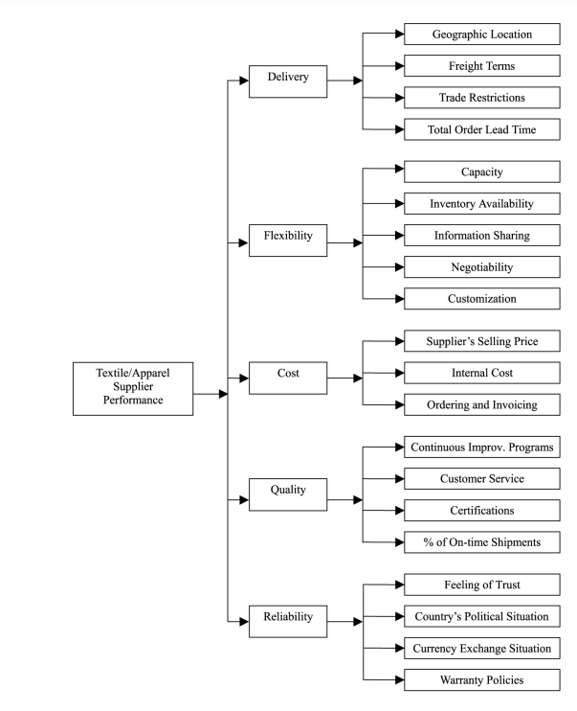

Important criteria that are taken into consideration while selecting vendors:

1. **Delivery:** The delivery cluster consists od four factors that include, geographical location, freight terms, trade restrictions and the lead time. The proximity of the supplier from the organization plays a major role in the process. The lead time also plays a major role. The vendor offering the lesser lead time will be more beneficial.
2. **Production Capacity**: The supplier evaluations should be critical of their limitations. If a supplier cannot scale production according to the production cycle it will not perform well in any review.
3. **Quality:** Quality of the goods, is often the central component of supplier evaluation. Certifications and certain criteria, that the supplier exhibits indicates that the supplier excels in resource management, product realization, and measurement, analysis and improvement.
4. **Performance:** The overall performance of the supplier needs to be overlooked. Previous clients, relevant recent projects and possible advances on current products or processes are things that need to be taken into consideration while the assessment.

Environmental Impact

Sustainability is an essential element of successful business for both financial and ethical reasons. The waste management and waste reduction strategies, material procurement procedures, as well as efforts to achieve energy efficiency and any protocols should be covered while evaluation.

Steps to ensure a successful supplier evaluation

While many companies can easily identify the criteria needed for supplier evaluation

Step 1 – Outline a schedule

Step 2- Provide the suppliers with a questionnaire that contains essential information.

Step 3- Visit supplier’s facilities- A visit can confirm the data gained from the questionnaire and offer insight and value addition to the supplier facility.

**Issues faced in Vendor Management**

Vendor management always has a positive impact, however there are certain challenges in the evaluation and selection process that can arise. Moreover, ot all vendors can specify all the required criteria. Therefore, it is crucial to choose the right vendors for excellent

**Risk of Vendor Compliance:**

When it comes to choosing vendors, always a critical choice needs to be made in terms of standards. This will enable the organization to make an informed choice. Moreover, not all the vendors can cater the needs required.

**Risk of Vendor Reputation**

It is highly essential to determine the quality of work before signing the contract. Often, vendors deliver poor performance and will not meet deadlines, To avoid such a situation, it is necessary to background check the vendors before selection.

**Vendor Data Storage**

To expand the business, the need for having a vendor management system grows and becomes inevitable. It is easier to store and retrieve, the important data with a vendor management system if the organization is dealing with multiple project s and vendors at the same time.

**Risk of Vendor Payment**

The vendors associate need to be in agreement of the standard payment terms. Certain vendors might have their own payment terms, hence it can get difficult to determine the payment terms of different vendors simultaneously.

**Methods of Vendor Assessment**

A few methods for the vendor evaluation process are Analytical hierarchy process(AHP), Objective matric and Traffic light system.

AHP is used to find out the relationship between criteria and sub criteria based on hierarchy structure and suggest the importance of each criteria individually. Objective matric and Traffic light system are used to evaluate the performance of each supplier and figure out the advantages and disadvantages of each supplier.

**Criteria and Sub criteria**

Some of the criteria for the evaluation are Quality, Price, delivery, payment, flexibility and responsiveness of the supplier.

The first process of research is to identify the criteria variable in the vendor evaluation process. After doing necessary research a few key criteria can be identified and these criteria can further be divided into sub criteria.

Further, after establishing a structure weightage to criteria need to be allotted. In addition to the criteria, all the sub criteria are there. Subsequently, all the criteria needs to weighted.

The weightage is usually given by the authority figure in the organization. This is usually the head of the supply chain department.

1. **Traffic Light system**

Traffic light system indicates the performance with the colour. Green colour indicates very good performance. Meanwhile, similarly in traffic light yellow colour indicates that there is scope for improvement.

**Benefits of Traffic Light system**

The good and poor performance can be easily identified, this eventually supports decision making.

A few applications are

* Performance reports and analysis.
* Customer satisfaction reports.
* Quality and compliance audit,
* Risk management and safety audits,
* Performance management of staff.

**ANALYTICAL HEIRARCHY PROCESS**

Applying AHP for the vendors of Continuum. AHP is a structured technique for organizing and analysing complex decisions.

AHP aids in finding the correct decision according to problem. It helps in providing a comprehensive framework for structuring a decision problem, for representing and quantifying its elements.

The benefit is that it helps divide the issues/problems into a subcategory which can be analysed independently. The elements of the hierarchy ight be a part of the decision problem, that impacts the decision on hand.

Steps involved in the process

Following are the steps which are involved to meet the required objective

1. Listing the parameters
2. Analyzing the data collected
3. Developing pair-wise comparison matrix
4. Setting priority wise vector
5. Subsequently ranking the criteria and the supplier

**Identifying the KPIs**

**Factory efficiency**

Factory efficiency indicates how efficiently the assembly lines are performing. This indicates the capacity planning of the factory and projected garment costing. It includes the minutes produced and total hours attended by labour in sewing floor.

Man to Machine Ratio

When the man to machine ratio is low, the factory is considered under manpower.

**Cut to Ship ratio**

The ratio is total quantity cut and total shipped quantity of an order. The ratio is calculated order wise and monthly shipped orders. Extra garments are manufactured to keep as a buffer. This indicates the control surplus quantity, reduction

**Order to Ship ratio**

The buyer expects to receive full quantity from the supplier that has been ordered. This is most important that factor that is used for vendor evaluation. This indicator is total order quality/ total shipped quantity. The target for the ratio is 1.

**On time delivery rate**

If the vendor meets the target of shipment date, the delivery is said to be timely.

**Right first time**

This indicator is represented in percentages. The total audits passed in first time of total audit conducted by auditors.

**Quality of Production:**

The quality level of each department is measured in DHU.

**Problem Identification:**

Deciding where to outsource from is a major issue in the supply chain process. the research. Vendor assessment is defined as a formal process that combines a vendor selection stage (vendor appraisal - to aid decisions on which supplier best suits the customer's requirements) with a vendor performance measurement stage (vendor rating - to monitor the performance of a supplier and compare it with the customer's expected levels of performance).

**Need for the study**

After interviewing the employees, and observing delay in the sample submissions and the vendors not adhering to TNA, it has been decided to develop a vendor evaluation criterion to rate the existing vendors associated with the firm. Merchants are currently dealing with at least 4-6 suppliers at a time.

Often times the buyers has certain criteria and standards like GOTS and BCI wherein audits are requested by the buyer themselves. There are a lot of compliance factors that the buyers already mention before allowing to on board a buyer.

However, a vendor evaluation criterion to make the vendor selection process easier is proposed through my project. There needs to be certain criteria on the basis of which the suppliers are selected in the company. The company needs a robust supplier evaluation plan for internal and external accountability and justification for a continuing relationship.

The style needs to be handed over to the best supplier according to the criteria. Vendor performance analysis is very crucial in achieving the objectives of the organization.

Customers all over the world are becoming more informed and particular, regarding the quality and the price point. The buying house may establish a comprehensive audit program covering all phases of plant design, procurement, construction and operation, either within the organization structure, or by contractual requirements, .ie specified in the purchase order to audit the vendor’s facilities.

**Research Methodology**

For secondary research, research papers were being referred. Vendor evaluation existing data was collected from the compliance head. The analysis was divided into the following:

* Issued faced from the suppliers.
* Relationship with the particular vendor.

**Primary Research**

* Qualitative research by interviewing the senior merchants and the SCM head of the firm.
* Interviewed 8 senior merchants.
* Field visit to factories and carried out meetings with merchants.

**Secondary Research**

* Existing research papers and articles.
* Data provided by the company.

Data Collected

Introduction of the Vendor Base

Compliance by

At continuum there is an existing vendor base consist of

* Eltex Exports
* Syadwad Impex, Noida
* Cornell, Noida
* The perfect Fit, Noida
* Sabpam Exports, Gurgaon
* R&A Silk International, Noida
* Jiva Exports, Faridabad.
* Renuka Exports, Gurgaon

The current supplier selection does not contain multiple criteria, which often creates problem in the long run. There are no specific sub divisions of criteria that helps in precise selection. After interviewing the senior merchants of the firm, the main causes according to them came out to be

**Vendor Profiles**

**Syadwad Impex, Noida**

Syadwad is located in Noida, sector 63. The production floors have over 400 direct drive stitching machine, separate pattern making and cutting infrastructure. Specialise in women’s wear and woven categories. The company has security compliance and the capacity to manufacture 1 million pieces a month, which includes a second unit nearby the head office.

Products:

* Wovens and Knits
* Men, women and kidwear manufacturimg
* Major focus on women’s wear.

The company has many certification

* **Production capacity – 1 lac pcs per month (40-50K for AY)**
* **Delivery Timeliness – 85-90%**

**Sabpam Exports, Gurgaon**

Sabpam exports is a factory that has been in the works since 1999. Specialise in high fashion garments. The lead is 75-90 days depending on the garment specifications.

|  |  |  |  |  |  |  |
| --- | --- | --- | --- | --- | --- | --- |
| Name of the Supplier | Production Capacity | Rejection Rate(Percentage) | Lead Time | Price negotiation | Delivery timeliness | Category of Products |
| Cornell | **40,000** | **2.5** | **45-90 days** | **Difficult** | **98%** | **Woven (Men’s & women’s)** |
| Sabpam | **10,000** | **1-2** | **75-90** | **Negotiable** | **85-90** | **Woven** |
| Syadwad | **1,00,000** | **2-3** |  | **Easily negotiable** | **85-90** | **Woven** |
| TPF |  |  |  |  |  | **Woven and Knits** |
| Meet | **6000** |  | **60-90 Days** | **Negotiable** |  | **Leather** |
| Renuka | **45,000** | **3-5** | **60-100 days** | **Easily negotiable** |  | **Woven & Knits** |

**Inferences from interviews**

Problems faced by merchandisers at continuum are, with the vendors and the merchandisers working their which leads to delay in the delivery of orders and affect the quality.

Problems faced by the merchandisers of the suppliers while execution of orders.

**Problems faced within the merchandising team at Continuum are:**

* Late response time of emails regarding the queries.
* TNA submitted is not being followed which creates bottleneck.
* Callouts regarding a style or a fabric is not given beforehand.
* The lab dips, embroidery mock ups, strike -off, bit looms were delayed and as a result approvals are delayed.

**Problems faced by the merchandisers of different vendors:**

* No clarity in the tech packs shared which causes a lot of queries.
* Approvals are not shared on time.
* Irregular visits to the factories.
* Internal quality check takes up time.
* Lack of communication leads to loss of data.

**Analysing the current method used at Continuum**

The traffic light system is followed to rate all the existing vendors. The inspection is done at regular intervals and then the scores of each supplier is reviewed, so as to see where they stand.

This is a very subjective method and offers no real database to rate the vendors. The traffic light system is used as an indicator of the value is at a level 8-10 then the supplier’s performance gets the green colour indicating that it is at par.

This is an example of the traffic light evaluation of one of the suppliers, that is Sabpam Exports.

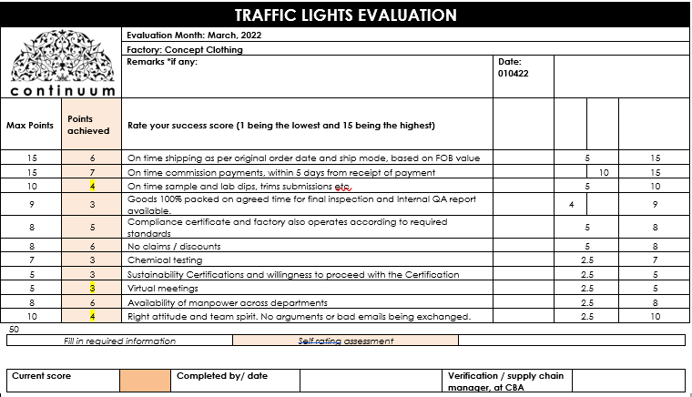 **‘**

**ANALYTICAL HEIRARCHY PROCESS**

Applying AHP for the vendors of Continuum. AHP is a structured technique for organizing and analysing complex decisions.

AHP aids in finding the correct decision according to problem. It helps in providing a comprehensive framework for structuring a decision problem, for representing and quantifying its elements.

The benefit is that it helps divide the issues/problems into a subcategory which can be analysed independently. The elements of the hierarchy ight be a part of the decision problem, that impacts the decision on hand.

Steps involved in the process

Following are the steps which are involved to meet the required objective

1. Listing the parameters
2. Analysing the data collected
3. Developing pair-wise comparison matrix
4. Setting priority wise vector
5. Subsequently ranking the criteria and the supplier

Step – I

**Listing all the criteria**

**P1- Costing**

**P2 – Response time (email replies)**

**P3- Delayed submissions for approvals**

**P4 -Time and action follow**

**P5- Less manpower**

**P6- Rejection rate**

**Preference Level**

**Deriving priorities and giving weightage**

|  |  |  |  |  |  |  |
| --- | --- | --- | --- | --- | --- | --- |
|  | P1 | P2 | P3 | P4 | P5 | P6 |
| P1 | **1** |  |  |  |  |  |
| P2 |  | **1** |  |  |  |  |
| P3 |  |  | **1** |  |  |  |
| P4 |  |  |  | **1** |  |  |
| P5 |  |  |  |  | **1** |  |
| P6 |  |  |  |  |  | **1** |

**Recommendations**

Several points can be withdrawn from my observations about working at Continuum. The main emphasis is to improve communication between Continuum and their respective vendors.

There are a few suggestions that can be implemented to promise timely delivery and can help sustain the quality of the products.

**References**

* Supplier selection and evaluation method using Analytical Hierarchy Process (AHP): a case study on an apparel manufacturing organisation by Mohammad Marufuzzaman and Kazi Badrul Ahsan
* A model for evaluation and selection of suppliers in global textile and apparel supply chains by S. Gary Teng and Hector Jaramillo.
* <https://www.purchasing-procurement-center.com/supplier-survey.html>
* Supplier Selection Problems in Fashion Business Operations with Sustainability Considerations.
* Sukendar, Irwan ; Implementation of supply chain management in supplier performance assessment using Analytical Hierarchy Process (AHP) Objective Matrix (OMAX) and Traffic Light System, Nurwidiana, Diah Nurul Hidayati.