**Week 3 Assignment**

**There are two questions for this assignment**

**Question 1**

**See the slides 41,36 to understand more about it.**

For Question one means (Parts 1 and 2) you will need to work within the context of a system that you are familiar with. Manufacturing process, hospital setting, construction site…something that you have a background of understanding so that you can use this knowledge to complete the assignment adequately

**(Think of any system like Boat sink, airplane blast, you are familiar with and once you think what it is explain that process in one page or one paragraph so that I can understand what are you working with)**

**Part 1:**

Construct your own ETA for some system for which you want to assess all possible outcomes (consequences). You must include a paragraph description of the system so that I can assess the robustness of the associated ETA.

* Identify and include relevant physical phenomena (if relevant to the system Initial Event), and lines of assurance that define the system.

You will follow the same general model as the USCG, and

1 – establish the base case to determine consequence

2 – repeat the analysis with at least one additional line of assurance (mitigation measure) to see what the impact of this LOA has on the consequence of the system

Note: you MUST use some drawing program to construct the ETA. DO NOT scrawl some diagram in pencil and/or pen to submit. There are many many many drawing programs AND you can always use excel. Excel is nice because you can set up the formulas to do the math…scary scary math…

**NOTE: Give your ETA drawing probability number of occurrence see the ppt slide 36 and the probability can only be in between 0-1 not more than this )**

**Part 2:**

**FTA slide 57 start looking for details from slide 57**

Now move backwards from your “initial event” and construct a FTA that tracks backwards the possible failure modes to the basic events.

* Include AND OR gates
* Estimate probabilities of basic events
* Estimate the probability that the initiating “T” event will occur

For Part 1 and 2, you will record a short PPT that explains your system, the ETA and the FTA. Clearly for this assignment there is no “right” answer. What I am looking for is a reasonable attempt to implement the ETA and FTA in the context of some system that you are familiar with. This does not have to be a complicated system, but if the system results on only one or two branches, this will not be viewed favorably.

**NOTE: Give your FTA drawing probability number of occurrence see the ppt slide 36 and the probability can only be in between 0-1 not more than this )**

**Question 2**

**Part 3**

Using the Fault Tree below

1 – convert this into Boolean algebraic expression

2 – simply the expression using the rules in the table below

3 – convert the simplified expression back into a Fault Tree as a minimum cut set

Post before and after illustrations and original and minimum cut set Boolean algebraic expressions to in a word document (or visio if you have it)

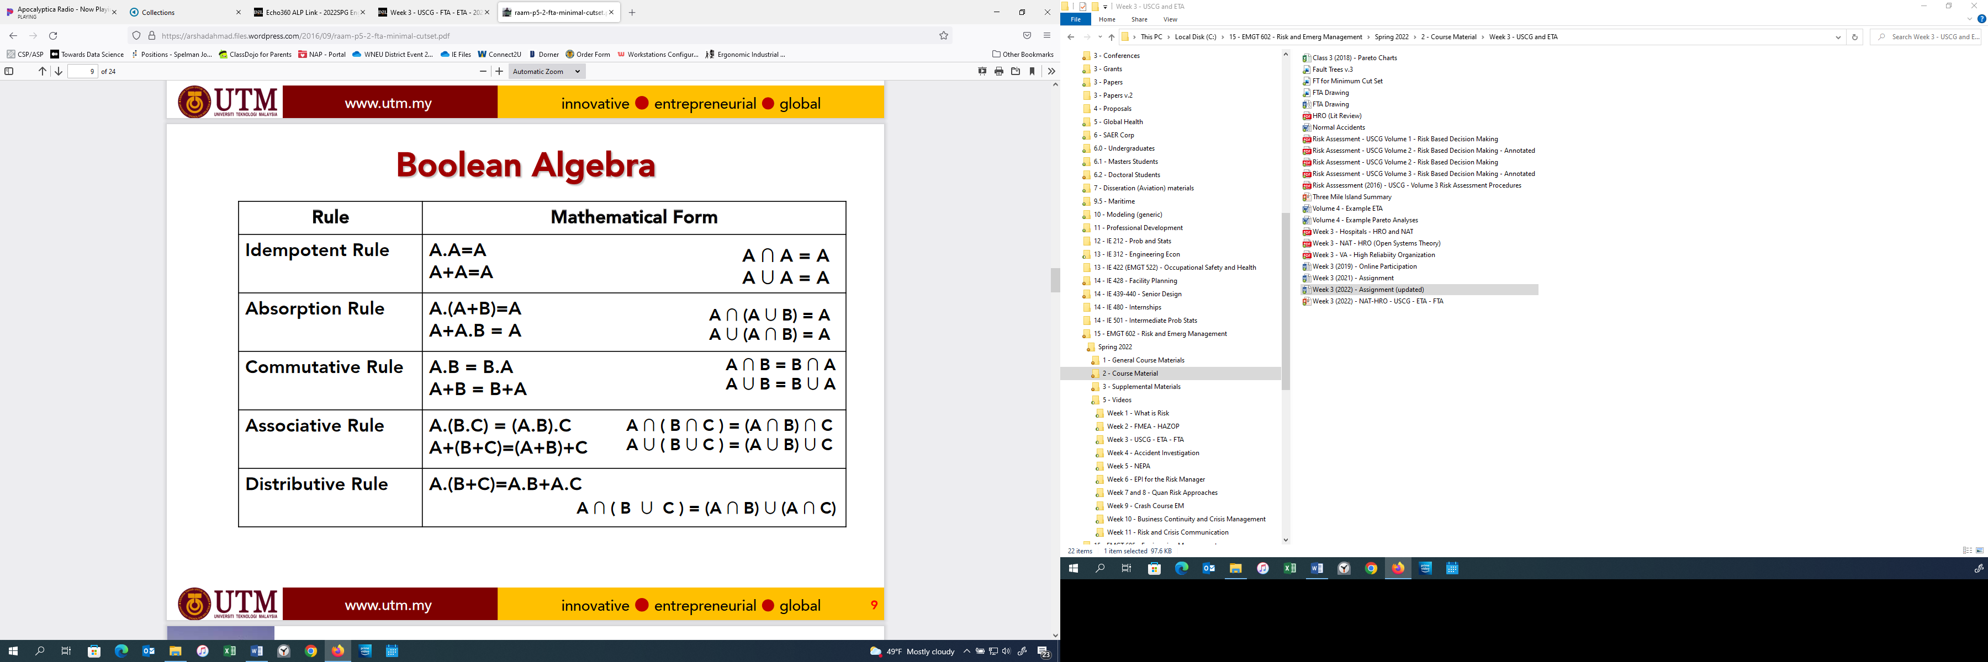

**See diagram below:**

**See Slide 66 you can take the reference.**

