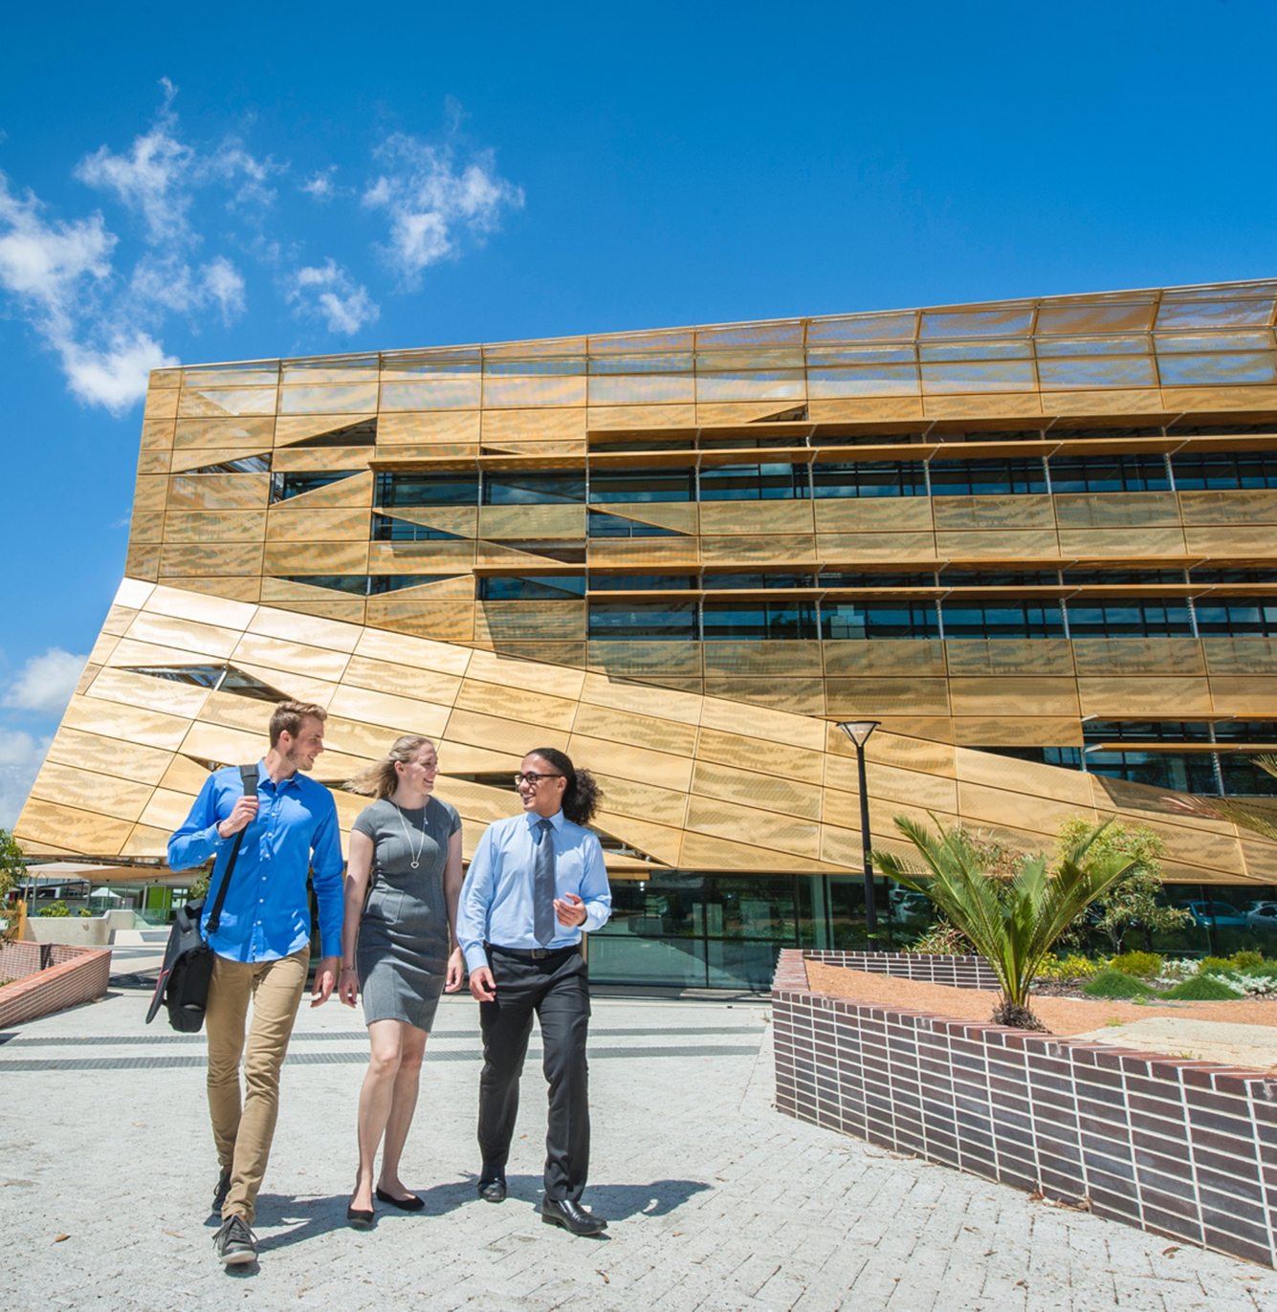

# Requirements

1. The following is a list of companies from the latest ASX. These companies are carefully chosen for this assignment and fit the learning outcomes of the unit.

|  |  |  |  |  |
| --- | --- | --- | --- | --- |
| ASX code | Company names | GISC sector | GICS industry group | Note |
| XRO | Xero Limited | Information Technology | Software & Services |  |
| ALU | Altium Limited | Information Technology | Software & Services |  |
| CL1 | Class Limited | Information Technology | Software & Services | Financial data available from 2016 |
| HVN | Harvey Norman Holdings Ltd | Consumer Discretionary | Retailing |  |
| MYR | Myer Holdings Limited | Consumer Discretionary | Retailing |  |
| WEB | Webjet Limited | Consumer Discretionary | Internet & Direct Marketing Retail |  |
| FLT | Flight Centre Travel Group Limited | Consumer Discretionary | Hotels, Restaurants & Leisure |  |

1. This a group project. The maximum number of members in a group is four.
2. In your group, select one company and analyse the latest five-year performance of the company.
3. Download the company financial data from [DatAnalysis](http://datanalysis.morningstar.com.au.ezproxy.ecu.edu.au/af/dathome?xtm-licensee=datpremium) (also known as Morning Star) for your analysis. The data shall include items from balance sheet, income statement, cash flow statements, and relevant financial ratios for the latest six years. You will need to download 1 year extra to be able to run a five-year analysis.
4. You can find a guideline to download the data from DatAnalysis at the end this document.
5. You are encouraged to analyse the company beyond the reported financial figures. It is advisable, but not limited, to look for further information on IBIS World (from IBIS <https://ecu.au.libguides.com/ibisworld>), the company’s annual reports, and other credible sources including the company’s official website.

# Details instruction

1. For the latest five-year period of your chosen company, assess the company’s profitability, liquidity, and solvency. The table below summarises some of the relevant ratios for each ratio category.

|  |  |
| --- | --- |
| Ratio categories | Example of ratios to analyse |
| Profitability | e.g., 1. Return on equity (ROE), and 2. Net profit margin. |
| Liquidity | e.g., 1. Current ratio, and 2. Acid test (also known as quick ratio). |
| Solvency | e.g., 1. Debt ratio, and 2. Net interest cover. |

Note: Each ratio does not sit in a vacuum. One ratio interlinks with other ratios of different categories. Therefore, you need to draw in more than 2 ratios in each category to provide substantive reasons and discussions. Industry average and competitors’ data also form a good platform to put your discussion into perspective. For example, a large difference between current ratio and quick ratio can be explained by an inventory build-up.

This can be confirmed by looking at inventory turnover (in days) which is longer compared to its competitors or the industry average. In that case, it could mean the company has difficulties to attract customers, which can also explain why it provides a longer credit term (receivable turnover ratio in days).

In some cases, you will need to manually calculate other ratios to provide substantive reasons and discussions for the trend captured in a published ratio. For example, a steady increase in revenue over a five-year period can be explained by a rapid expansion of the company. However, *revenue per store* indicates a negative growth which can be detrimental for the company (see Dick Smith case [here](http://www.news.com.au/finance/business/retail/mcgrathnicol-releases-dick-smith-report/news-story/c2897a8cf8023b3f7490b7f16c2781c2)). This revenue per store is a ratio that is not readily available and will need to be calculated manually, and it is dependent on the availability of the data. Some companies disclose the number of stores(outlets) they have in their annual reports.

1. Present your analyses in a form of a professional report for a group of potential investors. Charts and tables are encouraged. Your report should have the following sections (maximum possible marks are in the parentheses). The total possible marks are 35.
   1. A cover sheet which clearly identify all group members, class/campus, and your teaching lecturer. See example below.

|  |  |  |
| --- | --- | --- |
| *Family / Surname* | *First name* | *Student ID* |
| Member 1 |  |  |
| Member 2 |  |  |
| Member 4 |  |  |
| Member 5 |  |  |

*Lecturer/instructor : Lecturer/instructor name*

*Campus and class : ES (off-campus)*

* 1. Executive summary (4 marks).
  2. Introduction (6 marks).
  3. Profitability analysis (10 marks).
  4. Liquidity analysis (10 marks).
  5. Solvency analysis (10 marks).
  6. Conclusion (4 marks).
  7. There are also 3 marks (maximum) for grammar/spelling/sentence structure; and 3 marks (maximum) for presentation/formatting.

1. Other criteria for the report
   1. Must not exceed 2,500 words, excluding table of content, reference list and appendices, but inclusive of item 2.2 to 2.7. The report will be graded on the first 2,500 words of item 2.2 to 2.7.
   2. Line spacing: 1.5.
   3. Font-face and size: Calibri, Arial, or Times New Roman with 12-point (for body).
   4. Citations and referencing style: APA 7th Edition. See ECU Library [Guide](http://ecu.au.libguides.com/referencing) for APA 7th referencing style.
2. Submission
   1. Submit your MS Word document to Turnitin on Blackboard. Do not convert your Word document to PDF.
   2. Only one copy of the report should be submitted for every group.

# DatAnalysis data download guide

1. Go to <http://www.ecu.edu.au/centres/library-services/overview>
2. Choose Databases.

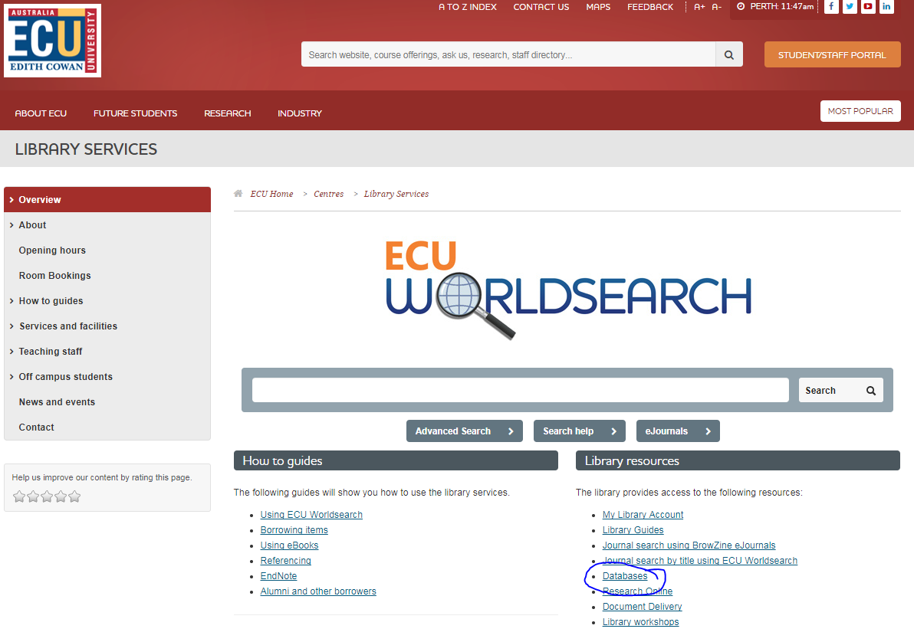

1. Select D and select DatAnalysis.

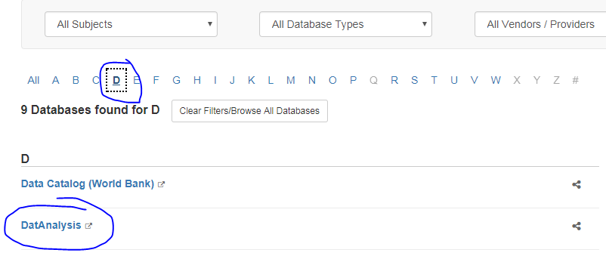

1. 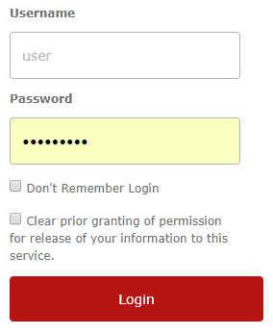Log in with your ECU credentials.
2. Enter the company names or its ASX code in the search field; and click search icon. The company, in this case it’s JB Hifi, is listed in the search result. Click the company name or code.

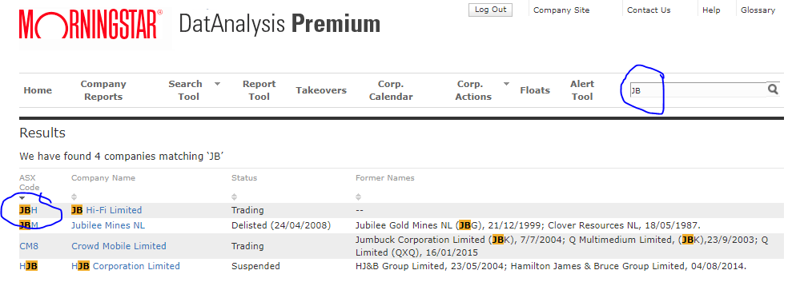

1. The company profile is displayed. Click Financial Data to start downloading the data file.

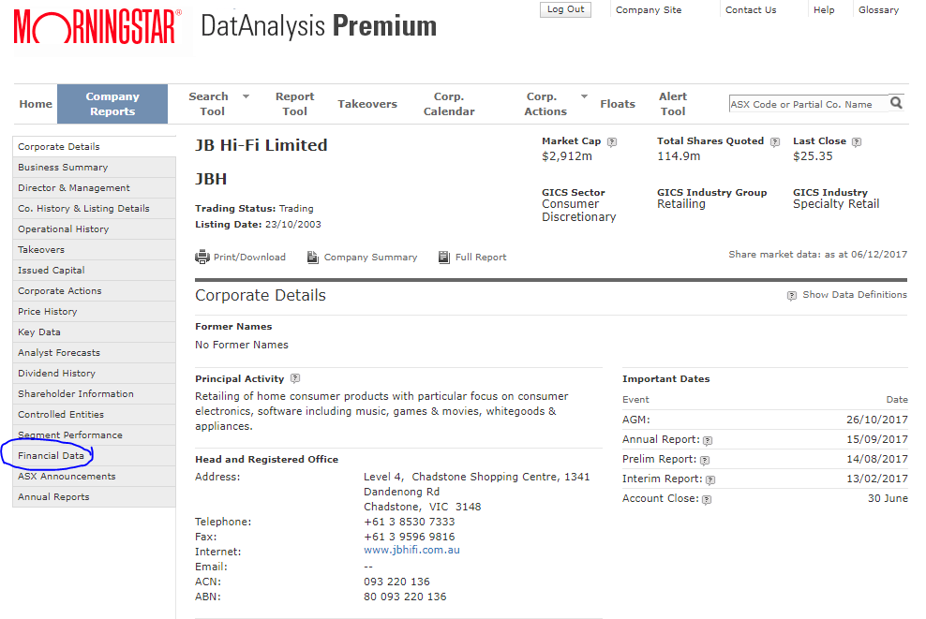

1. Enter the Year Range. In this example, it’s from 2014 to 2020. This example uses a 6-year period. At the time this document is written, the latest data available for JBH is up to Jun 2019.
2. You will need to analyse the latest 5-year period. However, it is advisable to download the data with an extra 1 year prior to the start of the 5-year period, as some ratios, e.g., return on asset (ROA) requires an average total assets which takes the opening plus closing balances divided by 2. The opening balance of year 1 is the closing balance of year 0. E.g., Average total asset for 2019 for JBH is calculated by taking the total asset value reported on the balance sheet in 2019 plus the value in 2018 and divide the total by 2. See the screenshot below.

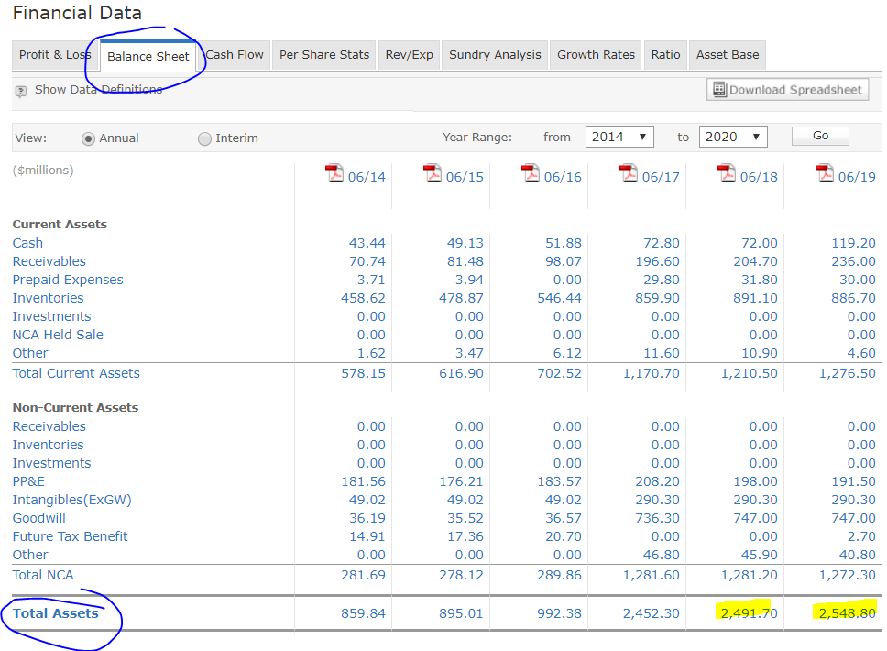

Average total assets in 2019

$$=\frac{2,491.70 + 2,548.80}{2}$$

= 2,520.25

1. Click Go.
2. Click Download Spreadsheet.

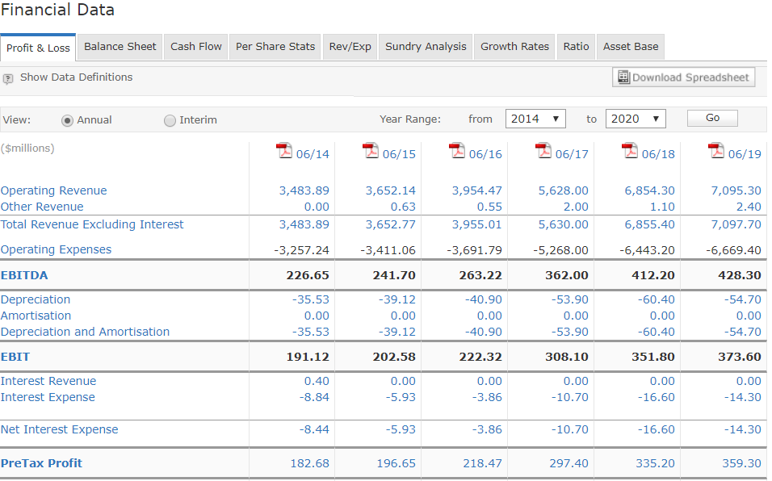

Make sure it’s set to Annual.

Categories of items that will be downloaded as a CSV file. Excel is the typical default app to view the document.

The PDF containing links to company’s annual reports, summary of company presentations to shareholders.