3000 WORDS ASSIGNMENT DETAILS.
PART 1 = 1200 WORDS
PART 2 = 900 WORDS
PART 3 = 900 WORDS.
Assessment will focus on sustainable competitive advantage in retailing. Assessment is based on a 3000-word assignment which will involve comparative analysis of aspects of retail performance. This mode of assessment has been chosen as it critically examines those factors within the retail marketing mix which are affecting the retailer’s sustainable competitive advantage.
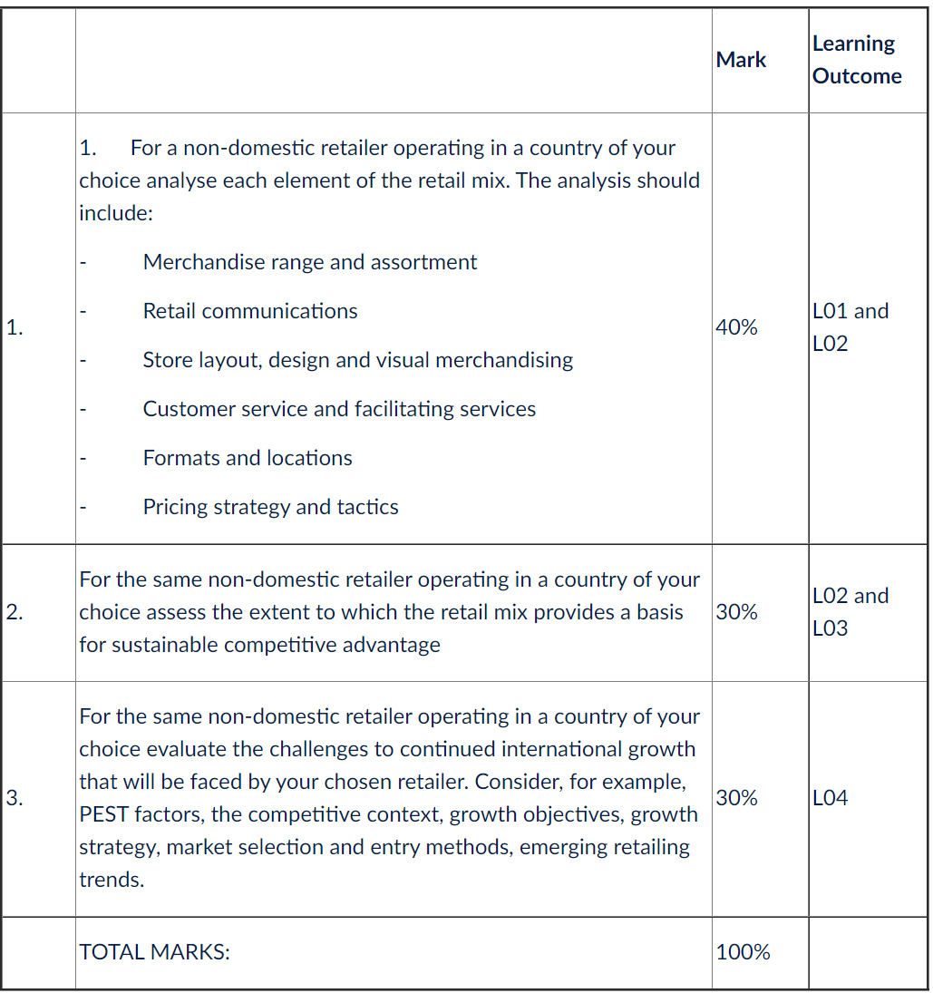
Page margins should not be less than 2cm top, bottom and sides.
Double line spacing should be used except for indented quotations or footnotes where single spacing may be used.
Pages should be numbered consecutively through the main text including photographs and/or diagrams when they are included as whole pages (including all appendices).
All type fonts should be 12pt in size as a minimum and Arial font used where possible.
Harvard Referencing version six should be used.

