**Biological Food composer**

**Abstract:**

Food waste is the major contributor to Greenhouse gas in turn climate change. Many of us don’t realize how much food we waste at some point in time. For instance, think about the days when we cook more than what we could eat or the milk that is left too long inside the refrigerator. All these are discarded in landfills which rot there for days to produce greenhouse gas. Throwing occasionally might sound like meager damage to the planet from one household. According to the Food and Agricultural Organization, we waste about one-third of all produced food. To say roughly, if food waste was a country it would be the third-largest in the world. When food is discarded it goes to the landfills, where it rots to produce Methane- a Greenhouse gas that is 28times much potent than Carbon dioxide. If we divert food waste from landfills to an innovative food waste treatment system then we can stop almost 11% of Greenhouse gas emissions. The Methane that is released from food waste hangs around our environment for 12 years and traps most of the heat from the Sun. Although methane is short-lived it contributes to 20% of Greenhouse gas emissions.

So we design eco-friendly biological food decomposers. In today's market food composers take **3 to 4 days** to compose food but we are going to design with maximum efficiency food composition done within **16 to 24 hours**.

**Introduction:**

Land waste with regards to food waste falls under two categories. The land used to produce food and the land used to dump waste food. There are two kinds of land: arable and non-arable. Arable lands are where crops can be grown and non-arable is not ideal for crops. These non-arable lands are perfect for livestock. About 900 million hectares of non-arable lands are used for livestock for producing meat. About 11.5 billion hectares of the global land surface are used for agriculture. The land used for growing crops or livestock is not a problem. The real problem is food waste. We never really understand what we waste along with the food.

About 67 million tons of food in India is wasted every year among which 70-75% of food waste rots in landfills. This puts an overstress on our land which has worked hard to produce food for us already. If we don’t care about losses soon, the ability to yield over-time will degrade as well.

This product makes food waste to compost material within a day. Food waste is regularly used in home, working places, events,and traveling all over the world . Food waste happens but these products can change that waste to organic fertilizer within a day.

Working:

The working Principle of compost food waste in combination of microorganisms and microorganisms with presence of air and some water at constant heating temperature turned to food waste to fertilizer.

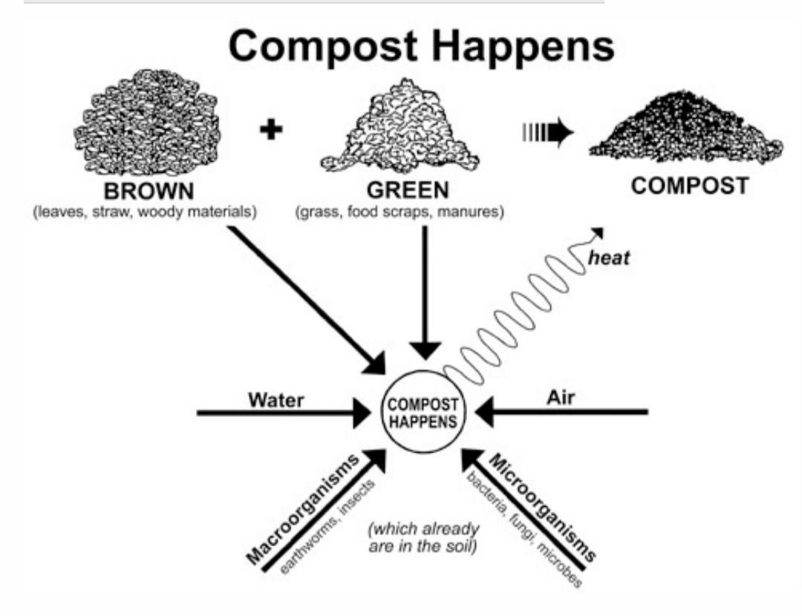

**Process:**

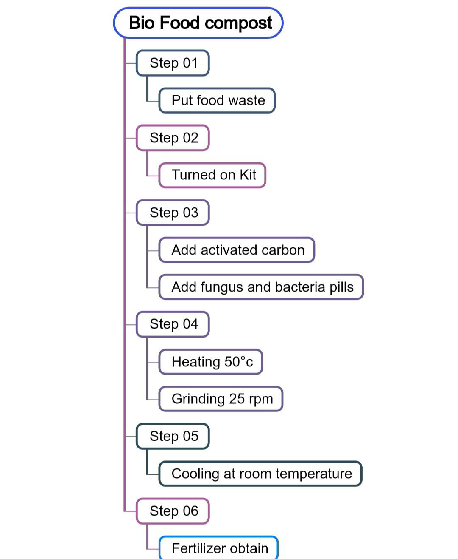

**Step 01:** put and close food waste on kit

**Step 02:** Turned on the kit

**Step 03:** Add activated carbon and fungus and bacteria pills with food waste on it. Activated carbon is used to lock bad smells during decomposition and used to breaking down waste faster. Fungus and bacteria pills act as a catalyst to boost the reaction.

**Step 04:** Heating at a warm temperature of 50°c and grinding at 25 rpm for 6 hours.

**Step 05:** cooling process makes cooling at room temperature itself for 4hours.

**Step 06:** fertilizer uptain

**Layout:**

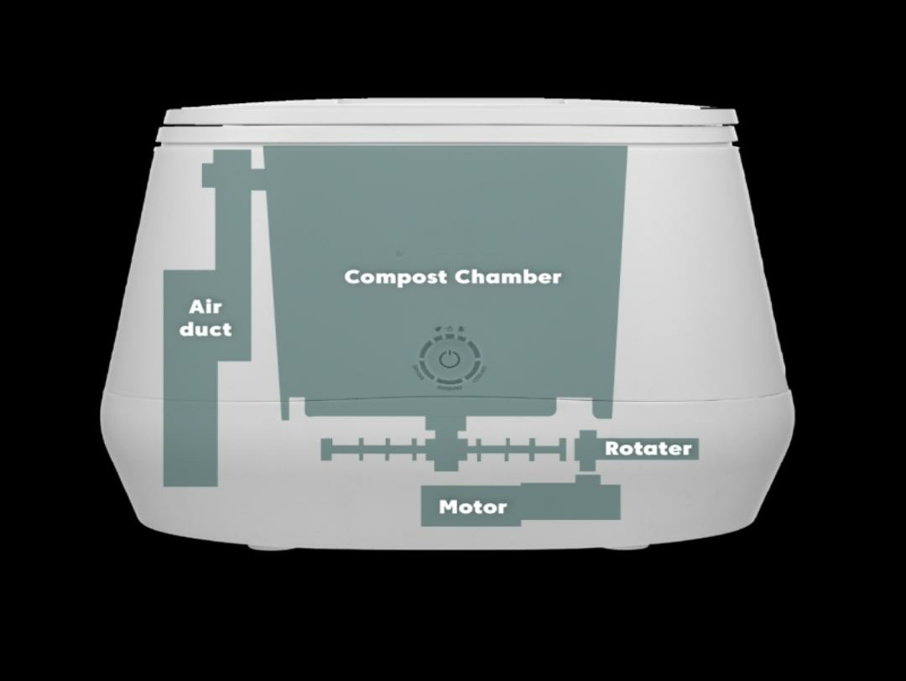

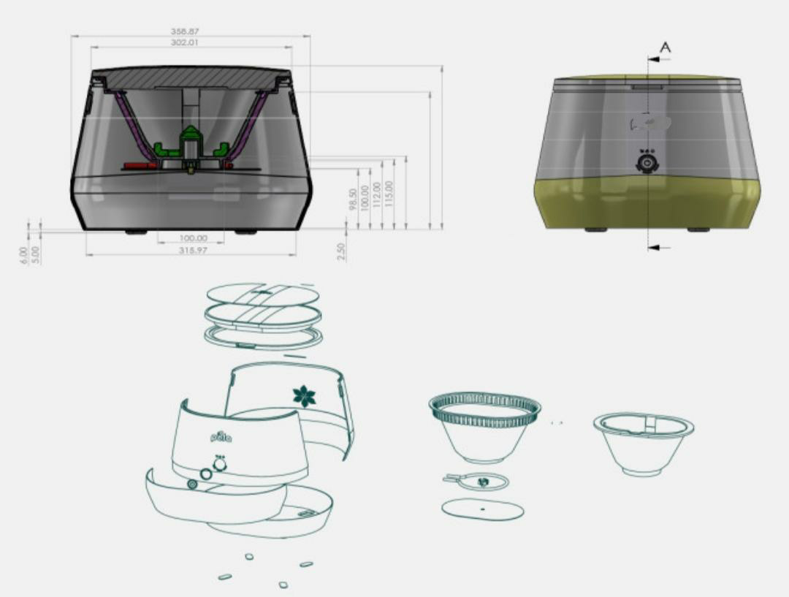

**Advantage**:

* Eco friendly
* **Economic**
* **Non toxic to human**
* **Time saving**
* **Easy locomotive**
* **Handy**
* **Easy to fit in any place**
* **Low noise pollution**

**Application:**

* For regular food waste place like company canteen, train and home this in used to convert that waste to useful products
* This entire process happen in a day so very quick and time saving products